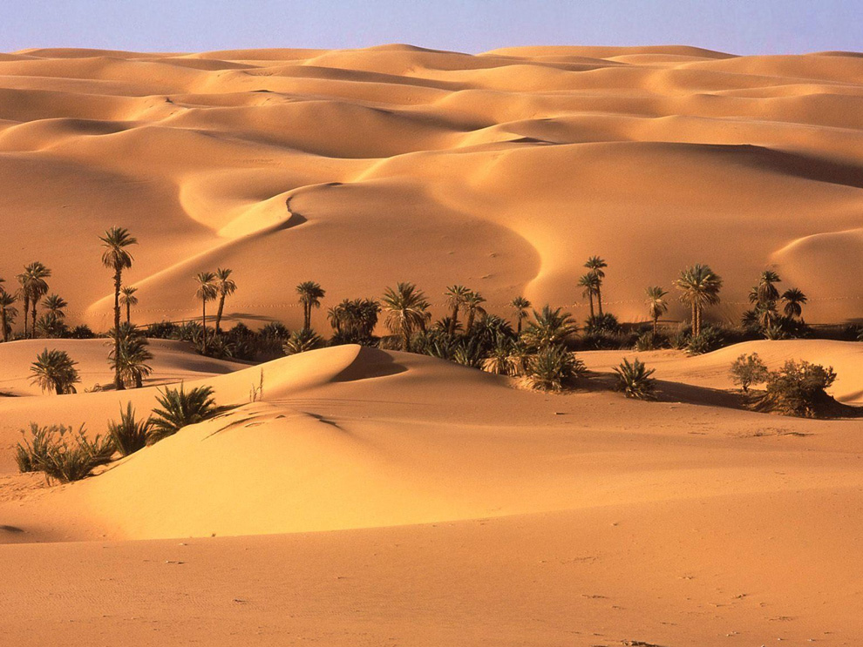

The Desert: An Enigmatic Landscape

The desert is a unique and enigmatic landscape that covers about 20% of the Earth's surface. It is a harsh and unforgiving environment that is characterized by extreme temperatures, low rainfall, and sparse vegetation. Despite its challenging conditions, the desert is home to a wide variety of plant and animal life, as well as diverse human cultures that have adapted to its unique conditions.

Deserts are found in every continent on Earth, and each has its unique features and characteristics. Some of the largest deserts in the world include the Sahara in Africa, the Arabian Desert in the Middle East, the Gobi in Asia, and the Mojave in North America. Each of these deserts is characterized by its unique landscape, climate, and biodiversity.

The desert landscape is often characterized by vast expanses of sand dunes, rocky mountains, and dry riverbeds. The sand dunes are formed by the wind, which blows sand into large piles that shift and change shape over time. The rocky mountains are often composed of hard, durable rock that has been eroded over millions of years by wind and water. The dry riverbeds, known as wadis, are the remnants of ancient rivers that once flowed through the desert.

The desert climate is characterized by extreme temperatures, both hot and cold. During the day, temperatures can reach well over 100 degrees Fahrenheit, while at night, they can drop below freezing. The low rainfall in the desert means that water is scarce, and plants and animals have adapted to survive in this dry environment. Many plants have developed long roots that reach deep into the ground to find water, while animals have adapted to store water in their bodies and to survive long periods without food or water.

Despite its harsh conditions, the desert is home to a wide variety of plant and animal life. Some of the most common plants in the desert include cacti, succulents, and shrubs. These plants are adapted to the dry environment and have developed strategies to conserve water. Animals that live in the desert include lizards, snakes, rodents, and birds. Many of these animals are nocturnal, meaning they are active at night when temperatures are cooler.

The desert is also home to a diverse range of human cultures that have adapted to its unique conditions. Nomadic tribes, such as the Bedouin in the Middle East and the Tuareg in North Africa, have lived in the desert for thousands of years. These tribes have developed unique lifestyles and traditions that are closely tied to the desert landscape. They have also developed strategies to survive in the harsh environment, such as using camels as a means of transportation and finding water sources.

Despite its beauty and importance, the desert is facing many threats. Climate change is causing temperatures to rise, and rainfall patterns are changing, making the desert even drier. Desertification, the process of turning fertile land into desert, is also a major issue. Overgrazing, deforestation, and land-use changes are all contributing to desertification, which can have severe consequences for the environment and human communities.

To protect the desert and its biodiversity, it is essential to take action. Strategies to reduce greenhouse gas emissions and combat climate change can help to slow the impacts of rising temperatures and changing rainfall patterns. Protecting areas of the desert from development and preserving biodiversity can also help to maintain healthy desert ecosystems. Supporting sustainable human communities that live in the desert can also help to promote conservation and protect the desert's unique cultural heritage.

In conclusion, the desert is a unique and enigmatic landscape that is home to a wide variety of plant and animal life, as well as diverse human cultures. It is a harsh and unforgiving environment that has challenged human communities for thousands of years. However, the desert is also.