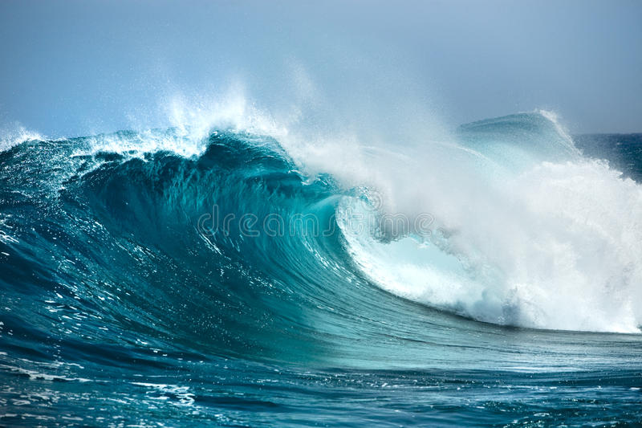

The Ocean: Our Beautiful Blue Planet

The ocean covers more than 70% of the Earth's surface and is home to millions of living organisms. It is an essential part of our planet, and without it, life as we know it would not exist. The ocean is not just a big body of water; it is a complex ecosystem that provides us with many resources, including food, energy, and medicine. It is also a source of inspiration and beauty.

The ocean is an immense body of saltwater that is constantly moving. It is made up of five main regions: the Atlantic, Pacific, Indian, Southern, and Arctic Oceans. Each region has its unique features, such as water temperature, depth, and currents. The ocean's water is salty because of the minerals that are dissolved in it. Saltwater is heavier than freshwater, which is why the ocean is deeper than most lakes and rivers.

The ocean is home to millions of living organisms, including fish, whales, dolphins, sharks, turtles, and many others. It is estimated that there are over one million species of plants and animals in the ocean. The ocean's biodiversity is essential for maintaining a healthy ecosystem. Some of the most important organisms in the ocean are phytoplankton, tiny plants that produce most of the oxygen we breathe.

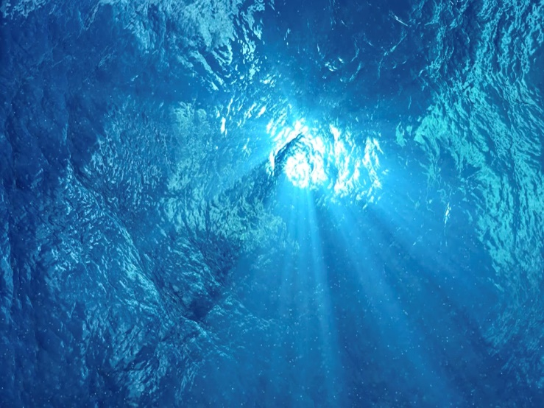

The ocean is also a vital source of food for humans. Fish, shellfish, and other seafood are an important part of the human diet. Many people around the world depend on the ocean for their livelihoods. Fishing and aquaculture are major industries that provide jobs and income for millions of people. However, overfishing and pollution are major threats to the ocean's health and the livelihoods of those who depend on it.

In addition to providing food, the ocean is also a source of energy. Waves, tides, and ocean currents can be used to generate electricity. Ocean energy is a clean, renewable source of energy that can help reduce our reliance on fossil fuels. However, harnessing ocean energy can also have negative impacts on marine life if not done sustainably.

The ocean is also a source of inspiration and beauty. Its vastness and beauty have inspired countless artists, writers, and poets throughout history. The ocean's waves, colors, and marine life have also captured the imagination of many. The ocean has a calming effect on many people and is a popular destination for recreation and relaxation.

Despite its importance, the ocean is facing many threats. Pollution, overfishing, and climate change are all putting pressure on the ocean's health. Plastic pollution is a major issue, with millions of tons of plastic waste ending up in the ocean every year. This plastic waste harms marine life and can even make its way into the human food chain.

Overfishing is another major threat to the ocean's health. Many fish stocks are being depleted due to unsustainable fishing practices. This not only harms the fish populations but also the communities that depend on them for their livelihoods. Climate change is also affecting the ocean, with rising sea temperatures and sea levels, and ocean acidification threatening marine life.

To protect the ocean and its resources, it is essential to take action. Reducing plastic waste, supporting sustainable fishing practices, and reducing our carbon footprint can all help to protect the ocean's health. Governments, businesses, and individuals all have a role to play in protecting our beautiful blue planet.

In conclusion, the ocean is an essential part of our planet, providing us with food, energy, and inspiration. It is home to millions of living organisms and is an important source of biodiversity. However, the ocean is facing many threats, including pollution, overfishing, and climate change. It is up to all of us.