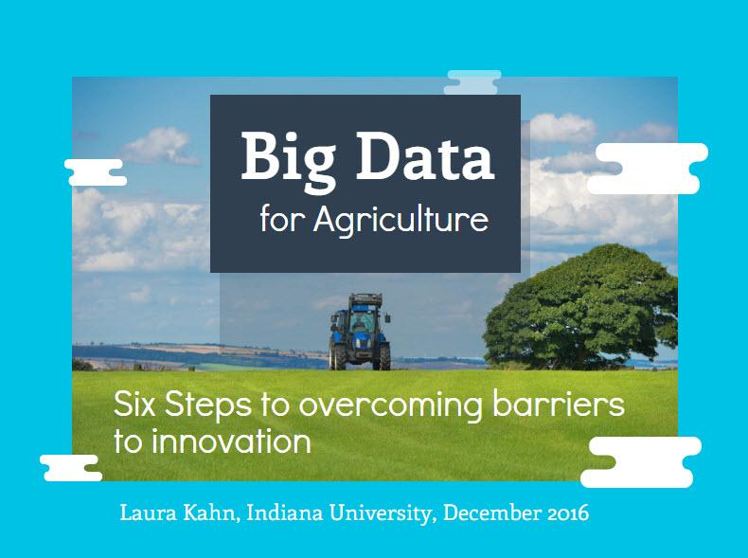

### 

**With the population reaching 9 billion by 2050, there is a need to increase agricultural productivity. By 2030, the Food and Agriculture Organization of the U.N. estimates there will be a 35% increase in global food demand [16]. Along with this increasing demand, climate change and a decreasing amount of arable land will affect the food supply. Leveraging information gained from big data analysis and implementing it in agriculture could help meet these growing demands on the food supply. Innovative solutions from big data insights will be the key to feeding the next generation.**

The good news is that emerging technologies continue to make it easier to collect and use large amounts of data cheaply. Big data can make a farmer more productive. This potential will drive agricultural innovation to minimize the effects of climate change, natural disasters and limited resources for society [10]. It is essential to break down barriers so farmers can produce more with less resources and so the world has enough to eat. The stakes have never been higher for overcoming these challenges.

Three main challenges in agricultural applications include: data infrastructure, data integration and deriving value from the data.

These steps will help overcome these challenges:

1. Set up an appropriate infrastructure.
2. Establish partnerships to integrate data.
3. Communicate across silos.
4. Ask the right questions.
5. Find the data’s value.
6. Data experts collaborate with domain experts.

For purposes of this research, big data means data that is generated by private entities such as corporations and non-government organizations [12]. This paper explains the three challenges along with the six steps to overcome them.

Introduction  
Big Data has the potential to dramatically improve agriculture especially in the developing world. Big data analysis for agriculture means transforming imperfect, complex and often unstructured data into insights and actionable information[9]. Productivity could be increased significantly if farmers had access to the right advice and information at the right time. For example, farming productivity in India is only 30-60% of what developed countries have [11]. Adoption of big data in agriculture can reduce crop failure. Big data innovations could literally give you or your family enough to eat when you’re hungry and mean the difference between life and death in the future. In this research, the three biggest challenges to implementing big data and six steps to overcome the challenges are discussed.  
  
Problem Definition   
The first challenge when implementing big data is creating an effective data infrastructure. The data infrastructure includes the data itself, how it is managed, analytics, storage and security [3]. All of these aspects are important from an organizational and social context because without one of them, big data implementation will fail.

The second challenge is how heterogeneous data are integrated. IBM Analytics defines data integration as ‘the combination of technical and business processes used to combine data from disparate sources into meaningful and valuable information’ [4]. Agricultural data includes weather data, sensor data from GPS transceivers, smart meters and cell phone data. In order to optimize production, the data need to be linked [8].

The third challenge is how to derive value from big data. Using big data means organizations have a lot of data that may not be needed for agricultural innovations. In two days, society now creates as much data as all of civilization created prior to 2003 [14]. Sorting through this amount of data and finding value has been compared to finding a needle in a haystack. Innovative solutions require stakeholders to ask what data is necessary and what value it will create.

### High-level Solutions

There are several high-level solutions for overcoming each of these challenges. Creating a *successful Infrastructure* may mean the organization has more cloud-based solutions with adequate storage, scalability and security that big data requires. One example is when an organization used [Eucalyptus](https://en.wikipedia.org/wiki/Eucalyptus_(software)) cloud software to give crop data access to remote areas of the country [6]. Next, in order to solve the *Integration challenge*, commercial applications such as [TeraStream](http://datastreams.co.kr/en/consulting-service/data-integration/) batch the data, link it and convert it to quickly process all of the data. This type of solution allows the data from a field sensor to communicate with the data from a farmer’s mobile phone. Finally, to solve the third challenge of *Deriving Value,* the success of big data for agricultural innovation depends on the participation, support from and collaboration between public and private entities.

Six Steps to Overcome Big Data Challenges



**Step 1** - As data volume continues to grow, organizations need to make investments in infrastructure to ‘capture, store, aggregate, manage, govern and analyze data’ [1]. One of the key aspects to a great infrastructure is setting up a cloud which offers a centralized knowledge repository [8]. When all the data is in one place, anyone with access can have the data at any time. A cloud infrastructure example is farmers in Sudan that use a cloud-based system with mobile phones to disseminate data about crop status, planting schedules, harvesting times and market prices using their mobile phones [15].



**Step 2** - With the use of big data comes more complex, messy data. There is a need ‘to link, match and transform data across heterogeneous entities and systems’ [8]. Various sources of data means that not one single entity has control over the data. It’s important for different groups to work together to link and manage their data. Partnerships between farmers and global technology companies benefits both parties and can serve as one way to integrate data.



**Step 3** - Silos of information are one of the biggest threats to

implementing big data in agriculture. A silo mentality is harmful because the information is not shared between groups inside of or outside of the organization. Collaboration and communication could help achieve advances in knowledge that otherwise might not be achieved if the data was hoarded [9].



**Step 4** - It’s important to understand what big data can and cannot do to benefit agriculture. Asking the right questions should ideally happen before you get the data. Without research questions that are relevant to the country context, researchers are less likely to produce findings with any local impact” [14]. It is important to ask the ‘right questions’ for the organization and society before you can find the right data.



**Step 5** - Before analysis begins it’s important to determine which data is valuable. What may seem at first to be unimportant data can be valuable when combined with other data sources. By asking the right questions, the most valuable data can be extracted. Adopting big data is also a cultural issue, where organizations don’t implement programs because they don’t appreciate how data can enhance their business. Tying valuable data to measurable business outcomes can help overcome implementation challenges*.

*<http://openag.io/blog/>



**Step 6** - To maximize the benefits of big data, people with data skills need to work with agriculture domain experts to understand the context and meaning of the data to create innovative solutions. Although there is no quantitative data that measures how much more effective a multi-disciplinary data team is, other research points to the value in having different people focus on their particular skillset to accomplish a goal [13]. The interaction between those with technical data skills and business acumen will help organizations integrate the information gained from the data into agricultural processes.

### Business benefits and risks

Typically, business benefits are seen in terms of return on investment. The benefits to implementing big data solutions for agriculture are 1) fewer resources are needed to produce more food and 2) a reduced dependence on foreign aid. Each of these benefits will be examined in more detail and should convince stakeholders to do the six steps above to overcome the big data challenges.

Each of these case studies describes ways that big data has measurably increased production and profitability for farmers. Although this is not an exhaustive list, it shows how big data innovations can yield more food for the planet. From increasing wheat production in Sudan to saving Columbian rice farmers millions of dollars, big data innovation is an exciting key to solving the global food supply problem.

**Table 1**. Fewer Resources to Produce More Food

|  |  |  |
| --- | --- | --- |
| **Case Study** | **Big Data Solution** | **Return on Investment** |
| Technical Centre for Agricultural and Rural Cooperation - Sudan [15] | Satellite and crop data sent to farmers’ mobile phone using cloud technology | Produced 10 times more wheat |
| Center for Tropical Agriculture – Columbia [7] | Machine learning models of weather data enabled 170 rice farmers to know when to plant. | Saved about $3.6 million |
| Accenture Precision Agriculture Service [2] | Tractor sensors and field monitoring by unmanned aerial vehicles provide real-time data to farmers. | Increase profitability by $55 - $110 per acre. |

In addition to producing more food with fewer resources, big data solutions could reduce dependence on foreign aid. According to the Organisation for Economic Co-operation and Development, in 2014 the U.S. gives about $275 billion dollars each year in aid to developing countries, or about 0.2% of its total federal budget [17]. The Center for Global Development says the assistance is for national security, political development, humanitarian crisis and long-term development purposes of developing countries [20].

There seems to be no quantitative data on how much of the $275 billion in aid dollars is given to feed people. However, if developing countries were producing more of their own food, it’s fair to presume they wouldn’t need the same quantity of foreign aid for food. There’s also the potential to alleviate some of the effects of poverty and disease with big data innovations if people can produce enough healthy food to eat.

Risks to implementing big data in agriculture will be the effort required to starting from scratch and collecting data where no sensors exist. Both of these risks are most prevalent in the developing world where generally there is less technological capability than in the developed world [5].

### Summary

Capitalizing on big data solutions will require changes in how data in seen within and across organizations [1]. Three challenges to implementing big data in agriculture for innovation are: infrastructure, integration and deriving value from the data. There are six steps to overcome the challenges: set up an infrastructure, establish partnerships to link data, communicate across silos, ask the right questions, find the data’s value and having data people collaborate with domain experts. Extracting knowledge from big data is and will be part of the solution to increasing global food production.

References

1. Adduci, R., D. Blue, G. Chiarello, J. Chickering, D. Mavroyiannis, S. Mirchandani, J. Solimando, J. Schleier-Smith, I. Wilson. Big Data: Big Opportunities to Create Business Value.

2. Digital Agriculture: Improving Profitability. Accenture digital. <https://www.accenture.com/_acnmedia/Accenture/Conversion-Assets/DotCom/Documents/Global/PDF/Digital_3/Accenture-Digital-Agriculture-Point-of-View.pdf>. Accessed 28 November 2016.

3. IBM Analytics. Data Integration. <http://www.ibm.com/analytics/us/en/technology/data-integration/>

4. Kobielus, J. and B. Marcus. Deploying Big Data Analytics Applications to the Cloud: Roadmap for Success. IBM Cloud Standards Customer Council, 2014.

5. Manning, L. What is Ag Big Data? How 8 Companies are Approaching it. 12 November 2015. <https://agfundernews.com/what-is-ag-big-data5041.html>. Accessed 29 November 2016.

6. OECD (2016), Geographical Distribution of Financial Flows to Developing Countries 2016: Disbursements, Commitments, Country Indicators, OECD Publishing, Paris.

7. Palmer, N. Cracking patterns in big data saves Colombian rice farmers huge losses. <https://ccafs.cgiar.org/research/annual-report/2014/cracking-patterns-in-big-data-saves-colombian-rice-farmers-huge-losses> . Accessed 29 November 2016.

8. Peisker, A. and S. Dalai. Data Analytics for Rural Development. Indian Journal of Science and Technology, Vol 8(S4), 50-60, February 2015.

9. Sonka, S. Big Data and the Ag Sector: More than Lots of Numbers. International Food and Agribusiness Management Review, Volume 17, Issue 1. 2014.

10. Stubbs, M. Big Data in U.S. Agriculture. Congressional Research Service Report 7-5700. January 6, 2016. <https://www.fas.org/sgp/crs/misc/R44331.pdf> . Assessed 22 November 2016.

11. Surya, P., L. Aroquiaraj, and M. Kumar. The Role of Big Data Analytics in Agriculture Sector: A Survey. International Journal of Advanced Research in Biology Engineering Science and Technology, Vol 2, Special Issue 10, March 2016.

12. Taylor, L. and R. Schroeder. Is bigger better? The emergence of big data as a tool for international development policy. GeoJournal (2015) 80:503-518.

13. The Characteristics of an Effective Multidisciplinary Team. National Cancer Action Team. February 2010. [www.ncin.org.uk/view?rid=136](http://www.ncin.org.uk/view?rid=136) Accessed 29 November 2016.

14. Upchurch, M. Finding that Needle in the Huge Data Stack. <http://www.fuzzylogix.com/fuzzy-logix-in-the-media/finding-that-needle-in-the-huge-data-stack/>. Accessed 27 November 2016.

15. Van der Elstraeten, A. Satellites and mobile phones improve crop productivity in Sudan. <http://www.cta.int/en/article/2015-06-17/satellites-and-mobile-phones-improve-crop-productivity-in-sudan.html>. Accessed 29 November 2016.

16. World agriculture 2030: Main Findings. Food and Agriculture Organization of the United Nations. 2002. <http://www.fao.org/english/newsroom/news/2002/7833-en.html>. Accessed 30 November 2016.

17. Zedillo, E. Rich World, Poor World. U.S. Assistance for Global Development. June 15, 2016. <http://www.cgdev.org/publication/us-assistance-global-development> Accessed 29 November 2016.