David Hackett

Data Visualization

Homework 1

I decided to focus on the trend of babies being named after princesses in the years following movies/tv shows featuring those princesses. A line chart is a good way to see it since it shows the time element. You can see how the name was trending before the movie or tv show appearance which are labeled (in all cases it was pretty flat at least compared to after) and then you can see the sharp incline after the appearance. This highlights the “bump” in babies named after that princess. It also shows the rise was temporary in the case of Tiana and Elsa, our two Disney princesses. Arya, perhaps because she was on a long running television show, had more staying power.

2.

The original:

My change:

The original was Biden’s approval rating and disapproval rating from 538. I wouldn’t say the original was a bad fit, but I think people have a have a hard time with these numbers. For example hearing that Biden’s approval is 49% one might assume that more people disapprove, however if the disapproval rating is 45% Biden’s still above water. 538 tried to handle this by including both numbers on a line graph. However, I think focusing on one number, net approval, makes the graph less noisy and easier to understand. Since it would be just one line, I used bars to emphasize the change. I think that, plus the different colors for positive and negative net approval paints a clearly picture of Biden’s popularity over time.

3.

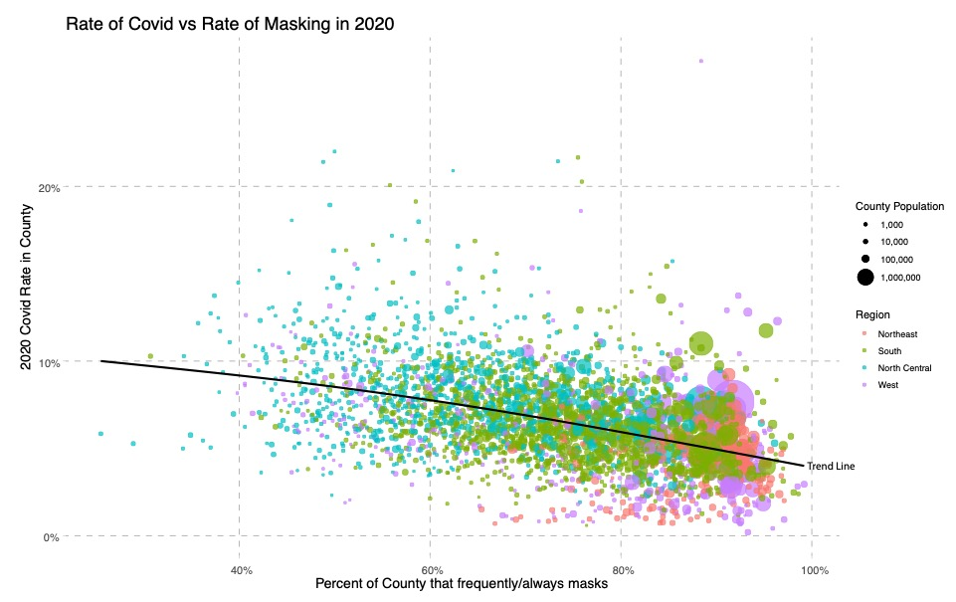

This mask data was sort of buried and only used here really: <https://www.nytimes.com/interactive/2020/07/17/upshot/coronavirus-face-mask-map.html>. I decided it would be interesting to use that plus the county data to see if in 2020 there was a relationship between masking and the rate of covid for the entire year. I was surprised to see that there was a negative correlation. The article made it seem like I should expect the opposite, a higher rate of covid where masking is high. This is obviously an interesting question, which is the dependent variable? Do people mask more when the covid rate is higher or does more masking reduce covid. This provides some evidence for the later. I plotted by county the rate of covid overall for 2020 (ie the amount of people who got covid divided by the amount of people in the county) vs the polling data for how many people in that county said they frequently or always wore a mask. I made the sizes of each point based on the county population and the color represent the region to see if there were any trends there. The data was pretty noisy, so I added a regression line (which I called a trend line since that seems more understandable to the average reader). Obviously or maybe not so obviously this trend doesn’t mean that masks are necessarily reducing covid since other factors (like more social distancing) could be correlated with masking and also having an effect.