David Hackett

Data Viz

Homework 4

1. ScrollyTelling: <https://thedavidhackett.com/stl-schools-scrollytelling/>
2. Bubble Map SVG

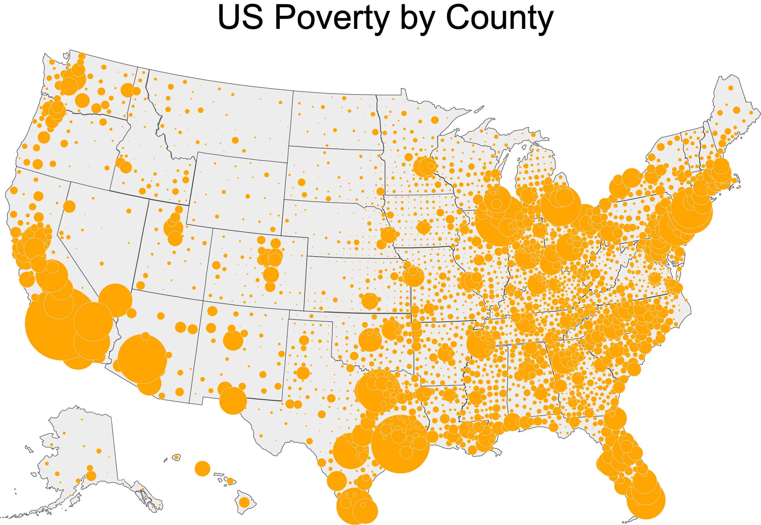

1. Live Bubble Map with Mouseover: <https://thedavidhackett.com/county-poverty-map/>