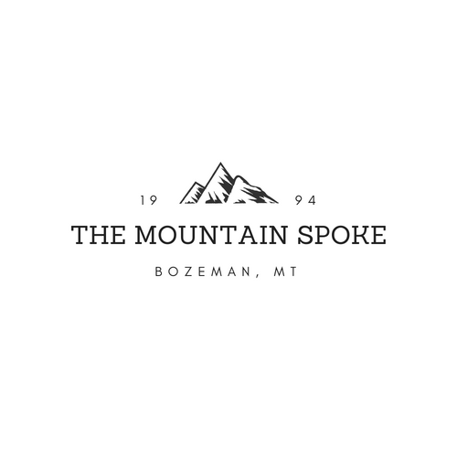

**Color Scheme:**



**Headings: Sanchez**

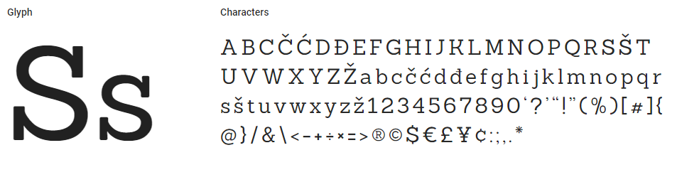

**Body: Open Sans**

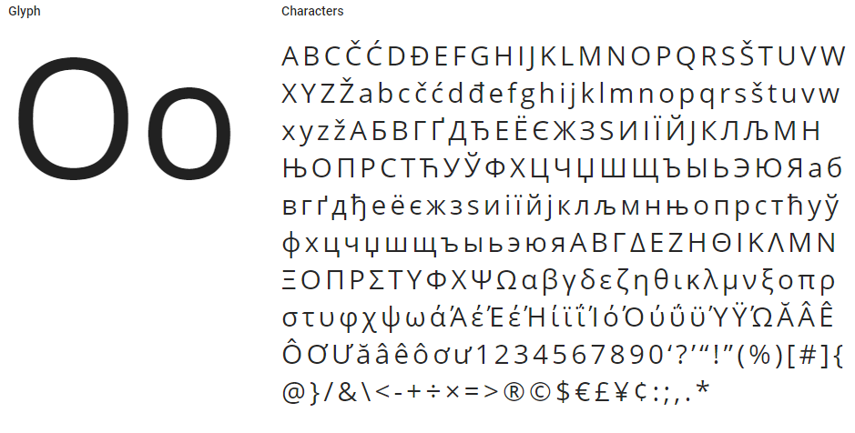

**Target Audience:**

* The community of Bozeman, MT.
* John, age 32, new hipster guy wanting to know the cool things to do in his new town.
* Mary, age 37, lives in ID, but wants to take her family on a fun (close) vacation. She wants easy to find prices and skill levels.

**Site Map:**

* **Home**
  + **Adventure Tours**
    - At least 2 adventures offered. Prices, skill level, location, and length will be mentioned.
  + **Events**
    - “Cycle the Continental divide”
    - Registration form.
  + **Sales**
    - At least 3 bike models w/ basic info.
  + **Services**
    - Data table format about what services we offer.
  + **Contact**
    - Embed Google maps
    - Basic contact form.
  + **About**
    - Image
    - Basic info.

**Wireframe:**

