TIDES OF KNOWING
Leilia · tidesofknowing.com
A Tarot Reading for Hannah
4 July 2026
THE QUESTION
“What obstacles or support is available as I launch my rebranded tea blend?”
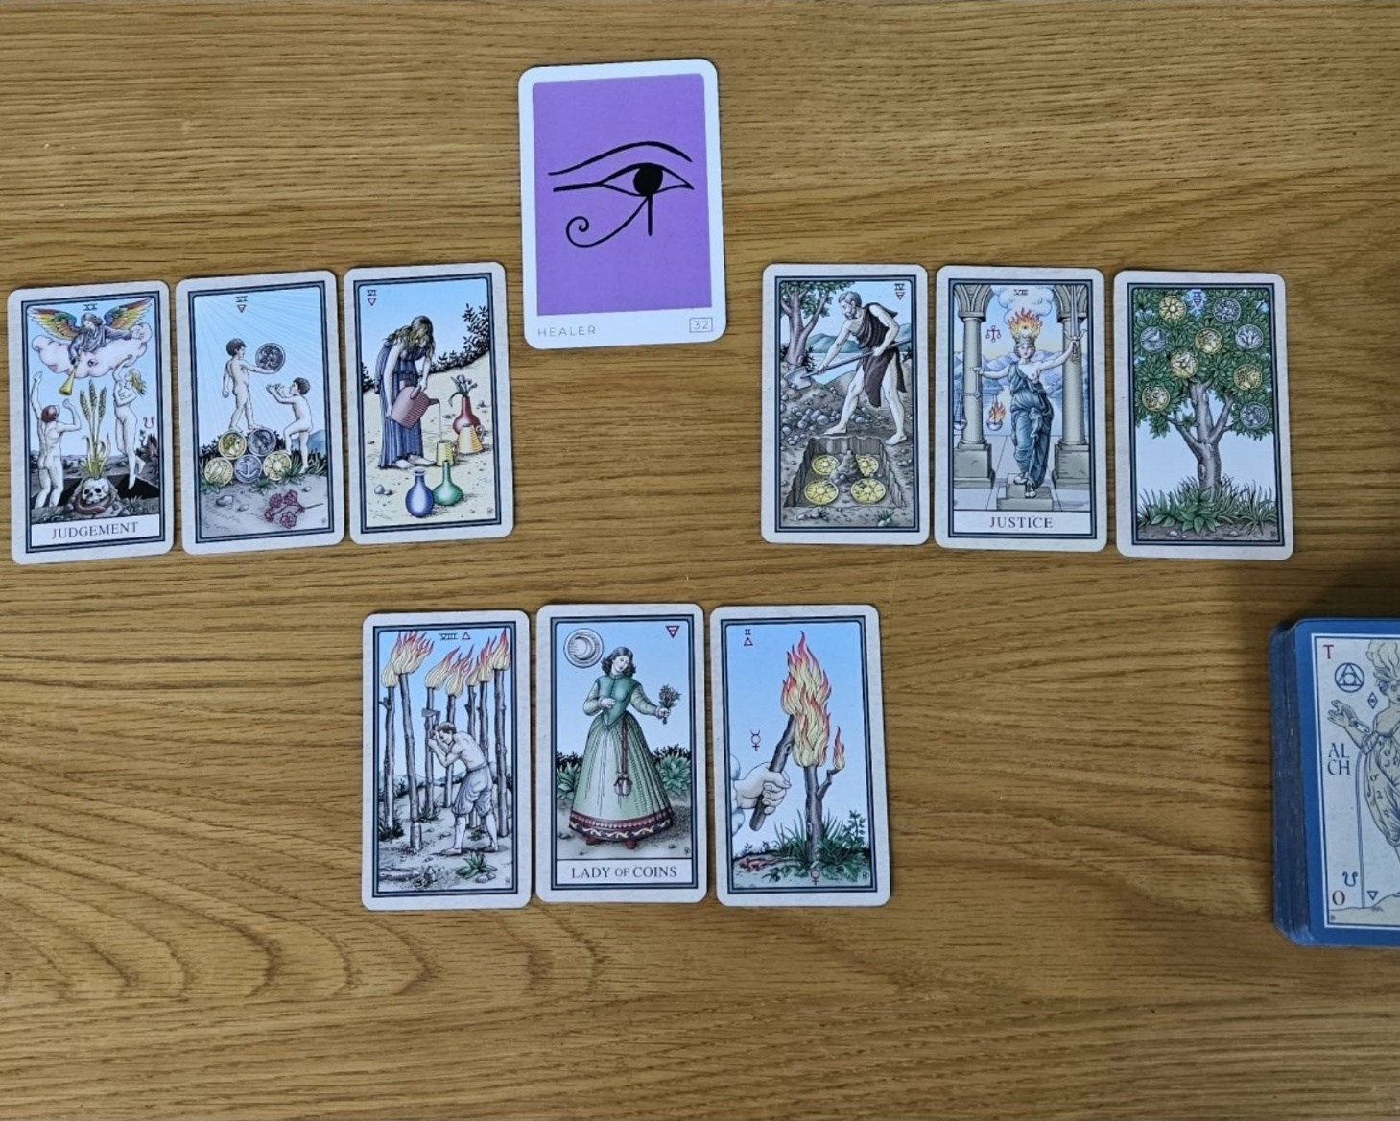

Hi Hannah, please find attached your reading around your rebrand.
THE ARCHETYPE: SETTING THE THESIS
The Healer
I first drew an archetype card to understand the overall energy surrounding the project. What came was the Healer, and to me that's the thesis statement for the whole reading.
I don't think this is simply saying that tea has healing properties. I think it's asking you to make sure your own philosophy and the reason you've created these teas becomes part of the brand itself. More than ever, people don't just buy products. They buy stories, values and authenticity. So I'd be leaning much more heavily into the healing narrative (Lady of Coins, with her bunch of herbs/flowers) and your own journey, because that feels like the heart of the rebrand.
I then divided the reading into what might thwart (left three cards) the rebrand and what would support (right three cards) it.
Interestingly, I don't actually see major outside opposition. The cards on the left feel more like habits or choices that could unintentionally slow things down.
WHAT MAY THWART THE REBRAND
Judgement, Six of Pentacles & Six of Cups
Judgement is really about discernment. It's asking you to choose consciously rather than simply taking the most obvious or easiest path. Alongside that are the Six of Pentacles and the Six of Cups. The repeated sixes immediately caught my attention. Six is the number of responsibility, service and nurturing, which is a beautiful energy for a wellness brand. At the same time, it asks whether you're giving too much away, whether that's your time, your energy, your pricing or even your message.
What I particularly love about Robert Place's imagery in the Six of Cups is that the child only has to step up ever so slightly to reach the fruit. It's right there. It's the lowest hanging fruit, and it's incredibly easy to access. There's nothing inherently wrong with that, but I do think that's part of what the cards are gently cautioning against. Sometimes what is easiest isn't necessarily what creates the strongest long-term outcome. So what could actually thwart the rebrand isn't failure. It's simply choosing the most obvious or comfortable path because it's readily available. Judgement keeps bringing you back to making decisions based on your long-term vision rather than what's easiest in the short term.
WHAT WILL SUPPORT THE REBRAND
Four of Pentacles
The support cards (right) tell a really cohesive story.
Robert Place's Four of Pentacles has a very different feel from many traditional decks. I don't read it as being tight with money. I read it as being strategic with your resources. It's asking how you can make your money go further. Spend where the story matters. Save where it doesn't. The Four is about protecting what has value so that it can grow into something much greater.
Justice
Justice sits beautifully in the centre because branding is ultimately about balance. Every decision can be weighed against a simple question: does this strengthen the story? Does this build trust? Does this move the brand forward? Justice asks you to make thoughtful, intentional decisions rather than emotional ones.
What I also find fascinating in Robert Place's artwork is that Justice's sword is raised, and it's raised on the side of the Nine of Pentacles. It's almost directing our attention there. To me, that's reinforcing the message that careful, disciplined decision-making is what ultimately leads to abundance. The sword represents clarity, discernment and truth, and it's those qualities that are supporting the outcome rather than the temptation to take the easier path shown on the other side of the reading.
Nine of Pentacles
Then we arrive at the Nine of Pentacles, and this is where another pattern emerged for me. Numerically, you're moving from the Four to the Nine. I don't see that as simply progression. I see it as the story of investing wisely. The Four protects what matters, while the Nine enjoys the rewards of those careful decisions. Together with Justice directing us towards it, the message seems very clear. Thoughtful stewardship now creates lasting abundance later.
Whereas, on the left-hand side of the reading we have the repeated sixes, which are all about relationships, nurturing, exchange and familiarity. On the right-hand side we're moving from the Four to the Nine, which is really about creating value and becoming self-sufficient. So the reading almost contrasts looking externally with building something that is so clear and valuable it naturally stands on its own.

THE BRIDGE: FROM NOW TO NEXT
The final three cards I drew are what I call the bridge. They're the pathway between where the brand is now and where you ultimately want it to be.
Eight of Wands
The Eight of Wands really stood out. In Robert Place's artwork, the figure is intentionally cutting away the wands rather than gathering them together, and I think that's incredibly significant. Rather than asking you to create more, the cards are asking you to edit. Strip away everything that isn't absolutely essential. Reduce the noise until only the strongest parts of the story remain.
Lady of Coins
Then we have the Lady of Coins in the centre, and I absolutely love her placement because she's the embodiment of everything you're trying to create. She's calm, grounded, abundant and completely comfortable in her own value. She's holding flowers, and her attention is directed towards the Two of Wands, almost as though she's nurturing the next stage of growth. To me, she represents both you and your ideal customer. She knows exactly what she's offering, why it matters and who it's for. She doesn't need to convince anyone. She simply embodies the qualities the brand is trying to communicate.
Two of Wands
Finally we come to the Two of Wands. One of the things I love about Robert Place's imagery is that there is a small third wand that has unexpectedly caught fire. To me, that's a reminder that when we focus on the essentials, unexpected opportunities often emerge. Rather than trying to communicate everything, I'd be identifying the two or perhaps three strongest pillars of your brand and becoming known for those. The strongest brands aren't memorable because they say everything. They're memorable because they say the right things consistently.
THE HIDDEN PATTERN: TWO NUMERICAL STORIES
What I found particularly fascinating is that there are two numerical stories running through the reading. In the support cards, we move from the Four to the Nine, showing resources being carefully protected and ultimately flourishing. Then, in the bridge, we move from the Eight down to the Two. That isn't a step backwards. It's refinement. It's reduction. It's concentrating your energy where it has the greatest impact.
To me, that's actually the hidden message running through the entire reading. The potency lies in the reduction. The more you simplify the brand, the stronger it becomes. Rather than saying more, say less, but make every word count. Rather than offering every possible benefit, identify the two or three defining qualities that make your teas different.
Given that you're working with tea, there's almost a beautiful parallel here. Tea itself is an extraction. Its strength comes from concentrating the essence of the plant. I can't help wondering whether the branding is being asked to do exactly the same thing. Distil the story down to its essence. Reduce the complexity. Emphasise the potency, the healing and the transformation your teas offer. I even wonder whether “potency” itself is a concept worth exploring as part of the storytelling around the brand.
CLOSING REFLECTION
When I step back and look at the reading as a whole, I don't actually think it's asking you to become more. I think it's asking you to become clearer. Lean into your identity as a healer, be intentional with your resources, resist the temptation to simply reach for the lowest hanging fruit, simplify your message, and allow the potency of both your teas and your story to become the brand itself. To me, that's what these cards say will make the rebrand truly successful.

