TIDES OF KNOWING
Leigh Spencer · tidesofknowing.com
A Tarot Reading for Sasha
4 July 2026
I am facing a dilemma. Which job offer to choose, or if I should decline both and wait for something better?
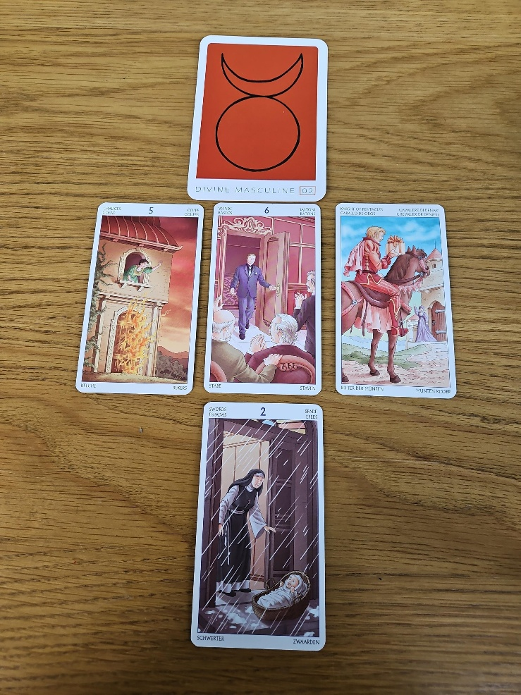
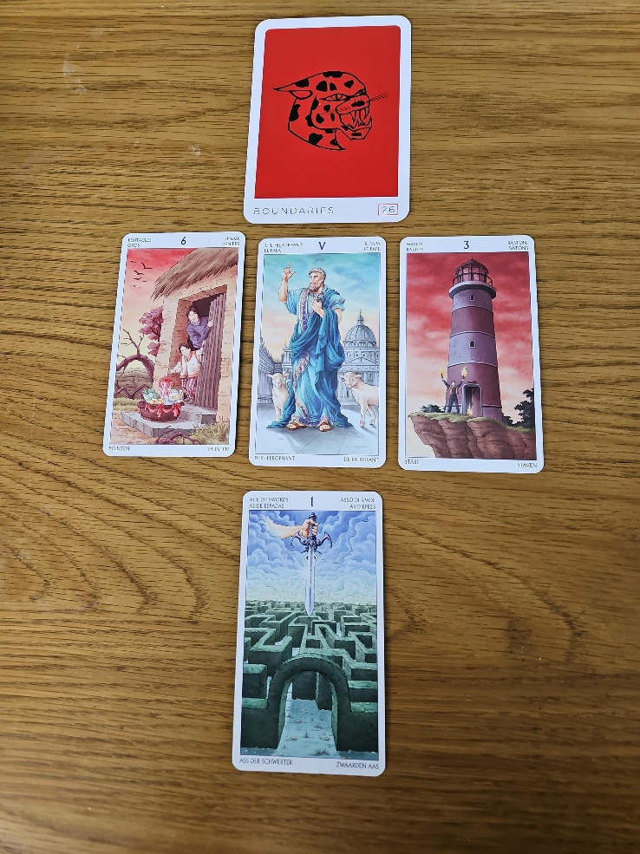

SETTING THE QUESTION
This is actually quite an interesting reading because neither job is “bad”. They both have something to offer you, which is why I pulled an archetype card for each role first, to understand the energy you're stepping into, and then I drew the card at the bottom asking a very specific question: “Which of these two jobs gets you closest to the career you're ultimately meant to be doing?” That's where the difference between them becomes much clearer.
JOB ONE
Archetype: Boundaries
The overarching energy is Boundaries. I don't think this is questioning whether you know your worth. From what you've written, you're already very aware that you're overqualified. Instead, I think it's asking you to recognise your value while also remaining flexible enough to use this role as a stepping stone rather than your destination.
Six of Pentacles, The Hierophant & Three of Wands
The Six of Pentacles suggests a supportive environment where there is a fair exchange. The Hierophant talks about learning, structure and building experience, while the Three of Wands is one of my favourite cards for looking beyond the immediate horizon. It's already asking you to think about where this role can take you next, rather than seeing it as where you'll stay.
Outcome: Ace of Swords
Then we come to the outcome card, the Ace of Swords. For me, that's the deciding factor. Aces always represent opportunity, and the Ace of Swords brings clarity, new thinking and doors opening. Out of the two options, this is the one that looks most likely to move you closer to the career you ultimately want.
JOB TWO
Archetype: The Divine Masculine
The archetype here is the Divine Masculine, and that's interesting because I don't necessarily think it's describing a man. I think it's asking you to lean into more traditionally masculine qualities like structure, discipline, logic and persistence. I do wonder whether this role is slightly more physical or procedural in nature.
Five of Cups
The Five of Cups immediately caught my attention, particularly in this deck. I chose the Tarot of the 78 Doors because the artwork often tells an extra layer of the story. Here the figure is literally looking out from the building, almost as if she's saying, “I want out.” That gives me the sense that although you'd be perfectly capable of doing the work, it wouldn't nourish you for very long.
Six of Wands & Knight of Pentacles
The Six of Wands says you'll do well. You'll probably receive recognition and people will appreciate your work. The Knight of Pentacles reinforces that by showing steady, reliable progress. Interestingly, I also wouldn't be surprised if this role introduced you to someone significant, perhaps even someone you'd be attracted to, because that Knight often brings people as much as opportunities.
Outcome: Two of Swords
The problem isn't your ability. It's the outcome. The Two of Swords doesn't show movement. Remember, this isn't asking which job you'll perform better in. It's asking which job gets you closer to the career you actually want. The Two of Swords feels like standing at a crossroads without really moving anywhere. It feels more like a holding pattern than a stepping stone.
CLOSING REFLECTION
So, if these were my cards, I'd be accepting the first position. Not because it's perfect, but because it appears to create more opportunity beyond itself. The second role looks perfectly respectable, and I think you'd succeed there, but it feels more likely to leave you feeling stuck, whereas the first role has much more momentum and points towards the next chapter rather than simply providing a pay cheque.

