TIDES OF KNOWING
Leigh Spencer · tidesofknowing.com
A Twelve-Month Reading for Shelley
5 July 2026
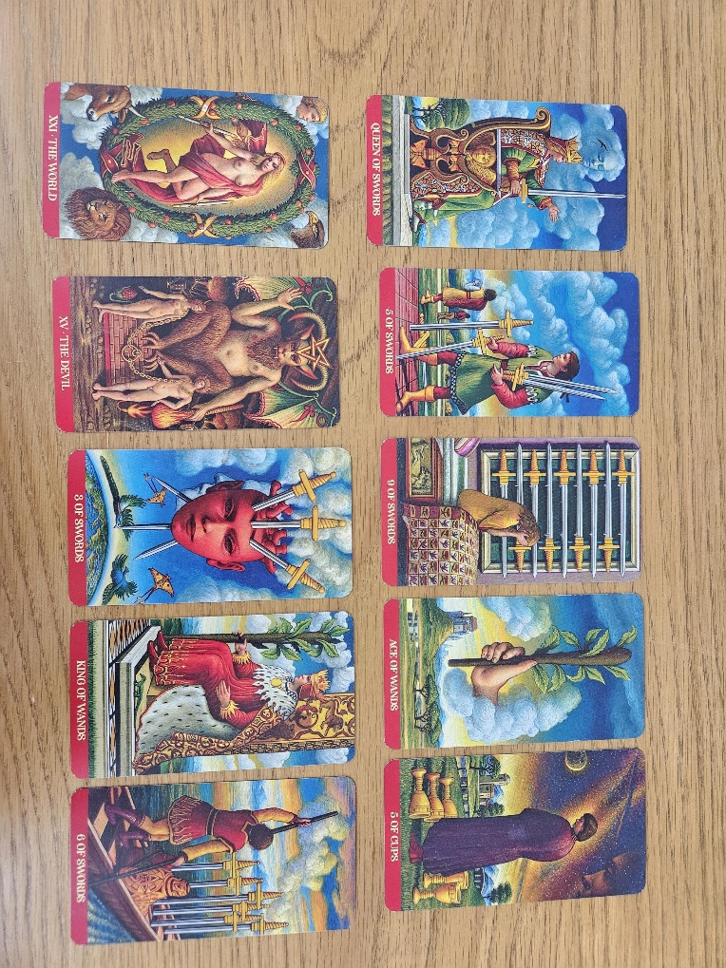
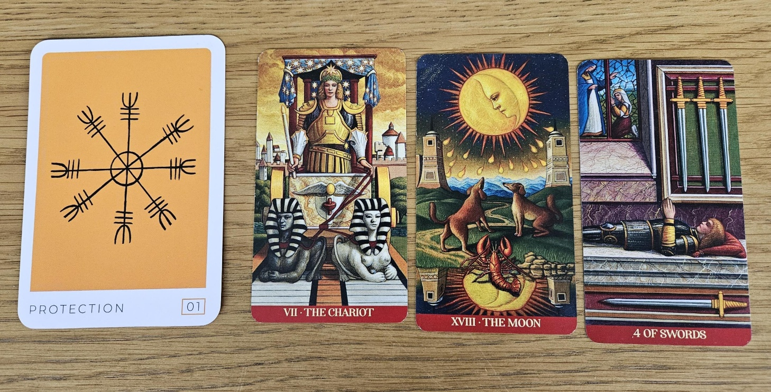
THE LESSON
Protection
What I drew for you first wasn't actually part of the timeline. I asked, “What is the lesson? What does Shelley need to learn from this?” and the card I drew was Protection.
For me, this is about developing a deeper faith that other people's words can't truly harm you. They may hurt, they may affect you emotionally, but they don't define who you are.
The message on the card says: “You're protected. You're safe in all matters of the body, mind and spirit. Your highest guidance has you covered on all fronts. Do not delay in moving forward.”
I think that ties in beautifully with the practical behavioural advice I gave you before I even drew the cards. Those are practical skills that you can develop to help you navigate your workplace. They don't change who you are. They simply help you communicate your professionalism in a different cultural environment.
THE FOUNDATION
The Chariot, The Moon & Four of Swords
The next three cards were the Chariot, the Moon and the Four of Swords.
The Chariot says, take charge. One practical thing I would recommend is keeping a diary of anything that happens in your workplace. Just note dates, conversations and any behaviours that you believe are bullying. Most workplaces don't tolerate bullying, and if you're constantly being put down or treated disparagingly, that can constitute workplace bullying.
The Moon reflects the emotional distress you've been experiencing, and that's completely understandable, particularly when you've been feeling isolated. You're also working in a caregiving profession, which is emotionally demanding for everyone involved, so it's important to recognise that this environment naturally carries heightened emotions.
The Four of Swords is asking you to look after yourself. Get plenty of rest, allow yourself time to recover, and try not to overthink every interaction.
THE FIRST SIX MONTHS
Queen of Swords, Five of Swords, Nine of Swords, Ace of Wands & Five of Cups
I then looked at the first six months. The cards were the Queen of Swords, Five of Swords, Nine of Swords, Ace of Wands and Five of Cups.
I do think there's a good chance you'll find new employment before Christmas. There may still be a few familiar patterns that repeat themselves initially, so I really want you to practise the behavioural skills we talked about. Treat them just like practical nurse training. These are skills you're going to need to thrive in the cultural environment you're working in, and the more you practise them, the more natural they'll become.
THE NEXT SIX MONTHS
The World, The Devil, Three of Swords, King of Wands & Six of Swords
Because I still didn't feel I'd fully answered your question, I drew another six months. The cards were the World, the Devil, Three of Swords, King of Wands and Six of Swords.
I think that over that period you'll continue thinking about where you truly belong and what sort of work environment will support who you are. I also wonder whether there may be different ways of using your nursing skills that are a better fit for your naturally kind and caring personality. That's something to keep in the back of your mind rather than something you need to decide now.
What I can clearly see is the mental anguish these experiences have caused, but I also see things improving. Your job now is to practise those practical behaviours so that when the next opportunity arrives, you're ready to approach it differently.
THE CLARIFICATION CARDS
Knight of Cups, Page of Pentacles & The Sun
Finally, I drew three clarification cards: the Knight of Cups, the Page of Pentacles and the Sun.
To me, that's a very encouraging way to finish. It tells me there is emotional support ahead, continued learning and growth, and ultimately a much brighter outcome than where you are now.
CLOSING REFLECTION
So the work is yours to do.
You don't have to stop being kind. Kindness is one of your strengths. But I do think you need to treat this as a practical exercise. Just as taking a patient's observations or administering medication are professional skills, so too is learning how to communicate confidently, set appropriate boundaries and interact effectively with your colleagues. Those skills are just as important, and I believe they'll help you enjoy your workplace far more in the future.

