TIDES OF KNOWING
Leigh Spencer · tidesofknowing.com
A Tarot Reading: Wages Owed
4 July 2026
THE QUESTION
“Will my boss pay me correctly for my pay check?”

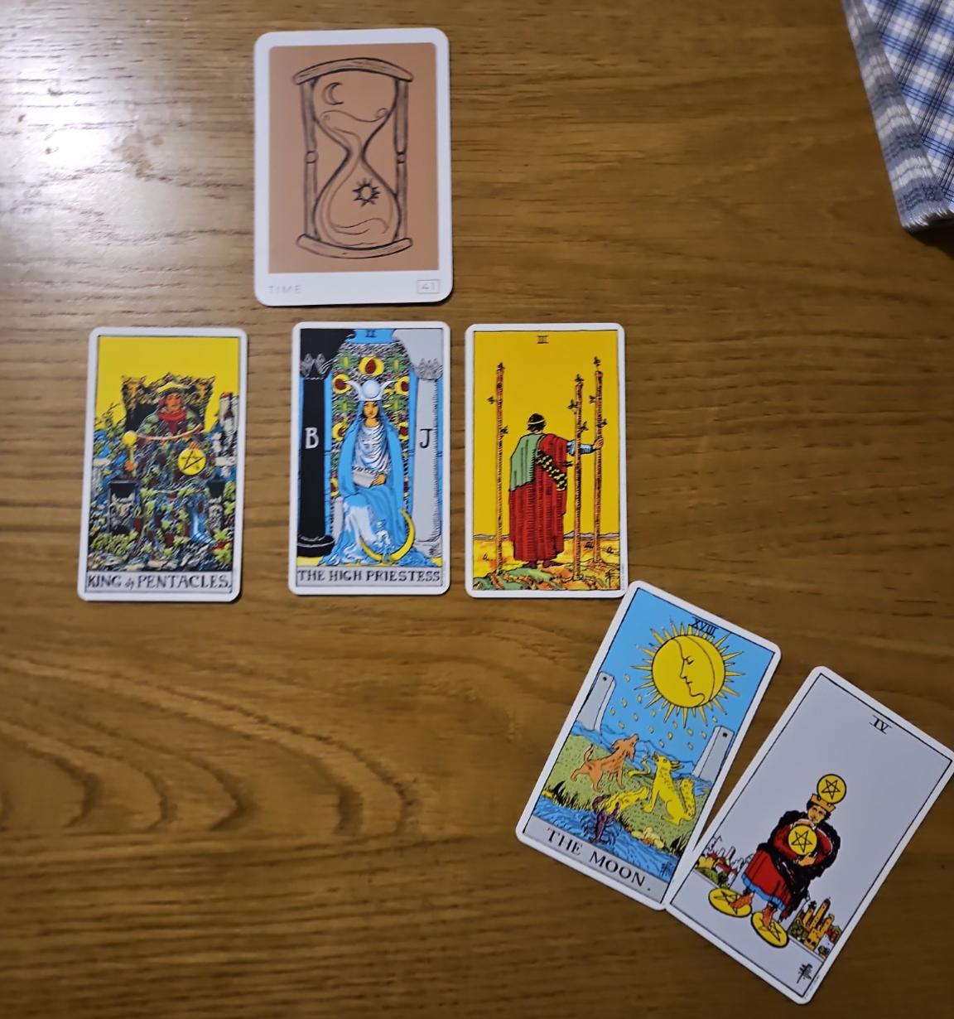
THE ARCHETYPE: NOT A NO, JUST NOT YET
Time
Whenever I'm looking at a question like this, I first draw an archetype card to understand the overall energy surrounding the situation. In this case I drew Time, and I think that's really significant. My immediate feeling is that this isn't a “no”, it's a “not yet”. Things are unfolding in their own time, even though I completely appreciate that doesn't make the situation any less stressful when you're waiting to be paid.
THE CORE READING
King of Pentacles
Looking at the tarot itself, the King of Pentacles immediately caught my attention. He isn't someone who is reckless with money. In fact, he's often extremely careful about how and when money leaves his hands. So I don't actually get the sense that your employer has no intention of paying you. I think he's deliberately holding onto his cash, whether that's because of cash flow or because he's trying to manage his finances as tightly as possible.
The High Priestess
Then we have the High Priestess, and to me that's you. She's patient, composed and quietly waiting. She isn't forcing the situation, but she is aware that something is happening beneath the surface that hasn't yet been fully revealed.
Three of Wands
The Three of Wands continues that theme of waiting. He's looking towards the horizon, knowing something is coming but recognising it hasn't arrived yet. It can sometimes be a timing card, so the number three may have some significance here. That could be three days, three weeks or another period connected to the number three, but I wouldn't lock into one timeframe just yet.
THE CLARIFYING CARDS
I then pulled two clarifying cards, and they reinforced exactly what I'd already been feeling.
The Moon
The Moon tells me that not everything is currently out in the open. There may be circumstances behind the scenes that you aren't aware of, or perhaps your employer hasn't been completely transparent about what's happening.

Four of Pentacles
Then we have the Four of Pentacles, which really echoes the King of Pentacles. Again, we see someone holding tightly onto their money. That's why I don't think these cards are saying the money isn't coming. They're simply showing that it's being held back.
So, overall, I do think you'll receive the wages you're owed. I just don't think it's going to happen as quickly as you'd like.

THE PRACTICAL PATH FORWARD
From a practical perspective, separate from the cards themselves, I think it's important to ask a direct question: “When can I expect payment?” Then allow the silence to do the work. Don't rush to fill it. Give him the opportunity to answer. If there is a genuine reason for the delay, these cards suggest he's likely to tell you. More importantly, it gives you a clear commitment rather than leaving you wondering.
CLOSING REFLECTION
So, for me, this reading is a yes, but it's a delayed yes. The cards consistently point towards time, patience and someone being very careful with their money, rather than someone intending not to pay you at all.

