Forecasting Rate of Spread of Covid19 using Linear Regression and LSTM

Kartik Puri

Ashwin Goyal

Rachna Jain

Preeti Nagrath

**Bharati Vidyapeeth’s College Of Enginnering**

COVID-19 virus, knows as novel coronavirus, has spread all over the world. World Health Organisation (WHO), marked 11th March, 2020 as the day when COVID19 was declared as pandemic. It, was first originated in Wuhan, China. In recent days, Covid19 caused an immense impact on various social and economic fiels in the world. It is necesssary to quantify its spread and make predictions on how it is going to affect the world in coming months. In this paper, our aim is to use linear regression and LSTM algorithms to forecast of Covid19 spread. The objective of this study is to determine if spread can be forecasted to better accuracy using linear regression and LSTM algortihms.  
KeyWords: Machine Learning, Linear Regression, LSTM, Mean Absolute Error, COVID-19

# Introduction

The spread of COVID19, the respiratory disease origination from coronavirus occured in Wuhan, China, is on the rise and has shaken the world. The World Health Organization named the disease COVID-19 when the first case of this virus was reported.

The Global spread of COVID19 has affected most countries and was defined as a pandemic by the WHO in March 2020.

This paper tracks the spread of the novel coronavirus, also known as the COVID-19. COVID-19 is a contagagious respiratory virus that first started in Wuhan December 2019.

The two types of coronaviruses, named as, severe acute respiratory syndrome coronavirus and (MERS-COV) have affected more than 20,000 people in past decade .

For helping combat coronavirus machine learning and deep learning models are used in this paper.These model will gives us a rough estimate as to how the disease will spread in the upcoming days how many more people will be effected.It will a rough estimate to the government of various countries about how the spread and will enable them to be prepared well in advance for the epidemic.

Most of the data driven approaches used in previous studies have been linear models and often neglects the temporal components of the data.

In this report data preprocessing techniques are applied on the confirmed cases data and then the preprocessed data is applied to two models i.e. LSTM and Linear Regression .The real and predicted cases are compared on a predefined metrics.A comparative study is drawn to see the performance of LSTM and Linear regression model to see which model best for the data.

The section **Literature Review** talks about similar work done by other reseachers on this topic and talk about the model and approach used by them.

The methodology used in the paper and the approach on how to handle this problem is also discussed.

The section **Methods and models** talks about the dataset used and and its features. Since classification is done worldwide, so the data was processed to suite the needs of the models in use and a brief description of the processed dataset was also provided.

Next, Evaluation metrics are discussed to understand and compare the result between the two models used. MAPE and Accuracy were used to compare the result and were used to draw conclusions.

Also the models of Linear regression and LSTM network are explained demonstrating our approach.

In the end **Experiment Result** are shown. Evaluation metrics are used to compare the result.

# Literature Review

In ,an machine learning based alternative to transmission dynamics for Covid-19 is used. This AI based approach is executed by implementing modified stacked auto-encoder model.

In , an deep learning based approach is proposed to campared the predicted forcasting value of LSTM and GRU model. The Model was prepared and tested on the data and a comparison was made using the predifined metrics.

In , LSTM and Linear regression model was used to predict the COVID-19 incidence through Analysis of Google Trends data in Iran. The Model were compared on the Basis of RMSE metrics.

In , an LSTM networks based approach is proposed for forecasting time series data of COVID in Canada. This paper uses LSTM network to overcome problems faced by linear model where algorthms assigns high probability and neglects temporal information leading to biased predictions.

In , temporal dynamics of the corona virus outbreak in China, Italy, and France in the span of three months are analyzed.

In , Several linear and non-linear machine learning algorithms were trained and picked the best one as baseline, after that chose the best features using wrapper and embedded feature selection methods and finally used genetic algorithm (GA) to find optimal time lags and number of layers for LSTM model predictive performance optimization.

In , temporal dynamics of the corona virus outbreak in China, Italy, and France in the span of three months are analysed.

In ,a modeling tool was constructed to aid active public health officials to estimate healthcare demand from the pandemic.The model used was SEIR compartmental model to project the pandemic’s local spread.

In ,a transmission network visualization (s) of COVID-19 in India was created and analysis was performed upon them. Using the transmission networks obtained there was an attempt to find the possible Super Spreader Individual (s) and Super Spreader Events (SSE) responsible for the outbreak in their respective regions.

In , it presents a comparison of day level forecasting models on COVID-19 affected cases using time series models and mathematical formulation. The forecasting models and data are used to suggest that the number of coronavirus cases grows exponentially in countries that do not mandate quarantines.

In ,phenomenological models that have been validated during previous outbreaks were used to generate and assess short-term forecasts of the cumulative number of confirmed reported cases in Hubei province.

## Proposed Work

In our report, the confirmed cases of corona virus are studied from the start of the epidemic and the two approaches of Linear Regression and LSTM networks are used, and an report is presented stating which of the above stated model works best these type of data on the basis of Mean Absolute Error.

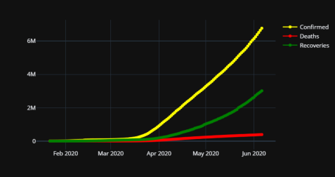

Number of cases around the world

# Methods and models

## Data

The dataset used was the 2019 Novel Coronavirus Dataset operated by the Johns Hopkins University Center for Systems Science and Engineering (JHU CSSE).

It consist of 3 dataset each of Death, Confirmed, Recovered cases of 188 countries datewise. The number of date columns are 138 starting from 22 Jan,2020 to 8 June,2020.Out of this about 85% are used as training data and the rest used as testing and validating data. So the model would be predictingnext 15% data value.

The prediction would not be made on a specific country rather it will be worldwide.

[table:world_df]

## Evaluation Metrics

To identify best model, it is necessary to put concentration on comparison of measures of the algorithm’s performance. In this report, MAPE and Accuracy are used to measure algorithm’s performance-

1. **Mean Absolute Percentage Error**: It is defined by the following formula:

$$MAPE=\frac{100\%}{n}∑\left|\frac{y−y′}{y}\right|$$

* Where y is true value and y’ is predicted value.

1. **Accuracy**: It is defined by the following formula:

$$Accuracy=(100−MAPE)\%$$

## Method

The prediction of confirmed cases of COVID 19 Corona virus are obtained using a Recurrent Neural Network method(LSTM) and Linear Regression.

Linear regression is a linear model, that assumes a linear relationship between the input variables (x) and the single output variable (y).When there is a single input variable (x), the method is referred to as simple linear regression.

A Recurrent Neural Network (RNN) is kind of neural network architecture that considers both sequential and parallel information processing. Incorporating memory cells to neural network; it is possible to simulate the operations similar to human brain.There are alternatives from RNN depending on the gating units, such as Long Short Term Memory (LSTM) RNN and Gated Recurrent Unit (GRU) RNN.Traditional RNN lacks of considering context based prediction, which can be overcome by introducing Long short- term memory (LSTM). LSTM has a good potential to regulate gradient flow and enable better preservation of long-range dependencies .

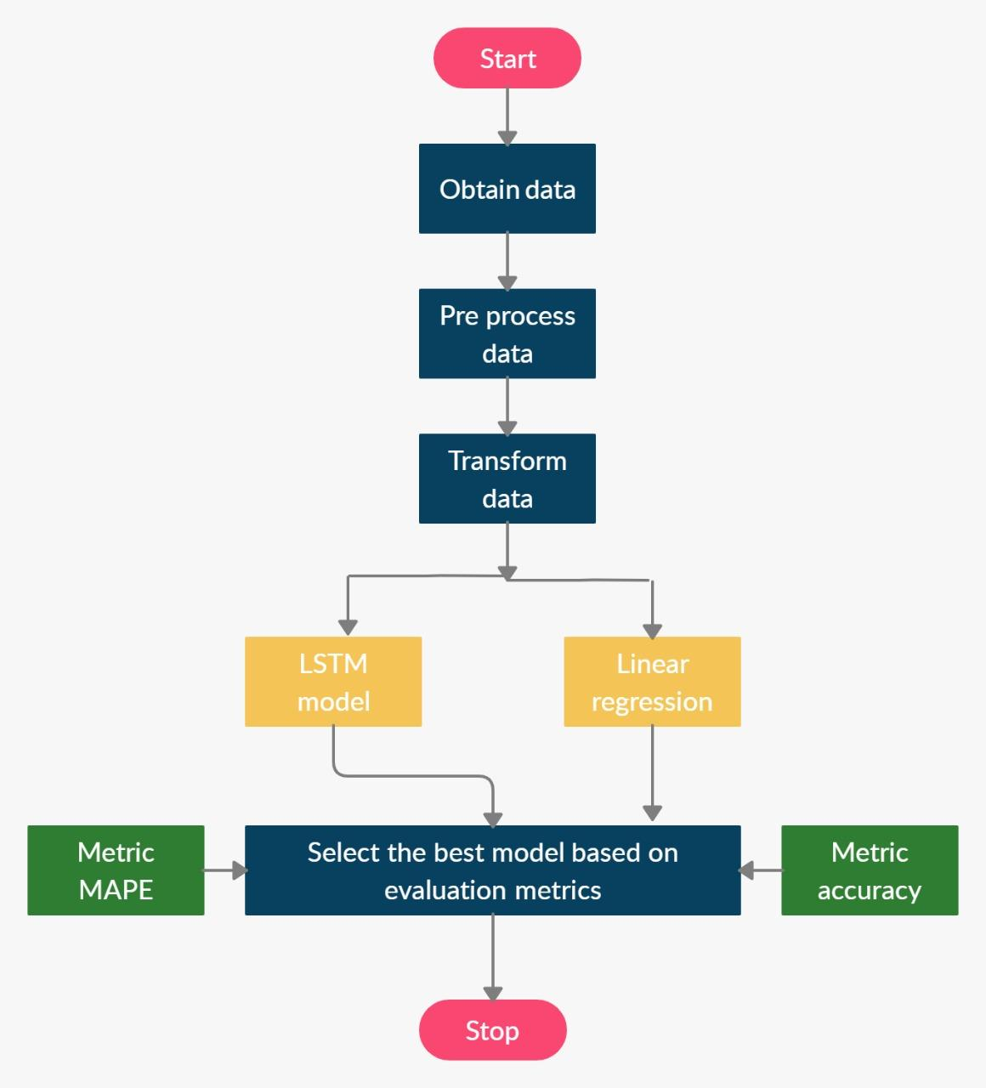

The dataset used for predicting the value is taken from John Hopkin University which contains cases form 22 January 2020 to 8 June,2020.Training and testing of both the models is done on this dataset.It contains 138 date columns out of which 120 are used for training and the rest 18days are used for testing data or for forecasting it.At first the data is preprocessed by converting the date columns into datetime object and also eliminate the missing values. The preprocessed data is then transformed in the required shape to be put into the model.The models are trained and the test data is predicted and prediction result are quantified using performance measures metrics such as MAPE and accuracy.The methodology performed for each of the step is shown in the figure [fig:method_flow] as show.

**Linear Regression**

Linear regression is used for prediction tasks.In a problem wuth one predicting value this technique is used which tries to best fit the value to a linear line.This line can be used to relate both the predicting and predicted value.When there is more than one value then the

In case of exponential relations, linear regression can not be directly used. But after transformation to a linear expression, even exponential relations can be predicted using linear regression. For example,

$$y=αe^{βx}$$

Taking the log on both sides of the equation, we get:

$$\text{ln}y=\text{ln}α+βx$$

This expression is of the form of a linear regression model:

$$y′=α′+βx$$

**LSTM Model**

Long Short term memory is an recurrent neural network which is most effective for time series prediction.The model used in this case is sequential.As the data was time series and we needed to predict the best positive corona cases so this model was best for our study.The model was build using tensorflow keras framework and the models performance was evaluated on the mean absolute error percentage (MAPE) and accuracy metrics. The proposed architecture of LSTM model is shown in the figure 2 as:

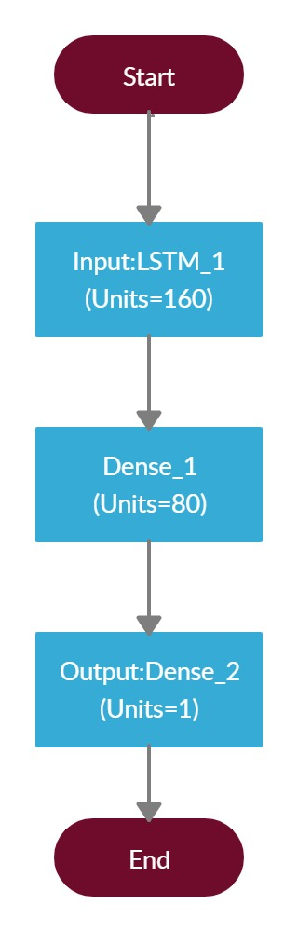

Architecture of LSTM model

# Experiment Result

In LSTM model, LSTM layers use sequence of 50 nodes. A 2 layered structure followed by a Dense Layer is used as LSTM model for verifying prediction result. The best hyperparameters used is a batch size of 1.The prediction accuracy of the model is shown in table [table:lstm]

[table:lstm]

Linear regression was also applied on the time series data and the date columns were taken as input and the 18 days data was predicted. The exponential fit of the model was fit and the prediction accuracy of the model is shown in table [table:linear]

[table:linear]

The prediction result of comparing the test data predicted data is show below:

## Comparing with other studies

In , they used an multi-step forecasting system on the population of china, and the estimated average errors are as show in 1

Result : Method and Average Errors

|  |  |
| --- | --- |
| Model | Error |
| 6-Step | 1.64% |
| 7-Step | 2.27% |
| 8-Step | 2.14% |
| 9-Step | 2.08% |
| 10-Step | 0.73% |

[table:three]

In , LSTM netwoks are used to on Canadian population, the reuslt are show is table 2

Results : Canadian Datasets

|  |  |  |
| --- | --- | --- |
| Model | RMSE | Accuracy |
| LSTM | 34.63 | 93.4% |

[table:four]

In , an deep learning based approach is proposed to campared the predicted forcasting value of LSTM and GRU model is used the result are as show in table 3:

Results : Canadian Datasets

|  |  |  |
| --- | --- | --- |
| Model | RMSE | Accuracy |
| LSTM | 53.35 | 76.6% |
| GRU | 30.95 | 76.9% |
| LSTM and GRU | 30.15 | 87% |

[table:seven]

# Conclusion and Future Scope

The comparison between Regression and LSTM model signifies that LSTM provides a comparatively better results in terms of prediction of confirmed data. This paper showcases a method that checks occurred cases of COVID-19. However it could be made automated to train on the updated data every week and see the predicted value. Also the model is trained only on confirmed cases same could be done for both recovered and death cases and predicted values could be found. The model shows only the worldwide cases however the dataset also provides country wise statistics so it can be used by different country to forecast the future outcome of the pandemic and take necessary preventive measures to be safe from this worldwide pandemic. In conclusion, the data mining models could help policymakers and health managers to plan health care resources and control the prevention of an epidemic outbreak. The availability of high- quality and timely data in the early stages of the outbreak collaboration of the researchers to analyze the data could have positive effects on health care resource planning.