E-Commerce Solution with 1and1.com eCommerce

|  |  |  |  |
| --- | --- | --- | --- |
| **#** | **Author** | **Date** | **Version** |
| 1 | Deepak Moktan | 16/10/2013 | 1.0 |

E-Commerce Solution with 1and1.com eCommerce

Introduction: 2

Consideration: 2

1and1 eShop Editions: 2

Target eShop Edition : 2

Domain(If required): 3

Hosting: 3

Technologies : 3

Data Security: 3

Pricing: 3

Payment Options: 3

Online Payment 3

Offline Payment 3

Key Features : 4

Other ecommerece considerations: 4

Introduction:  
 1an1.com is a hosting service provider . In addition to hosting service, it offers ecommerece solutions for customers who are looking for a quick online store set up. This document includes overview of the service. The objective of this document is to help company conclude with one of the ecommerce solutions.

Consideration:  
 As company is in need of a quick online store that can be used as portal for placing orders, ecommerce solution by 1and1.com is being considered.

1and1 eShop Editions:  
1and1.com providers its ecommerece solution in the following three major editions:  
Starter, Professional and Advanced

Target eShop Edition :   
Advanced eShop. This edition is mostly favoured as some key features are available only on this edition. For example, multiple currencies, access restriction etc.

Domain(If required):   
From $14.99/year. In case company needs domain resgistration with 1and1.com, the domain price starts from $14.99/year.

Hosting:  
The ecommerce portal will be hosted on cloud and the hosting is included with ecommerece package itself.

Technologies :  
1and1.com has not listed or revealed the technologies used for the ecommerce solution. For example: language , database used are not revealed.

Data Security:  
1and1.com has claimed to be highly secured and certified.

Data exporting:  
It provided data exposting on csv,xml format. Data here means orders and invoices.

Pricing:  


Payment Options:

PayPal, Credit and debit cards, cash, COD and Money Orders

### Online Payment

Paypal and RBS Worldpay

Offline Payment Cash  
 COD (cash on delivery)  
 Money order  
 Checks  
 Invoices

Key Features :

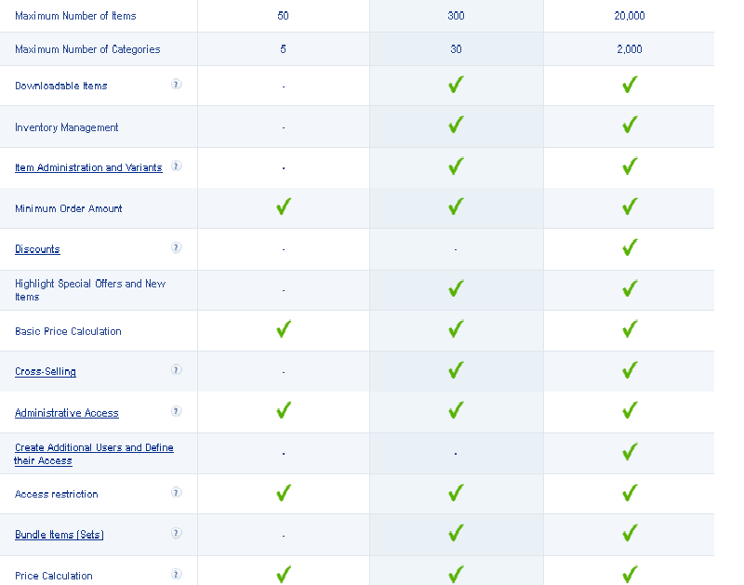

Other ecommerece considerations:  
<http://www.sunshop.com>  
<http://www.goodsie.com>   
 demo : <http://mydemostore.goodsie.com/>   
 admin: <http://mydemostore.goodsie.com/admin> (dmoktan@lesterinc.com/K!ngK0ng)