SEM and ACD API integration with SugarCRM

|  |  |  |  |
| --- | --- | --- | --- |
| **#** | **Author** | **Date** | **Version** |
| 1 | Deepak Moktan | 21/10/2013 | 1.0 |

SEM and ACD API integration with SugarCRM

Introduction: 2

Data Sources: 2

ACD: 2

SEM Tools: 2

Current system: 2

Complete workflow cycle: 3

Integration architecture: 3

Trigger Actions Table [Google Adwords-CRM]: 3

Trigger Actions Table [ACD-CRM]: 4

Integration flow chart: 5

Introduction:  
 In addition to other base and specific functionalities, Lester uses SugaCRM (referred as CRM) as the platform for report generation and viewing. Hence the CRM holds all data from different sources making it available for report generation. To make all data available on SugarCRM, integration between SugarCRM and different data sources is needed.

Data Sources:  
 Lester uses different application for different and specific purpose. The following are the main application that are being used and all of them generate some data for reporting and analysis.

ACD:  
 Automatic Call Dialer is a call handling interface which handles inbound and outbound calls.

SEM Tools:  
 Search engines like Google, Bing, AOL, ASK provide SEM tools for marketing online. Currently, Lester is using Google and Bing’s SEM tools. In return, these search engines generates tracking data and makes it available for reporting and analysis. As SugarCRM is used as reporting data storage, these data needs to be transferred to SugarCRM’s database. To meet this requirement, APIs provided for those search engines will be used.

Current system:  
 Currently, SugarCRM and those two search engines are integrated. The redesigning purpose is to enhance the integration architecture to make sure invalid data and no data situations are avoided. The existing integration uses raw method for integration meaning no standards have been followed. The data flowing from SEM Tools to SugarCRM is through raw sql queries. Although, the cycle is complete, there is no guarantee that faults will not happen. The new system will strictly follow the integration standards with all exception checks and logs. Majorly, new system will differ on using SugarCRM APIs and modules as existing system has skipped both of these.

Complete workflow cycle:   
 The workflow cycle starts opening different applications for activities. SugarCRM opens up its database for all activities, Dialer handles all inbound and outbound calls and SEM tracks all search engine marketing activities.

At the end, data generated on all those platforms are centralized in SugarCRM through data integration making ready for report generation.

**TFNs or Toll Free Numbers** are the numbers owned by company through which inbound calls are accepted. The numbers and details are stored in SugarCRM database which can be available to ACD through integration.

So, basically the complete cycle includes the following steps:

1. TFNs are stored in database.
2. Accounts are created on SEM tools(Google, Bing)   
   (note: We’ll consider Google Adwords to show the flow)
3. The same account is crated on SugarCRM also.
4. The accounts are assigned with a range of TFNs.
5. Under the accounts, campaign(s) is created on MCC (***My Client Center: an interface provided to manage multiple accounts) and transferred it to SugarCRM***.
6. Subset of TFNs of the parent account is assigned to the campaigns in SugarCRM.
7. Once again the AdGroups are created in MCC under campagns and transferred into SugarCRM.
8. TFNs from parent campaigns are assigned to the adgroups. One adgroup will have only one TFN assigned.

Integration architecture:   
 Integration architecture is designed considering Google’s SEM tool Adwords. Integration with other SEM tools will follow the similar architecture with minor alterations if required. The purpose is to solidify the integration architecture.

Trigger Actions Table [Google Adwords-CRM]:

|  |  |  |  |  |
| --- | --- | --- | --- | --- |
| **#** | **Action** | **Result** | **Example** | **Remarks** |
| 1 | Account is CREATED in MCC | Account is pulled to CRM | ACC1[MCC] -> ACC1[CRM] |  |
| 2 | Account is PULLED in CRM | Account is assigned with range of TFNs | ACC1[1-10] |  |
| 3 | Campaign is CREATED in MCC | Campaign is pulled to CRM | ACC1_CAMPG1[MCC]->ACC_CAMPG1[CRM] |  |
| 4 | Campaign is PULLED in CRM | Campaign is assigned with subset of TFNs of parent account | ACC1_CAMPG1[1-5] |  |
| 3 | AdGroup is CREATED in MCC | AdGroup is pulled to CRM | ACC1_CAMPG1_ADG1[MCC]->ACC_CAMPG1_ADG1 [CRM] |  |
| 4 | AdGroup is PULLED in CRM | AdGroup is assigned with subset of TFNs of parent campaign | ACC1_CAMPG1_ADG1 [1] |  |

Trigger Actions Table [ACD-CRM]:

|  |  |  |  |  |
| --- | --- | --- | --- | --- |
| **#** | **Action** | **Result** | **Example** | **Remarks** |
| 1 | A call lands[Inbound] | An Incident is created. | Incident1 | In addition to basic customer and incident details, respective adgroup, campaign and account details are included. |

Integration flow chart:  
  
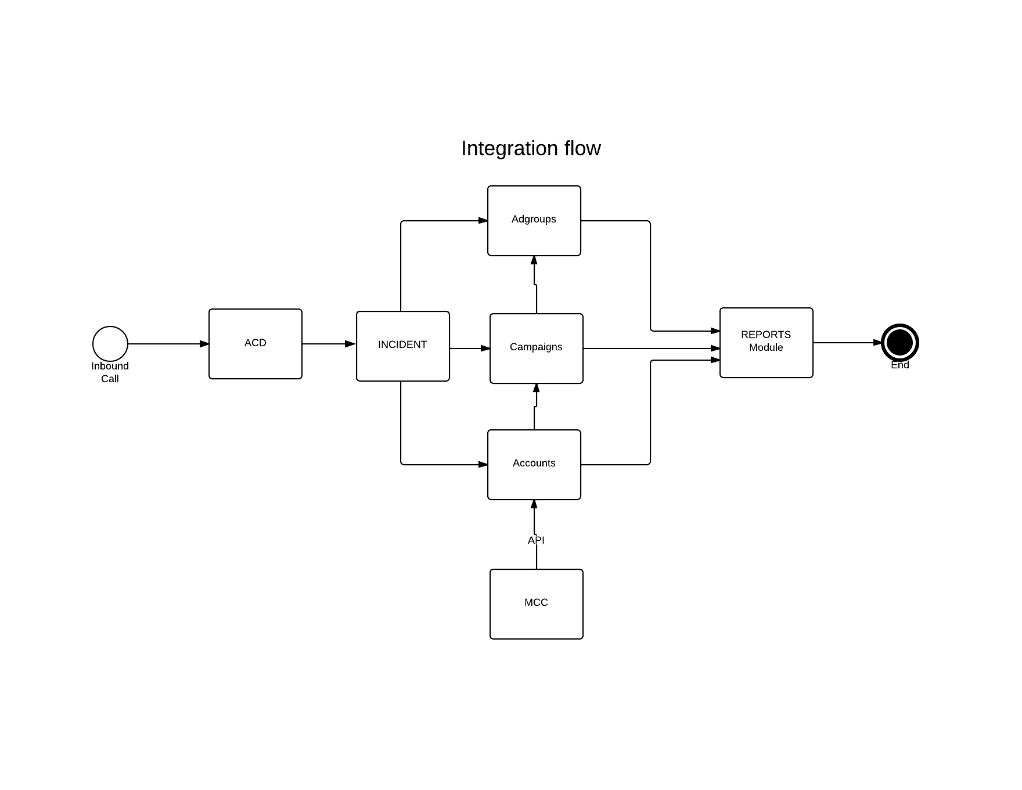  
**Diagram 1: Complete action flow chart  
