

GHANA COMMUNICATION

TECHNOLOGY UNIVERSITY

INSTITUTE OF CONTINUING

AND DISTANCE EDUCATION (ICDE)

|  |  |
| --- | --- |
| COURSE CODE | CICS 112 |
| COURSE TITLE | Programming with C++ |
| DATE | 22nd August, 2025 |
| GROUP NAME | GROUP 13 |

|  |  |
| --- | --- |
| **INDEX NUMBER** | **NAME** |
| 2425140073 | Francklina Delali Mensah |
| 2425140016 | RUNCIE FRIMPONG |
| 2425140023 | AGBENYO DELATOR ROGERS |
| 2425140099 | Darglo Isaac Mawuli |
| 2425140125 | Emmanuel Koomson |

**Question 1**

Write a C++ program that accepts a user's first name and last name as separate string inputs, then combines them into a full name and displays it in the format: "Hello, [Last Name], [First Name]!"

**The Solution**

*#include <iostream>*

*#include <string.h>*

*using namespace std;*

*int main()*

*{*

*string first_name;*

*string last_name;*

*string full_name;*

*cout << "\n Enter first name: "<< endl;*

*cin >> first_name;*

*cout << "\n Enter last name: " << endl;*

*cin >> last_name;*

*full_name = last_name + ", " + first_name;*

*cout << "\n Hello," << full_name << "!" << endl;*

*return 0;*

*}*

**Screenshot Of The Source Code**

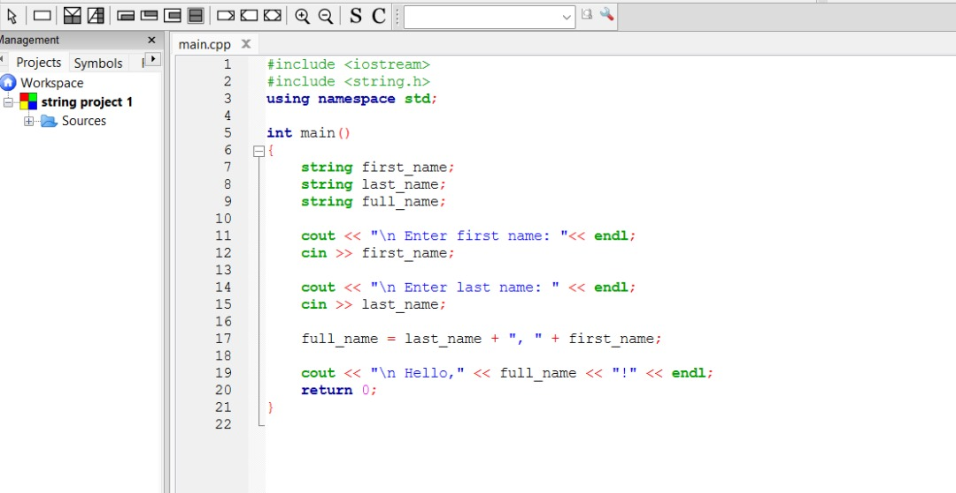

**Screenshot of the Output**

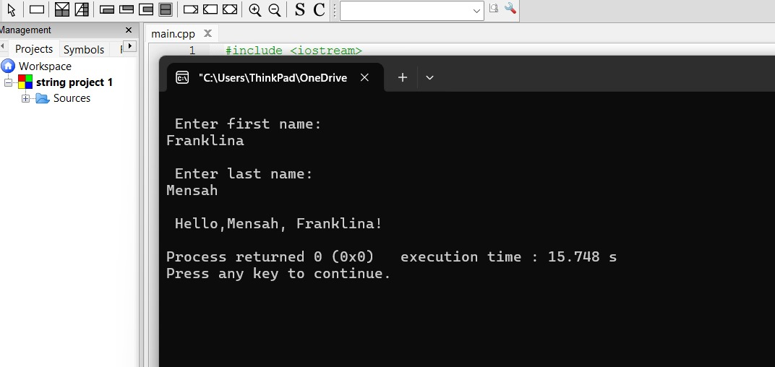

**Question 2**

Create a C++ program that prompts the user to enter a password. The program should check if the password contains at least 8 characters and includes the word "GCTU" as part of it. Display a message indicating whether the password is valid or not.

**The Solution**

*#include <iostream>*

*using std::cin;*

*using std::cout;*

*using string_t = std::string;*

*int main()*

*{*

*string_t password;*

*const string_t SUB_STRING = "GCTU";*

*const int MIN_LENGTH = 8;*

*cout << "\n\n------- PASSWORD CHECKER -------\n\n";*

*cout << "Enter a strong password. It must include the word, "*

*<< SUB_STRING << " and minimum length is "*

*<< MIN_LENGTH << " characters:\n";*

*cin >> password;*

*const bool IS_VALID = password.length() >= MIN_LENGTH && password.find(SUB_STRING) != string_t::npos;*

*cout << "\n\n" << (IS_VALID ? "Success! Valid password." : "Invalid password.") << "\n\n";*

*return 0;*

*}*

**Screenshot Of The Source Code**

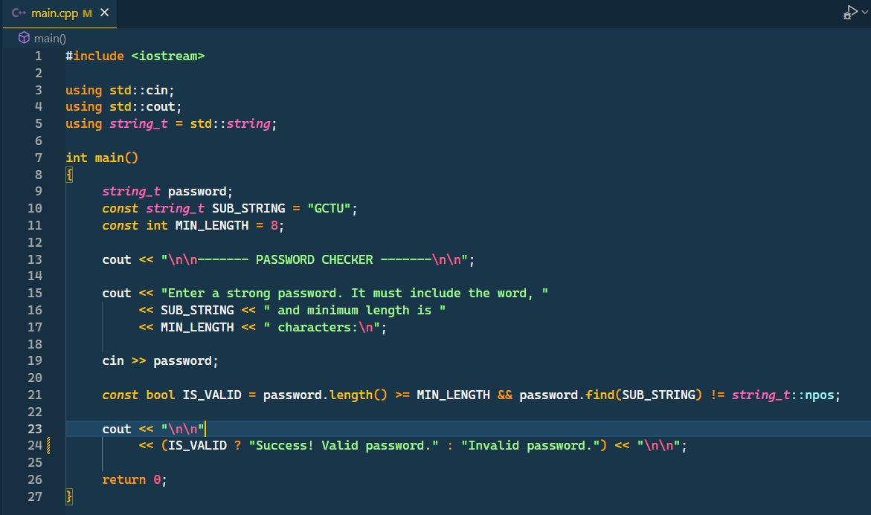

**Screenshot Of The Output**

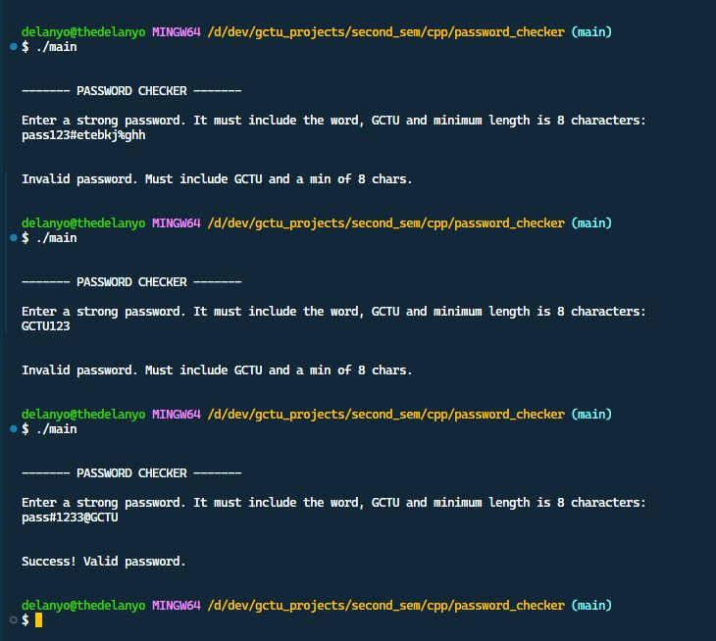

**Question 3**

Write a C++ program that accepts a sentence from the user and counts how many words are in the sentence. Assume words are separated by spaces.

**The Solution**

*#include <iostream>*

*#include<string>*

*using namespace std;*

*int main()*

*{string sentence;*

*int wordcount =0;*

*cout << "Enter a sentence:";*

*getline(cin,sentence); // Accepts entire sentence including spaces*

*bool inWord = false;*

*for (char c:sentence){*

*if (c!=' '&&!inWord) {*

*//Start of a new word*

*inWord = true;*

*wordcount++;*

*}*

*else if (c==' '){*

*//End of a word*

*inWord = false;*

*}*

*}*

*cout <<"Number of words in the sentence:" <<*

*wordcount <<endl;*

*return 0;*

*}*

Screenshot Of The Source Code

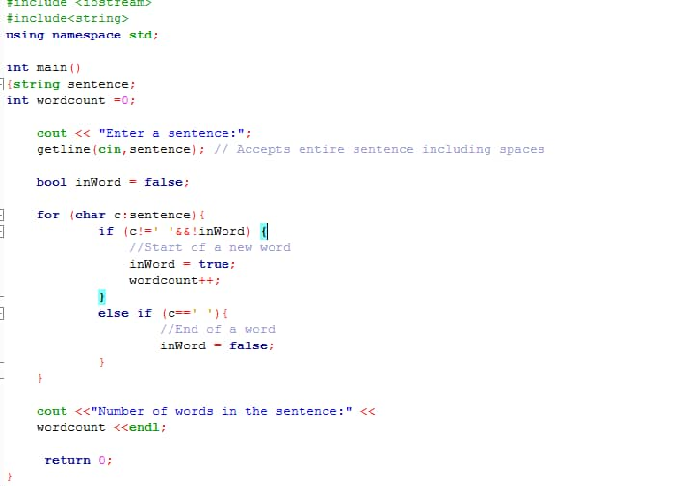

**The Output**

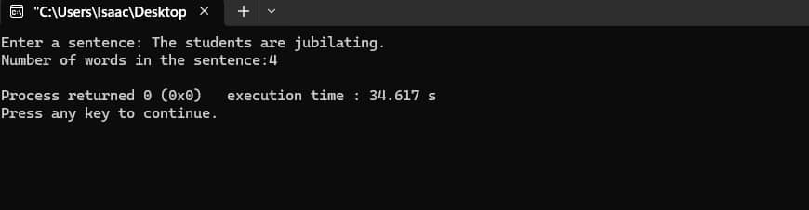

**Question 4**

As software engineer, write a C++ program to solve the quadratic equation y = ax^2 + bx + c. using constants for the coefficients a, b, and c.

**The Solution**

*#include <iostream>*

*#include <cmath>*

*using std::cin;*

*using std::cout;*

*using std::sqrt;*

*int main()*

*{*

*cout << "\n\n------- QUADRATIC EQUATION SOLVER ------\n\n";*

*double a, b, c;*

*cout << "Enter coefficients a, b, c: ";*

*cin >> a >> b >> c;*

*cout << "\n\n";*

*if (a == 0)*

*{*

*cout << "Not a quadratic equation (a must not be zero)";*

*return 0;*

*}*

*double discriminant = b * b - 4 * a * c;*

*if (discriminant > 0)*

*{*

*// two real roots*

*double root1 = (-b + sqrt(discriminant)) / (2 * a);*

*double root2 = (-b - sqrt(discriminant)) / (2 * a);*

*cout << "Two real roots: " << root1 << " and " << root2;*

*}*

*else if (discriminant == 0)*

*{*

*// one real root*

*double root = -b / (2 * a);*

*cout << "One real root: " << root;*

*}*

*else*

*{*

*// complex roots*

*double realPart = -b / (2 * a);*

*double imaginaryPart = sqrt(-discriminant) / (2 * a);*

*cout << "Complex roots: "*

*<< realPart << " + " << imaginaryPart << "i and "*

*<< realPart << " - " << imaginaryPart << "i";*

*}*

*cout << "\n\n";*

*return 0;*

*}*

**Screenshot Of The Source Code**

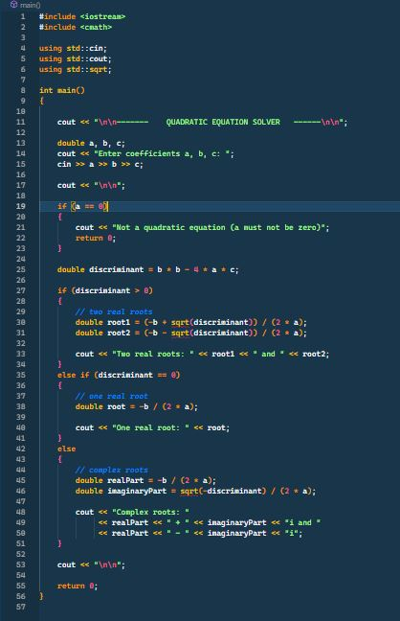

**Screenshot Of The Output**

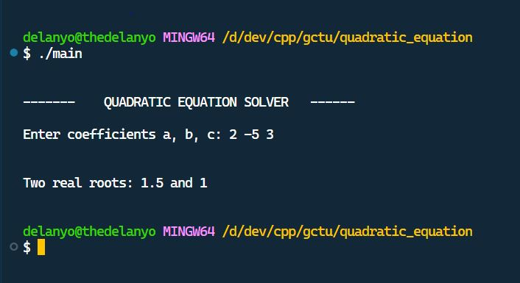

**Question 5**

Write C++ Program to build a simple calculator using switch Statement.

**The Solution**

*#include <iostream>*

*int main()*

*{*

*double first, second, result;*

*char operate;*

*std::cout << "Enter your first number: ";*

*std::cin >> first;*

*std::cout << "Enter operator (+, -, *, /): ";*

*std::cin >> operate;*

*std::cout << "Enter your second number: ";*

*std::cin >> second;*

*switch (operate)*

*{*

*case '+':*

*result = first + second;*

*break;*

*case '-':*

*result = first - second;*

*break;*

*case '*':*

*result = first * second;*

*break;*

*case '/':*

*result = first / second;*

*return 1;*

*default:*

*std::cout << "Invalid operator";*

*}*

*std::cout << first << " " << operate << " " << second << " = " << result << std::endl;*

*return 0;*

*}*

**Screenshot Of The Source Code**

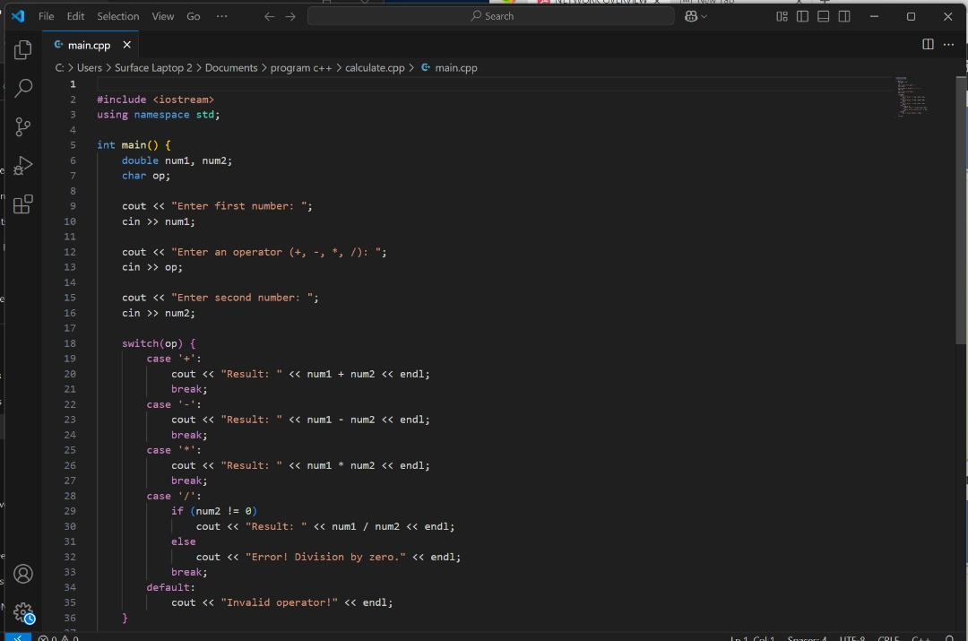

**Screenshot Of The Output**

