

GHANA COMMUNICATION

TECHNOLOGY UNIVERSITY

INSTITUTE OF CONTINUING

AND DISTANCE EDUCATION (ICDE)

|  |  |
| --- | --- |
| **COURSE CODE** | CIIS 152 |
| **COURSE TITLE** | Introduction to Information Systems |
| **DATE** | 24th September, 2025 |
| **GROUP NAME** | GROUP 13 |

|  |  |
| --- | --- |
| **INDEX NUMBER** | **MEMBERS** |
| 2425140073 | Francklina Delali Mensah |
| 2425140016 | RUNCIE FRIMPONG |
| 2425140023 | AGBENYO DELATOR ROGERS |
| 2425140099 | Darglo Isaac Mawuli |
| 2425140125 | Emmanuel Koomson |

**HOSTELLY –**

**A HOSTEL BOOKING**

**PLATFORM FOR STUDENTS**

**Hostelly** is a simple, self-served, web-app information platform that allows students to easily discover, book, and pay for hostel rooms online.

**Target Users**

* **Students:** Able to search, book, and pay for hostel accommodation
* **Hostel Managers:** Able to list and manage hostel rooms
* **Admins:** Able to oversee the platform and resolve disputes.

**Core Value**

To save time, reduce double-bookings, and increase bookings for hostels by having a professional online presence.

**System Purpose**

The Hostelly System aims to solve the problem of time-consuming, manual, and stressful hostel searches. The current problems are:

* Students travel long distances to find a hostel to find a hostel
* Lack of reliable information about available rooms.
* Manual booking processes leading to double-bookings.

**Solution**

A centralized easy-to-use platform where;

**students will be able to:**

* Search for hostels by location, price, and amenities.
* View photos and details of available rooms
* Reserve and pay for rooms online.

**Hostel managers will be able to:**

* Easily list and update room availability.
* Track bookings and payments.

**UI Mock-Ups**

|  |  |  |  |
| --- | --- | --- | --- |
| **Student Dashboard** | **Hostel Detail Page** | **Manager Dashboard** | **Admin Dashboard** |
| Search bar for hostels | Photos of rooms | View all their bookings | Manage users (students and hostel managers) |
| Filter by price, distance, amenities | Room descriptions | Update room availability | View system analytics |
| Ability to manage their bookings plus a return policy. | Room prize, size, amenities | Approve or decline bookings | Handle complaints |
|  | Booking form with available dates. | Ability to mark a room as “Under maintenance” |  |

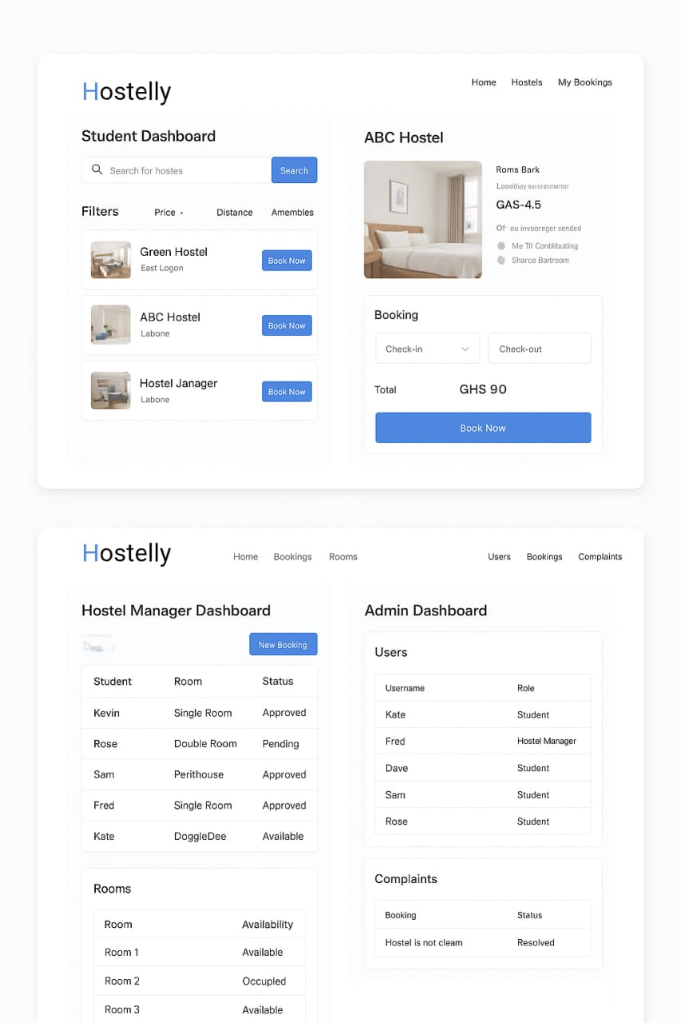

**Data Flow Description**

**Student Registrations**

Student enters their details => Data saved in the database => Confirmation email sent.

**Hostel Search**

Student searches by filters => System retrieves matching hostels form database => Displays results.

**Booking Process**

Student selects a hostel => Fills booking form => Payment processed => Booking saved.

**Hostel Manager Update**

Manager updates room availability => System updates database => Students see real-time availability.

**Admin Oversight**

Admin monitor bookings and complaints => Can take corrective actions.

**Technologies**

|  |  |
| --- | --- |
| **Component** | **Technology** |
| Frontend | SvelteKit, HTML5, CSS, Javascript |
| Backend | Node.js (Hono), TypeScript |
| Database | PostgreSQL, SQLite, Drizzle ORM |
| Authentication and Authorization | BetterAuth, JWT, |
| UI Design | Figma |
| Deployment | Cloudflare (Workers and Pages) |
| Payment | Paystack Ghana |

**Development Approach: Agile**

This ensures features can be delivered in sprints, starting with a basic booking system and later adding advanced features like payments and analytics. And also, the project will benefit from iterative development since requirements may evolve based on feedback from students and hostel managers.

**Experience Building the System**

**Challenges:**

* Integrating a smooth payment gateway
* Managing real-time room availability
* Designing an intuitive and simple UI

**Lessons Learned:**

* Importance of clear communication between team members.
* Agile methodology helped us adapt quickly when requirements changed.
* Planning database and structure schema early saved a lot of rework later.

**Team Collaboration:**

* Used GitHub for version control and CI/CD pipelines.
* Held weekly stand-up meetings to track progress.