

GHANA COMMUNICATION

TECHNOLOGY UNIVERSITY

INSTITUTE OF CONTINUING

AND DISTANCE EDUCATION (ICDE)

|  |  |
| --- | --- |
| COURSE CODE | CICS 112 |
| COURSE TITLE | Programming with C++ |
| NAME | Agbenyo Delator Rogers |
| STUDENT ID | 2425140023 |
| DATE | 19th August, 2025 |

**THE SOURCE CODE**

#include <iostream>

using std::cin;

using std::cout;

int factorial(int num)

{

if (num == 0)

{

return 1;

}

return num * factorial(num - 1);

}

int main()

{

int num;

cout << "\n\n===== FACTORIAL =====\n\n";

cout << "Enter a non-negative integer: ";

cin >> num;

if (num < 0)

{

cout << "Invalid input. Enter a non-negative integer: ";

cin >> num;

}

else

{

int fact = factorial(num);

cout << "\n\nThe factorial of " << num << " is: " << fact << "\n\n";

}

return 0;

}

**SCREENSHOT OF THE SOURCE CODE**

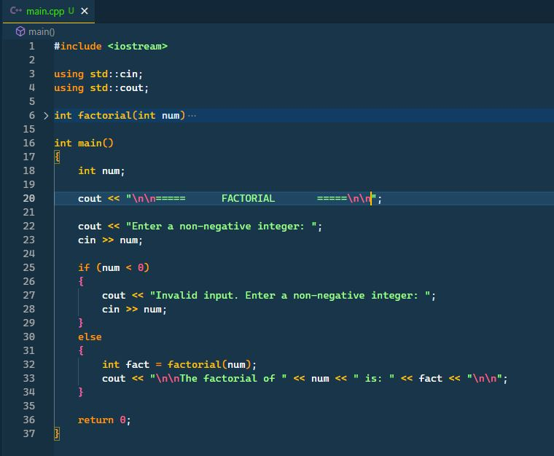

**SCREENSHOT OF THE OUTPUT**

