

GHANA COMMUNICATION

TECHNOLOGY UNIVERSITY

INSTITUTE OF CONTINUING

AND DISTANCE EDUCATION (ICDE)

|  |  |
| --- | --- |
| COURSE CODE | CICS 112 |
| COURSE TITLE | Programming with C++ |
| NAME | Agbenyo Delator Rogers |
| STUDENT ID | 2425140023 |
| DATE | 19th August, 2025 |

**THE QUESTION**

Write a C++ program to print whether a number is the greatest or not by using one if inside another if statement.

**THE SOURCE CODE**

#include <iostream>

using std::cin;

using std::cout;

int main()

{

int x, y, z;

cout << "\n\n===== To Determine Greatest Number =====\n\n";

cout << "Enter three numbers: ";

cin >> x >> y >> z;

if (x >= y && x >= z)

{

cout << x << " is the greatest.";

}

else if (y >= x && y >= z)

{

cout << y << " is the greatest.";

}

else

{

cout << z << " is the greatest.";

}

cout << "\n\n";

return 0;

}

**SCREENSHOT OF THE SOURCE CODE**

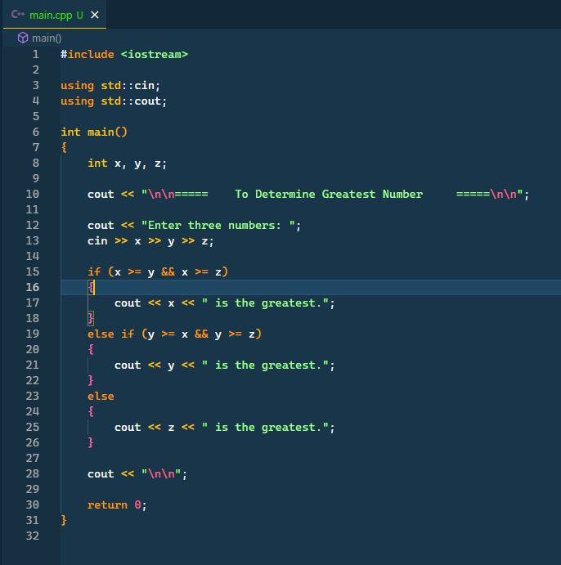

**SCREENSHOT OF THE OUTPUT**

