

GHANA COMMUNICATION

TECHNOLOGY UNIVERSITY

INSTITUTE OF CONTINUING

AND DISTANCE EDUCATION (ICDE)

|  |  |
| --- | --- |
| COURSE CODE | CICS 112 |
| COURSE TITLE | PROGRAMMING WITH C++ |
| NAME | Agbenyo Rogers Delator |
| STUDENT ID | 2425140023 |
| DATE | 2nd August, 2025 |

**QUESTION:**

Write a C++ program to check whether an integer entered is a positive, negative or zero.

**The solution**

#include <iostream>

#include <string>

using std::cin;

using std::cout;

using std::to_string;

using string_t = std::string;

int main()

{

int number;

string_t message;

cout << "\n\n------- POSITIVE NUMBER -------\n\n";

cout << "Enter a number:\n";

cin >> number;

if (number == 0)

{

message = "That's zero. Lol _:(.";

}

else if (number > 0)

{

message = to_string(number) + " is a positive.";

}

else

{

message = to_string(number) + " is a negative.";

}

cout << "\n\n" << message << "\n\n";

return 0;

}

**Screenshot of the source code**

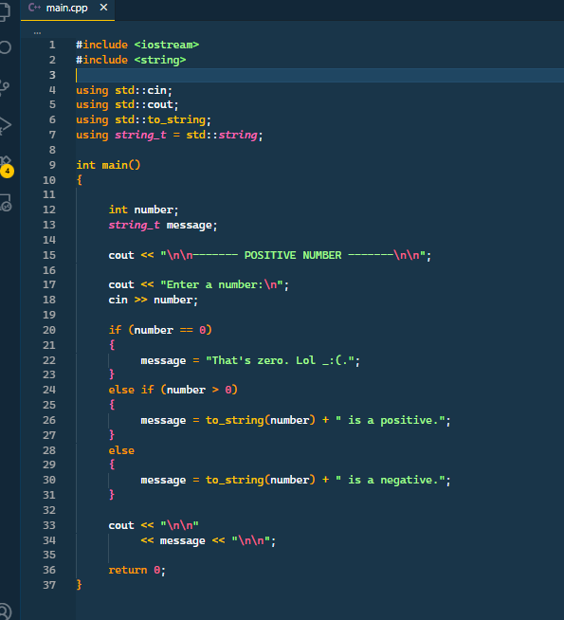

**Screenshot of the output**

