

GHANA COMMUNICATION

TECHNOLOGY UNIVERSITY

INSTITUTE OF CONTINUING

AND DISTANCE EDUCATION (ICDE)

|  |  |
| --- | --- |
| COURSE CODE | CICS 112 |
| COURSE TITLE | PROGRAMMING WITH C++ |
| NAME | Agbenyo Rogers Delator |
| STUDENT ID | 2425140023 |
| DATE | 2nd August, 2025 |

**QUESTION:**

Write a C++ program to find sum and average of three numbers.

**The solution**

#include <iostream>

using std::cin;

using std::cout;

int main()

{

cout << "\n\n===== Sum and Average Calculator. =====\n\n";

double a, b, c;

double sum, average;

cout << "\n\nEnter the three numbers: ";

cin >> a >> b >> c;

sum = a + b + c;

average = sum / 3;

cout << "\n\nThe sum of " << a << ", " << b << ", and " << c << " is: " << sum;

cout << "\n\nThe average of " << a << ", " << b << ", and " << c << " is: " << average;

cout << "\n\n";

return 0;

}

**Screenshot of the source code**

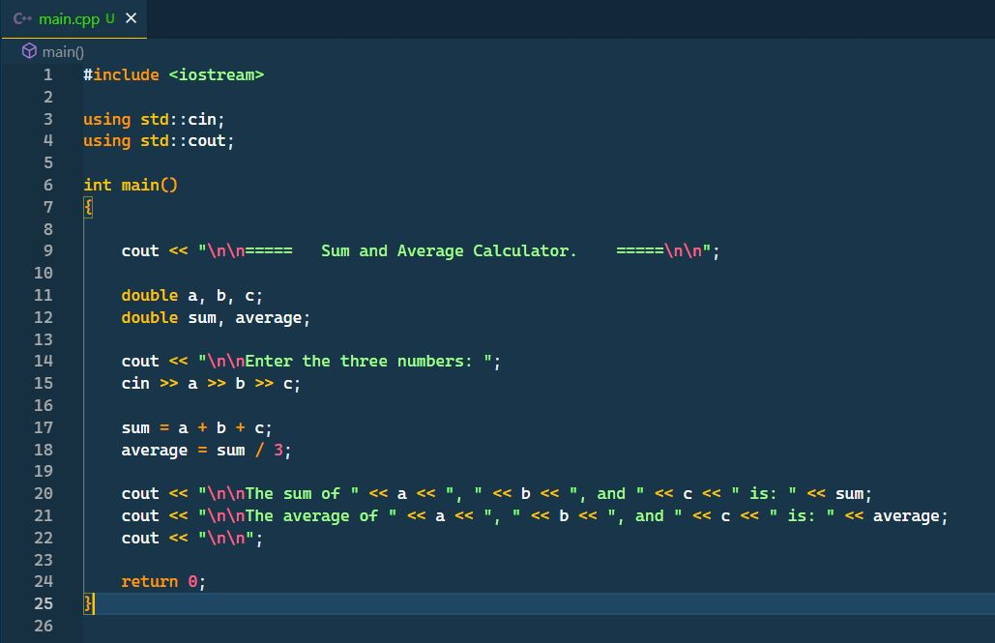

**The Result**

