

GHANA COMMUNICATION

TECHNOLOGY UNIVERSITY

INSTITUTE OF CONTINUING

AND DISTANCE EDUCATION (ICDE)

|  |  |
| --- | --- |
| COURSE CODE | CICS 112 |
| COURSE TITLE | Programming with C++ |
| NAME | Agbenyo Delator Rogers |
| STUDENT ID | 2425140023 |
| DATE | 19th August, 2025 |

**THE QUESTION**

Write a C++ program to check whether an integer entered by a user is positive or negative number.

NB: The program should consider 0 as a positive number.

**THE SOURCE CODE**

#include <iostream>

#include <string>

using std::cin;

using std::cout;

using std::to_string;

using string_t = std::string;

int main()

{

int number;

string_t message;

cout << "\n\n------- POSITIVE NUMBER ZERO INCLUSIVE -------\n\n";

cout << "Enter a number:\n";

cin >> number;

if (number >= 0)

{

message = to_string(number) + " is a positive number.";

}

else

{

message = to_string(number) + " is a negative number.";

}

cout << "\n\n"

<< message << "\n\n";

return 0;

}

**SCREENSHOT OF THE SOURCE CODE**

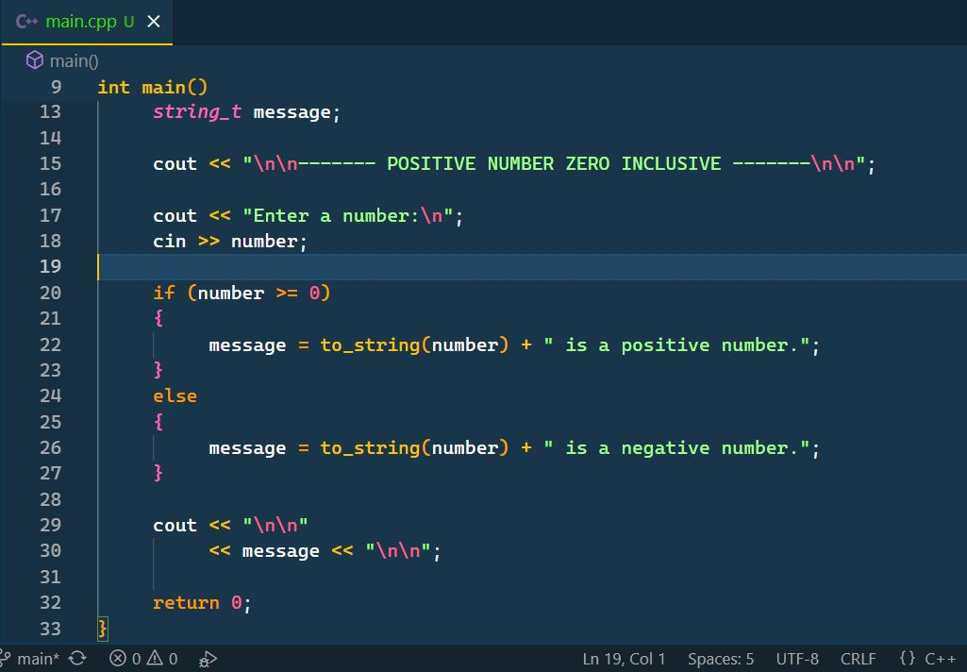

**SCREENSHOT OF THE OUTPUT**

