

GHANA COMMUNICATION

TECHNOLOGY UNIVERSITY

INSTITUTE OF CONTINUING

AND DISTANCE EDUCATION (ICDE)

|  |  |
| --- | --- |
| COURSE CODE | CIIS 154 |
| COURSE TITLE | Digital Electronics |
| NAME | Agbenyo Delator Rogers |
| STUDENT ID | 2425140023 |
| DATE | 10th August 2025 |

**QUESTION:**

1. Truth tables for all seven gates
2. Logic symbols for each gate
3. A short paragraph (3–4 sentences) explaining a practical application for each gate

**SOLUTION**

A logic gate (or electronic gate) is a circuit designed to process one or more binary signals to perform a specific logical operation.  
It acts as a device that controls the flow of information, typically in the form of pulses. Logic gates are categorized into seven main types: **AND, OR, NOT, NAND, NOR, XOR,** and **XNOR**.

**AND Gat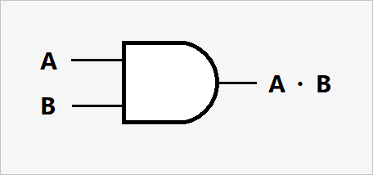e**

Outputs 1 only if ****all**** inputs are 1. A door with two locks — both locks must be unlocked for the door to open.

|  |  |  |
| --- | --- | --- |
| **A (Input)** | **B (Input)** | **A AND B (Output)** |
| 0 | 0 | 0 |
| 0 | 1 | 0 |
| 1 | 0 | 0 |
| 1 | 1 | 1 |

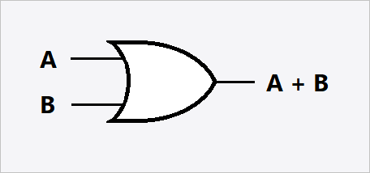**OR Gate**

Outputs 1 if **at least one** input is 1. An office door that opens if you use either a keycard or enter the correct passcode.

|  |  |  |
| --- | --- | --- |
| **A (Input)** | **B (Input)** | **A OR B (Output)** |
| 0 | 0 | 0 |
| 0 | 1 | 1 |
| 1 | 0 | 1 |
| 1 | 1 | 1 |

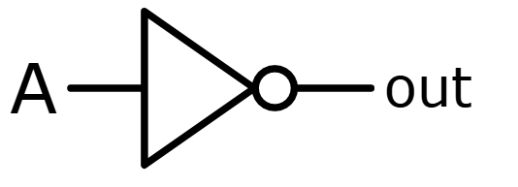**NOT Gate**

Produces the **opposite** of the input (inverts it). A fridge light — it turns ON when the door is open and OFF when the door is closed.

|  |  |
| --- | --- |
| **A (Input)** | **B (Output)** |
| 1 | 0 |
| 0 | 1 |

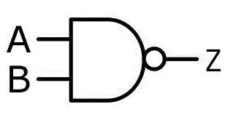**NAND Gate**

Outputs 0 only when **all** inputs are 1

(inverse of AND). A washing machine that stops only if both the lid is closed AND the timer is done. If not, it keeps running.

|  |  |  |
| --- | --- | --- |
| **A (Input)** | **B (Input)** | **A NAND B (Output)** |
| 0 | 0 | 1 |
| 0 | 1 | 1 |
| 1 | 0 | 1 |
| 1 | 1 | 0 |

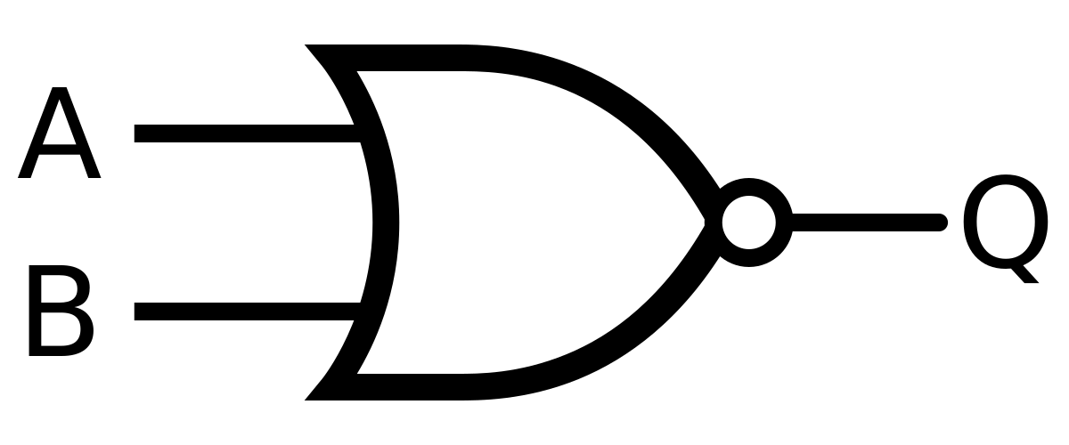**NOR Gate**

Outputs 1 only when **all** inputs are 0

(inverse of OR). Security alarm that stays silent unless all motion sensors are OFF — if any detect movement, it sounds the alarm.

|  |  |  |
| --- | --- | --- |
| **A (Input)** | **B (Input)** | **A NOR B (Output)** |
| 0 | 0 | 1 |
| 0 | 1 | 0 |
| 1 | 0 | 0 |
| 1 | 1 | 0 |

**XOR Gate**

Outputs 1 only if **exactly one** input is 1.

A two-way lamp switch where the light changes state only when one switch is flipped — not both at the same time.

|  |  |  |
| --- | --- | --- |
| **A (Input)** | **B (Input)** | **A XOR B (Output)** |
| 0 | 0 | 0 |
| 0 | 1 | 1 |
| 1 | 0 | 1 |
| 1 | 1 | 0 |

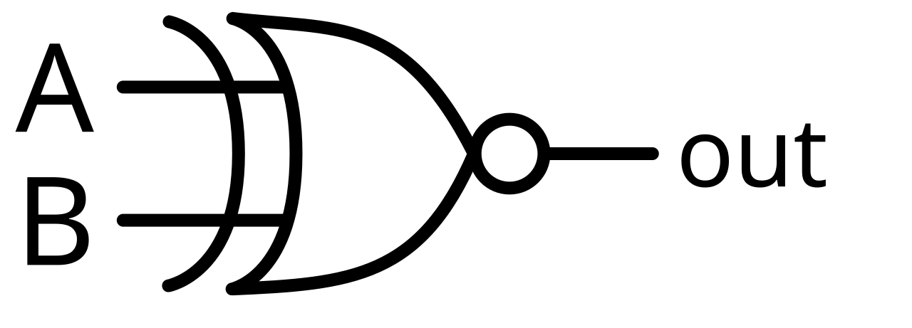**XNOR Gate**

Outputs 1 when inputs are **the same**

(inverse of XOR). A password checker — door unlocks only if the entered code matches the stored code

|  |  |  |
| --- | --- | --- |
| **A (Input)** | **B (Input)** | **A XNOR B (Output)** |
| 0 | 0 | 1 |
| 0 | 1 | 0 |
| 1 | 0 | 0 |
| 1 | 1 | 1 |