

GHANA COMMUNICATION

TECHNOLOGY UNIVERSITY

INSTITUTE OF CONTINUING

AND DISTANCE EDUCATION (ICDE)

|  |  |
| --- | --- |
| COURSE CODE | CICS 112 |
| COURSE TITLE | PROGRAMMING WITH C++ |
| NAME | Agbenyo Delator Rogers |
| STUDENT ID | 2425140023 |
| DATE | 2nd August, 2025 |

**QUESTION:**

Write a C++ program to accept four values from the user and computes the sum, product, and average of the entered values and display the results in the console interface.

**The solution**

#include <iostream>

int main()

{

using std::cin;

using std::cout;

double first_val, second_val, third_val, fourth_val;

double sum, product, average;

cout << "Sum, Product and Average Calculator.";

cout << "\n\nEnter the first number: ";

cin >> first_val;

cout << "\nEnter the second number: ";

cin >> second_val;

cout << "\nEnter the third number: ";

cin >> third_val;

cout << "\nEnter the fourth numbers: ";

cin >> fourth_val;

sum = first_val + second_val + third_val + fourth_val;

product = first_val * second_val * third_val * fourth_val;

average = sum / 3;

cout << "\n\nThe sum is: " << sum;

cout << "\nThe product is: " << product;

cout << "\nThe average is: " << average;

return 0;

}

**The source code**

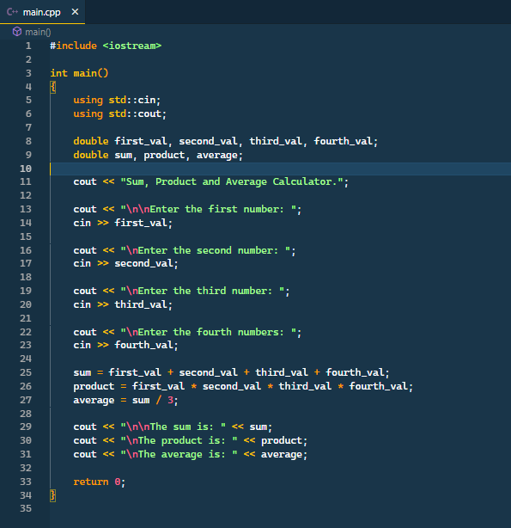

**The Result**

