

GHANA COMMUNICATION

TECHNOLOGY UNIVERSITY

INSTITUTE OF CONTINUING

AND DISTANCE EDUCATION (ICDE)

|  |  |
| --- | --- |
| COURSE CODE | CIIS 154 |
| COURSE TITLE | Digital Electronics |
| NAME | OBIKYENBI EMMANUEL KWAME |
| STUDENT ID | 2425140027 |
| DATE | 10th August 2025 |

**QUESTION:**

1. Truth tables for all seven gates
2. Logic symbols for each gate
3. A short paragraph (3–4 sentences) explaining a practical application for each gate

**SOLUTION**

A logic gate (or electronic gate) is a circuit designed to process one or more binary signals to perform a specific logical operation.  
It acts as a device that controls the flow of information, typically in the form of pulses. Logic gates are categorized into seven main types: **AND, OR, NOT, NAND, NOR, XOR,** and **XNOR**.

**AND Gat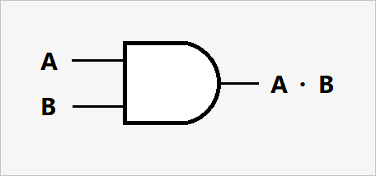e**

Outputs 1 only if ****all**** inputs are 1. ATM Withdrawal: An ATM dispenses cash only when a card is inserted AND a correct PIN is entered.

|  |  |  |
| --- | --- | --- |
| **A (Input)** | **B (Input)** | **A AND B (Output)** |
| 0 | 0 | 0 |
| 0 | 1 | 0 |
| 1 | 0 | 0 |
| 1 | 1 | 1 |

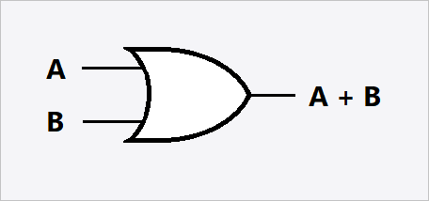**OR Gate**

Outputs 1 if **at least one** input is 1. Lighting Systems: Lights can be turned on using a wall switch or a remote control.

|  |  |  |
| --- | --- | --- |
| **A (Input)** | **B (Input)** | **A OR B (Output)** |
| 0 | 0 | 0 |
| 0 | 1 | 1 |
| 1 | 0 | 1 |
| 1 | 1 | 1 |

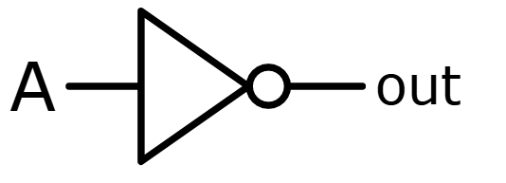**NOT Gate**

Produces the **opposite** of the input (inverts it). Temperature Control: A NOT gate can activate

a heating or cooling system when the temperature exceeds a set limit.

|  |  |
| --- | --- |
| **A (Input)** | **B (Output)** |
| 1 | 0 |
| 0 | 1 |

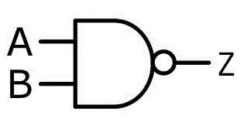**NAND Gate**

Outputs 0 only when **all** inputs are 1

(inverse of AND). Digital alarm clock: A NAND gate can be used to silence the alarm when both the "stop" button and the "snooze" button are pressed.

|  |  |  |
| --- | --- | --- |
| **A (Input)** | **B (Input)** | **A NAND B (Output)** |
| 0 | 0 | 1 |
| 0 | 1 | 1 |
| 1 | 0 | 1 |
| 1 | 1 | 0 |

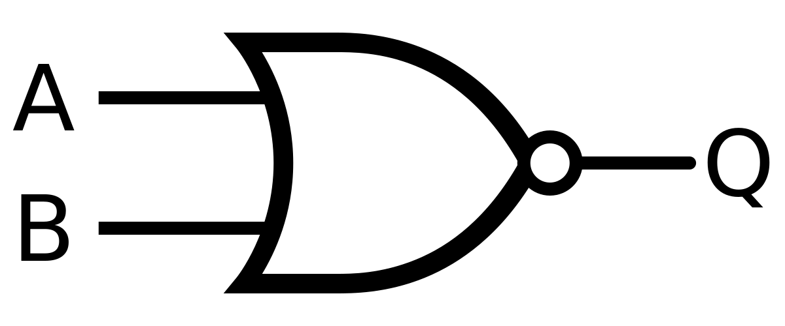**NOR Gate**

Outputs 1 only when **all** inputs are 0

(inverse of OR). Traffic lights: A NOR gate can be used to control traffic lights, where the light remains green (output 1) only when neither the "pedestrian crossing" button nor the "traffic sensor" is activated.

|  |  |  |
| --- | --- | --- |
| **A (Input)** | **B (Input)** | **A NOR B (Output)** |
| 0 | 0 | 1 |
| 0 | 1 | 0 |
| 1 | 0 | 0 |
| 1 | 1 | 0 |

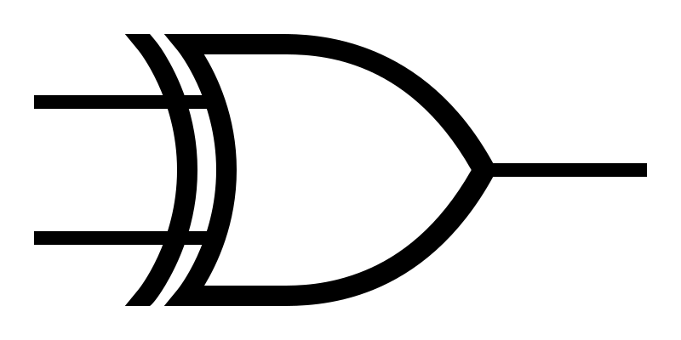**XOR Gate**

Outputs 1 only if **exactly one** input is 1.

Game logic: XOR gates can be used in game development to implement logic rules, such as "either A or B, but not both".

|  |  |  |
| --- | --- | --- |
| **A (Input)** | **B (Input)** | **A XOR B (Output)** |
| 0 | 0 | 0 |
| 0 | 1 | 1 |
| 1 | 0 | 1 |
| 1 | 1 | 0 |

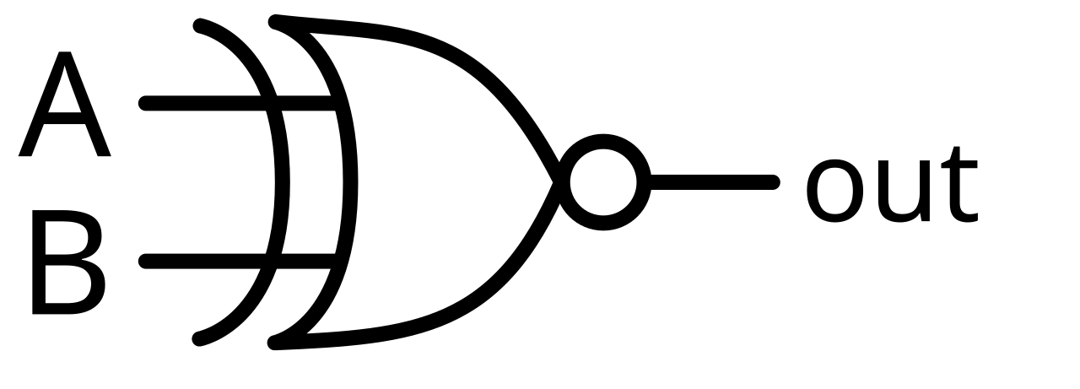**XNOR Gate**

Outputs 1 when inputs are **the same**

(inverse of XOR). Error detection: XNOR gates can be used to detect errors in digital data transmission by comparing the transmitted and received data.

|  |  |  |
| --- | --- | --- |
| **A (Input)** | **B (Input)** | **A XNOR B (Output)** |
| 0 | 0 | 1 |
| 0 | 1 | 0 |
| 1 | 0 | 0 |
| 1 | 1 | 1 |