# INTERFACES REQUIRED

## ASSUMPTIONS

These are the interfaces to the game board that are required for the following areas: Networking, AI, and GameplayScreen.

An example of how things are connected can be illustrated as follows:

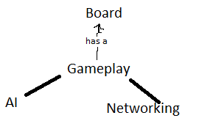

We are assuming that a move consists of a move and an attack. Attack is what triggers the recharge counter. A player can move a unit on a turn and still

## Networking

* Get Valid move(if performed) from GameplayScreen, else send empty move.
* Get Valid attack (if performed) from GameplayScreen, else send empty attack.
* Parse valid move(if performed), send it to the GameplayScreen
* Parse valid attack(if performed), send it to the GameplayScreen

## AI

* Gets gamestate(board layout) from GameplayScreen
* Sends a valid move and attack to GameplayScreen

## GameplayScreen

* Able to send moves and attacks to Networking
* Able to receive and apply moves and attacks from Networking and AI to the game board
* Able to send a copy of the game state to AI to process