Angels vs Demons Guide
Table of Contents
Game Overview 2
Turns 2
Recharge 2
Player Input 2
Using Spells 2
Spells 3
Units Overview 4
Demons / Angels 4
Imp / Soldier 4
Blood Guard / Angelic Guard 4
Skeleton Archer / Chosen One 4
Nightmare / Pegasus 4
Demon Lord / High Angel 5
Arch Demon / Arch Angel 5
Types Overview 6
Armour Types 6
Special Types 6
Game Grid 6
Gameplay 7
Move Phase 7
Attack Phase 8
Attack phase with your Champion 9
Winning the Game 9

Game Overview
The objective of Angels vs Demons (AvD) is to eliminate the opposing player’s champion. The champion for the Angels is the Arch Angel, and for the Demons it is the Arch Demon. The game plays somewhat similarly to chess except it adds a few more elements which are explained below.

Turns
Every turn you may take one action. An action involves either moving a piece, attacking with a piece, or both moving and attacking. The player starts on their ‘Move Phase’ meaning they can move a piece, after they have moved they enter their ‘Attack Phase’ meaning they can attack with the piece they have moved. Movements can be undone using the ‘U’ key, but after an attack is made the turn is over. Every time a unit finishes an action, that unit will need to ‘recharge’ for a set number of turns. The one exception to this rule is your champion’s spells. Your champion only needs to recharge when it moves or uses the ‘Rest’ spell.

Recharge
The recharge number of a unit indicates how many turns that unit must wait after taking an action in order to be active again. For example, a unit displaying “Recharge: 1” means that unit has 1 turn left until it can act again. The recharge counter of your units decrements at the beginning of your turn.

Player Input
The basic input for the game is handled by moving the cursor on the board to select which tile you want to effect. Pressing enter when a unit is selected will perform different actions based on what the current state of the game. The basic list of commands are:
- Arrow keys: move the cursor
- Enter: selects/deselects a unit
- ‘E’: ends the current phase
- ‘U’: undoes previous move
- Esc: Pauses game and allows users to exit
- Number Keys or Num Pad: Select Spell
- For the AI vs AI, pressing P will pause the game so you can evaluate the board.

Using Spells
If the unit selected was a champion the player can cast a spell rather then attacking during their Attack Phase. Each spell has a different effect and can be used on either enemies, allies, or the champion itself. During a Champions attack phase you can select the spell you want to use using the number keys, the commands are:

1: Bolt
2: Stun
3: Teleport
4: Buff
5: Heal
0: Rest

Spells

Spell | Cost | Description
Bolt | 20 MP | Deals 20 damage to target enemy unit. Range 3.
Stun | 20 MP | Target unit is snared. Adds 3 to rest time. Cannot target enemy Champion. Range 4.
Teleport | 30 MP | Swaps positions with allied unit. Range 5.
Buff | 30 MP | Changes the target unit’s armour type to imbued for 3 turns. Range 3.
Heal | 50 MP | Fully restores HP of target allied unit. Cannot target self. Range 6.
Rest | 0 MP | Fully restores MP. Unable to act for 5 turns.

Units Overview

Demons / Angels

Imp / Soldier
Health Points: 40
Attack Power: 10
Attack Type: Melee
Armour Type: Medium
Attack Range: 1
Movement: 3
Recharge: 1

Blood Guard / Angelic Guard
Health Points: 50
Attack Power: 25
Attack Type: Melee
Armour Type: Heavy
Attack Range: 2
Special: Hulking
Movement: 2
Recharge: 3

Skeleton Archer / Chosen One
Health Points: 30
Attack Power: 20
Attack Type: Projectile
Armour Type: Light
Attack Range: 4
Special: Projectile
Movement: 2
Recharge: 2

Nightmare / Pegasus
Health Points: 60
Attack Power: 25
Attack Type: Melee
Armour Type: Magic
Attack Range: 1
Special: Flying
Movement: 4
Recharge: 2

Demon Lord / High Angel
Health Points: 30
Attack Power: 30
Attack Type: Magic
Armour Type: Magic
Attack Range: 3
Special: Splash, Projectile
Movement: 3
Recharge: 4

Arch Demon / Arch Angel
Health Points: 100
Mana Points: 50
Armour Type: Imbued
Special: Flying, Champion
Movement: 2
Recharge: 1
Spells: See spell overview

Types Overview

Armour Types
Heavy: Reduces damage from melee and projectile attacks by 5. Increases damage taken from magic attacks by 5.
Medium: No mitigation.
Light: Increases damage taken from melee attacks by 5.
Magic: Reduces damage from magic attacks by 10.
Imbued: Reduces damage from all attacks by 15 to a minimum of 5.

Special Types
Flying: Ignores unit collision; can pass over any unit in its path.
Splash: Attacks effect a cross 2 area from the initial point.
Projectile: Can target any unit in attack range (no collision).
Hulking: Damage received above 25 is ignored.
Champion: You lose the game when this unit is defeated.

Game Grid

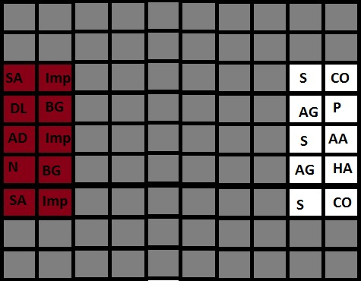

Gameplay
As stated in the game overview, the point of the game is to defeat the opponent’s champion. The move and attack phases are covered in this section.

Move Phase
Using the arrow keys, select the player you wish to move. The square with the grey highlight is the current tile (see Figure 1).

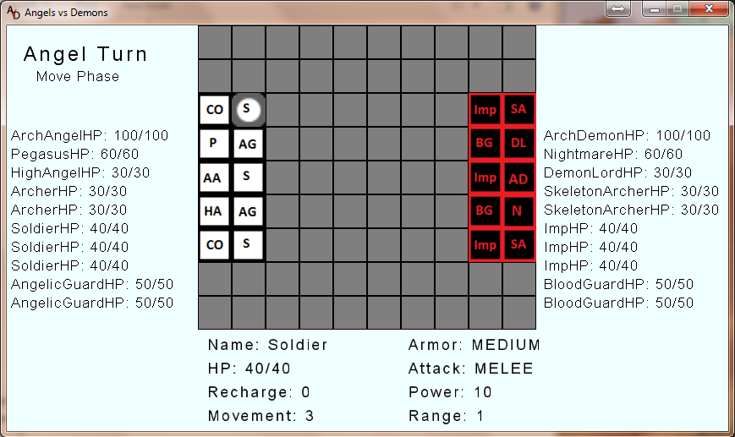
Figure 1

When you have highlighted the unit you wish to move, press enter. The unit’s movement range will now be highlighted in blue on the board (see Figure 2).

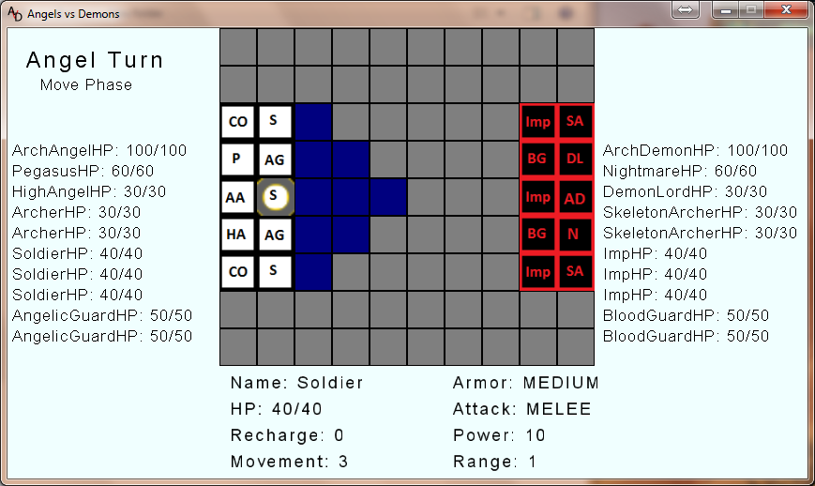
Figure 2
Using the arrow keys, select one of the highlighted squares to move to. When you have selected the tile to move to, press the ‘Enter’ key to move to it. Should you choose to undo a Move, simply press the ‘U’ key and pick a different Move. You can also choose to select a different unit if you undo a Move. To end your move phase, simply press the ‘E’ key.

Attack Phase
Once the move phase is completed, the attack range will highlight for the current piece. If no move was made during the move phase, then any unit is able to be used to attack with. If a move was made, then only the unit that moved can be attacked with.

The tile highlighting for the attack phase is different from the move phase in that not all tiles in the unit’s attack range are highlighted, only those which can be attacked are highlighted (see Figure 3).

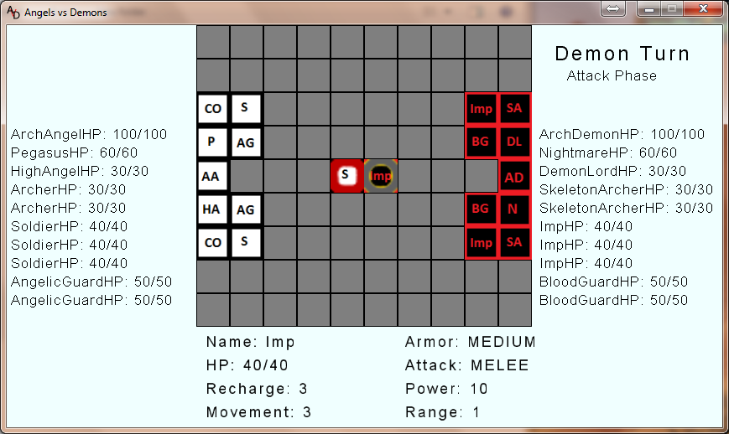
Figure 3

To attack a unit, simply move the arrow keys to select it (see Figure 4) with the cursor (gray highlighted square) and press enter.

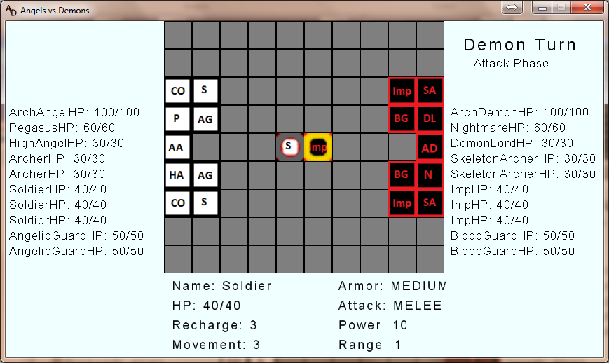
To end your attack phase, simply press the ‘E’ key. NOTE: Ending your attack phase will end your turn.

Attack phase with your Champion
Attacking with your champion plays out similarly to attacking with one of your non-champion units, except that it uses Mana points for each spell.

You can use one of the attack spells, (Bolt or Stun), or you can use one of the other spells that affects your own units. All spells count as an attack and can only be cast during your attack phase.

Winning the Game
The game is over when one of the Champion’s loses all of its hit points (HP).

