Southern New Hampshire University

Enhancing Technical Support: A Communication Strategy for the SNHU Help Desk

System Design Document

Information Technology-510

Rebekah Johansson

November 18, 2023

# Background:

Southern New Hampshire University has become one of the nation's largest non-profit online and campus higher educators. Between online and campus students, as well as campus and remote faculty and staff there are over 200,000 people that need technical support from Southern New Hampshire University. Supporting this many people is a large undertaking as well as meeting the company's expectations for customer satisfaction.

# Problem Statement:

The SNHU Technology Help Desk team needs a way to manage the ever-changing load of client requests they receive. Depending on the time of year they may receive 100 requests a day for help or more. The volume of requests is not the only issue. Another issue is they need a modern way to help students and employees. Not everyone wants to get on the phone for help. They are looking for ways such as texting and chatting to add a layer of satisfaction to the help desk team.

# Audience:

The audience for this study will involve several different types of people as well as different communication needs. Some of them are as follows:

# SNHU President and Top Leaders:

*Information*: The project overview and outcomes.

*Purpose*: To gain approval and make sure the project aligns with the school's mission in higher education.

# Help Desk Team:

*Information*: Details of changes to come and expect timelines in the change of workflow.

*Purpose*: To give the team the support and education they need in handling the increased volume of requests.

# Faculty and Staff (On - Campus and Remote):

*Information*: To provide changes in the support contact and procedures.

*Purpose*: To make sure they are well prepared about the new changes for asking for assistance.

# Students (On - Campus and Remote):

*Information*: To inform students of ways they can get help with technical issues.

*Purpose*: To meet expectations of the modern students as well as keep them informed.

# Alumni:

*Information*: To inform alumni of any changes that might impact related services.

*Purpose*: To keep a positive relationship with alumni and keep them engaged with the university’s progress.

# Work Breakdown Structure

#### Phase 1: Project Initiation

* Assemble Team
* Stakeholder Analysis
* Conduct Initial Risk Assessment
* Develop Project Charter and Gain Approval
* Secure Project Funding

#### Phase 2: Planning Phase

* Invest in Help Desk Software
* Enable Multichannel Support
* Allocate Resources
* Training

#### Phase 3: Process Improvement

* Guideline Creation
* Ticketing System Implementation
* Automation
* Support

#### Phase 4: User Education and Communication

* Information Spreading
* Training
* Feedback Collection

#### Phase 5: Closure

* Continue training, Help Desk staff and fix any technical issues.
* Test users to make sure they are satisfied.
* Complete documentation, reports, and guides.
* Hand over the project to ongoing support.

# Monitoring Control Plan:

#### Project Manager: Bek

* + Responsible for overall project planning, coordination, and monitoring.
  + Ensures that the project stays on track and meets its objectives.

#### IT Specialists: Bob

* + Responsible for technology and infrastructure upgrades.
  + Implement and manage the help desk software and automation.

#### Help Desk Team: Brad and Beth

* + Responsible for day-to-day support operations.
  + Handle user inquiries, issues, and requests.

#### Customer Service Representatives: Blake and Ben

* + Assist in user education and communication.
  + Deliver training sessions and gather user feedback.

#### Stakeholder Representatives: Bryce

* + Provide input and feedback throughout the project.
  + Represent the interests of different user groups.

#### Project Coordinator: Brody

* + Assist the project manager in coordinating various project tasks.
  + Ensure that timelines and deliverables are met.

#### Training Facilitator: Bella

* + Conduct training sessions for users on new communication channels and self-service options.

# Critical Path

The critical path outlines key tasks crucial for project success, each contributing directly to the overall timeline. Project Initiation establishes the groundwork, Planning Phase shapes the project, Process Improvement streamlines workflows, User Education and Communication ensures stakeholder adaptation, and Closure finalizes the project for long-term success. Managing these tasks efficiently is vital for project success, resource allocation, and timely completion.

Project Initiation Dependencies:Stakeholder approval, project charter completion, and securing funding are interdependent for a successful initiation.

Planning Phase Dependencies:Software investments and multichannel support must precede resource allocation and training.

Process Improvement Dependencies: Guidelines and ticketing system must be in place before automation, and all these elements are crucial for effective support.

User Education Dependencies: Information spreading is a prerequisite for training and collection feedback.

Closure Dependencies: Continuous training and user testing are essential before completing documentation and handing over the project.

Gantt Chart: The development of SNHU's Technology Help Desk Gantt chart is a methodical endeavor, aiming to outline key tasks and milestones essential for managing the diverse needs of over 240,000 users. This visual tool will capture critical activities, including daily support request management and preparations for significant events like the start of a new term. The Gantt chart provides a structured timeline for each task, facilitating effective resource allocation to meet the dynamic demands of SNHU's user base.

Timeline: The timeline for SNHU's Technology Help Desk is a detailed schedule, accounting for the initiation and completion of each task. Special attention is given to peak periods, particularly during key events like the start of a new term. The timeline accommodates the unpredictable volume of requests, aligning with diverse communication preferences, including quick responses reminiscent of modern communication methods like texting. This strategic timeline approach positions SNHU to navigate the ebb and flow of support requests while upholding a commitment to a superior customer experience.

# Gantt Chart:

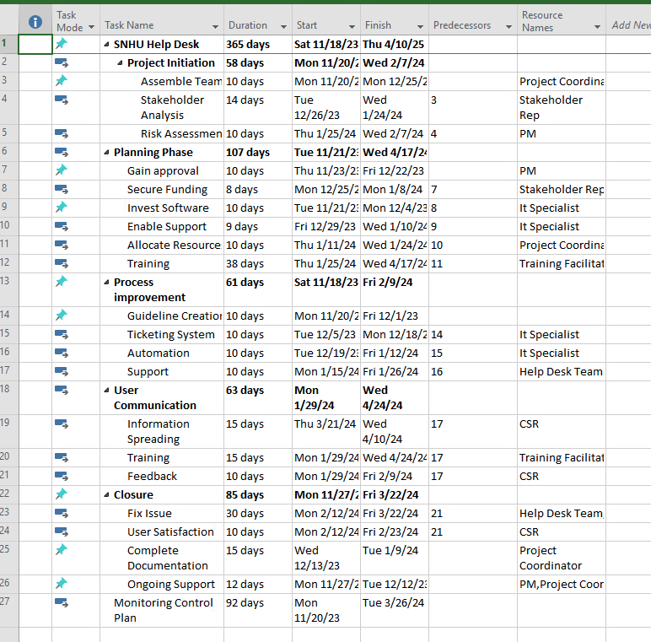

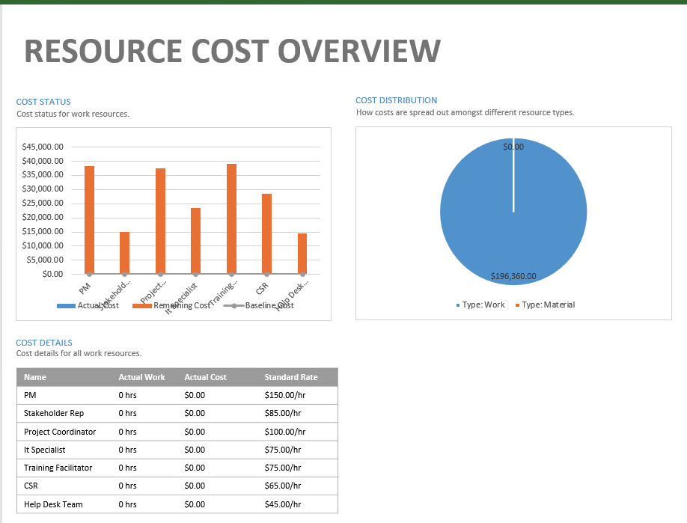

# Requirement Modeling:

#### Inputs:

* + Data on SNHU's user base: 240,000 users, including online and on-campus students, faculty, staff, and alumni.
  + User expectations: High expectations for user satisfaction and a preference for quick, modern communication methods.
  + Help Desk workload: Unpredictable volume of requests, varying from 100 to 200 per day, with spikes during key events like the start of a new term.

# Process:

#### User Support Management:

* + SNHU Technology Help Desk is the front line for all technical support.
  + Manages a fluctuating volume of support requests.
  + Adapts to spikes in requests during critical periods, such as the beginning of a new academic term.

#### Communication Channels:

* + Acknowledges the modern user base's preference for quick communication methods.
  + Adapts support services to meet user expectations, including a preference for non-phone communication like texting.
  + Meeting User Expectations:
  + Balances the need for efficiency with a commitment to user satisfaction.
  + Aims to provide technical support in a manner consistent with the speed of other modern communication channels.

#### Outputs:

* Resolved technical issues for users.
* User satisfaction levels.
* Performance metrics, including response times and ticket resolution times.
* Reports on the volume of support requests during different periods.

# Performance and Controls:

#### Performance Metrics:

* Monitoring and analyzing ticket resolution times.
* Tracking user satisfaction levels through feedback mechanisms.
* Assessing the ability to handle spikes in support requests during peak periods.

#### Adaptability:

* Ability to adjust support strategies based on varying workloads.
* Capacity to implement changes to meet the expectations of a modern user base.

#### Quality Assurance:

* Regular training for Help Desk staff.
* Continuous improvement initiatives based on user feedback.

# Security:

#### Data Security:

* Ensuring the confidentiality and integrity of user data during support interactions.
* Adhering to relevant data protection and privacy regulations.

#### System Security:

* Implementing measures to protect the Help Desk systems from cyber threats.
* Ensuring secure access to user information during support processes.

# Business Process Model:

A visual representation of the logical model for the system requirements based on the systems development life cycle is provided below.

# Data Flow Diagram:

A data flow diagram depicting the flow of data within the system is shown below.

# Data Dictionary:

The data dictionary for the Southern New Hampshire University (SNHU) User Support System provides a comprehensive overview of the data elements used to manage and track IT support services. It covers a wide range of data points, including user information, service requests, user preferences, performance metrics, user satisfaction, term-specific requests, security compliance, communication adaptation, employee training, and system security measures. This detailed data dictionary serves as a valuable resource for understanding and utilizing the data effectively to enhance IT support services at SNHU.

|  |  |  |  |
| --- | --- | --- | --- |
| Data Field | Description | Attribute | Text Field Size |
| User Type | Identifies the type of user, such as online student, on-campus student, faculty, staff, or alumni. | Categorical | Variable |
| Total Users | Represents the total number of users supported by SNHU. | Numeric | Integer |
| Request Volume | Indicates the number of support requests received by SHNU Technology Help Desk. | Numeric | Integer |
| Preferred Contact Method | Captures the preferred mode of contact for IT support (e.g., phone, text). | Categorical | Variable |
| Resolution Time | Records the time taken to resolve a user support request. | Numeric | Time Duration |
| Satisfaction Level | Measures user satisfaction with the provided IT support services. | Numeric (Likert Scale) | Integer |
| Term Specific Requests | Tracks support request. volume during key events, such as the start of a new academic term. | Numeric | Integer |
| Data Security Compliance | Indicates adherence to data protection and privacy regulations. | Binary (Y/N) |  |
| Communication Adaptation | Reflects the adjustments of support services to align with modern communication preferences. | Binary (Y/N) |  |
| Training Programs | Catalogs the training programs attended by Help Desk staff. | Text | Variable |
| System Security Measures | Lists measures implemented to safeguard Help Desk systems. | Text | Variable |

Object Model  
Southern New Hampshire University's User Support System is a comprehensive framework designed to efficiently manage the diverse needs of its educational community. At the core of this system is the SNHUUserSupportSystem class, encompassing key components like HelpDeskTeam, RequestVolume, UserExpectations, and Communication. The system is designed to include and facilitate interactions with various entities, including Users who can be enrolled in the system and initiate support Requests. The HelpDeskTeam, a critical part of the system, processes these Requests with the assistance of HelpDeskAgents. Communication plays a pivotal role, encapsulating messages exchanged between Users and HelpDeskAgents. With a focus on user satisfaction, the system aims to meet the expectations of an extensive user base, comprising online and on-campus students, faculty, staff, and alumni. This object model provides a structured representation of the system's components, their attributes, methods, and the dynamic relationships that govern their interactions, ensuring a seamless and responsive user support experience.

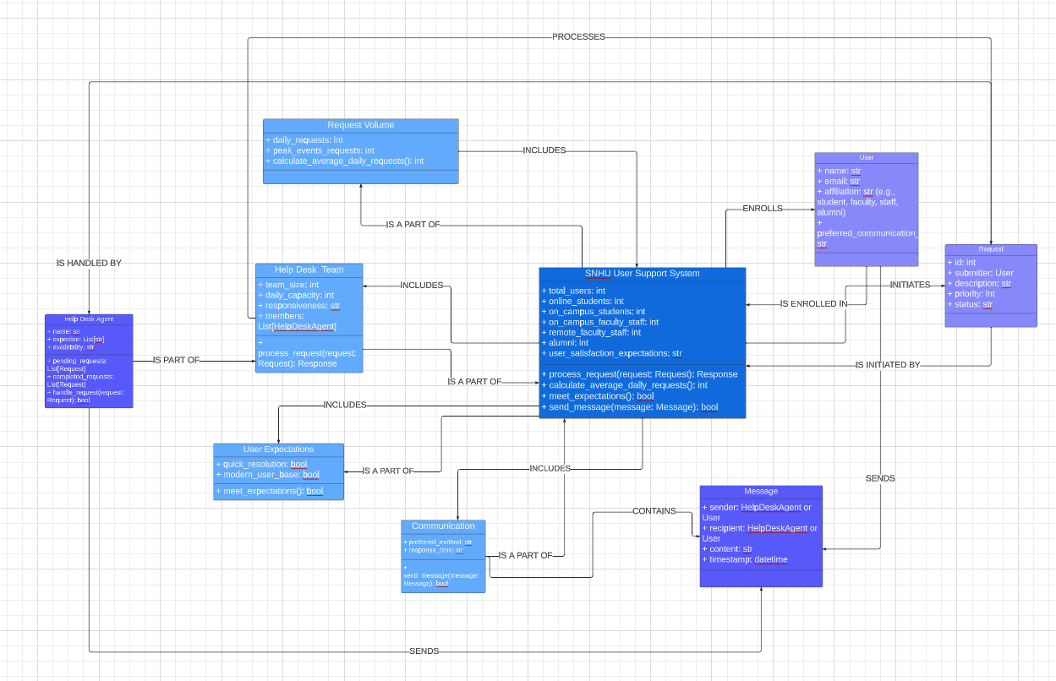

# Use Case Diagram:

The use case diagram demonstrates how SNHU’s help desk supports helps the student, faculty, and alumni.

# Corporate Organization and Culture:

SNHU's system architecture aligns with its organizational commitment to prioritize user satisfaction and deliver a superior customer experience. This emphasis likely influences the architecture to ensure a user-centric and responsive IT infrastructure.

# Enterprise Resource Planning (ERP):

SNHU employs a sophisticated ERP system that integrates key functions, including student information, academic administration, human resources, and financial management. This integration optimizes operational efficiency by providing a centralized platform for seamless information flow across diverse departments.

# Total Cost of Ownership (TCO):

Strategically mindful of financial considerations, SNHU's architecture addresses the total cost of ownership. This involves leveraging scalable cloud solutions to manage initial investments and ongoing operational costs efficiently, ensuring a cost-effective and sustainable IT environment.

# Scalability:

The dynamic nature of SNHU's user base necessitates a highly scalable architecture. Leveraging cloud-based solutions and virtualization technologies, the architecture is designed to flexibly handle fluctuations in demand, especially during critical periods like the commencement of a new academic term.

# Integration and Interface Requirements:

To create a cohesive user experience, SNHU's architecture focuses on seamless integration with various platforms. This includes learning management systems, communication tools, and other relevant applications. User-friendly interfaces, incorporating features like chatbots and self-service portals, enhance accessibility and efficiency.

# Security:

Security is a paramount concern for SNHU, reflecting the sensitive nature of student and faculty information. The architecture integrates robust security measures, including data encryption, stringent access controls, and regular security audits. Adherence to data protection regulations, such as FERPA, is prioritized to safeguard the integrity and confidentiality of institutional data.

# Components:

# Firewalls (2):

*Where*: Placed at the network entrances for security.

*Backup*: We have a spare in case one fails.

*Growth*: Can handle more traffic as SNHU grows.

# Server:

*Location*: Kept in a special room for good conditions.

*Backup*: If one part fails, another takes over.

*Growth*: Can handle more work as SNHU expands.

# Switch:

*Where*: Placed centrally for good connections.

*Capacity*: Enough ports for all workstations and room to add more.

Speed: Moves data quickly for a smooth network.

# Workstations (8):

*Where*: Spread where needed for easy access.

*Connections*: Wired for reliable and fast communication.

*Safety*: Protected with good antivirus.

# Cabling:

*Type*: Uses organized cabling for efficiency.

*Backup*: Extra paths for reliability.

*Labels*: Clearly labeled for easy fixing.

# Security:

*Control*: Limits access to the server room.

*Rules*: Set up rules for firewalls to keep the network safe.

*Encryption*: Keeps sensitive data secure during transfer.

# Planning for the Future:

*Upgrades*: Easy to add more or improve parts.

*Review*: Regular checks to see if more capacity is needed.

# Documentation:

*Diagram*: Keeps an updated drawing of the network.

*Instructions*: Notes how everything is set up for future reference.

# Entity-Relationship Diagram (ERD):

The foundation of SNHU's system architecture is built on a core principle: prioritizing user satisfaction and ensuring a positive customer experience. Every aspect of the architecture is meticulously designed to enhance user interactions, responsiveness, and overall satisfaction. By placing the user at the center of its design philosophy, SNHU aims to create an environment where technology seamlessly aligns with the needs and expectations of its diverse user base.

From user-friendly interfaces to innovative features like chatbots, the architecture is crafted to provide an intuitive and efficient experience. This user-centric approach extends beyond functionality to encompass the overall reliability, accessibility, and adaptability of the system. SNHU's commitment to delivering a positive customer experience through its system architecture reflects a strategic vision that recognizes the pivotal role technology plays in fostering satisfaction and engagement across the educational community.

# 3NF Tables

|  |  |  |
| --- | --- | --- |
| *USER TABLE* | | |
| Name | **DATA TYPE** | **DESCRIPTION** |
| UserID Old Key outline | INT | Primary key, unique identifier for each user |
| firstName | VARCHAR(255) | User’s first name |
| lastName | VARCHAR(255) | User’s last name |
| Email | VARCHAR(255) | User’s email address |
| Phone | VARCHAR(20) | User’s phone number |
| Role | VARCHAR(20) | User’s role (student, faculty, staff, alumni) |

|  |  |  |
| --- | --- | --- |
| *ONLINE STUDENT TABLE* | | |
| Name | **DATA TYPE** | **DESCRIPTION** |
| StudentID Old Key outline | INT | Primary key, unique identifier for each user |
| firstName | VARCHAR(255) | User’s first name |
| lastName | VARCHAR(255) | User’s last name |
| EnrollmentDate | DATE | Date of enrollment |
| GraduationDate | DATE | Date of graduation (Null for current students) |
| UserID Old Key outline | INT | Foreign key, references the UserID of the corresponding user |

|  |  |  |
| --- | --- | --- |
| *ON-CAMPUS STUDENT TABLE* | | |
| Name | **DATA TYPE** | **DESCRIPTION** |
| StudentID Old Key outline | INT | Primary key, unique identifier for each user |
| firstName | VARCHAR(255) | User’s first name |
| lastName | VARCHAR(255) | User’s last name |
| EnrollmentDate | DATE | Date of enrollment |
| GraduationDate | DATE | Date of graduation (Null for current students) |
| UserID Old Key outline | INT | Foreign key, references the UserID of the corresponding user |

|  |  |  |
| --- | --- | --- |
| *FACULTY TABLE* | | |
| Name | **DATA TYPE** | **DESCRIPTION** |
| FacultyID Old Key outline | INT | Primary key, unique identifier for each faculty member |
| firstName | VARCHAR(255) | Faculty member’s first name |
| lastName | VARCHAR(255) | Faculty member’s last name |
| Email | VARCHAR(255) | Faculty member’s email address |
| Phone | VARCHAR(20) | Faculty member’s phone number |
| UserID Old Key outline | INT | Foreign key, references the UserID of the corresponding user |

|  |  |  |
| --- | --- | --- |
| *STAFF TABLE* | | |
| Name | **DATA TYPE** | **DESCRIPTION** |
| StaffID Old Key outline | INT | Primary key, unique identifier for each faculty member |
| firstName | VARCHAR(255) | Staff member’s first name |
| lastName | VARCHAR(255) | Staff member’s last name |
| Email | VARCHAR(255) | Staff member’s email address |
| Phone | VARCHAR(20) | Staff member’s phone number |
| UserID Old Key outline | INT | Foreign key, references the UserID of the corresponding user |

|  |  |  |
| --- | --- | --- |
| *ALUMNI TABLE* | | |
| Name | **DATA TYPE** | **DESCRIPTION** |
| AlumniID Old Key outline | INT | Primary key, unique identifier for each faculty member |
| GraducationDate | DATE | Date of graduation |
| UserID Old Key outline | INT | Foreign key, references the UserID of the corresponding user |

|  |  |  |
| --- | --- | --- |
| *TECH-REQUEST TABLE* | | |
| Name | **DATA TYPE** | **DESCRIPTION** |
| RequestID Old Key outline | INT | Primary key, unique identifier for each faculty member |
| UserID Old Key outline | INT | Foreign key, references the UserID of the corresponding user |
| RequestDate | DATE | Date the request was submitted |
| RequestType | VARCHAR(255) | Type of request |
| Description | VARCHAR(255) | Description of the request |
| EventID Old Key outline | INT | Foreign key, references the UserID of the corresponding user |

|  |  |  |
| --- | --- | --- |
| *Event TABLE* | | |
| Name | **DATA TYPE** | **DESCRIPTION** |
| EventID Old Key outline | INT | Primary key, unique identifier for each faculty member |
| EventName | VARCHAR(255) | Name of event e.g., registration |
| EventDate | DATE | Date of the event |

# User Interface Design for SNHU Website

Header:

*Logo:* SNHU's logo is on the left for easy recognition so you know you are at the correct place.

*Contact Info:* The phone number and hours are on the right, making them easily accessible.

Main Section:

*Chat Box* (Left): For quick help, there's a chat box on the left, like texting.

*Contact Form* (Right): On the right, there's a simple contact form for more formal inquiries.

Design Highlights:

*Consistency*: The layout is consistent, keeping things in familiar places.

*User-Friendly:* The chat box is like texting, and the contact form is straightforward.

Responsive: It works well on all devices, from computers to phones.

*Branding:* The colors and logo match SNHU's brand for a cohesive look.

*Easy Interactions:* The chat box provides quick responses, and the contact form is user-friendly.

In short, the design is simple, consistent, and user-friendly, meeting SNHU's goal for a modern and satisfying user experience.

# SNHU System Architecture Overview:

# Corporate Focus:

The foundation of SNHU's system architecture is built on a core principle: prioritizing user satisfaction and ensuring a positive customer experience. Every aspect of the architecture is meticulously designed to enhance user interactions, responsiveness, and overall satisfaction. By placing the user at the center of its design philosophy, SNHU aims to create an environment where technology seamlessly aligns with the needs and expectations of its diverse user base.

From user-friendly interfaces to innovative features like chatbots, the architecture is crafted to provide an intuitive and efficient experience. This user-centric approach extends beyond functionality to encompass the overall reliability, accessibility, and adaptability of the system. SNHU's commitment to delivering a positive customer experience through its system architecture reflects a strategic vision that recognizes the pivotal role technology plays in fostering satisfaction and engagement across the educational community.

# Enterprise Resource Planning (ERP):

SNHU strategically employs a centralized Enterprise Resource Planning (ERP) system to streamline operations by integrating crucial components such as student information, administration, human resources, and finances. This centralized approach allows for a comprehensive and cohesive management of diverse aspects of the institution, fostering operational efficiency and data coherence.

The integration of student information ensures a unified and up-to-date view of academic records, facilitating informed decision-making and personalized support. Administration functions seamlessly connect, enhancing coordination and communication across various departments. Human resources are efficiently managed through the centralized system, promoting workforce optimization and streamlined HR processes. The integration of financial data enables accurate and real-time financial reporting, supporting sound financial management.

In essence, SNHU's utilization of a centralized ERP system exemplifies a strategic commitment to operational excellence, providing a unified platform that enhances collaboration, data accuracy, and overall efficiency across different facets of the institution.

# Cost Efficiency:

In a strategic cost-conscious approach, SNHU harnesses the power of scalable cloud solutions to achieve financial sustainability throughout the entire lifecycle of the system. The use of scalable cloud technologies not only ensures a cost-effective initial setup but also maintains ongoing operations within a budget-friendly framework. This forward-thinking strategy reflects SNHU's commitment to making informed financial decisions while optimizing the long-term efficiency and effectiveness of its operations.

By embracing scalable cloud solutions, SNHU can dynamically adjust its resources based on demand, avoiding unnecessary expenses during periods of lower usage and optimizing costs during peak times. This approach aligns with SNHU's overarching goal of financial prudence, allowing the institution to allocate resources judiciously, maximize operational efficiency, and ensure a sustainable and scalable technology infrastructure.

# Scalability:

SNHU's architecture demonstrates a high degree of adaptability to changing user numbers by leveraging flexible technologies such as cloud computing and virtualization. This strategic approach enables the system to seamlessly scale its resources, ensuring optimal performance even during peak periods. The utilization of cloud technology allows for dynamic adjustments in response to fluctuations in user demand, providing a robust and scalable infrastructure.

Virtualization plays a key role in enhancing scalability by abstracting computing resources, allowing them to be efficiently allocated based on demand. This dynamic and responsive architecture aligns with SNHU's commitment to providing a reliable and efficient user experience, accommodating the university's diverse and evolving user base. It exemplifies a forward-thinking approach to technology implementation, ensuring that the system can effectively meet the demands of a dynamic educational environment.

# Integration and User-Friendly Design:

SNHU's architecture is meticulously designed for seamless integration with diverse platforms, including learning systems, highlighting a commitment to interoperability and enhanced connectivity. The emphasis on user-friendly interfaces is a cornerstone of the architecture, ensuring accessibility and ease of use for the entire SNHU community. The incorporation of chatbots further underscores a dedication to efficiency, providing users with intuitive and responsive tools for streamlined interactions. This holistic approach to architecture aligns with SNHU's vision of creating a technologically advanced environment that promotes collaboration, accessibility, and a positive user experience across various platforms.

# Security Priority:

SNHU's system architecture places a paramount emphasis on security, employing robust measures such as encryption, access controls, and adherence to regulatory frameworks like FERPA. This steadfast commitment ensures the protection of user information and aligns with industry standards for data privacy. By implementing stringent security protocols, SNHU not only addresses potential vulnerabilities but also establishes a foundation of trust and confidence among its user base.

The architecture's multifaceted approach extends beyond security concerns to prioritize user satisfaction, cost efficiency, and seamless integration. This strategic design underscores SNHU's dedication to delivering a positive user experience while optimizing operational resources. The flexibility embedded in the architecture allows for adaptability to the dynamic needs of the educational community, including students, faculty, staff, and alumni. In essence, SNHU's system architecture strikes a balance between robust security measures and the pursuit of user-centric, efficient, and adaptable solutions.

# Feasibility Analysis for SNHU System Architecture:

# Operational Feasibility:

The new system makes things run smoother at SNHU. It helps with day-to-day tasks by bringing together student info, admin work, HR, and finances in one place. This simplifies the workflow and meets the needs of everyone at the university.

# Technical Feasibility:

The proposed system stands as a well-suited solution for SNHU's dynamic needs, characterized by its adaptability to fluctuations in user numbers, particularly during peak periods. The system's flexibility enables it to seamlessly scale and accommodate varying user volumes, ensuring optimal performance and user experience even during busy times. This adaptability aligns with SNHU's commitment to meeting the evolving demands of its diverse user base.

Moreover, the system's user-friendly interfaces and innovative features, such as chatbots, reflect a thoughtful consideration of contemporary communication preferences. By incorporating intuitive and modern communication tools, the system not only enhances user experience but also aligns with the way people prefer to interact today. This user-centric approach underscores SNHU's commitment to staying attuned to technological trends and fostering an environment where communication is both effective and user-friendly.

# Economic Feasibility:

The integration of the new system aligns seamlessly with SNHU's goal of financial prudence, ensuring that the institution's budget of $200,000 is utilized judiciously. By leveraging cost-effective cloud solutions, the architecture not only manages initial implementation expenses effectively but also demonstrates a commitment to controlling ongoing operational costs. The scalability of the system, allowing it to grow in tandem with the university's needs without incurring exorbitant expenses, is a testament to its long-term viability.

This cost-conscious approach reflects SNHU's strategic vision of making informed financial decisions while still prioritizing the delivery of a robust and scalable technology infrastructure. The balance between cost-effectiveness and scalability positions the institution to allocate resources efficiently, maintaining financial stability while providing a foundation for technological growth. In essence, the new system embodies SNHU's commitment to being financially smart, ensuring that investments in technology align with the university's broader financial objectives.

# Scheduling Feasibility:

The implementation of the new system at SNHU is strategically designed to be a streamlined and efficient process, acknowledging the importance of minimizing disruptions. The phased rollout approach ensures a gradual and systematic integration, allowing upgrades to take place without causing unnecessary chaos or interruption to regular operations. This meticulous implementation strategy is indicative of SNHU's commitment to a smooth transition, enabling the university community to adapt to changes seamlessly.

By taking a step-by-step approach, SNHU aims to navigate the implementation process with precision, addressing any potential challenges while maintaining the overall stability of operations. This approach not only mitigates the risk of disruption but also provides room for real-time adjustments, ensuring that any unforeseen issues can be promptly addressed. The careful orchestration of the rollout aligns with SNHU's dedication to user satisfaction, creating an environment where technological enhancements can be seamlessly incorporated into the daily activities of students, faculty, staff, and alumni.

# Target Audience Communication:

For decision-makers at SNHU, the decision to implement the proposed system is a strategic and prudent move. Not only does the system contribute to the enhancement of operational efficiency, but it also does so in a cost-effective manner. Its adaptability and user-friendly features, coupled with the ability to introduce it gradually, align seamlessly with SNHU's overarching objectives.

The proposed system represents a judicious investment, promising to make day-to-day operations smoother and more responsive to changes in user demands. Its cost-effectiveness ensures that the institution's financial resources are allocated efficiently, while the gradual introduction mitigates potential disruptions and facilitates a smooth transition. In essence, the proposed system emerges as a well-matched solution for SNHU, aligning with the institution's goals of operational excellence, adaptability, and prudent financial management.

# Appendix: Reference Documents

[Bard, Bard.AI (n.d.)](https://bard.google.com/chat)

[Bridges, J. (2023, September 15). *How to write a business case*. Project Manager.](https://www.projectmanager.com/blog/how-to-write-a-business-case)

[*Context diagram of order system [classic]*. create. (n.d.).](https://creately.com/diagram/example/ir5f9ksz/context-diagram-of-order-system-classic)

[Chatgpt, ChartGPT.(n.d.)](https://chat.openai.com/)

[Tilley, S., & Rosenblatt, H. (n.d.). *Systems Analysis and Design* (11th ed.). 2023](https://mbsdirect.vitalsource.com/reader/books/9781337424202/epubcfi/6/8%5b%3Bvnd.vst.idref%3DM4%5d!/4/2%5bcopyright%5d/4)

[YouTube. (2021, August 15). *Project Management Basics - Part 1 [the ultimate starter pack]*. YouTube.](https://www.youtube.com/watch?v=IJH17vkF2wg)

[YouTube. (2020, May 17). *Ms project tutorial 4 HOW TO APPLY resources & costs to a Schedule*. YouTube.](https://www.youtube.com/watch?v=FjCBCwD5Kzw&t=1948s)

[*Success story: Southern New Hampshire University*. GoTo. (n.d.-b)]().%20https:/www.goto.com/resources/case-study-southern-new-hampshire-university)