Erik Gonzalez-DeWhitt

CSCI-N311

Final Project

August 10, 2014

1. The purpose of the project is to create a back-end database for an online store selling Brazilian Jiu-Jitsu and mixed martial arts products. Along with collecting and holding standard information concerning product information, customer information, and also includes shipping information and considers valid promotional code entry.

The project is meant for individuals working to manage the database and to easily add and remove entries easily. It's also meant to be able to view information related to the customer behavior and promotional code usage. Also, all sales must consider the agreed upon discount rates given to corresponding customers.

Note: Customer_INFO names based on comic book characters and famed author Neil Gaiman.

1. **Create Tables**
   1. **Create**

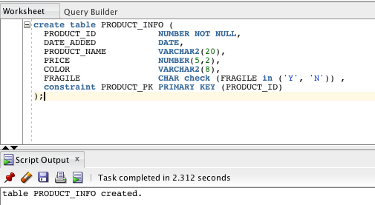

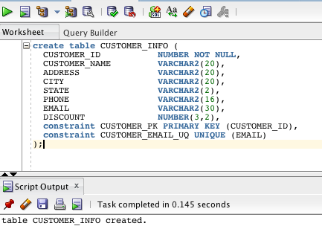

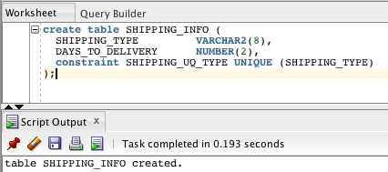

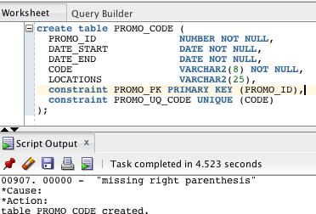

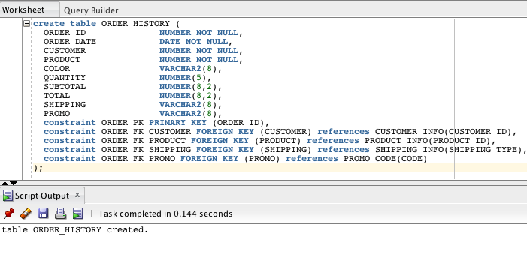

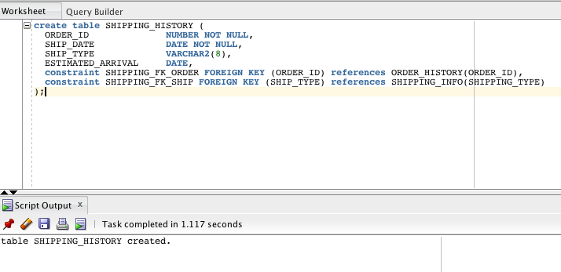

* 1. **Insert**

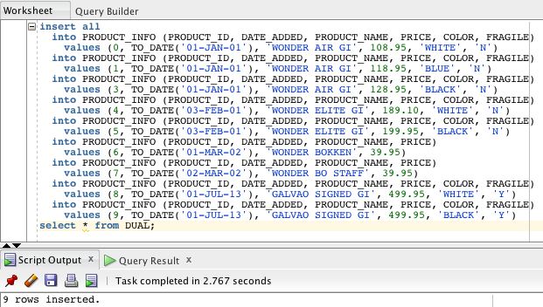

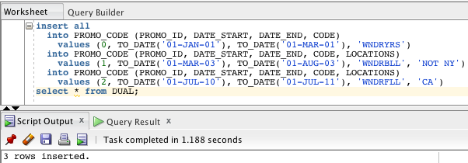

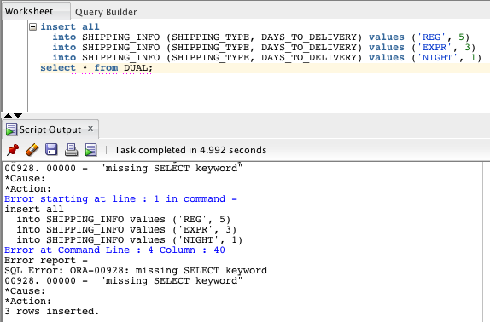

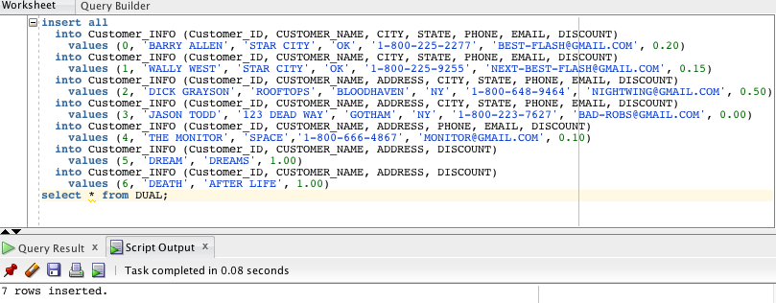

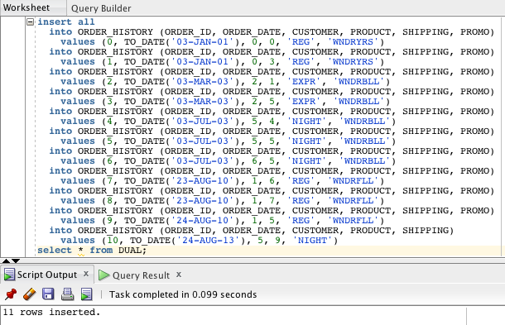

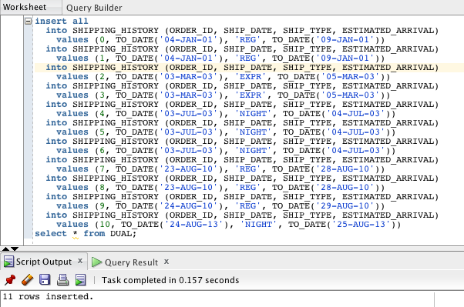

1. Views

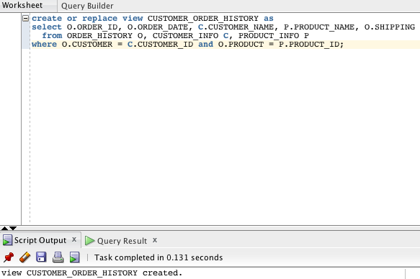

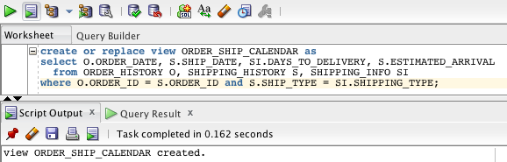

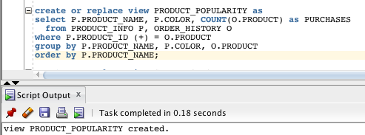

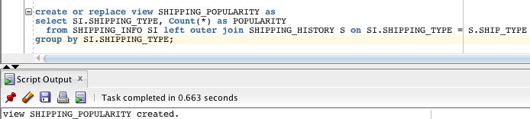

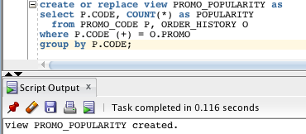

1. E-R Diagram

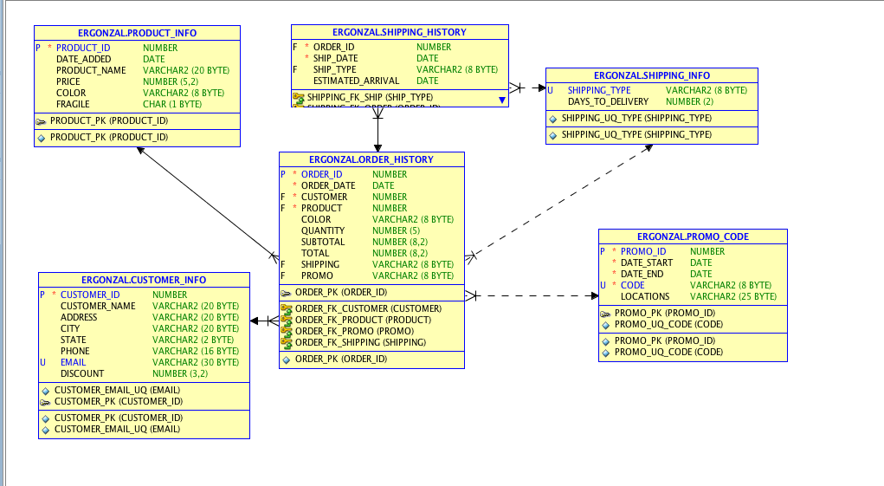

1. SQL Database Queries
   1. String Functions

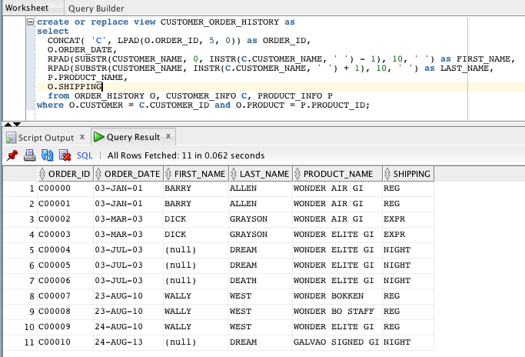

* 1. Number Functions

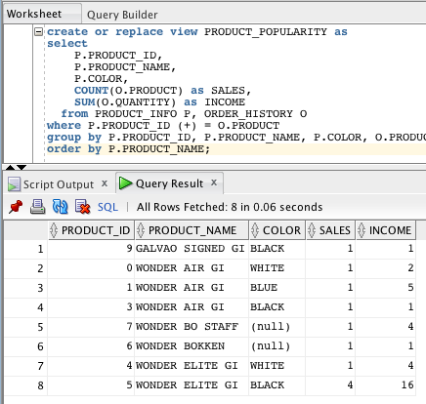

* 1. Date Functions

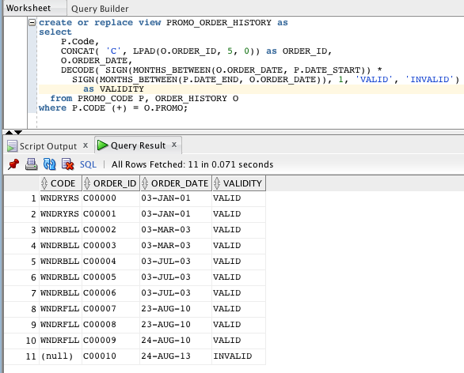

* 1. Decode Function

-- See section 5c or 8 --

1. Use Group By and Having

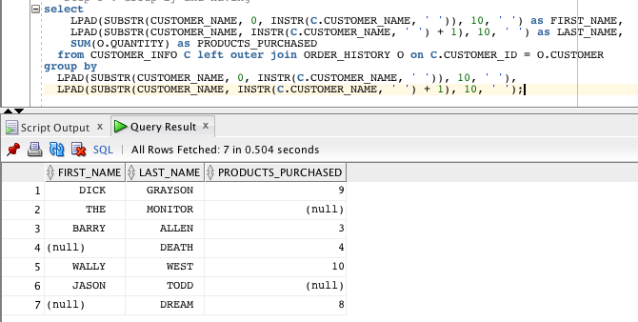

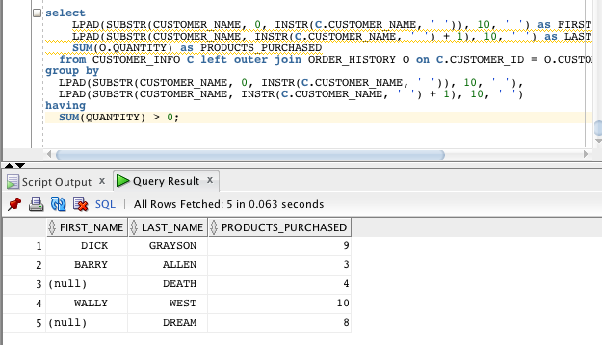

1. Use Subqueries

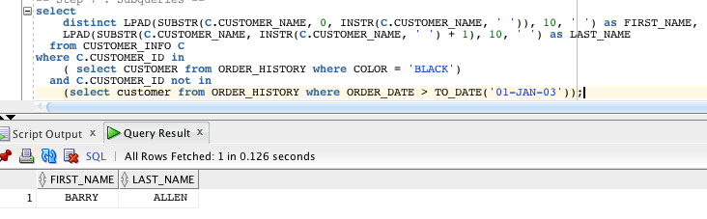

1. Use Decode

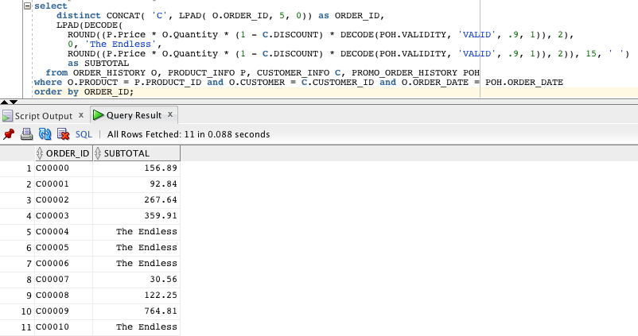

1. Use Join and Outer Join
   1. Inner join

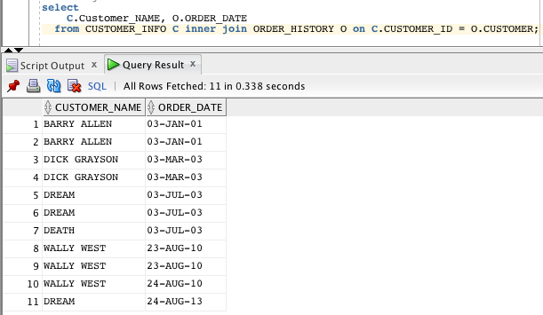

* 1. Outer join

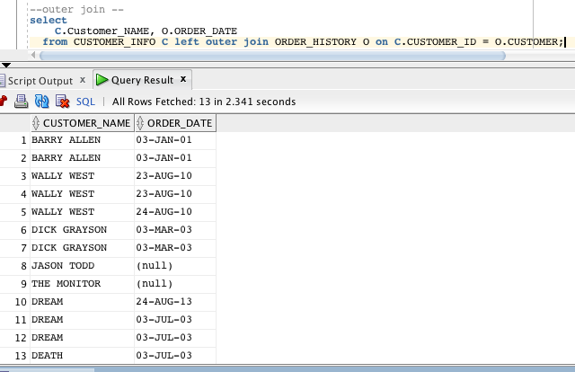

1. Demonstrate Savepoints

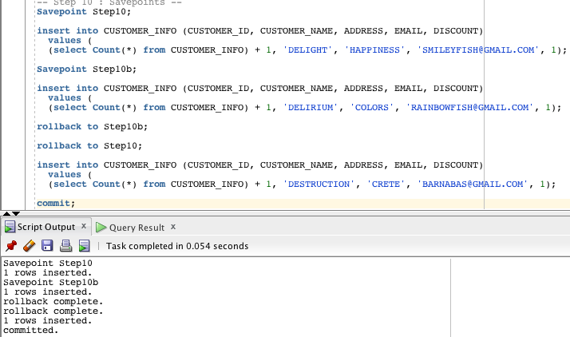

1. Insert Statements

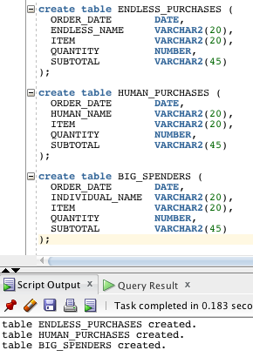

* 1. Insert All

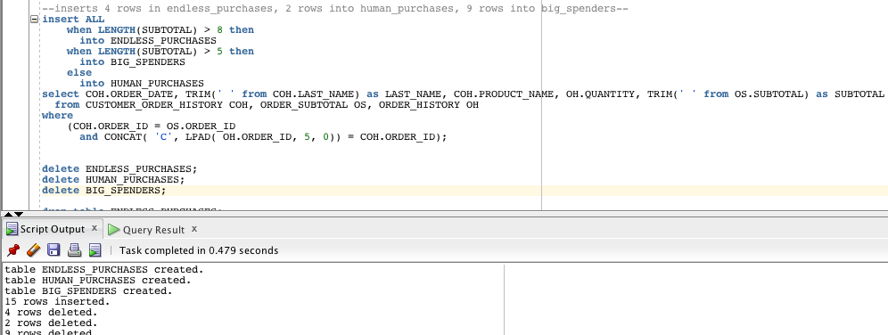

* 1. Insert First

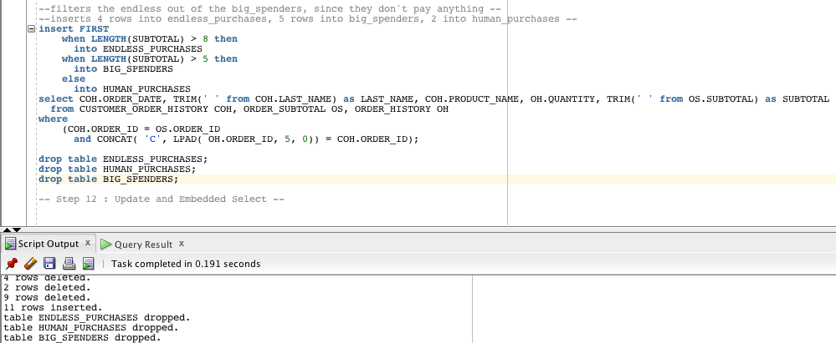

1. Demonstrate Update and Embedded Select



1. Demonstrate Merge

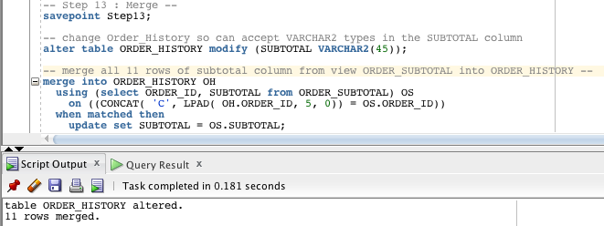

1. Create a unique constraint

Macintosh HD:Users:erikgonzalez-dewhitt:Desktop:Screen Shot 2014-08-11 at 1.32.00 PM.png

1. Create a table from another table

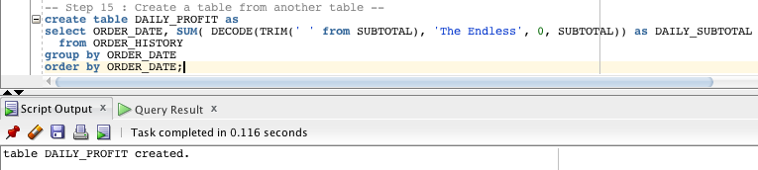

1. Create an index

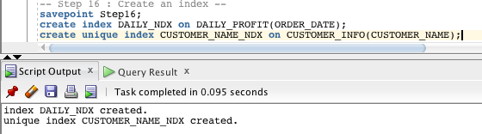

1. Create a sequence

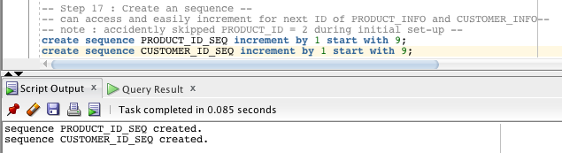

1. Materialized views and materialized view logs

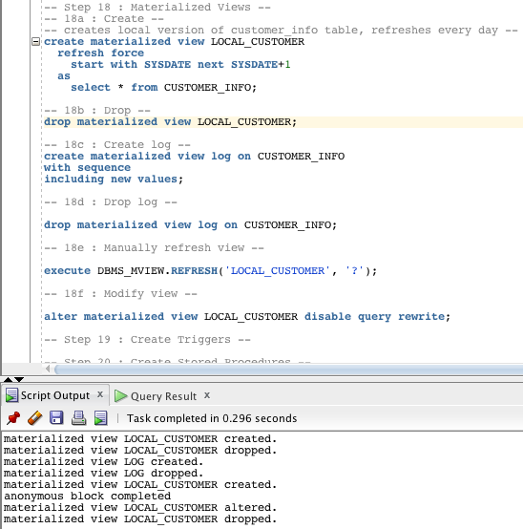

1. Create Triggers

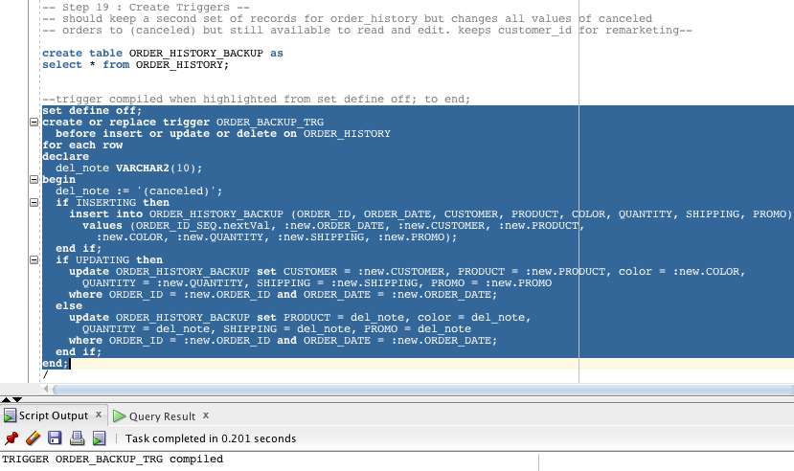

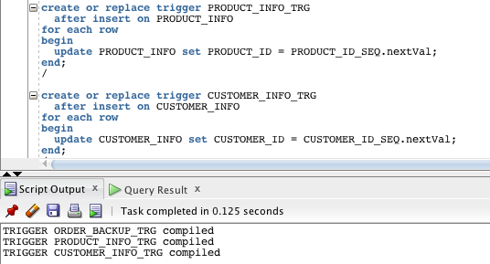

1. Create stored procedures

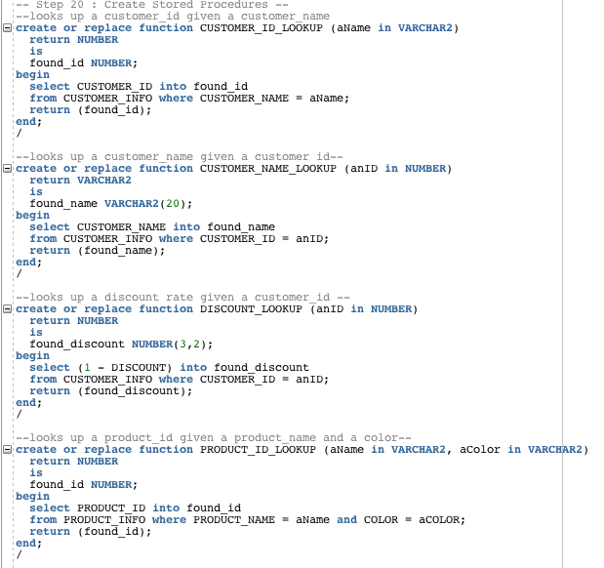

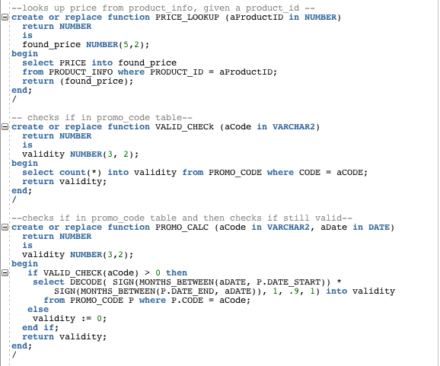

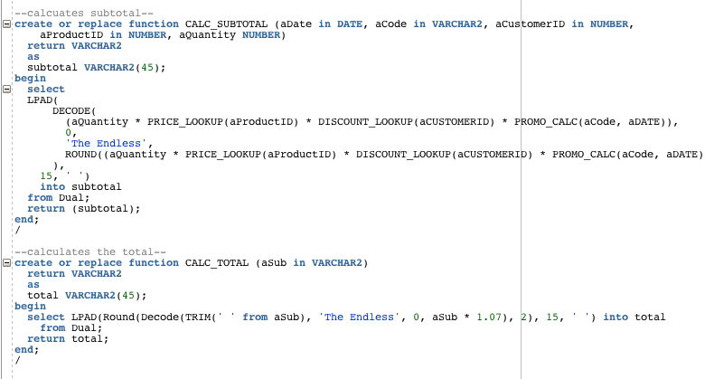

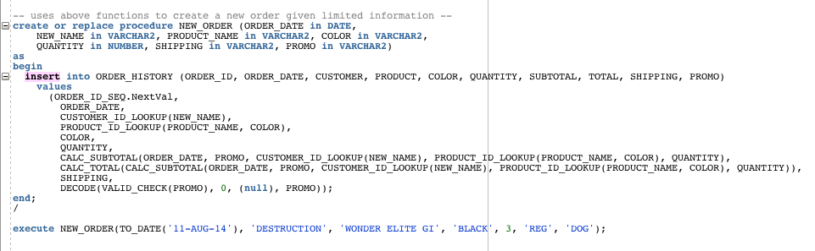

1. Create objects in database

