Erik Gonzalez-DeWhitt

CSCI-N311

Project 5

August 8, 2014

Step One:

create table PHONE_USERS (

TELEPHONE_NUMBER VARCHAR2(80) NOT NULL,

FIRST_NAME VARCHAR2(80),

LAST_NAME VARCHAR2(80),

KEYMAP_LASTNAME CHAR(4),

PASSWORD VARCHAR2(80),

constraint PHONE_USERS_PK PRIMARY KEY(TELEPHONE_NUMBER),

constraint PHONE_USERS_UQ UNIQUE(LAST_NAME)

);

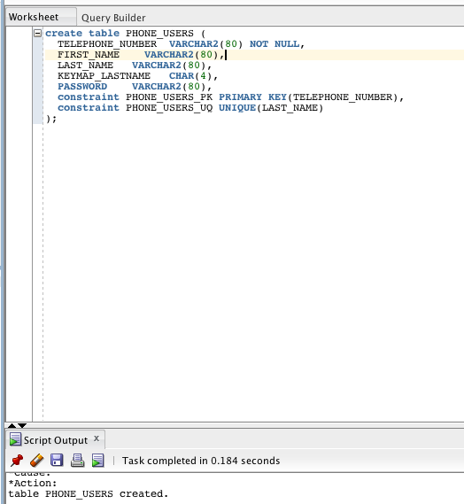

Step Two:

create or replace function KEYMAP (lname in VARCHAR2)

return VARCHAR2

is

trans_lname VARCHAR2(4);

begin

select translate( RPAD(LAST_NAME, 4, '0'), 'ABCDEFGHIJKLMNOPQRSTUVWXYZ', '22233344455566677778889999') into trans_lname

from PHONE_USERS

where LAST_NAME = lname;

return(trans_lname);

end;

/

Macintosh HD:Users:erikgonzalez-dewhitt:Desktop:Screen Shot 2014-08-08 at 4.01.22 PM.png

Step Three:

create table BBT_USERS_TEMP as

select * from LINGLU.BBT_USERS_TEMP;

Macintosh HD:Users:erikgonzalez-dewhitt:Desktop:Screen Shot 2014-08-08 at 4.12.51 PM.png

create or replace procedure BBTtoPHONEU (n in NUMBER)

is

num NUMBER := n;

begin

execute immediate 'truncate table PHONE_USERS';

while num > 0

loop

insert into PHONE_USERS (TELEPHONE_NUMBER, FIRST_NAME, LAST_NAME, KEYMAP_LASTNAME, PASSWORD)

select '(' + substr(TELEPHONE_NUMBER, 0, 3) + ') -' + substr(TELEPHONE_NUMBER, 3, 3) + '-' + substr(TELEPHONE_NUMBER, -1 , 3),

FIRST_NAME, LAST_NAME + '000' + TO_CHAR(num), KEYMAP(LAST_NAME), PASSWORD

from BBT_USERS_TEMP;

num := num - 1;

end loop;

end;

/

Macintosh HD:Users:erikgonzalez-dewhitt:Desktop:Screen Shot 2014-08-08 at 4.58.38 PM.png

Step Four:

create or replace package PROJECT5

as

function KEYMAP (lname in VARCHAR2) return VARCHAR2;

procedure BBTtoPHONEU (n in NUMBER);

end PROJECT5;

/

Macintosh HD:Users:erikgonzalez-dewhitt:Desktop:Screen Shot 2014-08-08 at 5.08.22 PM.png