Introduction to RabbitMQ

What is RabbitMQ?

RabbitMQ is a message-queueing software also known as a message broker or queue manager. Simply said, it is software where queues are defined, to which applications connect in order to transfer messages.

When and why should you use RabbitMQ?

Message queueing allows, for example, web servers to respond to requests quickly instead of being forced to perform resource-heavy procedures on the spot that may delay response time. Message queueing is also good when you want to distribute a message to multiple consumers or to balance loads between workers.

Exchanges

Messages are not published directly to a queue; instead, the producer sends messages to an exchange. An exchange is responsible for routing the messages to different queues with the help of bindings and routing keys. A binding is a link between a queue and an exchange.

There are four types of exchanges:

* Direct - The message is routed to the queues whose binding key exactly matches the routing key of the message.
* Fanout - A fanout exchange routes messages to all of the queues bound to it.
* Topic - The topic exchange does a wildcard match between the routing key and the routing pattern specified in the binding.
* Headers - Headers exchanges use the message header attributes for routing.

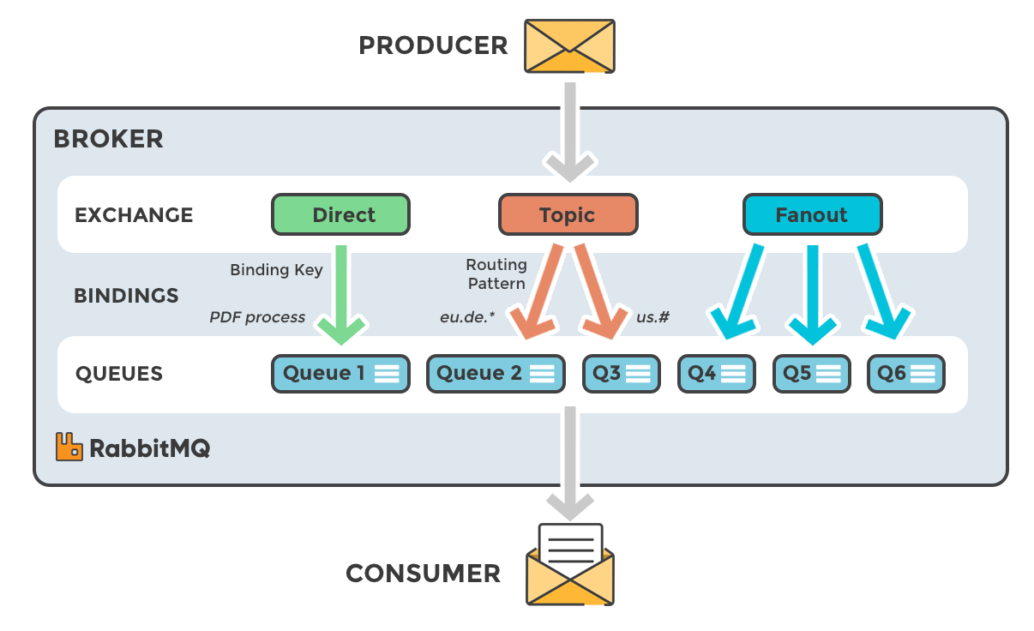

Examples on how to use each of these types of exchanges can be followed on the official RabbitMQ website at <https://www.rabbitmq.com/getstarted.html>

Bibliography and Resources:

1. <https://www.cloudamqp.com/blog/part1-rabbitmq-for-beginners-what-is-rabbitmq.html>