BillFlow
Automated Vendor Invoice Capture & Job Costing for QuickBooks
Product Requirements Document — Version 2.0 — April 2026 — Confidential
The Product in One Sentence
Set up email forwarding once, connect QuickBooks once, and vendor invoices flow into QuickBooks
automatically — correctly coded to the right job — without anyone touching them.

1. Product Philosophy

1.1 The Core Problem
Small businesses that buy materials or parts for specific jobs have a data entry problem that nobody has solved well. The vendor sends an invoice by email as a PDF. That PDF contains perfectly structured data — vendor name, invoice number, date, line items with descriptions, quantities, and costs. A human then opens QuickBooks and types all of that information in again by hand. This is maddening because the data already exists in a form a computer can deal with — and yet every FSM and accounting platform is completely blind to it.
The same problem exists in every trade and service business that buys materials for jobs: HVAC, plumbing, electrical, roofing, general contracting, auto repair, landscaping, custom fabrication. Any business using QuickBooks with job costing has this problem today.

1.2 The Existing Partial Solution — AutoEntry by Sage
AutoEntry by Sage solves the invoice capture and QuickBooks push problem. It works well for what it does. The gaps BillFlow fills:
- AutoEntry is not well marketed. Most contractors who have this problem do not know it exists.
- AutoEntry uses a credit-based pricing model that creates billing anxiety.
- AutoEntry does not attempt to match invoices to QuickBooks jobs. The job field is always blank.
- AutoEntry's onboarding does not guide users to the auto-publish feature. It is buried in vendor settings and most users never find it, so they do manual review forever.
- You cannot copy text from the PDF on the right side of the AutoEntry review screen. A basic usability failure.
- AutoEntry was designed primarily for accountants managing multiple client companies. The direct contractor experience is not its focus.

AutoEntry competitive research — the following screenshots were taken from a live AutoEntry account to understand the product being improved upon:

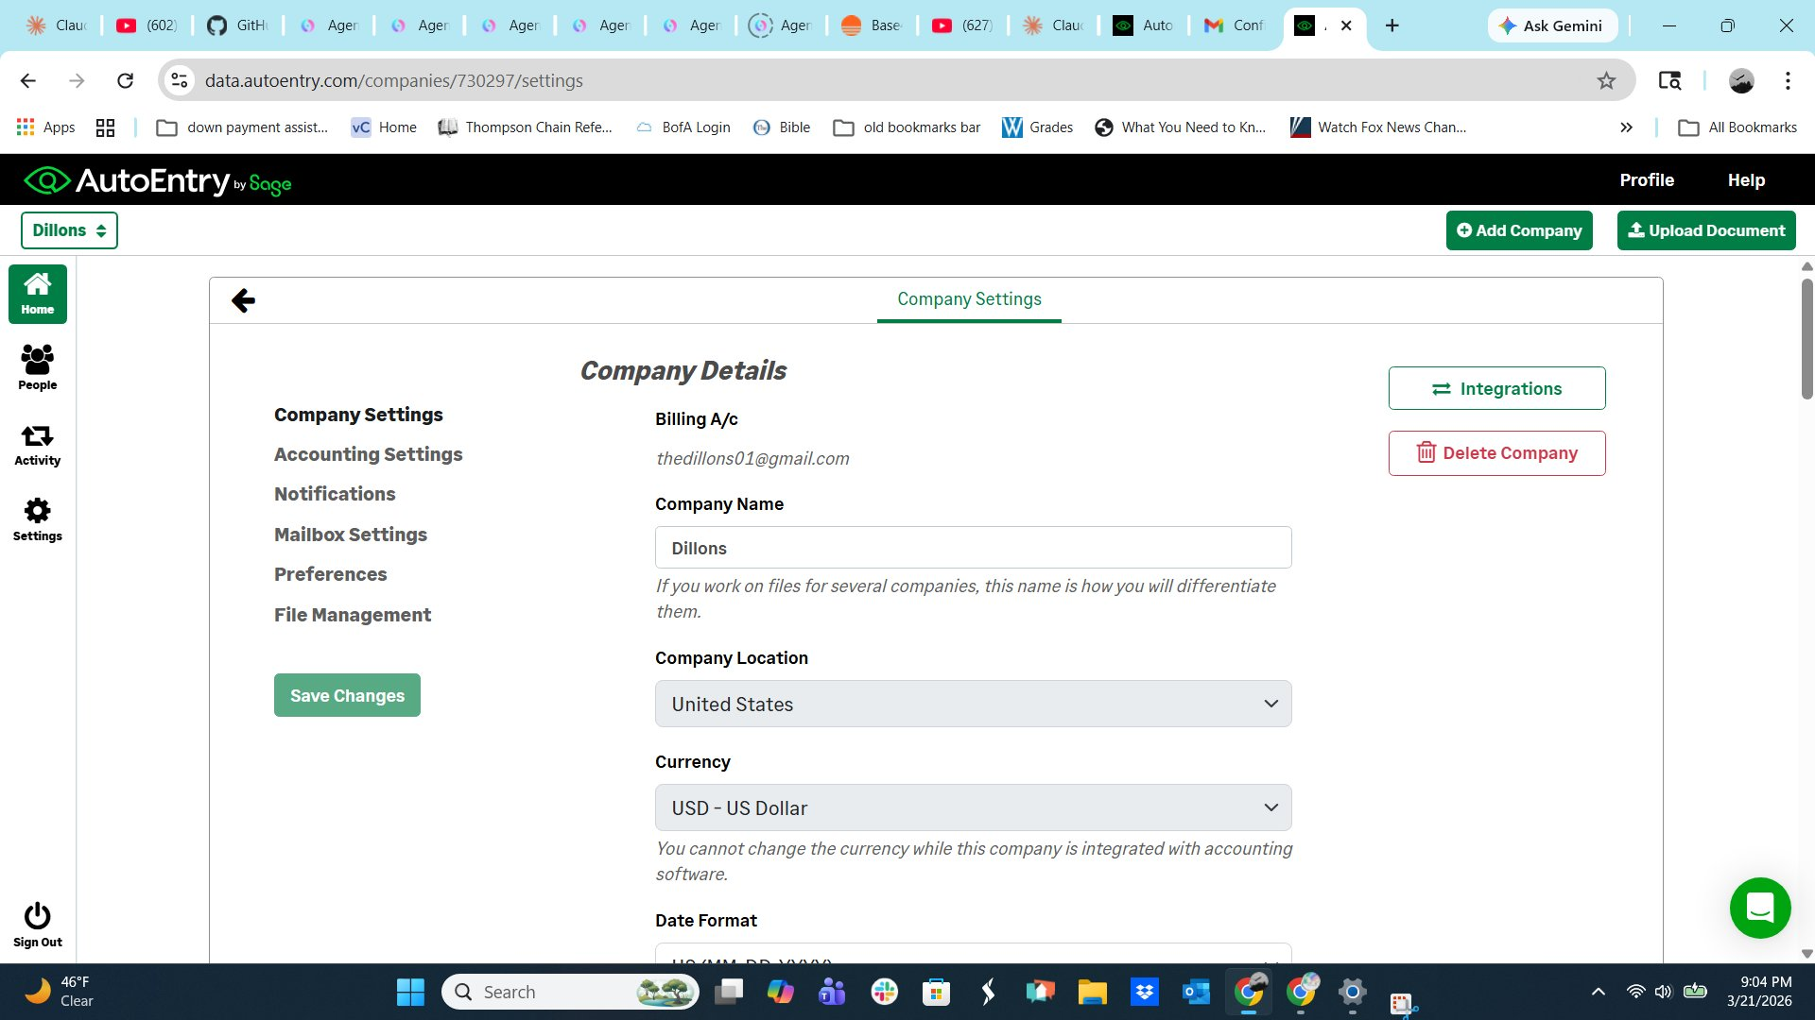
AutoEntry — Company Settings: Company Details & Accounting Settings
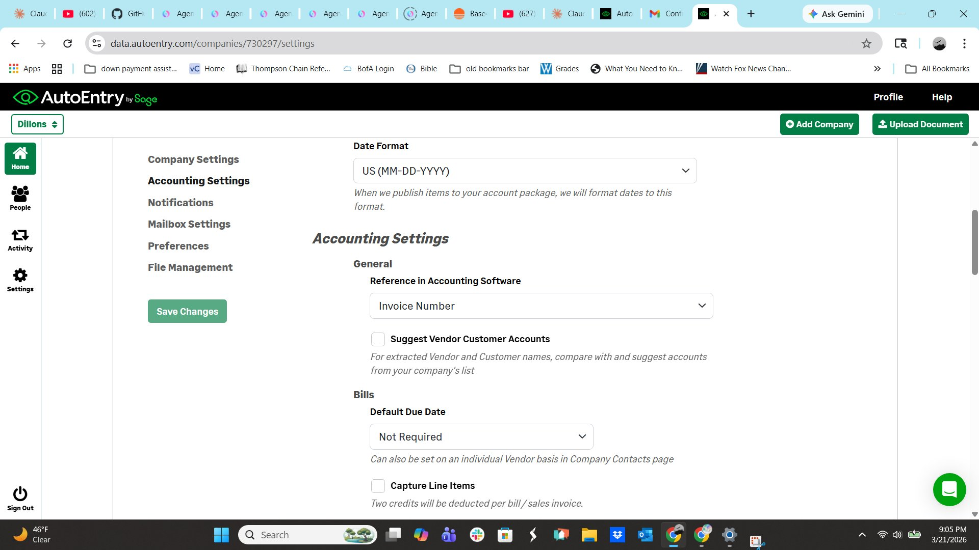
AutoEntry — Accounting Settings: Reference field, duplicate detection, line item capture
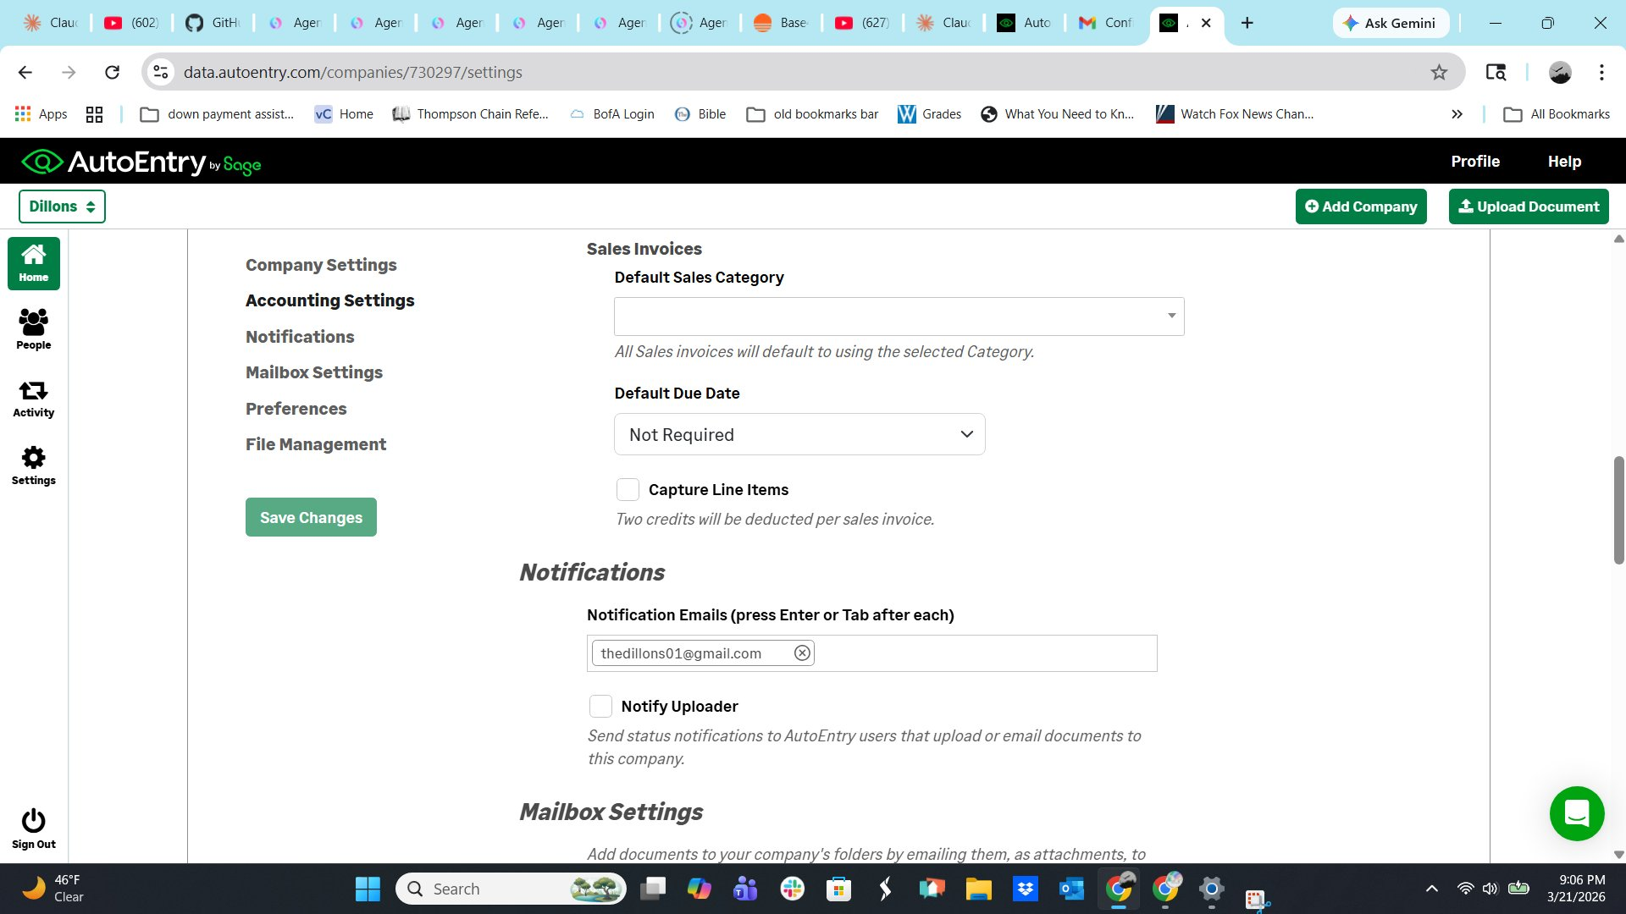
AutoEntry — Notifications & Mailbox Settings sections
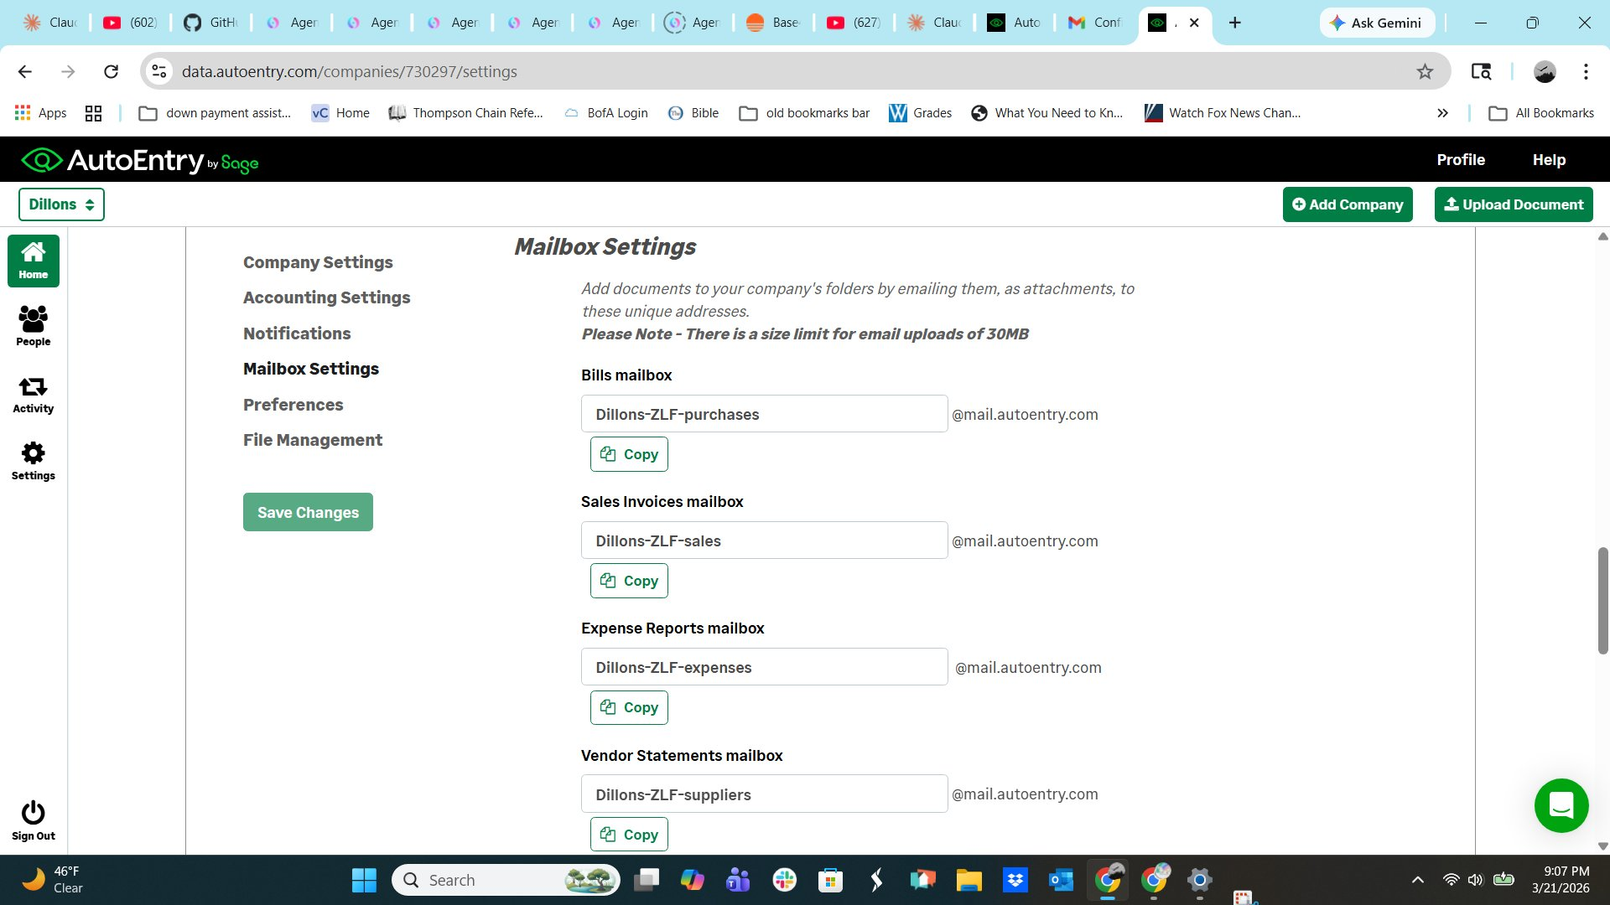
AutoEntry — Mailbox Settings: capture email addresses (@mail.autoentry.com)
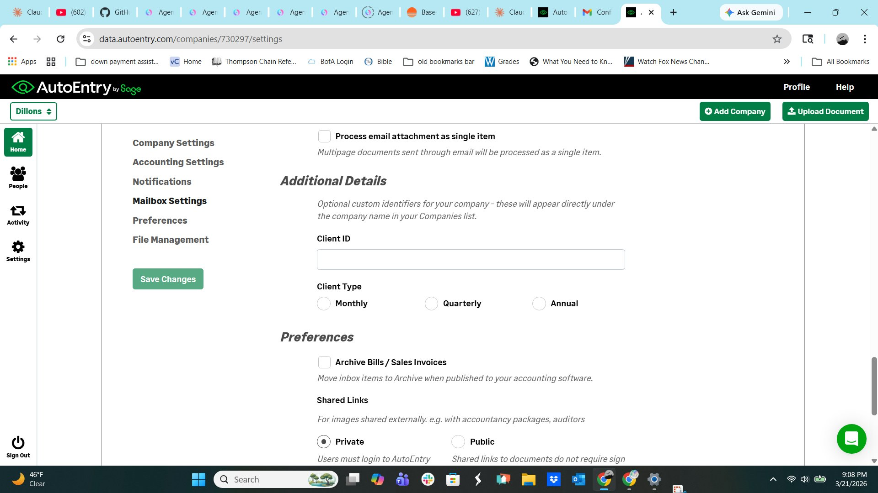
AutoEntry — Preferences: Archive on publish, shared links, invoice number display
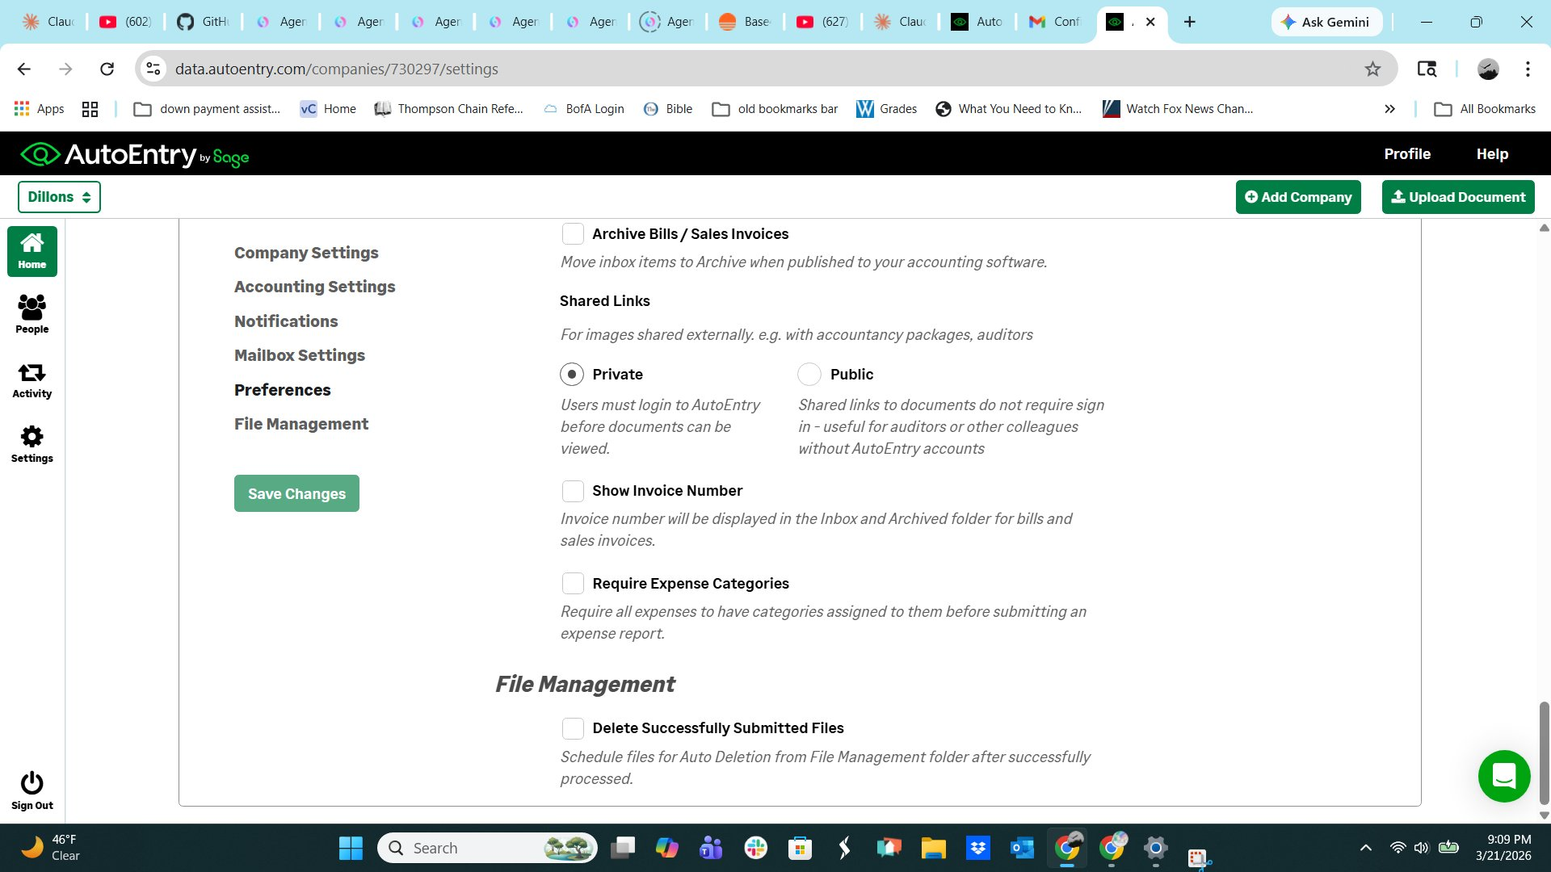
AutoEntry — Preferences continued & File Management

1.3 AutoEntry Pricing Model (Credit-Based — BillFlow Replaces With Flat Monthly)
AutoEntry charges per document processed using a credit system. BillFlow uses flat monthly pricing — no billing anxiety, no counting documents, no surprises.
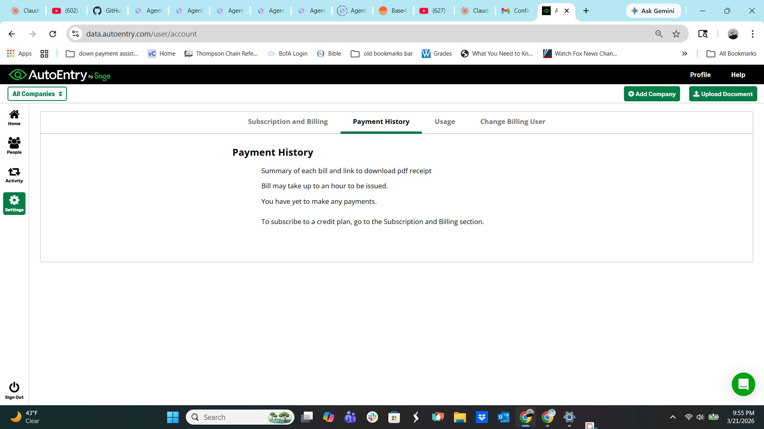
AutoEntry — Credits Summary showing per-document credit costs
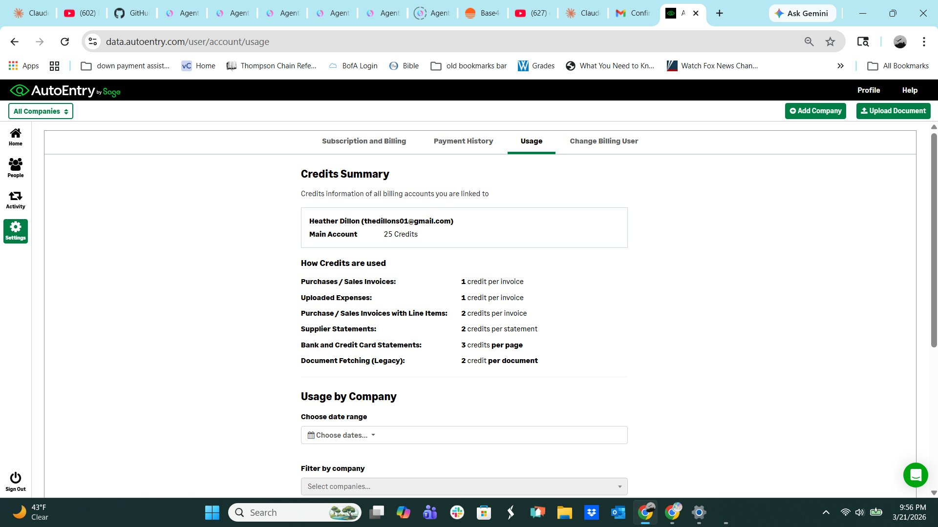
AutoEntry — Usage by Company and Account (25 free sign-up credits)
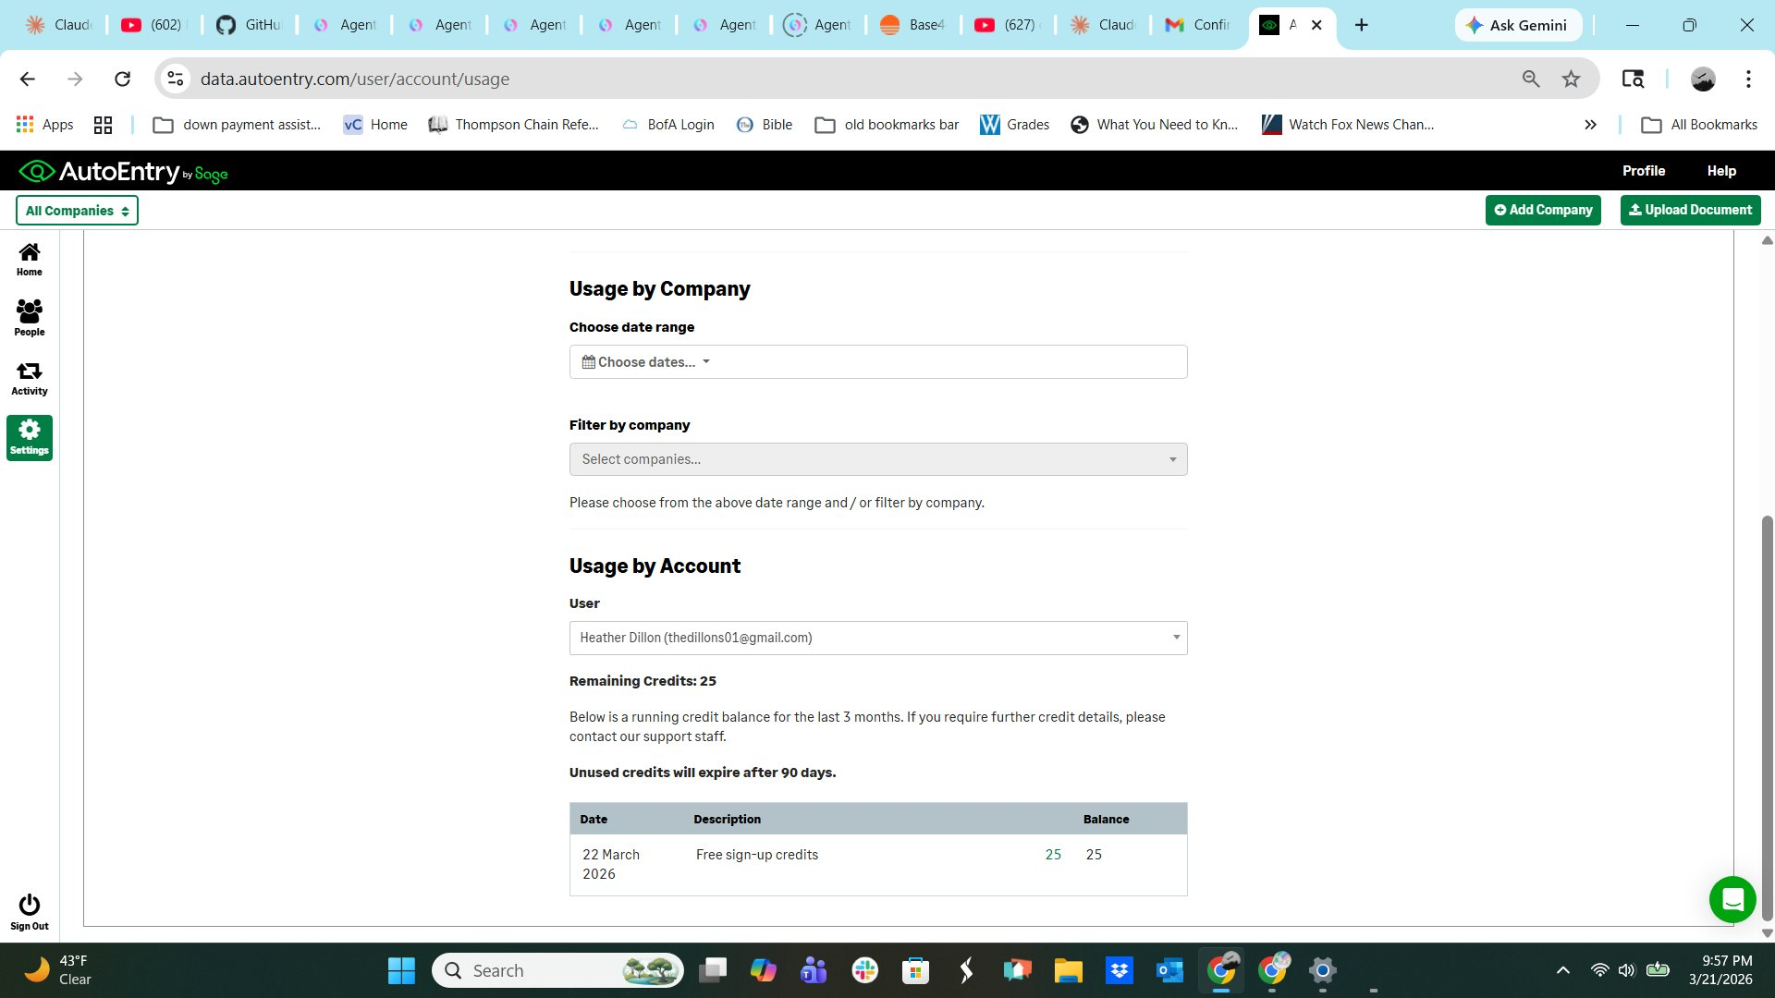
AutoEntry — Subscription and Billing page
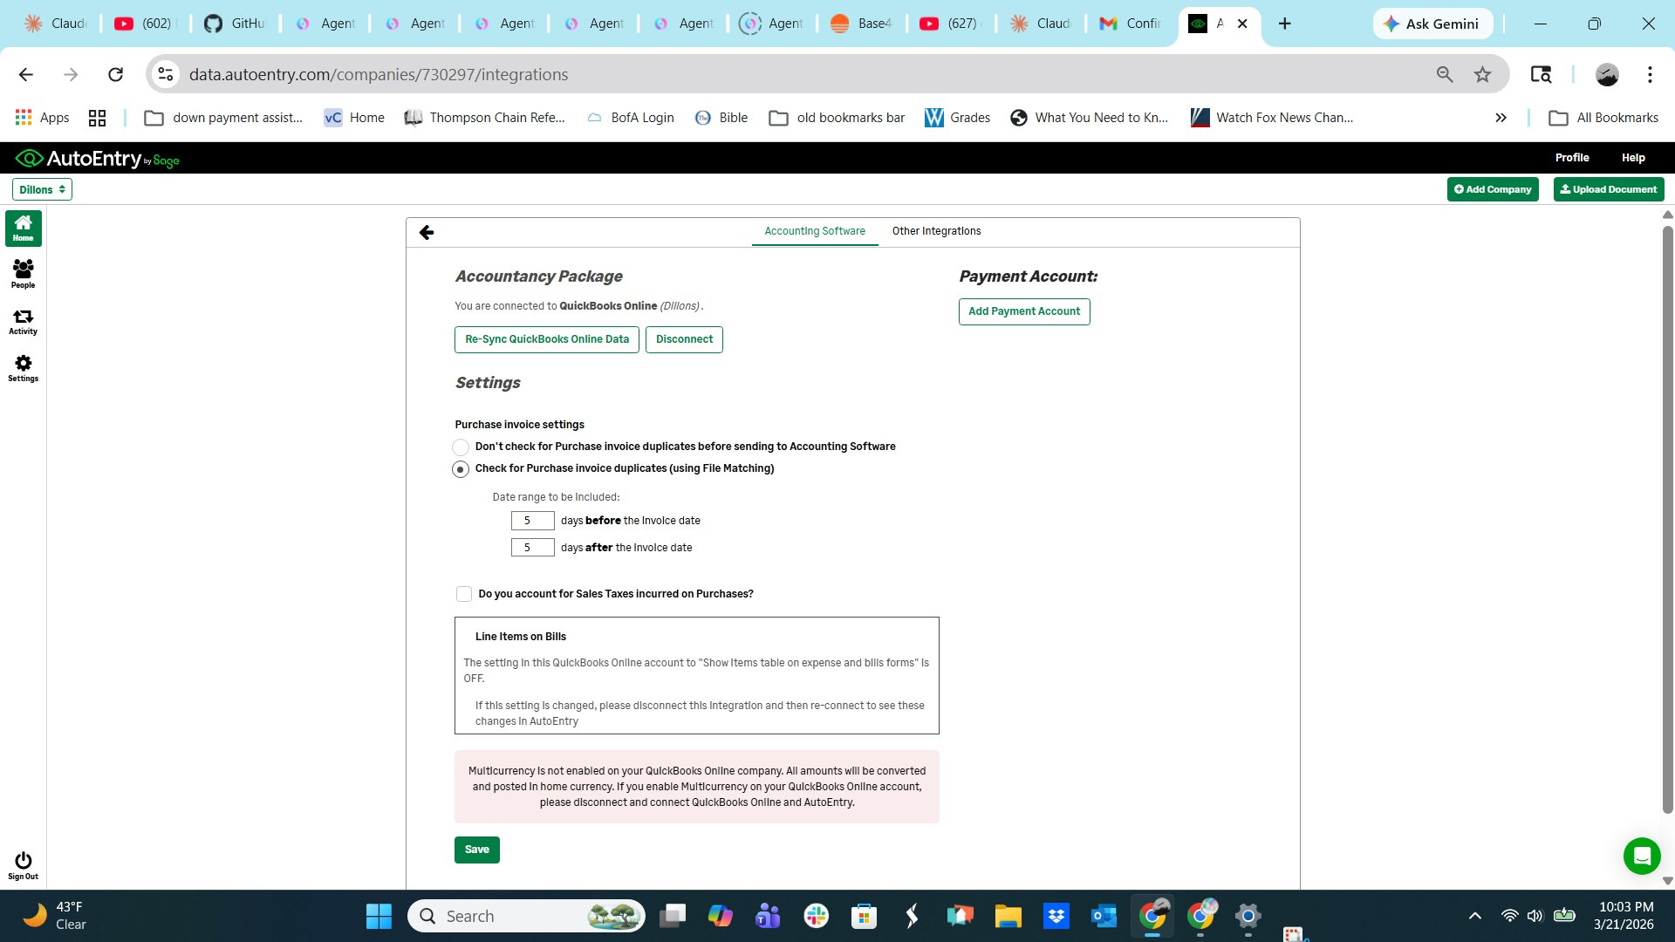
AutoEntry — Payment History

1.4 AutoEntry QuickBooks Integration
AutoEntry integrates with QuickBooks Online via OAuth. The integration settings screen shows duplicate detection configuration and the Items table setting — both of which BillFlow also implements.
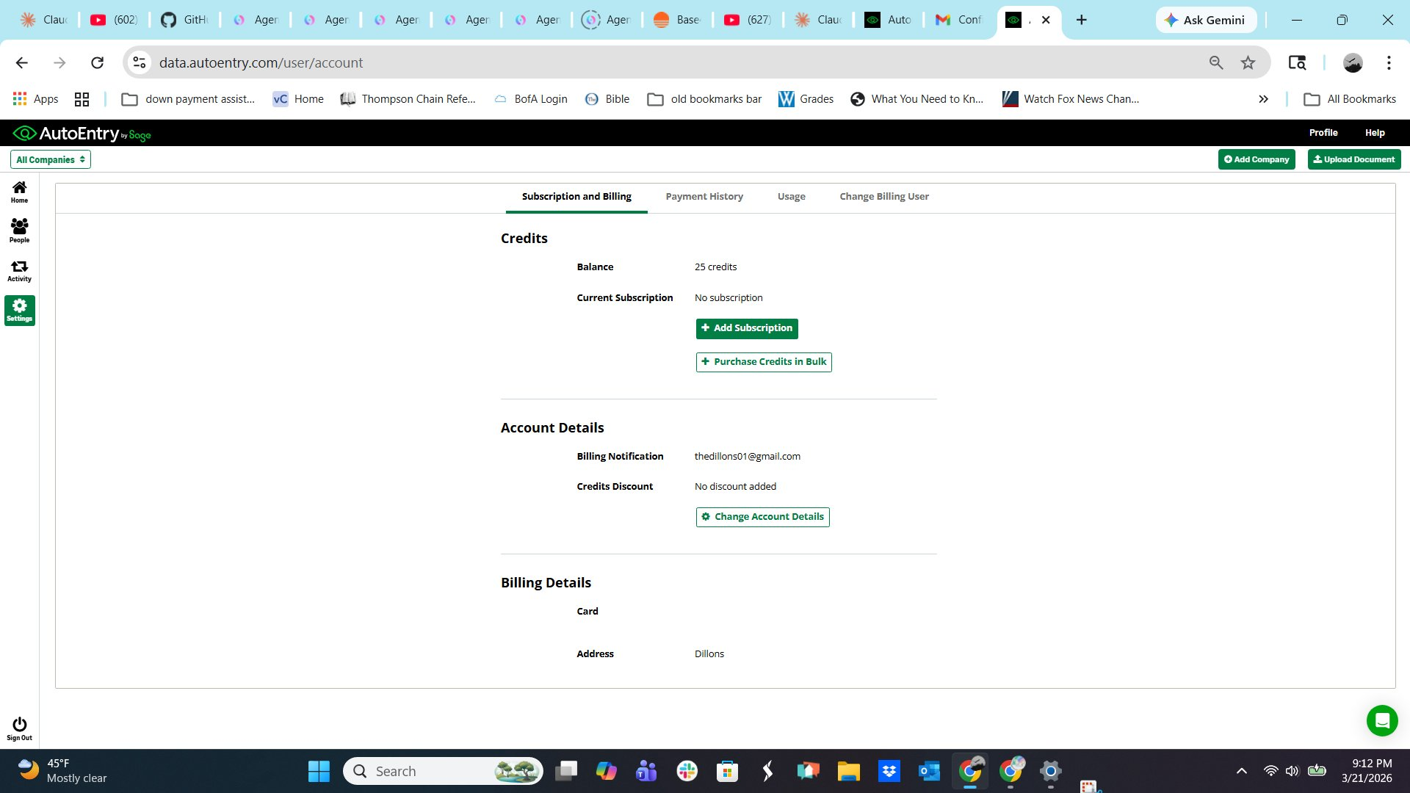
AutoEntry — QuickBooks Online integration: duplicate detection, Items table setting

1.5 AutoEntry User / People Management
AutoEntry supports multi-user access with role-based permissions. BillFlow V1 supports single company/owner login; multi-user access is a future enhancement.
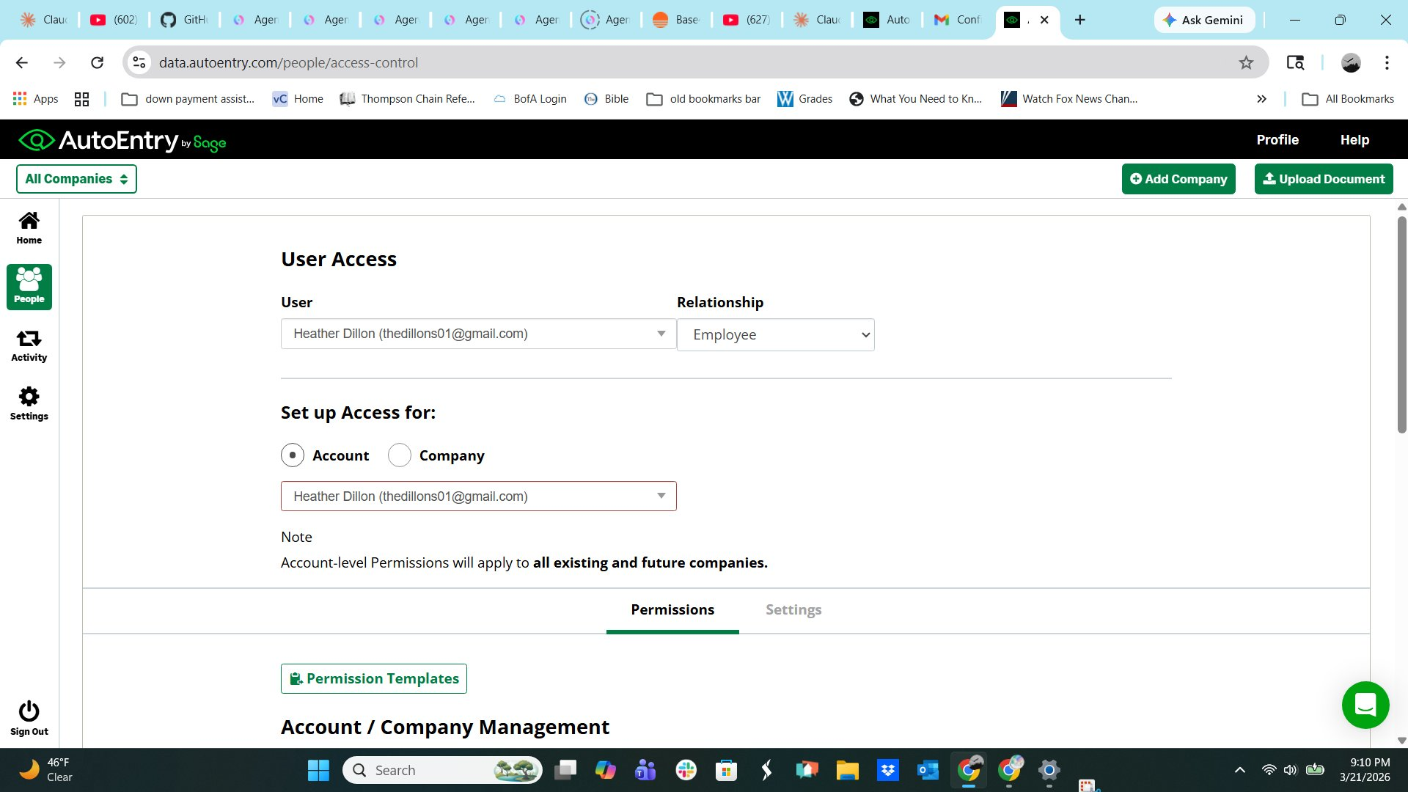
AutoEntry — People list: user access management
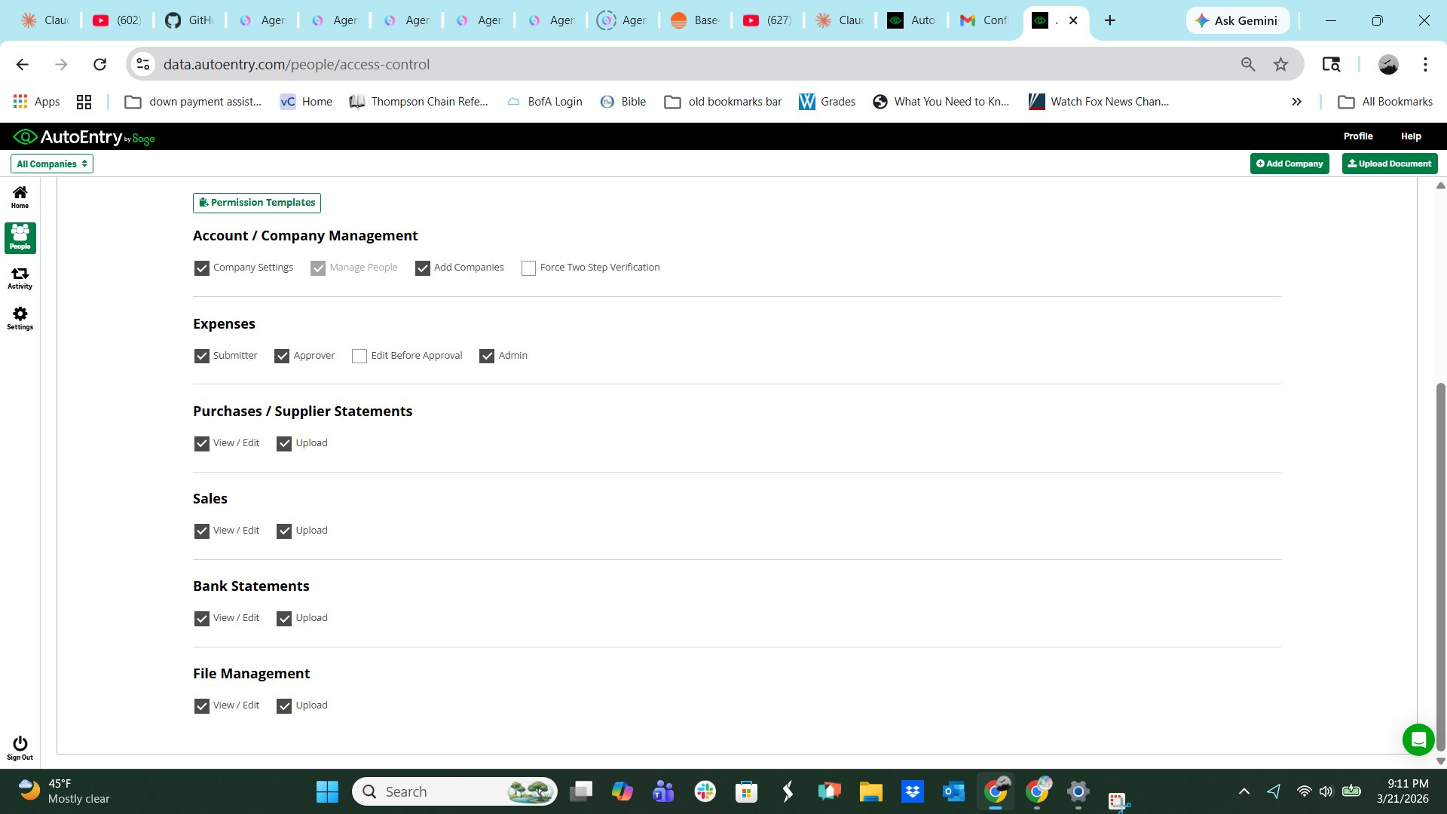
AutoEntry — User Access setup: Account vs Company level access

AutoEntry — Permission templates and role categories

1.6 The Glorious Moment
The user realizes they have not thought about vendor invoice entry in weeks. It has been happening correctly in the background without them. They open QuickBooks and the bills are there, coded to the right jobs, with the original PDFs attached. They did not touch any of it. This moment is the product. The goal is not a faster review process. The goal is no review process for the majority of transactions.

1.7 Target Markets
BillFlow is not HVAC-specific. Any business with these characteristics is a target customer:
- Uses QuickBooks Online or QuickBooks Desktop
- Receives vendor invoices by email as PDF attachments
- Has someone manually entering those invoices into QuickBooks
- Optionally: tracks job costing in QuickBooks
Initial go-to-market focuses on HVAC and mechanical contractors. Job costing is optional — contractors who only want invoice capture get enormous value without ever using the job field.

1.8 The 90/90 Rule
- 90% of invoices are for a single job.
- 90% of invoices from known vendors can be matched to a QuickBooks job with high confidence based on the vendor's PO/reference field.
The intersection means approximately 81% of all invoices — single job, high confidence match — should flow through auto-publish without human review once the vendor is configured. Most days the inbox should be empty or near-empty.

1.9 Job Costing Toggle
Job costing is entirely optional. Contractors who do not use QuickBooks jobs/projects must be able to turn off all job-related fields and UI. This is a company-level setting:
- job_costing_enabled — boolean, default OFF for new accounts
- When OFF: job fields hidden throughout the app, job matching logic skipped, FSM export not shown
- When ON: full job matching, line-item job assignment, and FSM Materials Entry export are active
This setting is surfaced prominently during onboarding so the contractor makes a deliberate choice.

2. How BillFlow Works — Complete User Journey

2.1 Setup (One Time)
The entire value of BillFlow depends on setup being completed correctly. Onboarding is a guided sequence that does not end until the user has successfully processed their first invoice end to end. It is not a help article.

Feature | Specification
Step 1: Connect QuickBooks | QBO: OAuth flow, user authorizes BillFlow in their browser, connection confirmed. QBD: Web Connector setup guide with step-by-step screenshots. BillFlow immediately pulls: vendor list with QB default GL accounts and payment terms, chart of accounts, job/project list with customer names, customer list, class list if class tracking is enabled.
Step 2: Set up email forwarding | BillFlow generates a capture email address. Format: [anything]@billflow.com. The prefix is customizable. Instructions for Gmail and Outlook with screenshots. Forwarding rule should forward only emails where the subject or body contains the word "invoice" — not "bill" and not "statement". User copies the address, sets up the rule, sends a test email to confirm.
Step 3: Process first invoice | User forwards a real vendor invoice email. BillFlow processes it and walks the user through reviewing extracted data. Onboarding is not complete until a bill has successfully landed in QuickBooks.
Step 4: Set vendor defaults | After the first invoice from each vendor is confirmed accurate, BillFlow prompts the user to confirm the default GL account. "Remember this for future invoices" prompt. Same UX pattern as AutoEntry.
Step 5: Enable auto-publish | After 5 invoices from a vendor with no errors and no corrections, BillFlow surfaces a prominent prompt: "We've processed 5 invoices from Johnstone Supply accurately. Enable auto-publish?" One tap to enable.
Step 6: Job costing setup | If job_costing_enabled is ON: contractor identifies which FSM they use (HCP, Workiz, ServiceTrade, Jobber, other, unknown). FSM platform improves job name pattern matching.

2.2 The Ongoing Workflow
- Vendor emails invoice. Forwarding rule catches it automatically. User never sees the email.
- BillFlow captures the PDF, extracts all data, matches to QuickBooks job (if job costing enabled), validates all fields.
- If vendor is set to auto-publish and all checks pass: bill pushed to QB automatically, PDF attached, status updated. User not notified unless they want a daily digest.
- If any condition is not met: bill appears in the inbox with a specific plain-language explanation of exactly why auto-publish did not fire.
- User checks BillFlow inbox periodically. Most days it is empty or has one or two items.
- Periodically (if job costing enabled): user exports the FSM Materials Entry report for bills processed since last export.

2.3 The Hold for Job Match Flag
Each vendor record has a "Hold for job match before processing" flag. When ON: bills without a confident job match go to Pending Job Match status and wait. When OFF: bills process regardless of job match status. This flag is OFF by default. Only visible when job_costing_enabled is ON.

3. Invoice Capture & OCR Processing

3.1 Capture Methods
Feature | Specification
Email forwarding (primary) | Contractor sets up a forwarding rule that automatically forwards vendor invoice emails to their BillFlow capture address. One-time setup, runs forever.
Manual email forward | User manually forwards any invoice email to the capture address.
Manual PDF upload | Drag-and-drop PDF upload in BillFlow interface. For invoices arriving by mail or fax.
Capture email address | [customizable]@billflow.com. User chooses prefix during onboarding; any string not already taken is accepted.
Email filtering | Forward only emails where subject or body contains "invoice". Not "bill" and not "statement".
Size limit | 30MB per email, consistent with AutoEntry.

3.2 OCR Processing Architecture
⚠ Accuracy is the Launch Gate. BillFlow's extraction accuracy on clean digital PDF invoices from major distributors must match or exceed AutoEntry's accuracy before the product is released to any paying customer.

Feature | Specification
Tier 1: Native PDF text extraction | For PDFs with a text layer (the vast majority of emailed invoices from major distributors). No AI cost. Handles Johnstone, Wesco, Ferguson, Gensco, and other major distributors.
Tier 2: AI text interpretation | When Tier 1 text extraction works but field identification confidence is low, send extracted text to Claude API as a text prompt. Significantly cheaper than vision.
Tier 3: Vision AI | When PDF has no text layer (scanned image), send image to Claude vision API. Flag low-quality scans for manual review.
Blended cost target | With 70% Tier 1, 20% Tier 2, 10% Tier 3: blended cost under $0.01 per invoice.
QB Items table support | Company-level setting: "Use QB Items table for bill line items" — off by default. When on: line item form shows an Item field instead of GL account.

3.3 Fields Extracted Per Invoice
- Vendor name (used to match to QB vendor record)
- Invoice number (combined with vendor for duplicate detection)
- Invoice date
- Due date (if present on invoice)
- PO number / reference field (primary input for job matching)
- Invoice total, subtotal, and tax amount if shown separately
- Line items: description, quantity, unit cost, extended cost (part number extracted if present)

4. QuickBooks Job Matching

4.1 The Job Matching Problem
Vendors put at most one PO or reference field on an invoice header. BillFlow uses the vendor's PO/reference field as the primary input for job matching. The match is made at the invoice header level and pre-populated to all line items. The user corrects individual line items that belong to different jobs.
⚠ Critical Design Decision: BillFlow NEVER creates job or project records in QuickBooks. BillFlow only matches invoices to records that already exist there. Creating QB job records would break FSM sync processes.

4.2 Matching Logic
Feature | Specification
FSM job naming pattern | During onboarding, contractor identifies which FSM they use. Each FSM has a known pattern for how it names jobs in QB (e.g., HCP creates "Job 1047"). When FSM is known, BillFlow applies that pattern to matching.
PO field exact/high-confidence match | High confidence. Pre-populate all line items with this job. Eligible for auto-publish if vendor confidence is also high.
PO field fuzzy match | Medium-high confidence. Pre-populate all line items. Show confidence indicator. User confirms or corrects.
PO field contains multiple references | Fuzzy match against all QB jobs and pre-populate each line item with best individual match. User corrects wrong lines.
No PO field or no match found | Behavior determined by vendor's "hold for job match" flag.
Job not yet in QuickBooks | Bill goes to Pending Job Match. BillFlow retries every 2 hours during business hours (7am–7pm local time). Manual "Find Match" button available.
QB reference number field | Per-vendor flag: "Copy PO field text to QB reference number field" — ON by default.

4.3 Line Item Job Assignment
Feature | Specification
Pre-population | When a header-level job match is found, all line items are pre-populated with that job. Correct for 90% of invoices.
Apply to all lines | When user changes the job on one line: "Apply this job to all lines?" One tap to apply.
Individual line override | User can change the job on any individual line without affecting other lines.
Shop stock / no job | User can clear the job on any line item. Lines with no job still post to QB but without a job tag. Excluded from FSM Materials Entry export.
Class tag per line | Only visible if QB company has class tracking enabled. Completely generic — whatever the contractor has defined in QB. Never required unless contractor enables "Require class" setting.

5. The Bill Review Screen
Used for the minority of invoices that need human attention. Design priority: make review as fast as possible.

5.1 Layout
Feature | Specification
Split screen | PDF viewer on the right half. Extracted data form on the left half. Both panels scroll independently.
PDF viewer — native PDFs | Text is fully selectable and copyable. Eliminates the AutoEntry frustration of not being able to copy from the PDF side.
PDF viewer — scanned PDFs | Clicking on a region runs OCR on that region and copies the result to clipboard automatically.
Field highlighting | Click a form field on the left → corresponding region on the PDF is highlighted. Reduces errors and builds confidence.
Keyboard navigation | Tab moves between form fields. Enter confirms and moves to next. Designed for fast keyboard-driven review.

5.2 Header Fields
Feature | Specification
Vendor | Pre-populated from vendor recognition. If new vendor: searchable dropdown with quick-add option. "Remember this match" prompt.
Invoice number | Pre-populated. Editable. Duplicate detection: same vendor + same invoice number within configurable date window (default 5 days before/after invoice date) triggers warning.
Invoice date | Pre-populated. Editable. Date format matches QB company setting.
Due date | Pre-populated if found. Editable. Can be left blank.
Invoice total | Pre-populated. Read-only display. Discrepancy warning if sum of line items does not match.
Vendor PO / reference | Pre-populated. Editable. Shown prominently so user has context for job assignment decisions.

5.3 Line Item Fields
Feature | Specification
Description | Pre-populated. Editable. Part number included in description if extracted.
Quantity | Pre-populated. Editable. Displayed between description and cost on the review screen — normal invoice field order. (Quantity appears at end of lines only in the FSM export, not here.)
Unit cost | Pre-populated. Editable.
Extended cost | Pre-populated. Editable. Recalculates automatically if quantity or unit cost is edited.
Job / project | Pre-populated from header-level job match. Never required to publish. Searchable dropdown: type any part of job number, name, or customer name. Most recently created jobs shown first. Arrow keys navigate, Enter selects.
GL account | Pre-populated from vendor default. "Remember this for future invoices" prompt when user changes it.
Class | Only visible if QB company has class tracking enabled. Optional. "Remember this" prompt when user sets it.
Apply job to all lines | When user changes job on any line: "Apply this job to all lines?" with one-tap confirm.

5.4 Auto-Publish Explanation in Inbox
When a bill lands in the inbox despite the vendor being set to auto-publish, a specific plain-language explanation is shown. Examples:
- "Auto-publish held: job match confidence too low — PO field says '1047 and stock items', needs manual line item assignment"
- "Auto-publish held: new vendor, first invoice requires review"
- "Auto-publish held: possible duplicate — Invoice #48291 from Johnstone Supply already exists in QuickBooks"
- "Auto-publish held: GL account not set for this vendor"
- "Auto-publish held: job '1052' not yet in QuickBooks — waiting for job to sync from FSM"

5.5 Publish Actions
Feature | Specification
Publish to QuickBooks | Primary action. Validates all required fields before sending. Bill pushed asynchronously, PDF attached, status updated when QB confirms receipt.
Bill status states | Draft, Ready, Publishing, Published (QB bill ID stored), Sync Error.
Unpublish | Available ONLY when bill has NOT been confirmed in QB (Sync Error or Publishing status). Once Published, unpublish is not available — correct in QB directly.
Pre-publish validation | Vendor exists in QB, GL account exists, job exists if assigned, no duplicate detected, all required fields populated, class present if required. All validated against cached QB data — no live API calls.
QB sync confirmation | After pushing to QB: query QB to confirm bill record exists. Do not mark Published until QB confirms.

6. Auto-Publish System
Auto-publish is the feature that delivers the glorious moment. When enabled for a vendor, invoices from that vendor flow straight to QuickBooks without appearing in the inbox.

6.1 Auto-Publish Eligibility per Invoice
Every auto-published bill passes ALL of these checks:
- Vendor is set to auto-publish: yes
- Minimum 5 invoices processed from this vendor: yes
- Zero extraction errors on last 3 invoices from this vendor: yes
- Job match confidence above threshold (or hold-for-job-match is off and no job required): yes
- No duplicate invoice number + vendor combination detected: yes
- All required fields extracted successfully: yes
- GL account for vendor is set: yes
- Job exists in QB if a job was matched: yes
- Not a new vendor: yes

6.2 Auto-Publish Promotion
Feature | Specification
Eligibility prompt | When a vendor becomes eligible (5 invoices, no recent errors), a prominent prompt appears in the inbox. Clear explanation before enabling.
One-tap enable | User taps Enable on the prompt. Active immediately. No navigation to settings required.
Per-vendor control | Auto-publish configured independently per vendor.
Auto-disable on errors | If a vendor's auto-published bill is later found to have an extraction error, auto-publish is automatically disabled for that vendor with a specific notification.

7. QuickBooks Integration

7.1 QuickBooks Online (QBO)
Feature | Specification
Connection method | OAuth 2.0. User authorizes BillFlow through Intuit's standard OAuth flow. Refresh token stored securely.
Data pulled from QBO | Vendor list (with default expense account and payment terms), chart of accounts, customer list, job/project list (with customer names), class list if enabled. Job list refreshed every 15 minutes. Vendors and accounts refreshed hourly.
Bills pushed to QBO | Vendor bills created via QBO API: vendor, invoice number, date, due date, Ref No field, line items (description, quantity, unit cost, GL account, job/class tag per line), total. PDF attached after confirmation.
Async processing | All QBO API calls in background jobs. User never waits. Rate limiting respected with exponential backoff.
Sync confirmation | After push: query QB to confirm bill record exists. Do not mark Published until confirmed.

7.2 QuickBooks Desktop (QBD)
Feature | Specification
Connection method | Intuit Web Connector. Windows application polling BillFlow on contractor-configured interval (typically 5–30 minutes).
Fundamental difference from QBO | QBD sync is not real-time. Bills queue until Web Connector polls. Status shows "Queued for Sync" until picked up.
Web Connector heartbeat monitoring | Every successful poll records a heartbeat timestamp. If no heartbeat for longer than 2x the expected interval: notification sent to user. Notification clears automatically when next heartbeat received.
Web Connector status indicator | Persistent indicator in BillFlow UI: green (recent heartbeat), yellow (overdue), red (significantly overdue).
PDF attachment for QBD | PDF is stored in BillFlow and accessible there, but cannot be attached to the QBD bill record. Known QBD limitation.

8. Inbox & Bill Status Management

8.1 Two-Area Architecture
Feature | Specification
Inbox | Active working queue. Contains only bills not yet fully processed: Needs Review, Pending Job Match, Sync Error. Most days it should be empty or have a small number of items.
Archive | Everything fully processed. Published bills organized by date. Searchable and filterable. Bills move from inbox to archive automatically when published and confirmed in QB.

8.2 Inbox Views
Feature | Specification
Needs Review (default) | New bills from vendors not set to auto-publish, bills that failed auto-publish checks (with specific explanation), bills in Sync Error state.
Pending Job Match | Bills where a job reference was found but no matching QB job exists yet. System retries every 2 hours during business hours.
All Inbox | All bills not yet archived, any status.

8.3 Notifications
Feature | Specification
Default behavior | Notify only when human action is required. Silence when everything is auto-publishing correctly. Silence is success.
Daily digest (optional) | Configurable summary email. Off by default.
Action required | Immediate notification when: bills arrive in Needs Review, Sync Error occurs, Web Connector heartbeat lost, new vendor invoice arrives.
Notify uploader | When user manually forwards an invoice, confirmation sent when processing completes.
No per-invoice noise | Auto-published invoices do not generate individual notifications.

9. Vendor Record
Feature | Specification
Vendor name as extracted | The name as it appears on invoices, as extracted by OCR. Visible and editable.
Mapped QB vendor name | The QB vendor record this vendor maps to. Both name fields shown clearly so user can see the mapping.
Default GL account | Source priority: (1) QB vendor record default expense account, (2) BillFlow override. Both shown with source label. "Remember this" prompt on review screen.
Default class | Only visible if QB company has class tracking enabled. Generic dropdown of contractor's QB-defined classes. "Remember this" prompt on review screen.
Default payment terms | Source priority: (1) QB vendor record payment terms, (2) BillFlow override. Shown with source label.
Auto-publish enabled | Boolean. When on, eligible invoices go straight to QB without inbox review.
Hold for job match | Boolean. Default: OFF. Only visible when job_costing_enabled is ON.
Copy PO to QB reference | Boolean. Default: ON. Copies vendor PO text to QB's Ref No field.
Known invoice format | System-maintained. Shared platform-wide — Gensco's format learned from one client applies to all clients.
Vendor confidence score | Displayed as High / Medium / Low. Based on percentage of last 20 invoices published without correction.
Invoices processed | Count of total invoices processed from this vendor.

10. FSM Materials Entry Export
Solves the double data entry problem for contractors who track material costs in both QuickBooks and their FSM platform. Only available when job_costing_enabled is ON.

10.1 Export Format Example
Job 1047 — Johnson Mechanical — 123 SE Stark St
Johnstone Supply — Invoice #48291 — March 15, 2026
Run Capacitor 45/5 MFD $18.47 (x1)
Contactor 24V 40A $22.13 (x1)
Wesco — Invoice #W-009341 — March 15, 2026
Wire 12/2 Romex 250ft $94.50 (x1)
Job 1047 Total Materials: $134.10

10.2 Format Design Decisions
- Grouped by job. Each job section contains line items from ALL vendors billed to that job in the date range.
- Line items: description, cost, quantity. No part number column — FSMs do not have a part number field.
- Quantity at end of line in parentheses, de-emphasized. Appears in normal position (between description and cost) on the bill review screen.
- Lines with no job assignment excluded entirely.

10.3 Export Controls
Feature | Specification
Date range | Default: since last export. Last export date tracked automatically.
Filter by vendor | Multi-select. Export only bills from selected vendors.
Filter by job | Multi-select. Export only bills allocated to selected jobs.
Scope | Only Published bills included.
Format | PDF and Excel.

11. Job Profitability View
Feature | Specification
Data source | QB job profitability data pulled via API. BillFlow does not maintain a parallel calculation.
Display per job | Job number and name, customer name, revenue, material costs, gross profit, gross margin percentage.
Jobs shown by default | Jobs with any transaction in the last 30 days. Activity-based filter — QB job status fields are not used.
Date range filter | Current month, last month, last 90 days, custom range, or all time.
V2 enhancement | When BillFlow becomes part of the full FSM platform, labor costs from GPS clock-in records are added.

12. Technical Architecture & Data Model

12.1 Technology Stack
Feature | Specification
Frontend & API | Next.js 15 with React and TypeScript. App Router, Turbopack. Hosted on Vercel.
Database | PostgreSQL via Supabase. Multi-tenant with company_id on all records.
Authentication | Supabase Auth. Email/password.
File storage | Supabase Storage for original PDFs. Organized by company_id/bill_id.
Background jobs | Vercel Cron for scheduled tasks. Supabase Edge Functions for event-driven processing.
Email capture | Inbound email processing service (SendGrid or Postmark). PDFs extracted, processing triggered.
OCR processing | Tiered: pdf-parse for Tier 1, Claude API text prompt for Tier 2, Claude vision API for Tier 3.
QB integrations | QBO: direct REST API. QBD: Intuit Web Connector protocol.
Notifications | Resend for email. In-app via Supabase Realtime.

12.2 Key Data Model Tables
Feature | Specification
companies | company_id, name, qb_type (qbo/qbd), qb_connection_status, qb_last_sync, capture_email_prefix, fsm_platform, job_costing_enabled (boolean, default false), created_at
vendors | vendor_id, company_id, vendor_name_extracted, vendor_name_display, qb_vendor_id, qb_vendor_name, qb_default_gl_account_id, billflow_gl_account_id, gl_account_source, qb_default_class_id, billflow_class_id, class_source, qb_payment_terms, billflow_payment_terms, payment_terms_source, auto_publish_enabled, hold_for_job_match, copy_po_to_qb_reference, invoices_processed, confidence_score, known_format (JSON), email_domains (array), last_invoice_date
bills | bill_id, company_id, vendor_id, invoice_number, invoice_date, due_date, total, vendor_po_reference, qb_reference_number, status (draft/ready/publishing/published/sync_error), publish_method (manual/auto), qb_bill_id, qb_sync_error, autopublish_hold_reason, pdf_url, capture_source (email/upload), created_at
bill_line_items | line_id, bill_id, company_id, description, quantity, unit_cost, extended_cost, gl_account_id, qb_item_id (nullable), job_id (QB job reference), class_id, extraction_confidence
qb_jobs_cache | job_id, company_id, qb_job_id, job_name, job_number, customer_name, customer_id, qb_class_id, last_transaction_date, cached_at
qb_vendors_cache | Cached QB vendor list with default expense account and payment terms. Refreshed hourly.
qb_accounts_cache | Cached QB chart of accounts. Refreshed hourly.
qb_classes_cache | Cached QB class list. Only populated if QB company has class tracking enabled.
processing_log | Append-only. bill_id, action, actor (user_id or "system"), timestamp, before_state, after_state. Never deleted.
exports | company_id, export_date, date_range_start, date_range_end, vendor_filter (array), job_filter (array), bill_ids_included, format (pdf/excel).
qbd_heartbeats | company_id, last_heartbeat_at, last_sync_at, connector_status (running/overdue/alert).

12.3 Dropdown Search Standard (ALL Dropdowns)
- Click the field, start typing anything — partial match against all relevant fields
- Most recently used or most recently created items shown first before typing
- Arrow keys navigate, Enter selects, Escape cancels
- Each result shows enough context to make the right choice (job dropdown: job number + job name + customer name)
This is how every modern search field works. It is not how QuickBooks list fields work. BillFlow's dropdowns will feel noticeably better than QB's.
⚠ Accuracy is the Launch Gate. Validate against 20–30 real vendor invoices from the pilot contractor covering multiple vendors. Process each through BillFlow and through QBO native capture. BillFlow must win on accuracy before launch.

