Documentation SLM 2023 RetroRealTTT

authors

Jai SINGH (thedizzle69) (ic22b037)
Tahir Omerovic (Taomero) (ic23b092)

1. Introduction

The task has been, to implement a TicTacToe game using GitHub workflows and to have a nice project structure and workflows.

The following paragraphs portray the process of this project

2. In the beniging

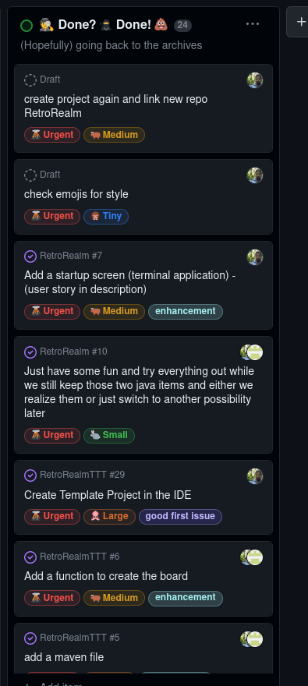
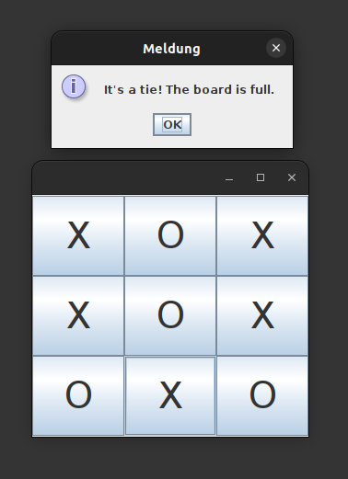
The first thing to do was to create a github project… so we did that. In the following we will refer to the different stages and tasks:

The first tasks were to link the repo and most importantly to have a structured project. Columns for every step of the project were created (and obviously emojis were added to make it look nicer).
Screenshot of the whole project (a little bad to read as I had to zoom out)
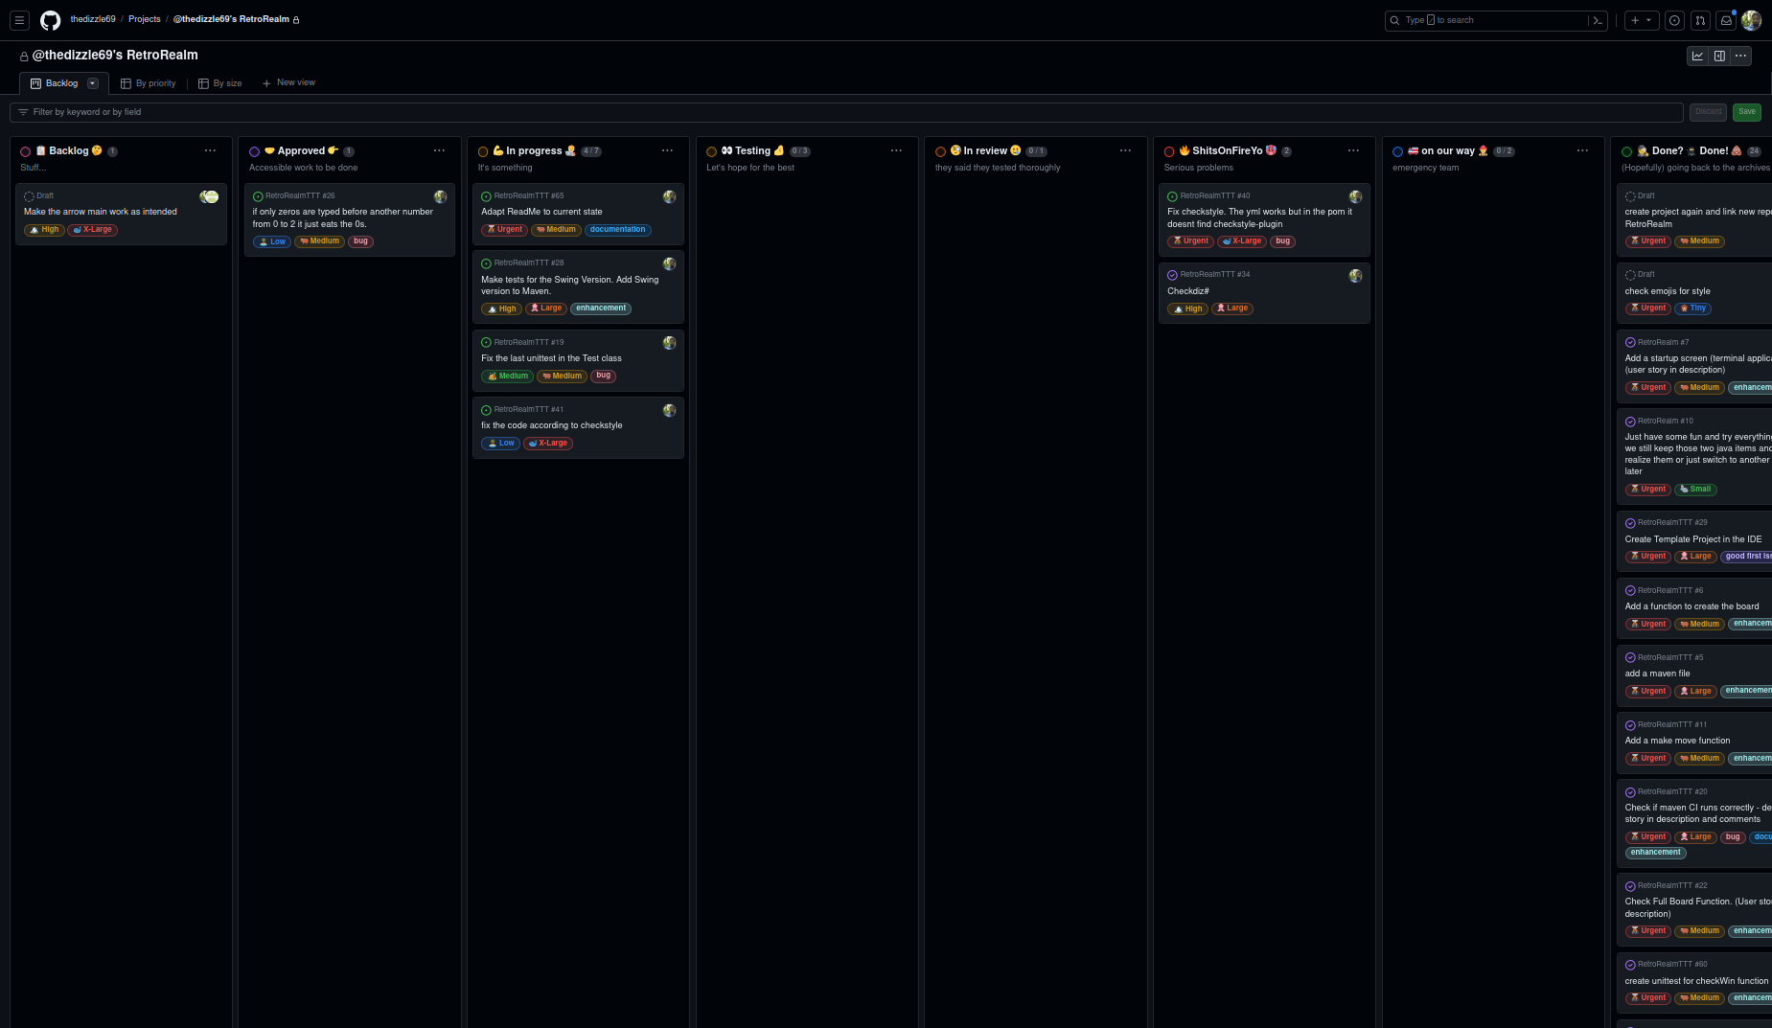

Let’s skip the part where everyone was advised to just get to know git and have fun. We then created a functioning Repo and made a template maven project in the IDE and pushed that thing.

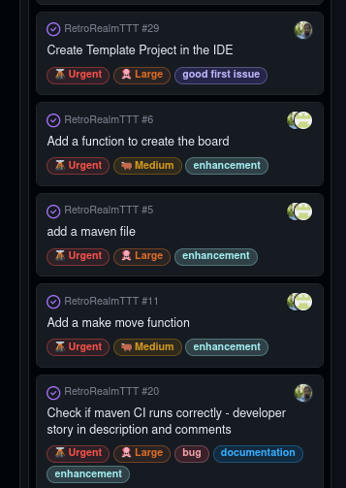
Now we started to implement the first functions and also created the first maven job as seen below:

The new auto job called maven.yml made sure that on every pull, the project gets checked for build errors.

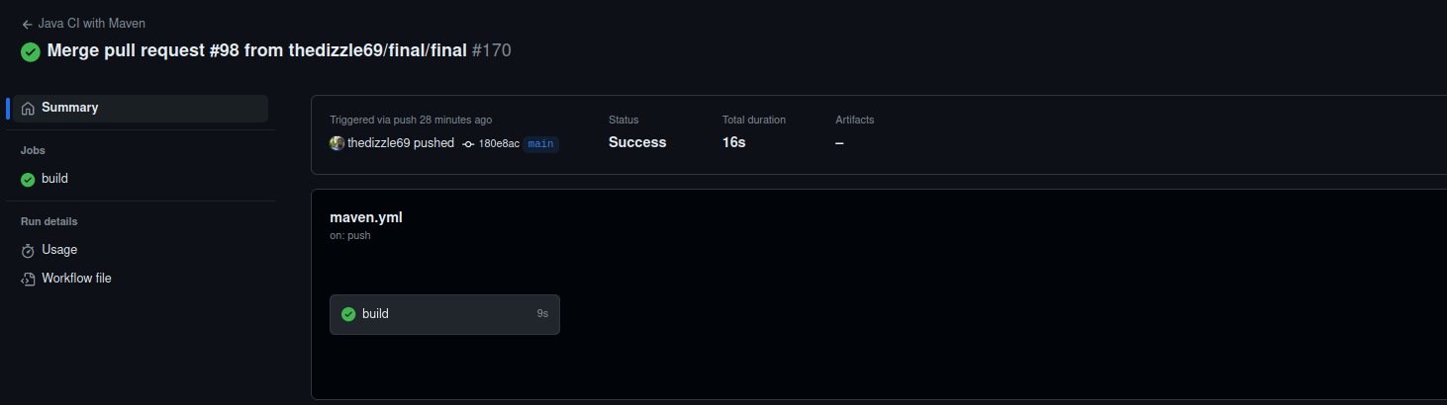
At the moment it looks like this (It mostly looked like this from the beginning)

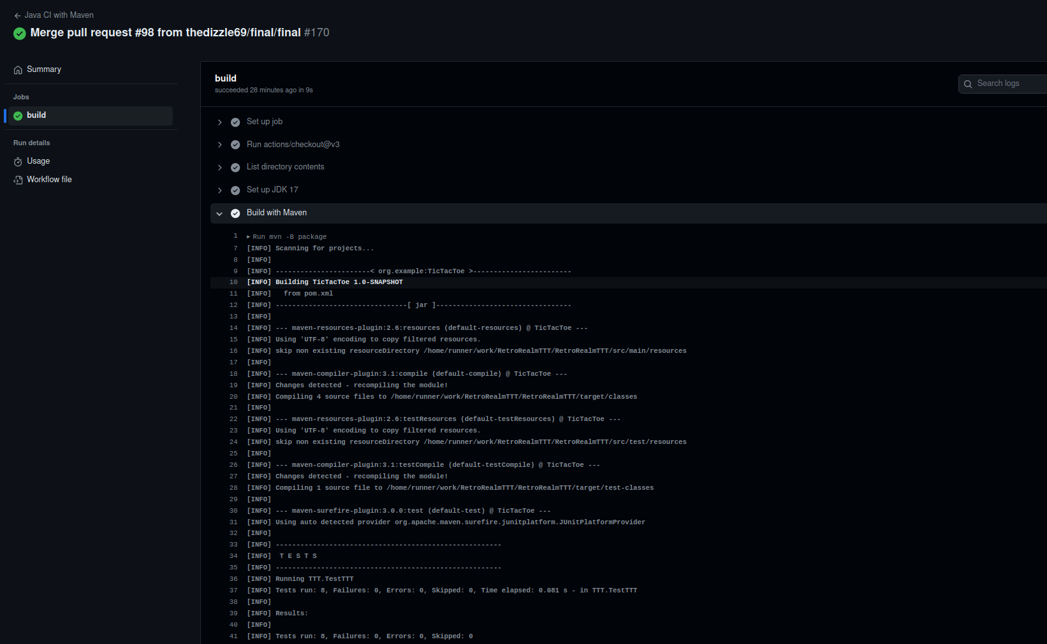

Also we had to make sure that the test file will be included. As seen it is included and runs all tests before finishing the job:

3. Developing
As we now were good to go, we implemented functions for the app itself, cheked them for build errors and wrote test files (they are located in the src directory parallel to the main folder)

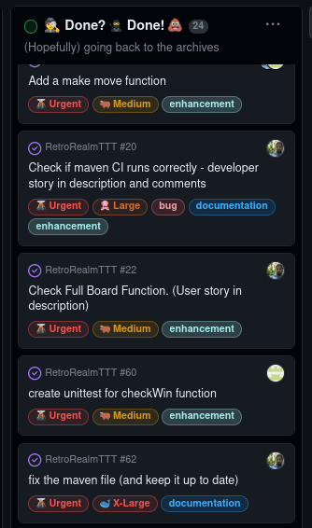

While making the program itself we included functions, tests, JavaDoc comments, and also implemented a GUI Version which runs on Java Swing (way better than the fucked up terminal app. My C java is terminal but 1000 times better than this crap)

4. Developing Jobs (workflow .ymls) (jar job, javadoc job, checkstyle job)
But there were a few jobs to be done still. So we created workflows which export our newly made JavaDoc.comments, compile the respective files to differentiate between the 2 apps and only compile the needed files and then copy it into a specific folder. There is a folder for the docs (/docs) and a folder for the execs (jar) in which only the wanted files get copied too. Also we made a gh-pages branch where we deploy our docs.
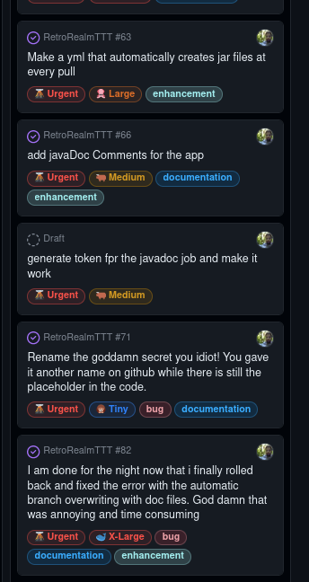
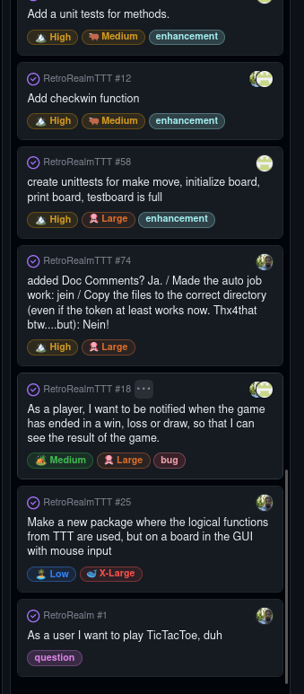
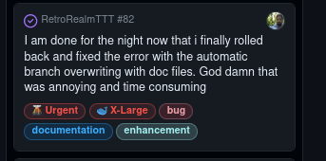
5. Finishing
The jobs worked out pretty well, even if some of them were a pain in the ass, (and one fucking job overwrote the whole structure, so we’ve had to roll back. But manually and using another branch. The default branch wouldn’t use our git anymore, so it was hours of trying to find a workaround to roll back in a sensible way!!!)

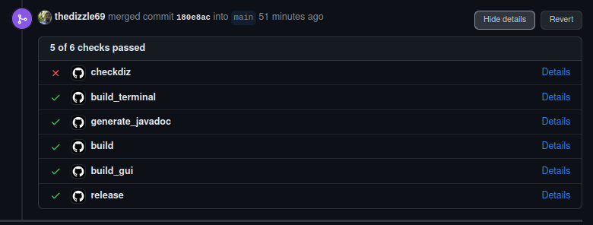
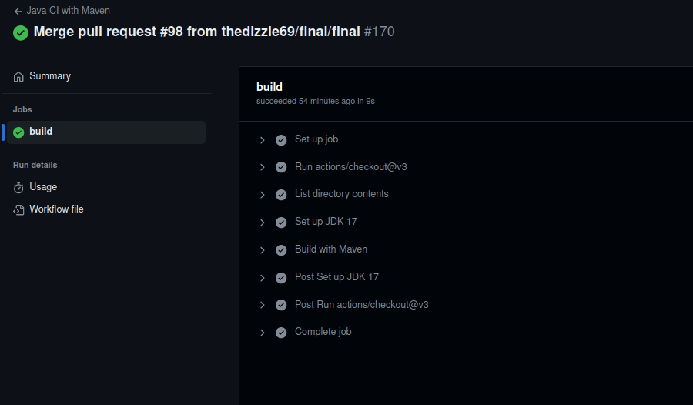
Well. I am drifting away. As said. The jobs work very well, and in the logs one can see that everything runs as expected (the checkstyle fails but this is expected as the job is not customized, but uses standard values like „80 symbol line length):
In the following details from the jobs:
basic Maven Job called maven.yml

In the following the detailed jobs:

maven.yml build job and javadoc.yml javadoc job:

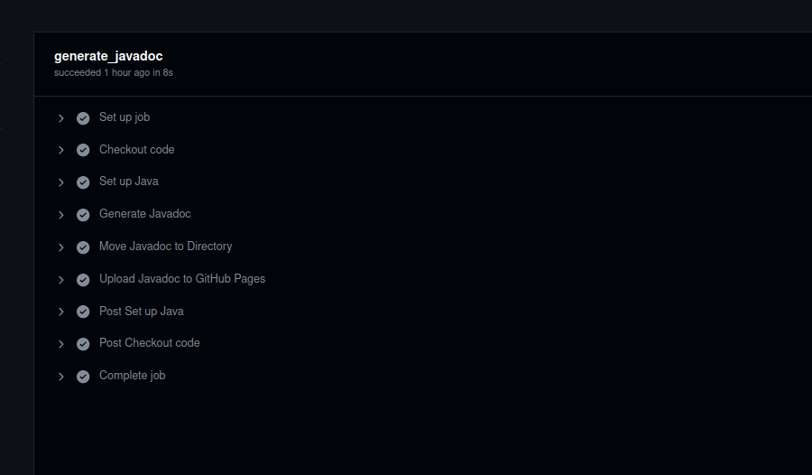
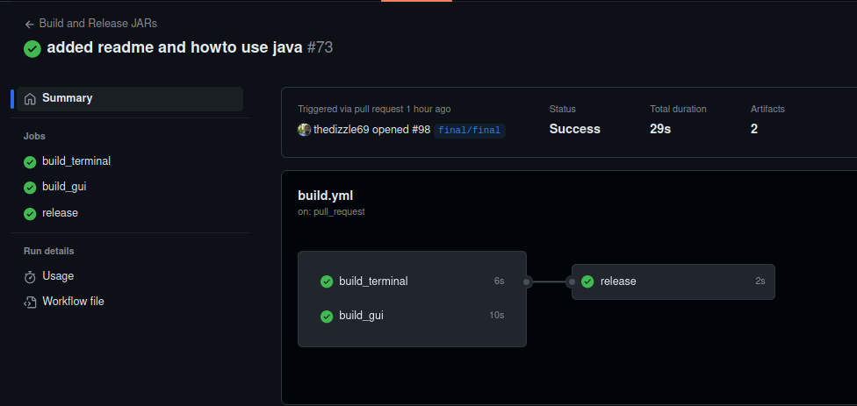

build.yml jar job and checkdiz.yml checkstyle job:

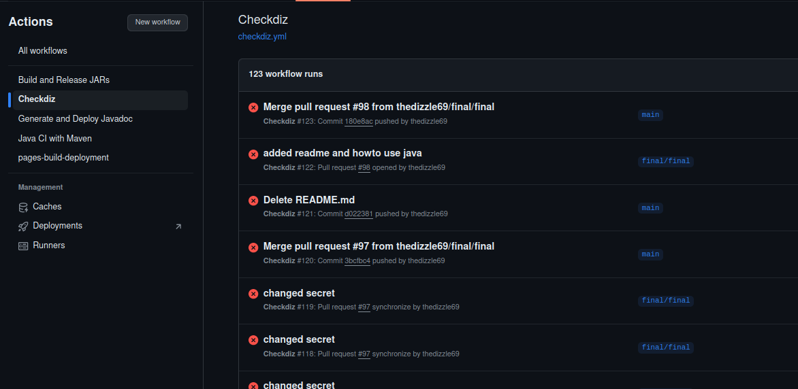

Summa summarum: I think the project is done well according to the tasks given. Now have fun to read all that.

