**Advanced Deployment with OpenShift - Homework**

This is a document to provide the necessary information about running the script which is used to deploy the OpenShift cluster and complete the CICD pipeline which is needed to successfully complete the homework assignment.

Git repository with the homework scripts:

<https://github.com/thednd1992/ocp_advanced_deployment_homework.git>

|  |  |  |
| --- | --- | --- |
| **Step** | **Description** | **Command** |
| 1 | Login to VM | ssh -i ~/.ssh/id_rsa djordje.gajisin-devoteam.com@bastion.6a28.example.opentlc.com |
| 2 | Switch to root user | sudo -i |
| 3 | Clone the Git repository | git clone https://github.com/thednd1992/ocp_advanced_deployment_homework.git |
| 4 | Run the ansible playbook | ansible-playbook ./ocp_advanced_deployment_homework/homework.yaml |
| 5 | Uninstall the cluster | sh ./ocp_advanced_deployment_homework/scripts/uninstall.sh |

The homework.yaml script automatically deploys the OpenShift cluster, creates PVs with different sizes (5G and 10G) and creates the different users requested in the assignment. The script also deploys the NodeJS-Mongo-Persistent app as a smoke test to see the ability to deploy a simple app. The CICD pipeline is created in the task-dev project and it is promoted to the task-prod project automatically through the pipeline. In the end the scripts provide two groups with the requested users and creates the limit ranges.

The following table represents the projects, their routes and login credentials.

|  |  |  |
| --- | --- | --- |
| **Service name** | **Route** | **Login credentials** |
| gogs | gogs-tasks-dev.apps.6a28.example.opentlc.com | gogs/gogs |
| jenkins | jenkins-tasks-dev.apps.6a28.example.opentlc.com | andrew/r3dh4t1! |
| nexus | nexus-tasks-dev.apps.6a28.example.opentlc.com | admin/admin123 |
| sonarqube | sonarqube-tasks-dev.apps.6a28.example.opentlc.com | admin/admin |
| tasks | tasks-tasks-prod.apps.6a28.example.opentlc.com |  |
| node-js-app | nodejs-mongo-persistent-smoke-test.apps.6a28.example.opentlc.com |  |

**Release version**: 3.11.16

**Instructor**: Jindrich Kana

**Venue**: Garni Hotel Centar, Novi Sad, Serbia

**Participant**: Djordje Gajisin (djordje.gajisin@devoteam.com)

**Gogs**

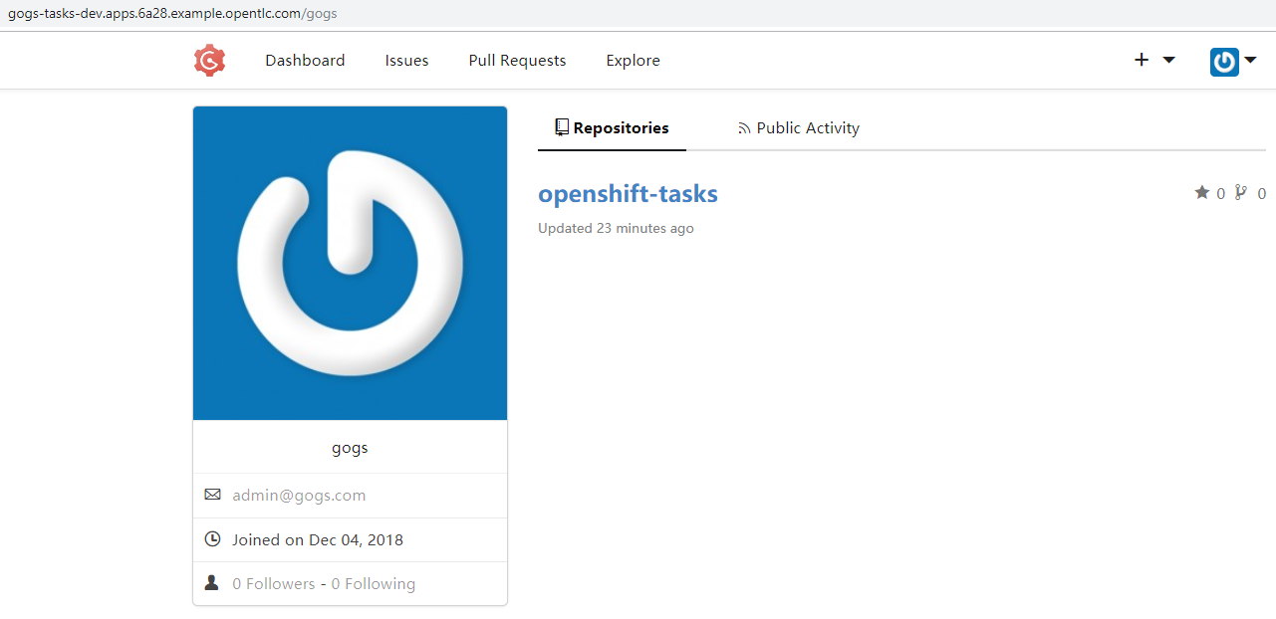

**Jenkins**

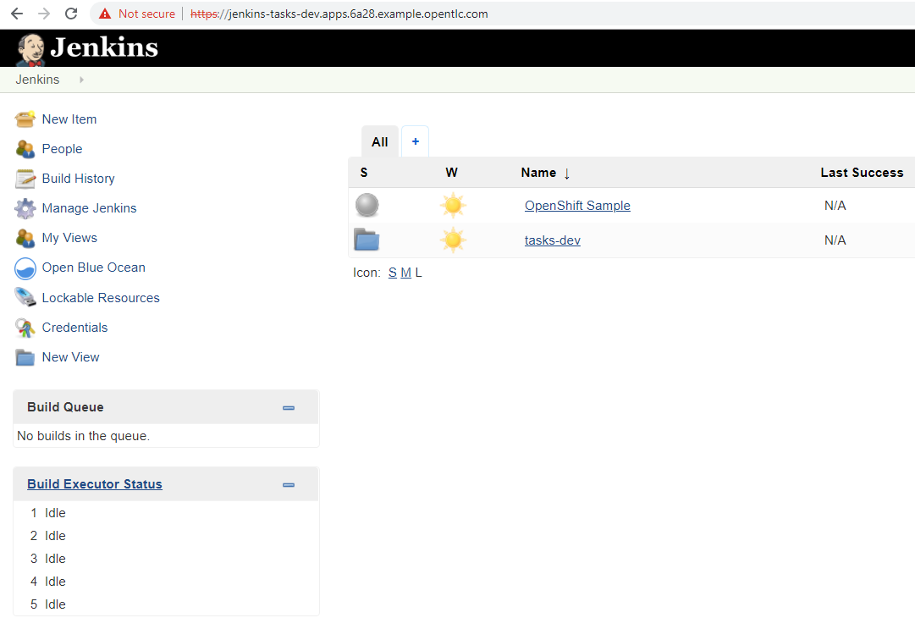

**Nexus**

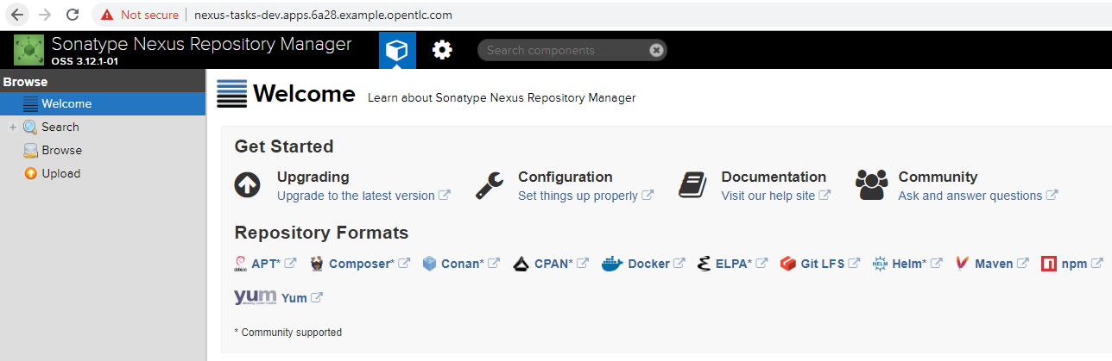

**SonarQube**

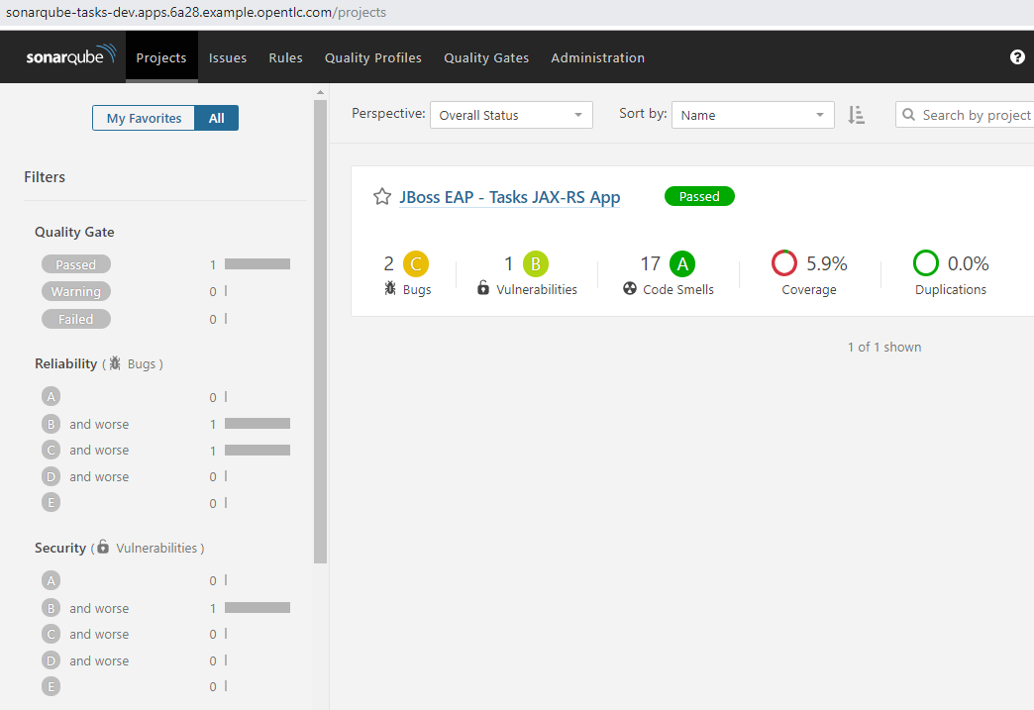

**Task-prod**

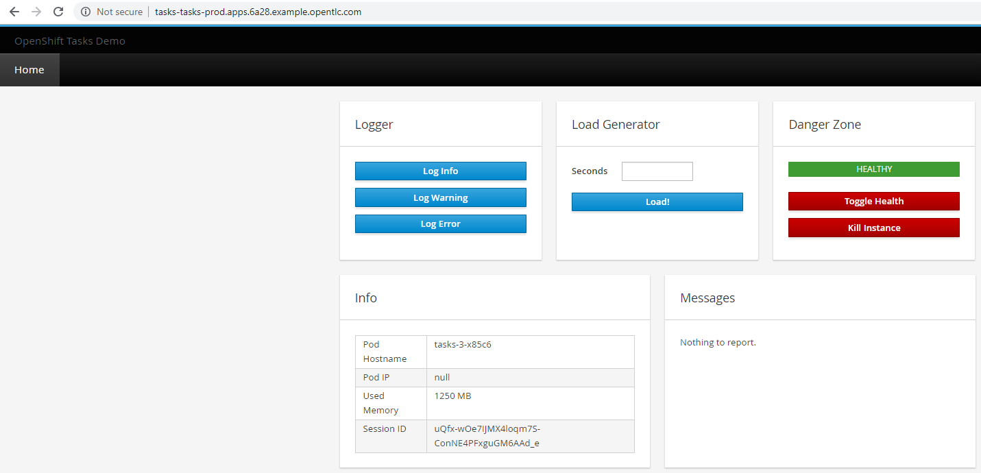

**Nodejs-mongo-persistent**

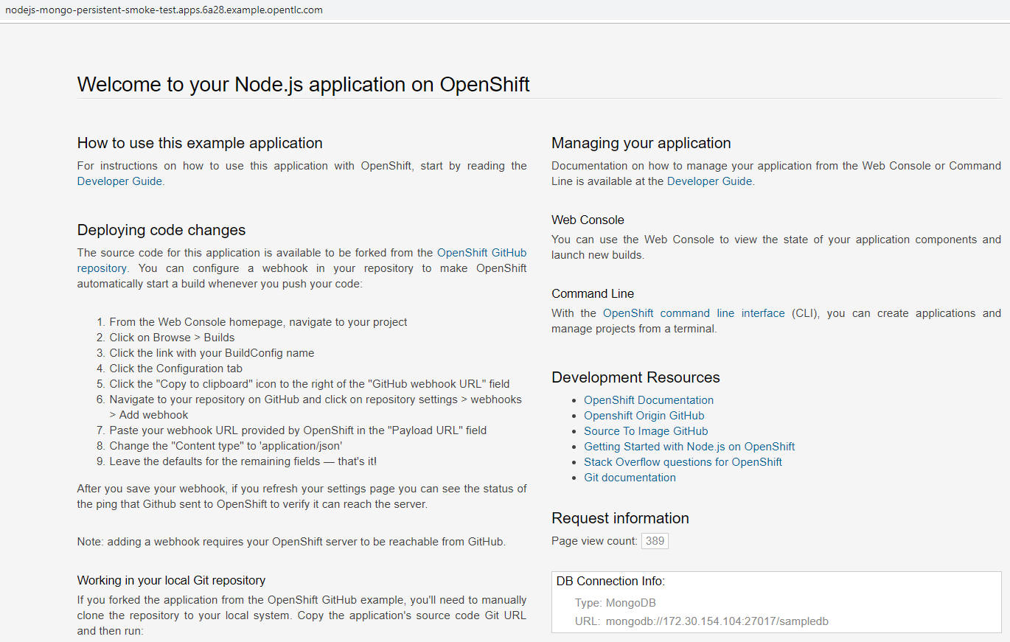

**Git Bash**

