SouthAudioLab

dsPIC33 Audio Effects Pedal Project

v.1.01

The all information and materials what are assignable by SouthAudioLab have an only for acquire and educational purposes.

If you have some questions or suggestions, or you have desire to join to the SouthAudioLab projects please write us thru feedback.

Best regards and new creative ideas.

SouthAudioLab

Contents

Contents 3

Goals 3

Device characteristics: 3

Description 4

How to run 4

Conclusions 4

APPENDIX 4

A. How to create own MPLAB X project 5

B. How to use MATLAB scripts 7

References 8

# Goals

The DSPIC series by Microchip are not powerful but really simplest MCU’s or DSC’s (by Microchip classification) what can use for audio processing purposes. This project get ability to create own guitar DSP Pedal, understand how it work, and modify it with own preferences.

Attention:

* **You must have** any Microchip **programmer or/and debugger** (like Pickit 2, Pickit 3, ICD 2, or other, compatible with dsPIC series) to program the device.
* **The project** compiles **in C30 compiler** v3.21 or later. Install it before compilation.
* This Pedal sound quality can be characterized like “may be it can be better”☺, see next chapter.

# Device characteristics:

**Effect types** 12

**Effects applying** max 3 simultaneous effects

**Patches** -

**Sampling frequency** ~20 kHz

**A/D converter** 12 bit

**D/A converter** 16 bit,

**Signal processing** 16 bit

**Frequency response** 20 Hz – 10 kHz

**Display** 1-digit 7-segment LED indicator

**Input** Standard mono phone jack

Rated input level -20 dBm

Input impedance 1 megohm

**Output** Standard stereo phone jack

**Control input** -

**Power requirements**

AC adapter 9 V DC, 300 mA (center minus plug)

**Dimensions**  mm (D) x mm (W) x mm (H)

**Weight** 500 g

**Options** –

# Description

There are twelve audio effect algorithms implemented based at dsPIC33FJ1128GP802 DSC IC at custom HW platform. It can applies in chain with three positions:

First chain position:

* Hard clipping.
* Square root clipping.
* Digital Fuzz.
* Simple amplitude compressor.

Second chain position:

* Tremolo.
* Vibrato.
* Flange.
* Chorus.

Third chain position:

* 0.5 second delay.
* 0.5 second feedback delay.
* 0.5 second 4 tap echo.
* Schoeder’s 1 reverberator.

# How to run

Open Project at MPLAB X. Assure that C30 compiler installed. Press “Make and Program Device” button. If programming completed successfully, the signal what is present at audio input will replies at the output and character “1” will displays at 7-sigment indicator, what is mean that device is ready to use. Please see *device_seet.pdf* at current folder to understand how to use device.

If you need device programming only, find opj.hex file in opf.x folder and program device using any dsPIC compatible programmer.

# Conclusions

Device can be modified in next directions:

* Hardware modifying:

More buttons and LED’s can be added to the device. More substantial improvement is adding the audio ADC or audio CODEC to the project.

* Firmware modifying:

Modify exist or develop own audio effects algorithms.

# APPENDIX

## How to create own MPLAB X project

1. Install C30 compiler, v3.21 or later
2. Check the project properties. The C30 compiler must be active:

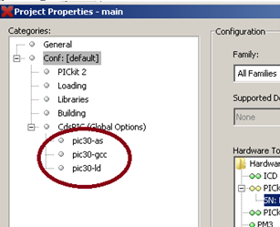

Figure 1 — Project properties.

1. Add C30 libraries to project :

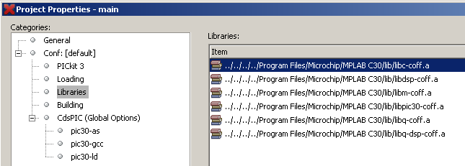

Figure 2 — C30 libraries.

1. Set the next C30 compiler and loader settings:

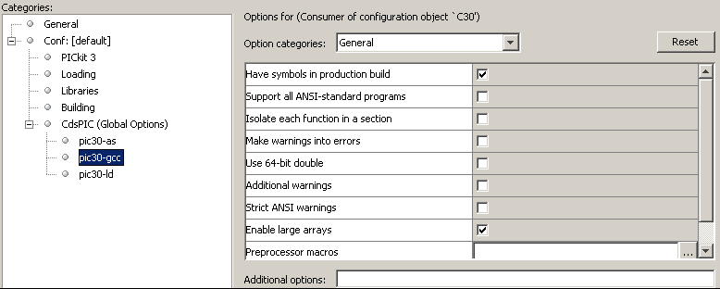

Figure 3 — C30 compiler general settings.

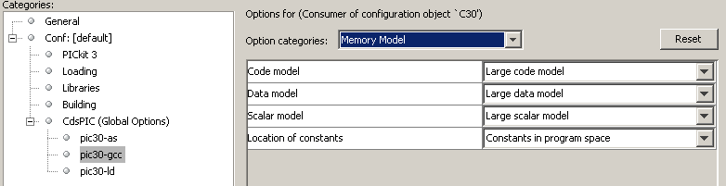

Figure 4 — C30 compiler memory model settings.

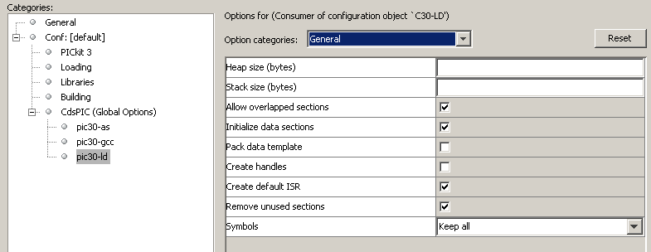

Figure 5 — C30 loader general settings.

1. Create next structure of files in project:

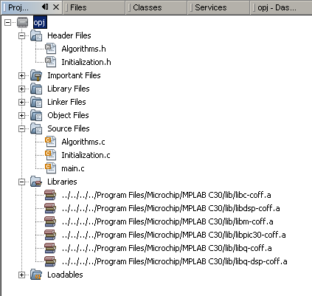

Figure 6 — Structure of project.

## B. How to use MATLAB scripts

The next scripts can be found in the MATLAB folder: wave_tables_gen.m and lfo.m. Run MATLAB, set MATLAB folder like current folder. Open script wave_tables_gen.m in Editor. Push RUN button. There are two files can be found in the MATLAB folder: int_part.dat и frac_part.dat. The first file contains the integer part of sine wave table. It’s plot below.

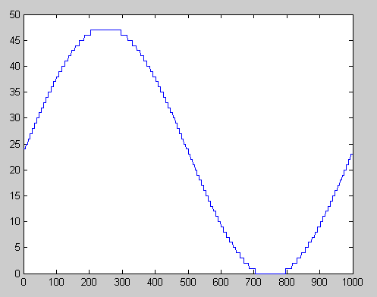

Figure 7 — Plot of integer values from file int_part.dat with DEPTH=48.

The second file consists of fractional values of sine wave. It’s plot below.

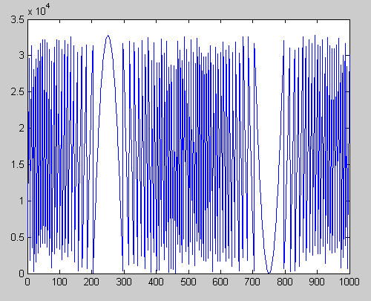

Figure 8 — Plot of fractional values from file frac_part.dat with DEPTH=48.

The file frac_part.dat consists of Q15 values.

# References

1*. «DAFX: Digital Audio Effects» Second Edition. Edited by Udo Zolzer.*

2. *microchip.com*