Carbon Lab
Project plan and design record
An interactive 3D guide to Grade 12 organic chemistry, built for the AI + Education hackathon track: helping learners move beyond memorisation to understand concepts, make connections and apply what they learn.
Subject: Physical Sciences (CAPS), Grade 12, Chemistry: Organic molecules
Textbook basis: Siyavula Physical Sciences Grade 12, Chapter 4 (Creative Commons Attribution)
Current build: Version 6, a single HTML/CSS/JavaScript file with no dependencies, runs offline in a browser
This document: the plan, the teaching pipeline, the user flow, the interface design, what was built and tested, and what comes next

1. Summary
Learners often memorise organic chemistry rules (names, formulas, reactions) without seeing why they work. Carbon Lab replaces memorising with exploring. The centre of the product is an interactive 3D model that learners rotate, tap and change. Beside it, the symbols (name, formulas, structural drawing) update live, so the picture and the notation are always taught together.
Version 6 adds the thing earlier versions lacked: a teaching flow. The app no longer shows every tool at once. It opens on a learning path, each lesson reveals only the tools its current step needs, and every lesson ends with a recap and a clear next step.

What is built
- A 3D molecule engine with correct bond lengths and angles (109.5°, 120°, 180°), smooth morphing between molecules, and three display styles.
- Seven guided lessons (42 steps) that follow the Siyavula chapter order and use a predict, manipulate, observe, explain pattern.
- A naming engine that generates IUPAC names, reads typed names and builds them in 3D step by step.
- Four linked representations of every molecule: molecular, condensed, semi-structural and structural (H–C–C–H), with hover links between the drawing and the 3D model.
- Reactions: addition, substitution, elimination, esterification, combustion and cracking, with before and after structural drawings and balanced equations.
- Practice with six question types, hints, and review links to the right lesson.
- An Explore mode that opens every tool for free play.

How it meets the hackathon requirements
Requirement | How Carbon Lab meets it
Working project in a track | AI + Education: a working web app for CAPS Grade 12 organic chemistry, from first bond to reactions.
Real-world problem | Learners meet organic chemistry in about 12 lesson hours, often without lab kits or molecular model kits. The 3D models and virtual bromine water test fill that gap for free in a browser.
Clear use of AI/ML | Honest status: the current build is rule-based (geometry, naming, reaction and hint engines). The Claude-powered tutor, misconception detection and question generator are designed and planned in Section 12. The rule-based engines are what keeps that AI accurate.
Tangible value | Works offline on a laptop or phone, needs no installation, follows the textbook learners already use, and gives learners and teachers a shared visual language.

2. Curriculum basis
The content, order and scope follow the Siyavula Grade 12 Physical Sciences textbook (Chapter 4, Organic molecules), which is aligned to CAPS. Siyavula content is released under a Creative Commons Attribution licence, so it can be built on with clear credit.
- Time is short: Organic molecules is the first chemistry chapter of the Grade 12 year, with about 12 hours in CAPS.
- Three representations: Siyavula asks teachers to stress the macroscopic, sub-microscopic and symbolic views and the links between them. This is the backbone of the app: what you would see in a test tube, what the atoms do in 3D, and the formulas and names.
- 3D matters: Learners should understand that molecules are not two-dimensional. The textbook recommends model kits, which many schools lack.
- Prerequisites: Grade 11 bonding and intermolecular forces are assumed, so the first lessons rebuild them visually.
- Scope limits: one type of functional group, chains of up to eight carbons, and equations rather than reaction mechanisms. The app enforces these.
Note: the sections 4.4 to 4.6 mapping (properties, applications, reactions) was inferred from the chapter order and should be checked against the official CAPS document before the final demo.

3. Teaching pipeline
Every lesson step follows the same pipeline. Visualisation and understanding are one system: each visual exists to answer a "why" question, and each "why" question is answered with a visual.
Stage | What the learner does | What the app does | Example
Hook | Looks at one real molecule | Loads it in 3D with its name above it | Methane, one carbon holding four hydrogens
Predict | Commits to an answer before seeing it | Offers 2 to 3 options; no answer is revealed yet | "What shape does a double bond give?"
Manipulate | Rotates, taps, presses a button, changes a bond | Responds instantly and smoothly; morphs atoms | Press "Change -ene to -yne"
Observe | Watches what changes | Spotlights the atoms that matter, shows bond lengths and angles | Angle label changes from 120° to 180°
Explain | Reads a short why-sentence | Links the picture to the rule in plain language | "Each carbon now has only 2 neighbours"
Apply | Tries a new molecule | Practice question on an unseen molecule, with hints | Name a molecule you have not met
Connect | Moves to the next idea | Recap card, then the next lesson on the path | Naming leads to functional groups

Teaching principles used
- Progressive disclosure: show only what the current step needs, then reveal tools as they become useful.
- Predict before reveal: a guess makes the observation meaningful.
- Three linked representations: the 3D model, the symbols and the structural drawing always change together.
- Scaffolding for beginners: every lesson starts from the simplest case (one carbon, then two) and adds one idea at a time.
- Retrieval practice: Practice mode asks learners to recall and apply on new molecules, not repeat examples.
- Immediate, specific feedback: wrong answers are explained with the model, not just marked wrong.

4. User flow
The flow answers the question that earlier versions left open: what should the learner do next? The app now has one clear path, with free exploration always available.
 | Stage | What happens
1 | Learning path (home) | A map of seven lessons plus Practice. It shows what is done, recommends the next lesson and offers "Skip the path and explore freely".
2 | Lesson step loop | One idea per step. The guide card gives a short explanation, then a "Your turn" box says exactly what to do. Next stays locked until the learner has acted or answered; a small "Skip this step" link is always available.
3 | Lesson recap | "Lesson complete" card with two or three key ideas, then three choices: next lesson, "Try it yourself" (opens Explore on the matching tool) or back to the map.
4 | Practice | Question types rotate. A wrong answer offers a hint, a walk-through and a link to the lesson that covers it. After a few answers the app says which question type to revisit.
5 | Explore | Every tool is open: the builder, name decoder and solver, reaction lab, boiling point scale and Practice. Progress is saved in the browser.

Progressive disclosure: what appears when
Each lesson step declares which parts of the interface it needs. Everything else stays hidden, so the learner looks at the molecule first.
Lesson | Interface shown | Revealed later
1. Carbon's four bonds | 3D model and name only; then electron, spotlight and shape tools | Build panel when the learner must change a bond
2. Four ways to see a molecule | Structural drawing dock, switching representation each step | Spotlight tool for the hover link
3. Reading a name | Name with colour-coded parts, meaning chips, carbon numbers | Names tab (Explore) for the builder and solver
4. Functional groups | Meaning chips, spotlight; structural drawing for the acid step | Build panel for the final "build one yourself"
5. Isomers | Facts panel with formula and isomer chips, structural drawing | none
6. Boiling points | Facts panel with the boiling point, style tool | Forces tab (Explore)
7. Reactions | Structural drawing, before and after strips, atom tables | Reaction lab (Explore)

5. Interface design
The interface plays on the empty space around the 3D model. The name sits above the model, facts sit in the empty space beside it, a slim vertical toolbar sits on the right, and the guide card (the teacher) sits at the far right.
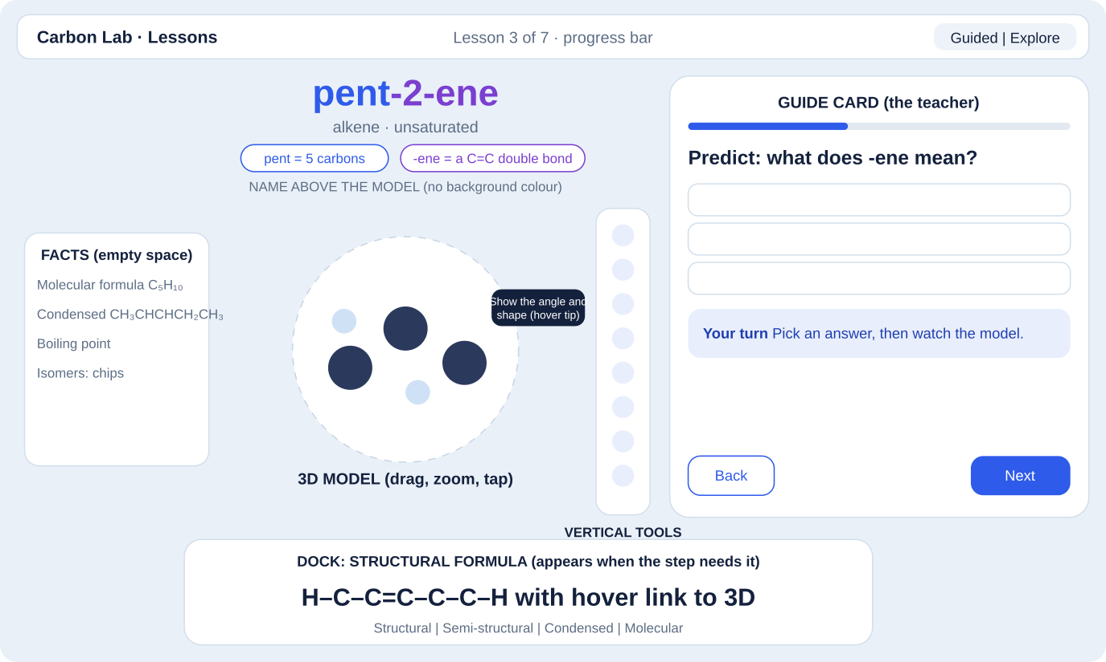
Figure 1. Screen layout: name above the model, facts in the empty space, vertical tools with tooltips, guide card, structural dock

Design decisions
- Name above the model, large, with each part colour-coded: stem (blue), bond ending (purple), group suffix (green), branches (orange). There is no background colour behind the name, so the colours carry the meaning.
- Meaning chips under the name decode each part: "pent = 5 carbons", "-ene = a C=C double bond".
- Facts (molecular formula, condensed formula, boiling point, isomers) float in the empty space beside the model instead of sitting in a heavy panel.
- The structural drawing (H–C–C–H) lives in a dock under the model and appears only when a step needs it.
- A vertical toolbar on the right holds the display tools. Each button shows a short description when hovered or focused.
- Soft light background, rounded cards and plain language keep it friendly while the chemistry stays serious.
- Animations are short and meaningful (morphing atoms, a spotlight glow). Reduced-motion settings are respected.

Toolbar and hover descriptions
Button | Hover description
Ball and stick | Atoms as balls, bonds as sticks.
Space-filling | How much room the atoms really take up.
Skeleton | Thin lines only, so the shape is easy to see.
Labels (Aa) | Show or hide the element letters on the atoms.
Electrons | Show each bond's shared pair of electrons as gold dots.
Spotlight | Tap an atom to zoom in, dim the rest and see its bonds.
Numbers | Number the carbons the way the name does.
Shape guide | Show the angle and shape around a selected carbon.
Reset view | Reset the view to the starting angle.
Save image | Save a picture of the model.
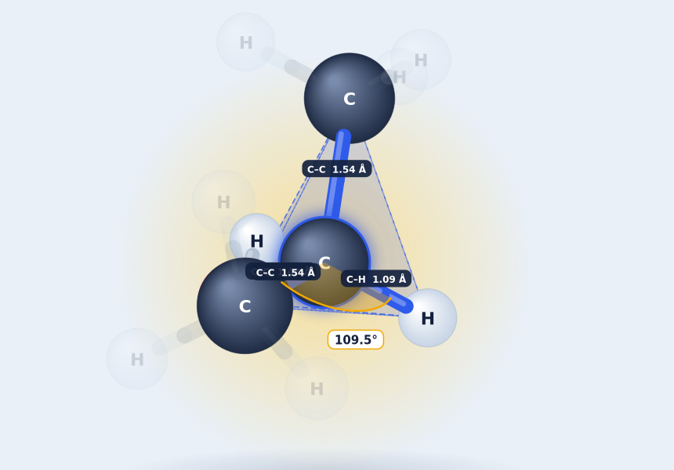
Figure 2. Spotlight on one carbon: neighbours stay bright, bond lengths and the 109.5° angle are labelled

6. Lesson plan
Lesson (steps) | Goal | Key visual | Predictions
1. Carbon's four bonds (6) | See why carbon makes four bonds and how that sets the shape | Methane tetrahedron, shared electron pairs, angle label | Shape of a double bond; shape of a triple bond
2. Four ways to see a molecule (6) | Read molecular, condensed, semi-structural and structural formulas | Dock drawing with hover link to 3D | none (hands-on)
3. Reading a name (8) | Decode stem (carbons) and ending (bonds or group) | Carbon counting, numbered carbons, name tokens | What -ene means; what -ol means
4. Functional groups (5) | Meet -OH, C=O, -COOH and halogens | Spotlight on the group | Ketone or aldehyde?
5. Isomers (4) | Chain, position and functional isomers | Atoms rearranging between isomers | none (hands-on)
6. Boiling points (3) | Link structure to boiling point | Facts panel, chain growth and branching | Boiling point with hydrogen bonding
7. Reactions (10) | Addition, substitution, elimination, esterification, combustion, cracking | Atoms flying in and out, before and after drawings, atom tables | Bromine water with a saturated molecule

Lesson 3 in detail: reading a name
This lesson was requested explicitly: show that meth, eth and prop count carbons and that -ane, -ene and -al describe the bonds or group, starting with one carbon and then two.
- Step 1: methane. Meth means 1 carbon, -ane means single bonds only. The drawing shows H–C–H with four lines on the carbon.
- Step 2: add a second carbon. Eth means 2. H–C–C–H grows while each carbon keeps 4 lines.
- Step 3: keep adding. Prop 3, but 4, pent 5, hex 6, hept 7, oct 8. The name and the drawing change together.
- Step 4: predict what -ene does, then watch ethane become ethene (a double bond, two lines).
- Step 5: -yne gives a triple bond (three lines, a straight shape).
- Step 6: predict what -ol does, then watch ethanol appear.
- Step 7: -al, -one and -oic acid, shown with propanone.
- Step 8: open the name builder in Explore mode and type any name to see it solved.

7. Visualisation system
- Geometry: real bond lengths (C–C 1.54 Å, C=C 1.34 Å, C≡C 1.20 Å, C–H 1.09 Å) and angles. A bond-count rule places hydrogens, so every carbon always has four bonds.
- Morphing: atoms keep identities across changes, so a single bond becoming double animates instead of jumping. Reaction atoms fly in and out.
- Spotlight: tapping an atom zooms in, dims everything else, glows the atom and labels its bonds with length and type. The same mechanism spotlights the parts a lesson is explaining.
- Shape guide: a translucent tetrahedron, triangle or line shows the shape, and a live angle label updates during a morph.
- Numbers: carbons are numbered the way the IUPAC name numbers them, so the lowest-number rule is visible.
- Linked drawing: hovering an atom in the structural drawing lights it in 3D and the reverse.
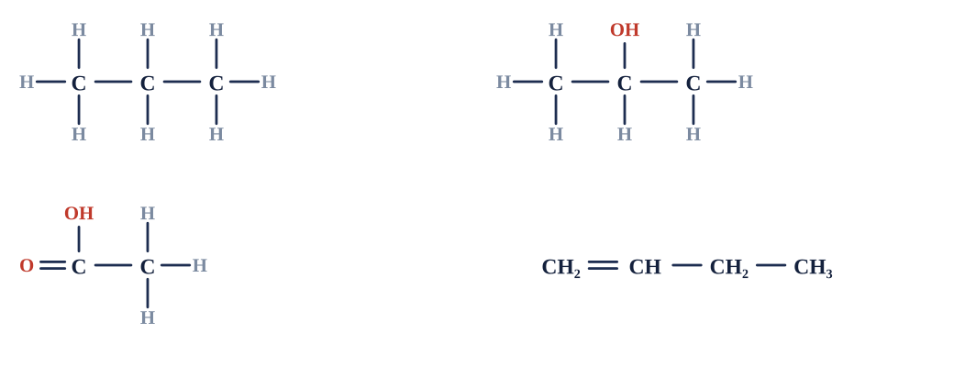
Figure 3. Structural and semi-structural drawings generated from the same model

8. Naming engine and solver
- Generator: finds the main chain, the principal group (acid, ester, aldehyde, ketone, alcohol), the lowest numbering and the alphabetical order of branches.
- Reader: parses typed names such as 2-methylbutane or methyl ethanoate, rebuilds the molecule and reports mistakes in plain language.
- Step-by-step solution: chain, bonds, group, branches, then a result that compares the typed name with the correct IUPAC name and explains differences (longest chain, lowest numbers).
- Scope: straight chains up to 8 carbons with methyl branches, halogens, –OH, C=O, –COOH and methyl esters.
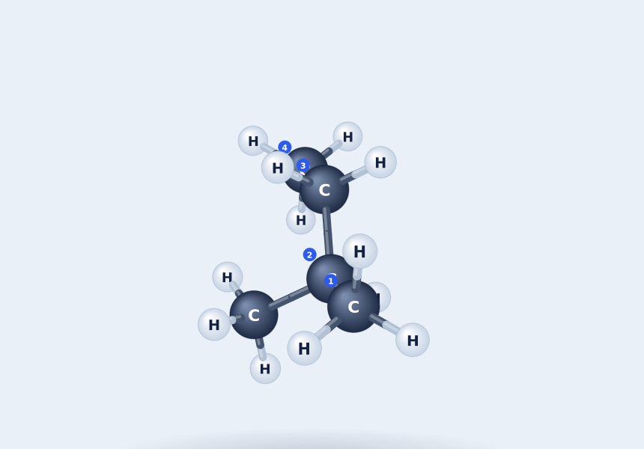
Figure 4. The solver building 2-methylbutane, with the branch step spotlighted and carbons numbered

9. Reactions
Type | Reactions | Visual
Addition | Br₂ (bromine water test), H₂, HBr, H₂O (major product follows Markovnikov's rule) | Atoms fly in; the bromine water vial fades from orange to colourless
Substitution | Cl₂ or Br₂ in light; NaOH(aq) on a haloalkane; HBr on an alcohol | Atom swap; carbon bonds unchanged
Elimination | Dehydration (remove H₂O); dehydrohalogenation (remove HBr) | Atoms fly out; a double bond forms
Other | Esterification with methanol; complete combustion; cracking | Atom table showing C, H and O balance; two carbons leaving

Every reaction shows the equation, the conditions, a one-sentence reason, and before and after structural drawings with the changed carbons marked. On longer chains the learner taps a carbon to choose where the reaction happens, and hovering a reaction button previews where it will act.
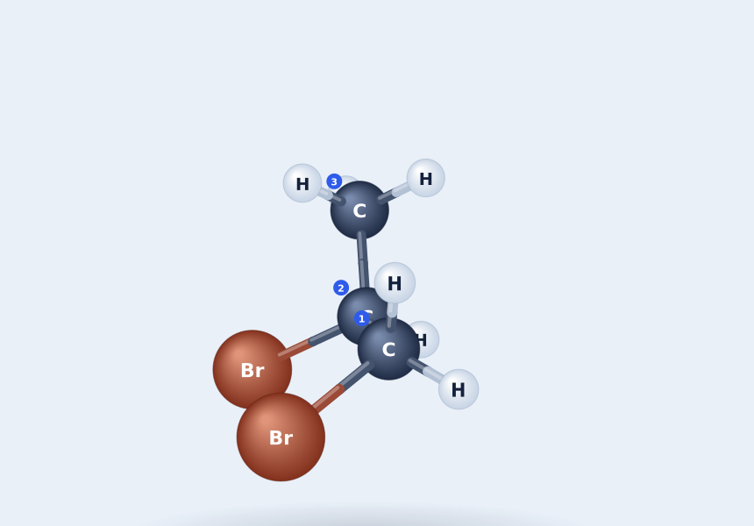
Figure 5. Propene after the bromine water test: 1,2-dibromopropane, carbons numbered

10. Practice and adaptivity
Question type | Task | Explanation after answering
Name it | Type the IUPAC name of the molecule shown | Walk-through of how to name it, step by step
Build it | Build a named molecule in the 3D model | Compares what was built with the target
Which family | Choose alkane, ketone, ester and so on | Spotlights the group and says why
Predict the product | Choose the product of a reaction | Runs the reaction in 3D
Boiling points | Rank three molecules | Names the strongest force in each
Isomers | Choose the isomer | Morphs into it and names the isomer type

- Hints come in three steps for naming and building: find the longest chain, find the groups, then see the meaning of each part.
- A wrong answer offers a link to the lesson that covers it. After a few answers the app says which question type to revisit.
- Progress (lessons completed) is saved in the browser. Practice scores are kept for the session.
Today these rules are fixed. In the AI phase they become a learner model that adapts the order and difficulty (Section 12).

11. Technical design
- One self-contained HTML file with inline CSS and JavaScript. No libraries, no network needed.
- 3D is drawn with the browser canvas using a custom projection and depth sorting, so it runs on low-end phones.
- Molecule data is generated from a small model (chain length, bond orders, groups per carbon), so the 3D model, drawings, name, formulas and reactions all come from one source of truth.
- Lesson content is data: each step lists its text, its model setup and which interface parts it needs.
- Responsive layout: on phones the panels stack under the model.
- Web first, app later: the same file can become an installable web app (PWA) and then be wrapped for Android and iOS.

12. AI roadmap
Feature | Plan
Socratic tutor | Claude receives the current molecule, selected atom, step and recent answers, and asks "why" questions that point back to the model instead of giving answers.
Misconception detection | Wrong answers are classified (for example confusing aldehydes with ketones) and answered with a specific visual fix.
Question generator | New questions in the style of Siyavula exercises and past NSC papers, on fresh molecules, within the scope limits.
Textbook grounding | Retrieval over the Siyavula text so definitions and wording match what learners see in class.
Accuracy guard | The existing geometry, naming and reaction engines validate every molecule and name, so the AI never invents chemistry facts.
Learner model | Replaces the fixed rules: mastery per concept, adaptive order, spaced review.
Photo input (optional) | A photo of a textbook structure becomes an editable 3D molecule.

Why rule-based first: the AI needs a trustworthy chemistry core. The engines built so far are that core, and they are already tested.

13. Quality checks
Check | Result
Name generator and reader round trip on 600 random molecules | No mismatches
Geometry and valence of all 38 preset molecules | Correct angles; every atom has the right number of bonds; no overlapping atoms
Reactions run on every applicable preset (203 runs) | All products valid and nameable
Combustion equations for every preset without halogens | Balanced for C, H and O
All 7 lessons (42 steps) walked in a simulated browser | Every step works; recap and next-lesson links work; progress saved
Practice: 25 mixed questions in guided mode | No errors; names hidden until answered
Script errors across all flows | None

Known limits
- Tested in a simulated browser, not yet on real phones and laptops. Cross-browser and touch testing come next.
- Not yet tested with real Grade 12 learners. A short before and after test is planned.
- Boiling point values were entered from memory (about 30 compounds) and must be checked against the CAPS data sheet.
- The AI tutor is designed but not yet integrated.
- Out of scope for now: ethyl and longer branches, rings, polymers, and esters other than methyl esters.

14. Plan, demo and risks
Phase | Work
Done | 3D engine, seven lessons, naming engine and solver, reactions, practice, guided flow and explore mode
Next (1) | Test on phones and laptops; fix layout and touch issues; check boiling points against CAPS data
Next (2) | Test with 3 to 5 learners using unseen molecules; compare before and after scores
Next (3) | Add the Claude tutor and learner model; add polymers and more reactions
Next (4) | Installable web app, then Android and iOS wrapper

Three-minute demo script
- Open on the learning path: "one path, one idea at a time" (15 s).
- Lesson 3, step 1 to 3: add carbons and show the name and H–C–C–H drawing growing together (45 s).
- Predict -ene, then watch ethane become ethene and the angle change to 120° (30 s).
- Spotlight a carbon and show its four bonds with lengths (20 s).
- Type 2-methylbutane in the solver and walk through the steps (30 s).
- Run the bromine water test and show orange turning colourless (20 s).
- Close with the learner evidence and the AI roadmap (20 s).
Risk | Mitigation
Too much content for the time | Polish lessons 1 to 3 first; later lessons reuse the same engine
Wrong chemistry from the AI | The rule-based engines validate every molecule and name
Curriculum mapping errors | Confirm against the official CAPS document and past NSC papers
Untested on real devices | Device testing before the demo

Sources
Siyavula Physical Sciences Grade 12, Chapter 4 Organic molecules (siyavula.com/read/za/physical-sciences/grade-12/organic-molecules), sections 4.1 and 4.2. Licensed under Creative Commons Attribution.

