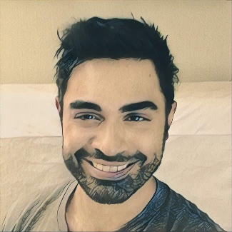

**Analyst | SRE |Full-Stack Developer**

**Data Scientist***theDifference/Collaboration.Ai*

* Used Natural Language Processing, Social Network Analysis, and Neural Networks to reduce corporate silos by 35%
* Developed over 14 classification models for personality profiles with accuracy rates 90%+
* Facilitated over 27 ETL/Analytics Projects for United Health Group, World Bank, TED Talk, United States Air Force
* Take a look at our [Collaboration.Ai](https://www.collaboration.ai/display/citibankmr/fullgraph/) engine helping Citibank optimize their Executive Communication Initiative

2017-2018

2018-Present

**Lead Reporting and Analytics | SRE***Wells Fargo*

* Collaborated to create the first Analytics platform for PuppetDB that spans 100,000 servers across the entire bank
* Team Lead for Metrics, Analytics, and Reporting in IaaS
* #1 In Github contributions
* 50+ Automated Reports and Machine Learning based insights for System Admins and Senior Leaders
* Time-Series based metrics to monitor success rates of 20+ releases
* Leading several teams across 7 different applications with Agile/SCRUM methods and CI/CD Pipelines

**Data Analyst Consultant***Udacity*

* Tutored over 10,000 Students through various Data Science disciplines
* Created automated system to reduce student wait times by 40%
* Increased reviewer profit-rates by 175%
* Eliminated 86% of cost by converting dashboard functionality from browser to REST API calls
* Tested and deployed over 34 courses and functionality improvements
* Maintained an average Quality Feedback Rating of 96%

2015-2018

**EXPERIENCE**

**PROFICIENCIES**

**Data Science Certification***John Hopkins, Coursera*

* **Key Focus:** Exploratory Analysis, Inferential Statistics, Central-Limit Theorem, Statistical Learning, Data Structures, Algorithms, Visualization Packages (D3.js, ggplot, Plotly, Bokeh)
* **Applications:** Human Activity Recognition, Sentence Completer

2014-2015

**Deep Learning Certification***Stanford, Coursera*

* **Neural Networks:** Convolutional, Recurrent, Long-Short-Term-Memory, General Adversarial
* **Applications:** Image Recognition, Time-Series (Stocks), Image Creation

2017-2018

2017-2018

**Big Data Certification***UC San Diego, Coursera*

* **Key Focus:** Hadoop, MapReduce, Apache Spark, Stream Processing, Cluster Computing, SQL, NoSQL, ETL/ELT
* **Applications:** HDFS Deployment, MLib Analysis

**EDUCATION**

**PROJECTS**

**I am a storyteller.**   
Information is simply evidence. It tells us not of the why, simply the what. As machines become better at acquiring data, the duty of the individual becomes more involved in creating the narrative from which a business or institution can draw insight and act. I want to be that point-man between the data and the decision-makers.

**Strengths**

* Self-Taught
* Analytical
* Routined and Disciplined
* Grasp of the *Bigger Picture*

**Objectives**

* Leadership/Management Experience
* Expand on the Specialized Elements of Data Science
* Achieve Work/Life balance by merging my passions my work
* A long-term relationship with an organization that supports all of the above.

<https://www.linkedin.com/in/miadadrashid/>



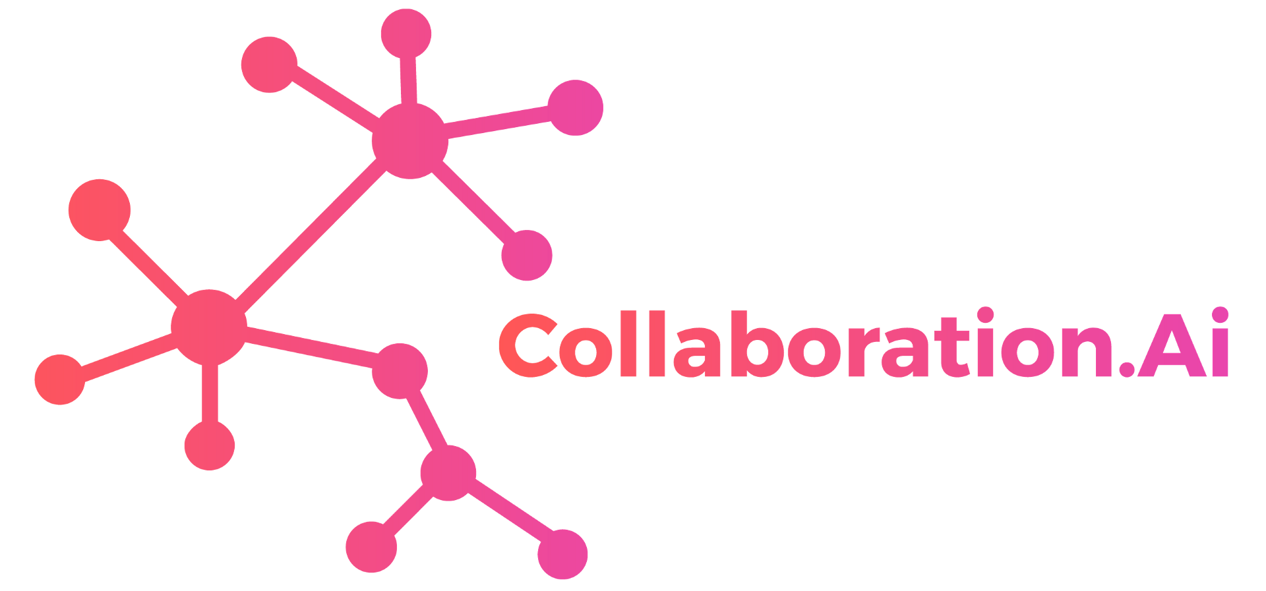

https://www.collaboration.ai/

<https://github.com/thedurphy/Portfolio>

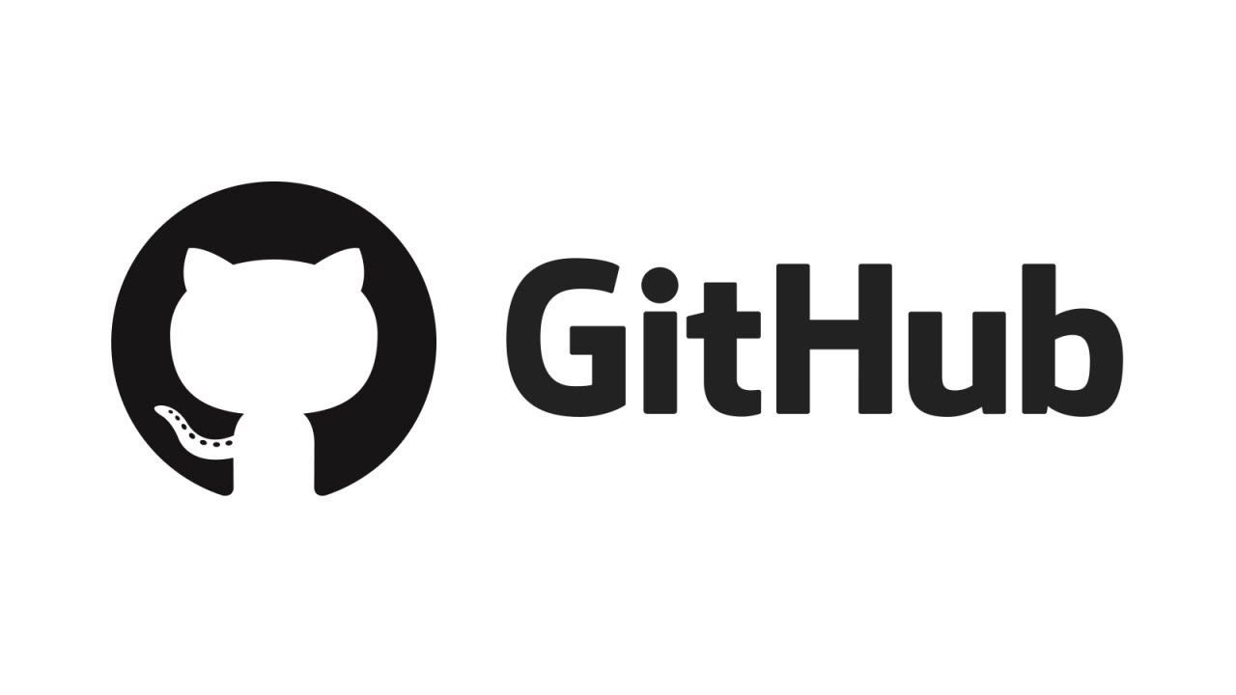



[miadadrashid@gmail.com](mailto:miadadrashid@gmail.com)

952.237.1421



**CONTACT**

*It is a capital mistake to theorize before one has data. Insensibly one begins to twist****facts******to******suit theories****, instead of****theories to suit facts****. - SH*

A/B Testing

Inferential Statistics

Time-Series Analysis

Tableau/Alteryx

SQL

Apache Spark

Angular

TensorFlow

Hadoop

Python

NoSQL

Scala

**PROFILE**

MIADAD RASHID

Your adress tunisie azertyazert azerty  
hhhhhhhhh