**Link of Website:** [**https://65c76b7d5afb4164e650e98b--magnificent-pithivier-a68f37.netlify.app/**](https://65c76b7d5afb4164e650e98b--magnificent-pithivier-a68f37.netlify.app/)

**Explanation of Implications**

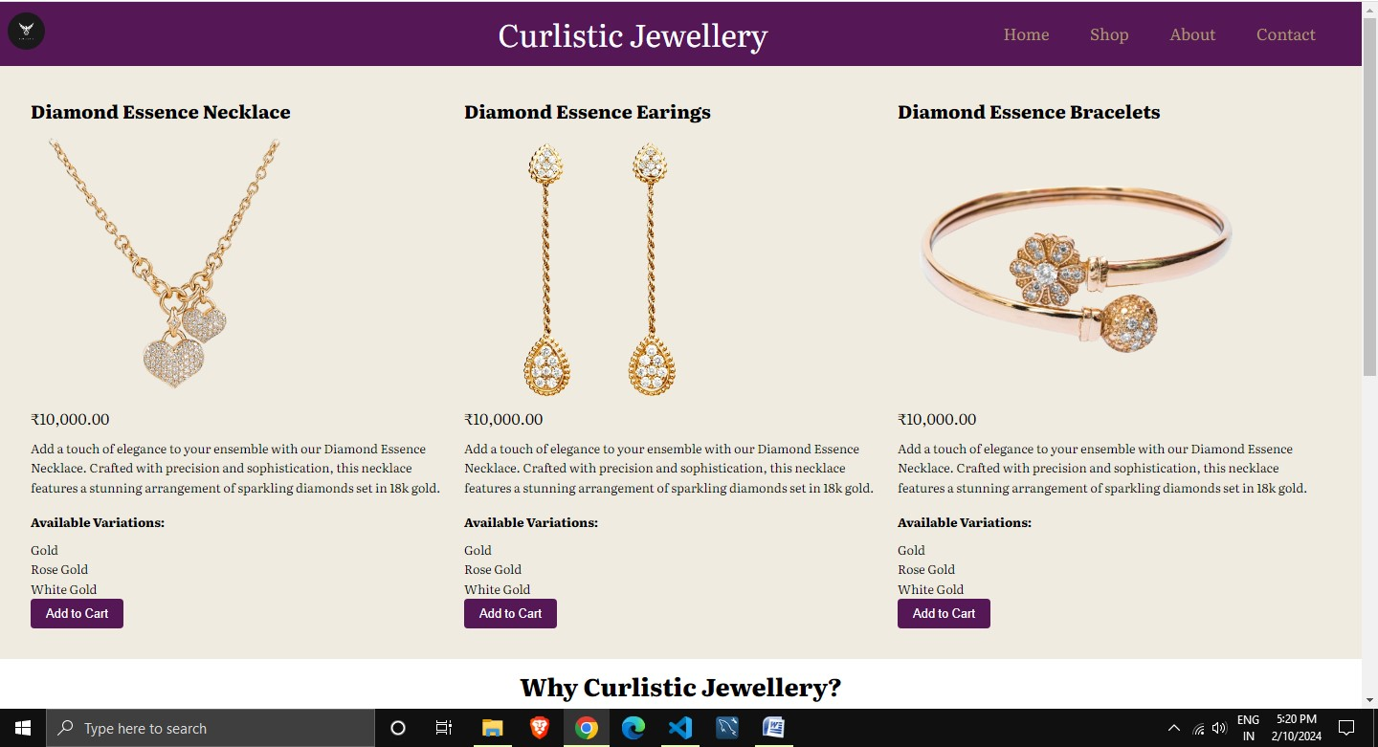

**Three sections of our products with add to cart features hover features with button.**

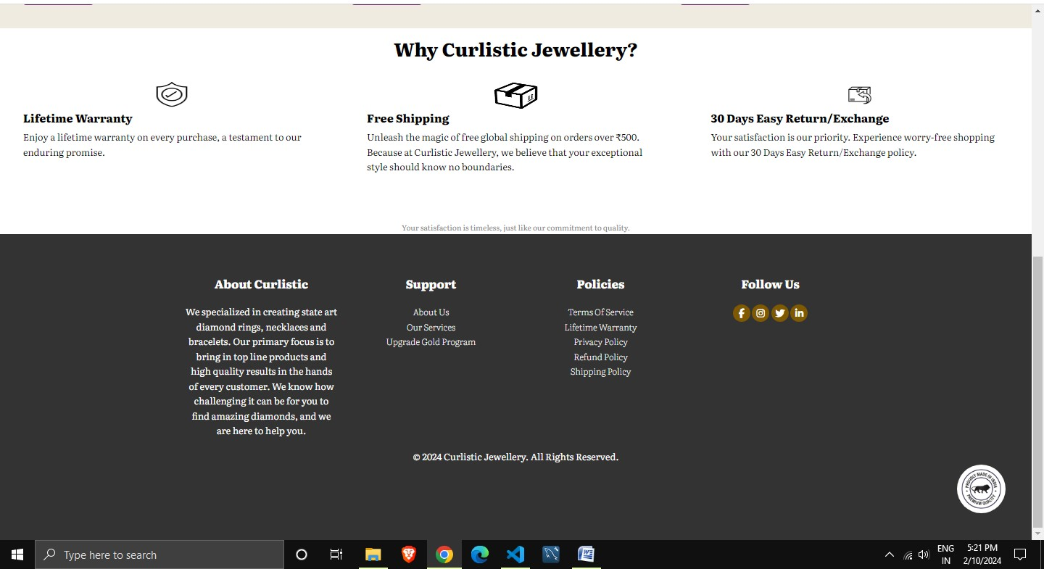

**Most important section why customer will buy from us only because we are offering “Lifetime Warranty” free shipping and 30 Day Return and Exchange policy. All this features added in our website.**

**Footer having good demonstration of, about our company Curlistic Jewellery , our company policy.**

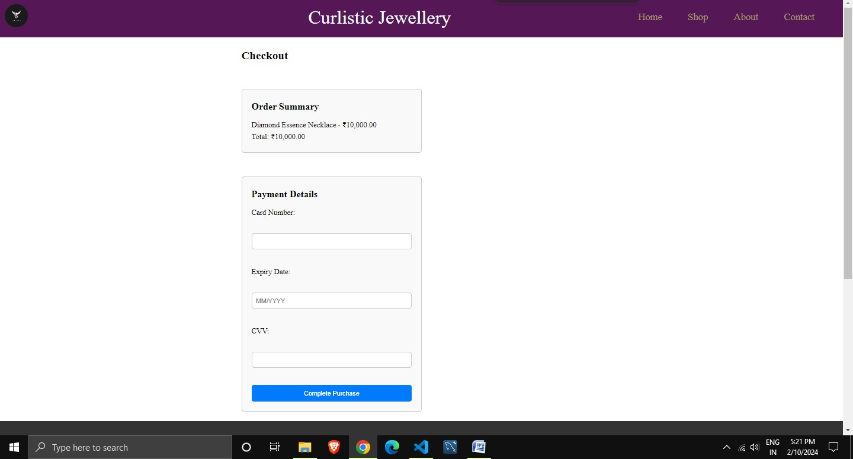

**Payment page with all features demonstrated above.**

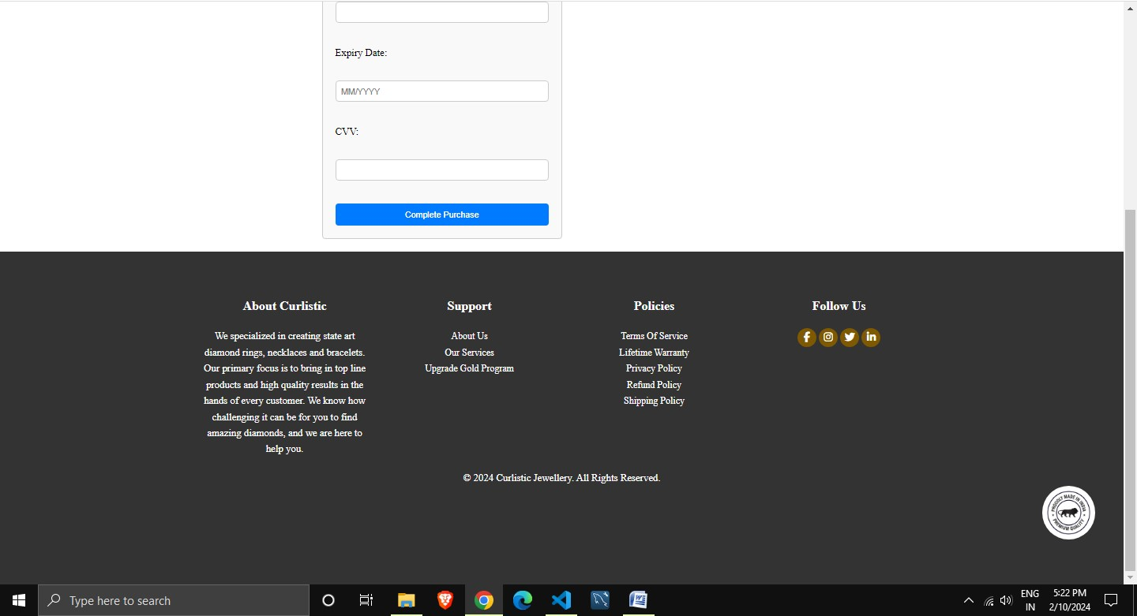

**HTML Part**

1. **Header Section:**The header section includes the logo, brand name, and navigation links (Home, Shop, About, Contact).
2. **Checkout Section:**The main content of the checkout section includes:
   1. <h1> heading with the text "Checkout".
   2. An order summary section (<div class="order-summary">) displaying the item name and price, along with the total amount.
   3. A payment details section (<div class="payment-details">) containing a form for entering card details (cardNumber, expiryDate, cvv) and a button for completing the purchase.
3. **Footer Section:** The footer section contains:
   1. Various divisions (<div>) for different sections such as About Curlistic, Support, Policies, and Follow Us.
   2. Links to different pages (About Us, Our services, Upgrade Gold Program) under the "Support" section.
   3. Links to policies (Terms of Service, Lifetime Warranty, Privacy Policy, Refund Policy, Shipping Policy) under the "Policies" section.
   4. Social media icons for Facebook, Instagram, Twitter, and LinkedIn.
   5. Copyright information and an image indicating "Made in India" that our prime minister is supporting also present which is a prided for us.

**This website is entirely developed by me.**