VBC Guideline for Providers

Preface

Abbreviations
Abbreviation
CHI | Council of Health Insurance
VBHC | Value Based Healthcare
VBC | Value Based Contract
VBP | Value Based Payment
DRGs | Diagnosis Related Groups
PROMs | Patient Reported Outcome Measures
CROMs | Clinical Reported Outcome Measures
PREMs | Patient Reported Experience Measures
MSR | Minimum Savings Rate

Executive Summary
The Council of Health Insurance (CHI) has developed this Value-Based Contracting (VBC) guideline to support the transition of Saudi Arabia's private healthcare sector from volume-based reimbursement models to arrangements that reward better health outcomes, higher quality of care, and efficient resource utilization. Value-based contracting is defined as a payment arrangement where provider reimbursement is explicitly linked to achievement of predefined quality metrics, patient outcomes, and cost efficiency targets. These guidelines provide a structured and consistent framework to support healthcare providers and payers in designing, negotiating, and implementing value-based contracts, with initial focus on seven CHI-supported bundled payment areas including Total Knee Replacement, Laparoscopic Cholecystectomy, Diabetes Management, and others. The guidelines reflect CHI's role as the private healthcare regulator, facilitating the adoption of value-based approaches without interfering in commercial negotiations between payers and providers. CHI also helps in establishing frameworks, monitoring market behavior, and coordinating implementation support.

The document establishes a phased implementation roadmap that enables gradual risk transfer aligned with provider capability and market readiness. Phase 1 (Report & Measure) focuses on establishing data collection systems and measuring baseline performance with fixed bundled payments and no financial risk. Phase 2 (Share Risk) introduces shared savings arrangements where providers earn incentive payments for achieving cost reductions above a Minimum Savings Rate (MSR) while maintaining quality, with no downside risk. Phase 3 (Own Outcomes) involves two-sided risk arrangements where providers assume both upside gains and downside losses linked to performance. Clear gating criteria define the requirements for progression between phases, including data completeness thresholds, outcome performance standards, governance capabilities, and financial management maturity. This graduated approach protects provider sustainability and market stability while building the capabilities necessary for successful value-based contracting.

The guidelines outline essential contract design requirements that all value-based arrangements must include: clearly defined episode scope with start and end points, patient attribution methodology with minimum volume thresholds, specified outcome measures including clinical outcomes and Patient-Reported Outcome Measures (PROMs), risk adjustment methodologies to ensure fair comparison across different patient populations, and transparent benchmarking approaches with financial parameters such as MSR and risk corridors. The document clearly delineates stakeholder responsibilities, requiring providers to deliver evidence-based care, collect and report outcome measures, ensure data accuracy, and manage resources efficiently within bundled prices, while payers must design fair contracts, provide timely performance data, apply methodologies consistently, and maintain network adequacy.

For providers, these guidelines offer the opportunity to be rewarded for clinical excellence and care coordination rather than service volume, with potential for enhanced revenue through shared savings, competitive differentiation through demonstrated quality outcomes, and more predictable multi-year contracts. For patients, value-based contracting promotes better health outcomes through coordinated evidence-based care, improved experience through active engagement via PROMs collection, and reduced complications and readmissions. For the healthcare system overall, VBC is expected to reduce unwarranted clinical variation, support more sustainable cost growth, generate robust outcome data to inform continuous improvement, and align financial incentives with clinical objectives. At a macroeconomic level, improved outcomes and reduced avoidable utilization contribute to labor productivity and support the long-term affordability and sustainability of private health insurance in alignment with Vision 2030 objectives, while maintaining patient protection, access equity, and provider sustainability throughout the transformation journey.

Executive Summary 4
1. Purpose and Scope 6
1.1. Purpose and Core principles 6
1.2 Policy Context and Market Readiness 7
1.3 Scope of the Guidelines 7
1.4 Important Considerations 8
2. Expectations from the Parties for Successful Implementation of the Framework 9
2.1 Responsibilities of Healthcare Providers 9
2.2 Key succuss factors and expectations from Payers 10
2.3 Shared Responsibilities 11
3. Methodology: Phased Risk Transfer and Implementation Framework 11
3.1 Adopt a Phased Risk Transfer Policy Framework 11
3.2 Implementation of roadmap and gating criteria 12
4. Contract Design and Payment Structures for Value-Based Contracting 14
4.1 Scope of Services and Episode Definition 14
4.2 Patient Eligibility, Attribution, and Volume Thresholds 14
4.3 Outcome, Quality, and Performance Measures 15
4.4 Risk Adjustment and Case-Mix Protection 15
4.5 Benchmarking and Economic Parameters 15
Conclusion 16
References (to be added from the library): 16
Annexes (contract template, principles map, measure specs) 18

1. Purpose and Scope

1.1. Purpose and Core principles
The purpose of Value-Based Contracting (VBC) guidelines for healthcare providers is to support the transition of the Saudi private healthcare sector from volume-based reimbursement models toward value-based contracting arrangements that reward better health outcomes, higher quality of care, and efficient resource utilization. Value-Based Contracting VBC is a payment arrangement where provider reimbursement is explicitly linked to achievement of predefined quality metrics, patient outcomes, and cost efficiency targets, rather than volume of services delivered (1).

Building on the Council of Health Insurance’s (CHI) ongoing reforms in improving healthcare outcomes, benefit package design, private sector’s payment mechanisms, and healthcare pricing, these guidelines aim to:

- Provide a structured and consistent framework to support healthcare providers and payers in designing, negotiating, and implementing value-based contracts.
- Enable effective contracting over bundled payment models, where reimbursement is linked not only to predefined prices but also to quality and outcome performance.
- Promote alignment between clinical outcomes, patient experience, and financial incentives, while safeguarding access, equity, and patient protection.
- Reduce unwarranted variation in clinical practice and costs, while maintaining provider sustainability and market stability.

The guidelines reflect CHI’s role as the private healthcare regulator, facilitating the adoption of value-based approaches without interfering in commercial negotiations between payers and providers. This guide is intended for healthcare providers participating in or planning to participate in bundled payments or value-based contracts where Bundled payments are defined by CHI as (Refer to Bundled payments white paper). The guide might also support the payers designing value-based purchasing arrangements. Additionally, it will support CHI’s internal teams who are responsible for benefit packages, reimbursement models, pricing, contracting oversight, and market enablement. Other stakeholders are involved in a VBC activity, data, quality measurement, and care transformation initiative can also benefit from this guide.

The core objective of value-based contracting is to enable standardized monitoring of quality, outcomes, and sustainability metrics, thereby supporting policy evaluation, system learning, and continuous improvement within the private healthcare sector.



1.2 Policy Context and Market Readiness

Value-based contracting is defined as a contractual arrangement in which provider remuneration is explicitly and materially linked to performance on predefined health outcomes, quality indicators, and cost-efficiency metrics, rather than service volume alone. This definition aligns with foundational value-based healthcare literature emphasizing outcomes relative to costs over the full care cycle (1, 2).
As part of its strategic initiatives, CHI has initiated and supported contracting efforts across seven priority bundled payment areas, creating an initial platform for value-based payment implementation in the private health sector. These bundles represent high-volume and/or high-cost services where clinical pathways are sufficiently defined, outcomes can be meaningfully measured, and variability in cost and practice patterns presents opportunities for improvement.
The introduction of bundled payments marks an essential first step toward value-based payment. However, without explicit linkage to quality and outcome measures, bundled payments alone remain primarily a reimbursement mechanism rather than a complete value-based contracting model. That said, Contracts that rely solely on fixed prices or bundled reimbursement without outcome-linked financial consequences are classified as advanced reimbursement models, not full value-based contracts (2-3).

These guidelines aim to bridge that gap by outlining how outcome measurement, risk adjustment, and incentive design can be systematically integrated into bundle-based contracts.



Scope of the Guidelines
These guidelines apply to value-based contracting arrangements implemented within the Saudi private healthcare market under CHI’s regulatory oversight, with an initial focus on bundled payment contracts covering either 1. Procedural bundles (e.g. surgical episodes) are episode-based, time-limited arrangements, or 2. a condition-based longitudinal bundle, such as the Diabetes Management program, represents distinct attributes, outcome measurement, and settlement characteristics.

The seven CHI-supported clinical areas:
- Laparoscopic Cholecystectomy
- Total Knee Replacement
- Tonsillectomy with Adenoidectomy
- Spinal Fusion
- Laparoscopic Sleeve Gastrectomy
- Pregnancy and Childbirth
- Diabetes Management Program
- Other conditions: additional conditions agreed between the payer and provider where the provider is aligned with CHI guidelines.

The scope includes guidance on:
- Contract design elements for value-based bundles, including outcome measures, quality thresholds, and financial incentives.
- Roles and responsibilities of providers in delivering, measuring, and reporting value.
- Governance, data, and operational requirements necessary to support fair and transparent contracting.
- Principles for risk sharing, patient attribution, and performance assessment.

The core principles underpinning value-based contracting are set out in Annex 2. These principles ensure VBC arrangements balance outcome accountability with fairness, transparency, and patient protection, while enabling phased risk adoption that matches provider capability and supports both clinical excellence and financial sustainability.
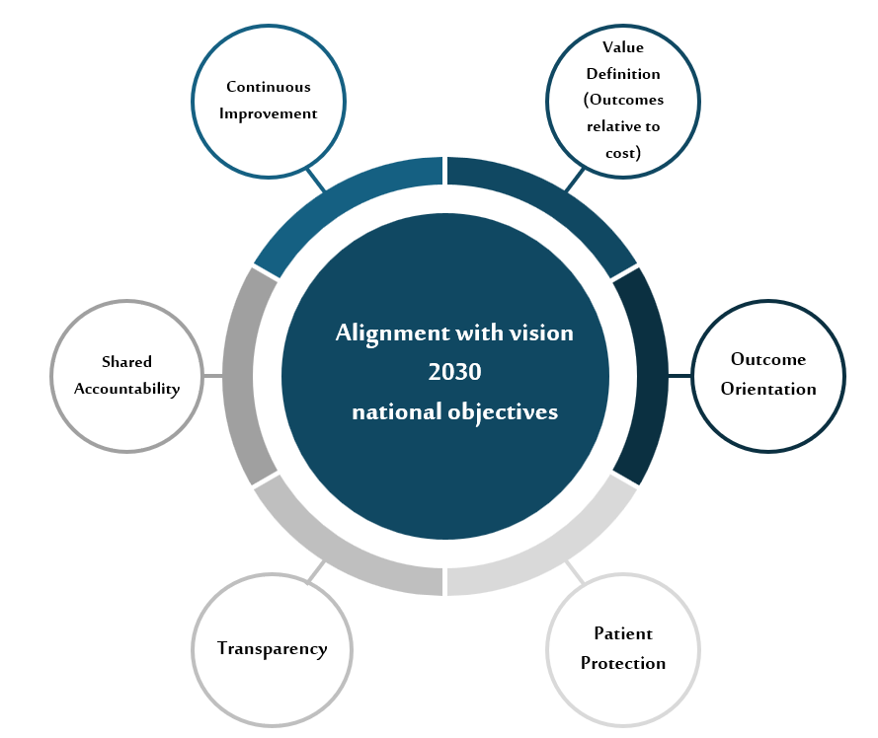

1.4 Important Considerations
As this document describes an initial phase of VBC, it is important to note that this document does not:
- Mandate participation in value-based contracts.
- Prescribe specific commercial terms, prices, or sharing ratios.
- Replace existing CHI regulations, benefit package requirements, or pricing policies.
- Apply to public-sector funding mechanisms unless explicitly stated in future policy updates.

Instead, the guidelines are intended as a reference and enabling framework, supporting voluntary and phased adoption of value-based contracting models aligned with market readiness.

2. Expectations from the Parties for Successful Implementation of the Framework

Effective implementation of value-based contracting requires a transparent allocation of responsibilities among healthcare providers, payers, and the regulator.

While value-based contracts are negotiated commercially between payers and providers, CHI acts as a regulator for private healthcare providers and a system enabler, ensuring alignment with national health priorities, patient protection (in terms of access and equality), and market sustainability. This role includes establishing regulatory frameworks and contracting guidelines, ensuring consistency with national health policies and care provision requirements, and coordinating alignment across related CHI initiatives. In addition, CHI monitors market behavior to safeguard competition, access to care, and provider sustainability.

This section outlines the minimum expected responsibilities of each stakeholder group to support transparent, fair, and outcome-oriented value-based contracting.

2.1 Responsibilities of Healthcare Providers
Healthcare providers are primarily responsible for clinical delivery, outcomes’ achievement, and care efficiency within the scope of the contracted bundle or population. Key responsibilities include:

Figure #x
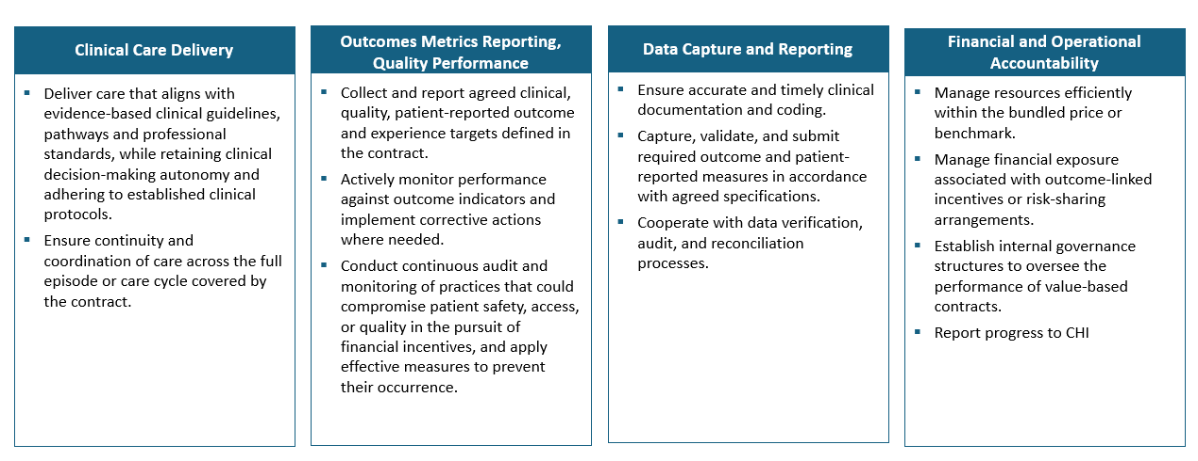

2.2 Key succuss factors and expectations from Payers
Payers are responsible for contract design, administration, and performance assessment, ensuring that value-based arrangements are implemented fairly and transparently.
Key responsibilities include:
Contract Design and Administration
- Design value-based contracts that align reimbursement with outcomes, quality, and efficiency.
- Clearly define contract terms, including benchmarks, outcome measures, attribution rules, and settlement methodologies.
- Ensure that contract structures are understandable, measurable, and operationally feasible.
- Offer a range of incentives (financial or non-financial) based on a defined level of maturity.

Data Sharing and Transparency
- Provide providers with timely and accurate data necessary for performance monitoring, including claims data and utilization reports.
- Disclose benchmarking methodologies and any applicable adjustments.
- Support data integration and alignment with agreed measurement frameworks.
Fair Performance Assessment
- Apply outcome measurement, risk adjustment, and financial reconciliation methodologies consistently.
- Ensure that performance assessments reflect factors within the provider’s reasonable influence.
- Manage disputes in accordance with defined escalation and resolution mechanisms.
Patient Protection and Network Management
- Ensure that contracting arrangements do not restrict beneficiary access to entitled services.
- Maintain network adequacy and continuity of care.
- Align utilization management practices with the objectives of value-based contracting.

2.3 Shared Responsibilities
Specific responsibilities are inherently shared between providers and payers and require collaboration to achieve intended outcomes, such as agreement on outcome measures, benchmarks, and risk-adjustment approaches. Also, during the first phase, there should be ongoing performance reviews and joint problem-solving to support continuous improvement informed by performance data, leading to increased payer-provider trust and emphasizing partnership rather than adversarial risk transfer.

All stakeholders involved in value-based contracting remain subject to existing regulations and regulatory oversight.

3. Methodology: Phased Risk Transfer and Implementation Framework

3.1 Adopt a Phased Risk Transfer Policy Framework
This phased plan aims to formalize a graduated pathway from reimbursement -Bundled payments- without financial risk, to Bundles with outcome-linked upside incentives, then finally an introduction of two-sided risk arrangements. The gating criteria align the pace of risk transfer with demonstrated provider capability in data quality, care coordination, and financial management.
CHI is to support the mandate to use risk corridors, stop-loss, and minimum savings thresholds to mitigate random variation and protect provider sustainability.

Roadmap: 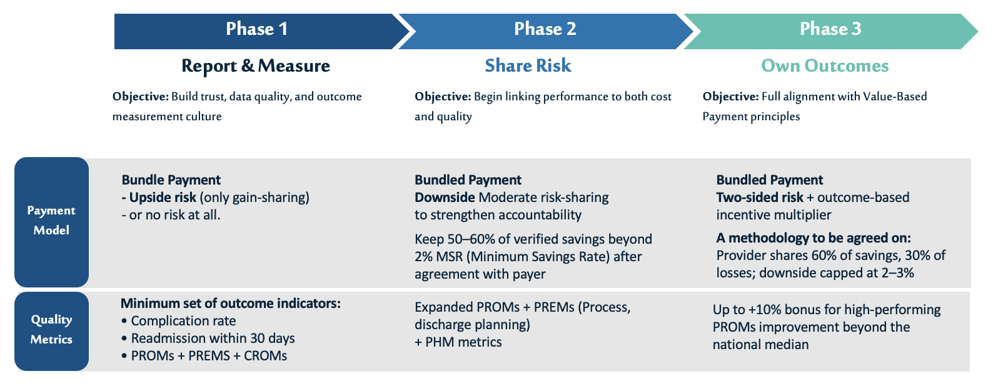
Given this roadmap, gating criteria to support the phased move was developed to ensure that progression between phases is based on demonstrated patient outcome, data readiness, and provider capability while safeguarding patient outcomes and market stability.

The Minimum Savings Rate (MSR) is the minimum percentage savings below the benchmark that must be achieved before the provider earns shared savings payments; for example, with a 2% MSR, a provider achieving only 1.5% savings receives the bundled payment only, while savings of 3% would trigger incentive payments on the 1% exceeding the threshold.
- Note for reviewer: An MSR calibration subsection or annex can be added, however it is technical.

3.2 Implementation of roadmap and gating criteria

Gating criteria to move from Phase 1 → Phase 2
(Measure & Validate → Shared Accountability)

Category | Criterion | How to Demonstrate | Verification Method
Data Completeness | ≥85% outcome measure completion | Submit data quality report showing numerator/denominator for each measure | CHI Data
PROMs | Collection for ≥70% of eligible cases | Show PROMs response rates by quarter; implement improvement plan if below target | Quarterly reporting
Coding Accuracy | ±5% variance | Complete external coding audit; implement coder training for discrepancies | Independent audit firm
Outcome Performance | No significant deterioration | Present risk-adjusted outcome trends vs. Baseline; investigate any adverse signals | Statistical analysis by CHI
Governance | Named VBC lead (has access to business owners such as medical team, finance and others) | Provide role description, authority matrix, and reporting structure
Care Pathway | Documented protocol | Submit clinical pathway document showing decision points, roles, timing | Clinical review
Settlement Compliance | 100% on-time submissions | Zero late submissions in past 12 months | Regulator tracking
Contracting | Agreement | Signed methodology addendum covering risk adjustment, benchmarking, MSR | Contract review

Gating criteria to move from Phase 1 → Phase 2  (Measure & Validate → Shared Accountability) | Gating criteria to move from Phase 2 → Phase 3  (Shared Accountability → Full Ownership)
A. Data & Measurement Readiness  - ≥85% completeness in required outcome measures  - PROMs collected for ≥70% of eligible cases (To be checked with PRM team)  - Coding accuracy within acceptable audit variance (e.g., ±5%). (To be checked with HIM team)  B. Performance Stability  - Risk-adjusted outcome indicators do not demonstrate statistically, or clinically significant deterioration compared to the agreed baseline period.  - Readmission/complication rates within expected risk-adjusted ranges  - Settlement frequency, data cut-off points, and reconciliation rules were met.  C. Governance & Capability provided by the provider has:  - Named VBC clinical lead  - Internal performance review process  - Documented care pathway for the bundle  D. Contracting Readiness, the parties must have an agreement on:  - Risk adjustment method  - Benchmark methodology  - MSR definition and application  - Minimum number of patients in a contractual period. | A. Financial Performance Maturity  - Demonstrated savings in ≥1 cycle without quality deterioration  - No major disputes in reconciliation or benchmarking  B. Outcome Performance  - Statistically significant improvement in ≥1 outcome metric or  - Sustained performance above national or market median  C. Risk Management Capability  Provider demonstrates:  - Internal cost control mechanisms  - Ability to absorb limited downside (financial reserves or governance approval)  D. Advanced Measurement  - PROM completeness ≥85% (or Completeness of ≥ 80% of the entire measure set (this aligns with ICHOM standards and includes PREMs, PROMs and CROMs)  - Ability to stratify outcomes by risk group or severity  E. Strategic Commitment to:  - Two-sided risk  - Outcome-linked downside exposure  - Multi-year contract horizon

Incentives Examples Tables
VBC Phase | Financial Incentives | Non-Financial Incentives
Phase 1: Report & Measure | • An incentive for reporting data  • Performance reporting support payments | • Technical assistance  • Access to analytics dashboards  • Providers are rewarded for participating in/and sharing data, with no financial penalties.
Phase 2: Share Risk | • Shared savings payments  • Limited financial risk with caps | • Reduced administrative burden  • Faster contract renewals  Increase in Patient Volume
Phase 3: Own Outcomes | • Outcome-based payments  • Long-term contract stability | • Strategic partnership recognition  • Public reporting of high performance (where appropriate)  • Priority participation in advanced initiatives

4. Contract Design and Payment Structures for Value-Based Contracting
To ensure consistency, transparency, and regulatory alignment, all value-based contracts implemented under these guidelines shall include, at a minimum, the clauses set out in this section. These clauses establish the foundational requirements necessary for credible outcome measurement, fair financial settlement, patient protection, and effective regulatory oversight.
The inclusion of these clauses does not prescribe specific commercial terms or prices. Still, it defines the minimum structural and governance elements required for value-based contracting arrangements within the Saudi private health insurance market.
A contract guideline (annexe 1) which was released by CHI, with an example of 1 bundle payment (TNR) that aligns with the bundle journey and the outcomes approved by CHI.

4.1 Scope of Services and Episode Definition
Each contract shall clearly define the scope of services covered, including:
- The covered episode or care pathway, with explicit start and end points of clinical and financial accountability
- Included services across the full care cycle (pre-intervention, intervention, and post-intervention phases)
- Explicit exclusions, carve-outs, and services not covered under the contract
- Rules governing transfers, referrals, complications, and readmissions related to the episode
Episode definitions shall be clinically coherent, aligned with approved benefit packages, and suitable for outcome and cost measurement.

4.2 Patient Eligibility, Attribution, and Volume Thresholds
Contracts shall specify:
- Patient eligibility criteria and exclusion rules
- Attribution methodology for assigning accountability to the provider (prospective or retrospective, as applicable)
- Minimum eligible case volume per contract period required to support statistical reliability and fair performance assessment
- Handling of patient choice, provider switching, and continuity of care

4.3 Outcome, Quality, and Performance Measures
Each contract shall include a defined set of outcome and quality measures, specifying:
- Clinical outcome indicators relevant to the episode or population
- Patient-Reported Outcome Measures (PROMs), and Patient-Reported Experience Measures (PREMs) where applicable
- Safety and appropriateness indicators, as relevant
- Measure definitions, numerators, denominators, exclusions, and reporting frequency
- Time horizon of data collection
Contracts shall clarify whether measures function as:
- Eligibility or quality gates.
- Performance thresholds or financial modifiers affecting settlement.

4.4 Risk Adjustment and Case-Mix Protection
Contracts shall specify the risk adjustment methodology applied to outcome and cost evaluation, including:
- Variables used for risk adjustment (e.g. clinical severity, comorbidities, demographic factors) where outcomes or costs influence financial settlement.
- Treatment of high-risk or outlier cases
- Safeguards against risk selection and inappropriate case exclusion

4.5 Benchmarking and Economic Parameters
Each contract shall document:
- Baseline period used to establish benchmarks and benchmark calculation methodology
- Treatment of outliers and catastrophic cases
- Minimum Savings Rate (MSR) and/or Minimum Loss Rate (MLR), where applicable
- Risk corridors, stop-loss, or protection mechanisms

The contract should also include clauses on financial incentives, risk sharing, and settlement that align with the regulators’ RCM policies. Data sources, patient protection and Access Safeguards are also important clauses. In the same contrast, the clauses related to contract duration, modification, dispute resolution, and termination (11).

Conclusion

Value-Based Contracting represents a critical mechanism for translating Saudi Arabia’s VBHC vision into contractual reality within the private health insurance sector. This can be done by building on existing bundled payment initiatives and applying a phased, evidence-informed approach supporting:
- Improved outcomes for a healthy nation,
- Sustainable provider participation,
- Long-term efficiency and resilience of the private health insurance market.
At a macroeconomic level, improved outcomes and reduced avoidable utilization contribute to labor productivity, mitigate healthcare cost inflation pressures, and support the long-term affordability and sustainability of private health insurance, in alignment with Vision 2030 objectives.

References (to be added from the library):
1. Porter M. Redefining health care: creating value-based competition on results: Harvard Business Press; 2006.
2. Porter ME. What is value in health care? N Engl J Med. 2010;363(26):2477-81.

- OECD. Innovative Providers’ Payment Models for Promoting Value-Based Health Systems. Organisation for Economic Co-operation and Development (2023).
- MedLibreText. 5.3: Value-Based Contracting in Healthcare (LibreTexts, 2024).
- Outland, B. E. Modernizing Risk Adjustment in Health Care: A Position (Annals of Internal Medicine, 2025).
- Panturu, A. A Framework for the Design of Risk-Adjustment Models (Health Services Research, 2025).
- Conrad, D. A. The Theory of Value-Based Payment Incentives and Their Outcomes (Health Services Research, 2015).

Annexes (contract template, principles map, measure specs)

ANNEXE 1: Contract template
Screenshots of the CONTRACT guide.

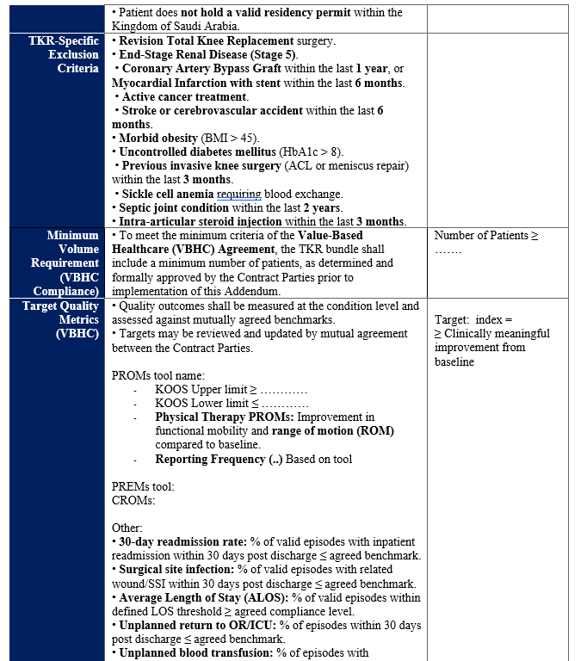

ANNEXE 2: VBC principles
VBC Principle | How the Principle Is Operationalized in the VBC | Regulatory Intent
Value Definition (Outcomes relative to cost) | Each bundle defines a fixed episode price covering pre-, intra-, and post-intervention care. Performance is assessed using outcome and quality indicators tied to the episode rather than individual services. | Shift providers focus from service volume to episode-level value.
Outcome Orientation | Bundles include mandatory outcome and/or quality measures (clinical outcomes, complications, readmissions, PROMs where feasible). Financial incentives are applied only if outcome thresholds are met. | Ensuring bundles evolve beyond price-based reimbursement.
Fairness and Patient Protection | Risk adjustment is applied to outcome and cost evaluation. Exclusion criteria (e.g., extreme complexity) and stop-loss mechanisms are defined. Providers remain accountable for clinical appropriateness and continuity of care. | Prevent risk selection and under-provision of care.
Transparency and Predictability | Episode definitions, measure specifications, benchmark methodology, and settlement rules are documented and shared ex-ante with providers and payers. | Reduce disputes and enhance provider confidence.
Shared Accountability | Providers are accountable for care delivery and outcomes within the episode; payers are accountable for timely data provision, beneficiary eligibility confirmation, and settlement. | Balance responsibilities across contracting parties.
Phased Risk Adoption | Initial bundles focus on fixed prices and outcome-linked upside incentives. Two-sided risk may be introduced in later phases for providers demonstrating readiness. | Protect market stability and provider sustainability.
Data Integrity and Measurement Credibility | Bundles rely on agreed data sources (claims, clinical records, outcome tools). Providers are required to meet minimum data completeness and coding standards. | Ensure credibility of performance assessment.
Continuous Improvement | Bundle performance reports are used to identify variation, inform pathway refinement, and update outcome benchmarks over time. | Promote system learning and quality improvement.
Alignment with National Objectives | Bundle selection and outcome focus align with Vision 2030 goals, benefit package optimization, and sustainability of private health insurance. | Ensure system-level impact beyond individual contracts.

ANNEXE 3: Value-Based Contracting Readiness Checklist (Suggestion example)
Area | Check
Governance | ☐ A responsible person/team for value-based contracts is identified
Data | ☐ Ability to collect and report the required outcomes  PROMs Data are collected for the condition to be contracted over.
Baseline | ☐ Current performance baseline is available
Monitoring | ☐ Performance can be reviewed regularly
Operations | ☐ Care processes related to the contract are in place
Financial Understanding | ☐ Basic understanding of incentives and financial risk
Contracting | ☐ Access to legal or contracting support

