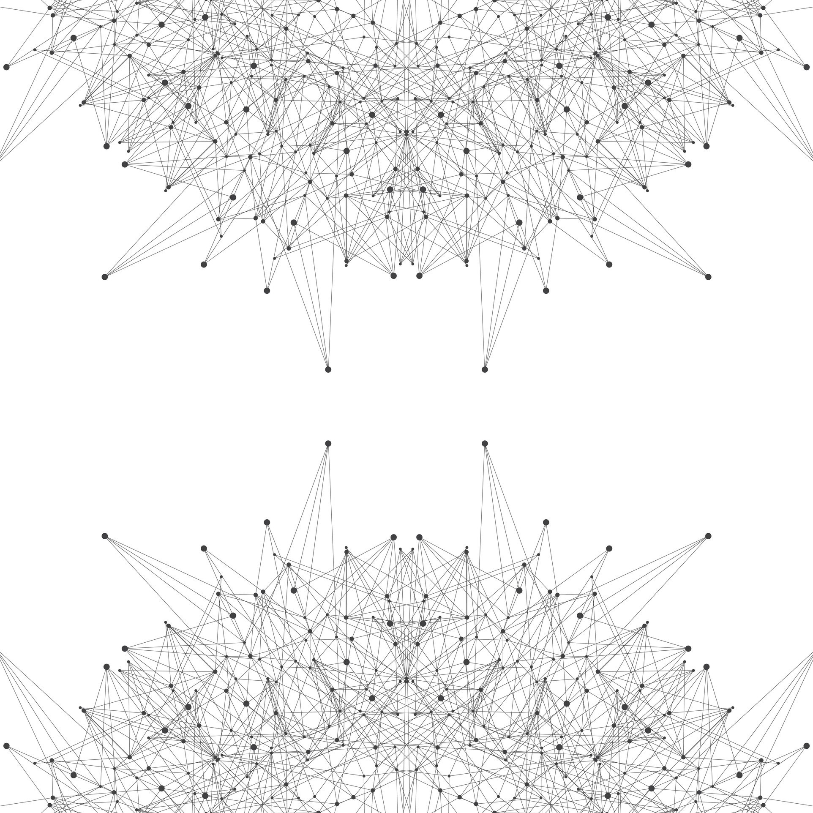

SCIENCEOPEN PROPOSAL

Saudia Arabian Preprint Repository

Berlin, 10 April 2024

Stephanie Dawson, PhD
ScienceOpen GmbH
Pappelallee 78/79
10437 Berlin, Germany
Tel: +49-176-72614581
Stephanie.Dawson@ScienceOpen.com



SCIENCEOPEN PROPOSAL
A Saudia Arabian Preprint Repository
ScienceOpen has been innovating in the fields of open access, preprints and open peer review from its start in 2013 in Berlin and Boston. The ScienceOpen platform provides a unique publishing environment embedded within a discovery and communication infrastructure of over nearly 100 million article records with essential built-in features such as preprint aggregation, open peer review and versioning that meet the full spectrum of requirements of Saudia Arabia for a preprint repository. ScienceOpen has worked with a range of multilingual publishers all over the world and has developed attractive solutions for the challenges of the Arabic language in a discovery context.
ScienceOpen proposes a preprint publication and open peer review forum as an independent subdomain, powered by the ScienceOpen technology. It will have its own URL and independent branding. Authors and reviewers can register on the platform and opt-in to e-mail communication. Managers can have access to a full set of usage analytics via Google or Matomo Analytics. A current example of this set up is the Drug Repurposing Central https://drugrepocentral.scienceopen.com/ publishing portal created for the EU funded drug repurposing project REPO4EU (Figure 1). A similar portal for open review of preprints was also created for the University College London.

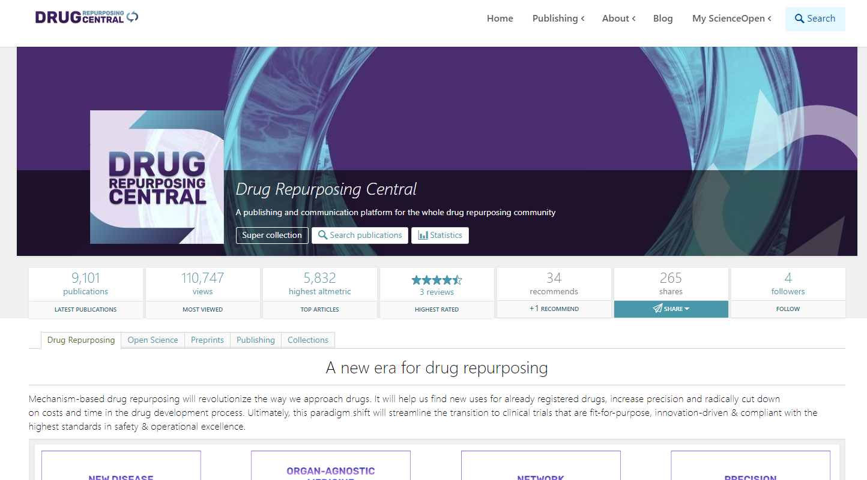
Figure 1

Preprint publishing and quality control
Preprints can be submitted through a simple online interface that provides state-of-the-art metadata capture and quality control mechanisms. An ORCID ID is required from the corresponding author and further ORCID IDs can be added for all authors, institutional affiliations can be easily extended with a ROR ID from the Research Organization Registry, funding bodies can be added from the Open Funder Registry. The interface also includes a mandatory data availability statement with links to open data repositories to increase the awareness of FAIR Data principles. The goal of all of these persistent identifiers is to increase the discoverability of each preprint within the larger body of scholarly literature. The submission form can be viewed on the ScienceOpen Preprints site by clicking “Submit a manuscript”.
An AI-driven check for scientific rigor powered by SciScore and a plagiarism check via Crossref/iThenticate can be integrated into the submission process. Preprint submissions must be approved by an editor before public posting in the system. The system strives to provide a combination of digital support and human interaction to ensure the research integrity of all preprints posted.
Further, a human editorial check for content (e.g., is it actual research? Does it contain potentially harmful content/profanities, etc.? Have ethical clearance/funding details been provided? Is the author list complete?) and authorship (e.g., have they valid profiles? Does their publication history and affiliation/department match the topic of the paper?) can be performed both on English and Arabic content.
Upon editorial acceptance, the preprint is posted publicly and a permanent preprint DOI is deposited at Crossref. All preprints are clearly flagged as “Preprint” and provided with a cover page that explains that this work has not undergone expert review. The site offers automatic integration with ORCID to deposit metadata of published preprints into an author’s profile. All content is indexed in Google Scholar and Baidu Scholar and further indexing platforms. Long-term archiving is provided by CLOCKSS. All preprints are posted with a Creative Commons open access attribution license CC BY 4.0.
After an article has been finally published in a peer-reviewed journal, a link between the preprint and the published article can be established and displayed for better integration of preprints into the scholarly record. Here is an example: https://www.scienceopen.com/document?vid=497478a9-d037-445f-a216-7f1b6a51e199.
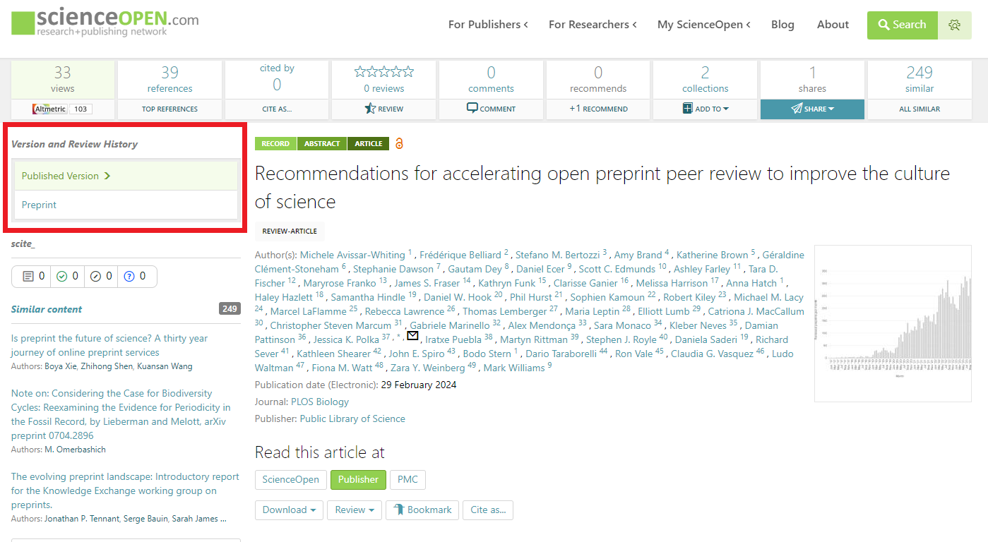

Managing Open Peer Review
An attractive interactive interface is essential for the success of the platform. The ScienceOpen infrastructure offers fields for commenting, recommending, citing and sharing preprints, as well as writing public peer reviews. An ORCID ID ensures that comments are made only with an author’s own identity, as we believe that openness creates a more civil environment. Reviewing an article requires authorship of 5 publications but exceptions can be made by editors. The interface allows for reviews to be written in English or Arabic or both. For preprints that may use the open reviews as part of their submission to a peer-reviewed journal, English-language reviews may be more portable. All peer reviews receive a Crossref peer review DOI and are linked to the reviewer’s ORCID profile.
Both authors and editors may invite and remind reviewers directly through the system. Reviewers can be invited by simply entering an e-mail address or through a search of related articles and registered users. A peer review dashboard gives editors oversight over the progress of preprints.
Authors can submit revised versions, including notes to the reviewers about what was improved. Each revised version receives its own Crossref DOI and is presented as a version set on the platform.

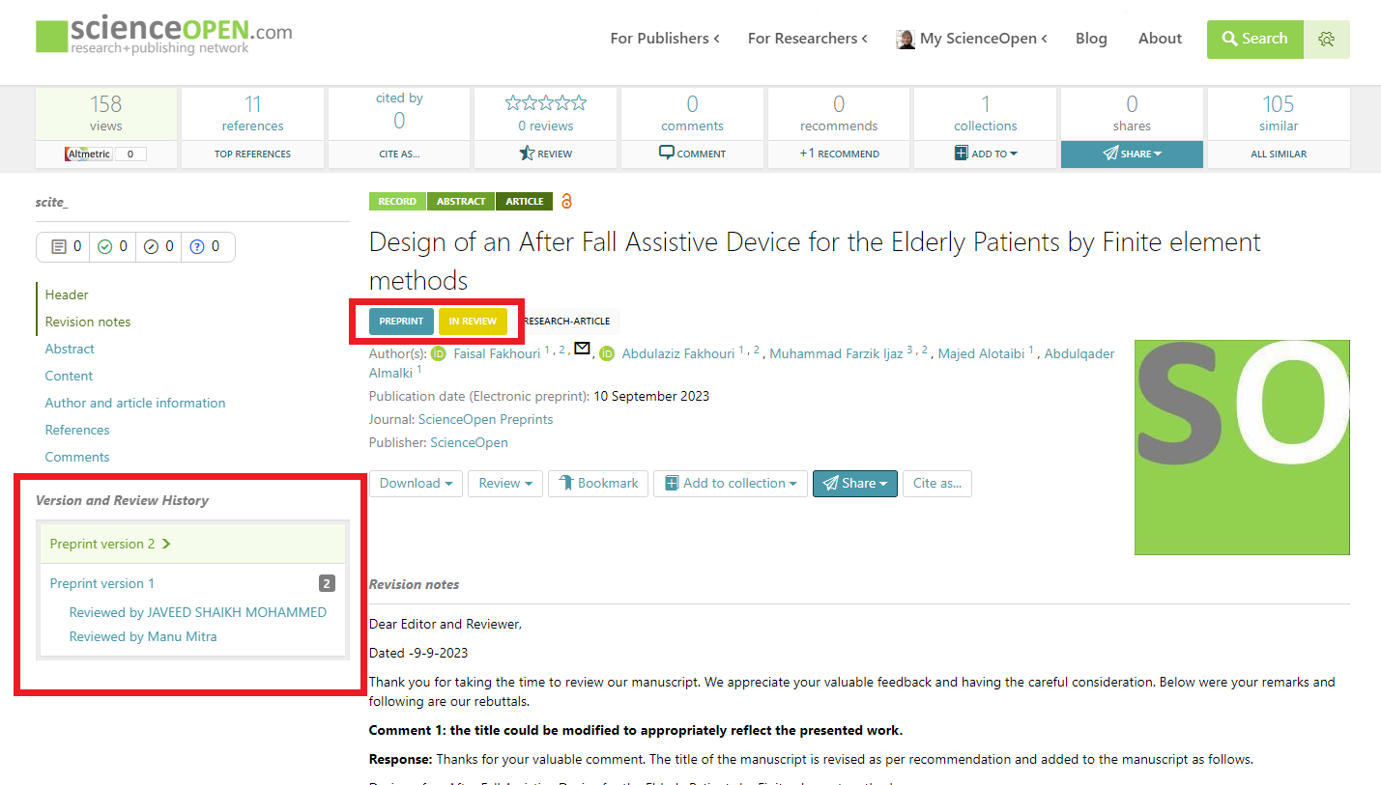
Figure 2.

Arabic Metadata and Interfaces
ScienceOpen currently has partnerships with the King Salman Center of Disability Research, Qatar University Press, Naif Arab University for Security Sciences, Bethlehem University, and Institute of Policy Studies, Islamabad, among others. Currently all HTML interfaces (for manuscript submission, writing reviews and lay summaries and Collection information interfaces) allow for right to left scripts when capturing metadata. ScienceOpen can display attractive bilingual metadata and ensure that this metadata is shared in a format compatible with international discovery engines and Crossref metadata affiliates. Here is an example from Qatar University Press indexed on the ScienceOpen platform: https://www.scienceopen.com/document?vid=ca3a5ce1-3a2b-41aa-b6ed-d92fc0eeaeed. Here is an example from a hosted article from the Bethlehem University Journal: https://www.scienceopen.com/hosted-document?doi=10.13169/bethunivj.39.2-2022.03.
Site navigation menus at the top of the page can be displayed in Arabic and English language. Instructions on the manuscript submission form can be added in Arabic language. The full extent of customization must be assessed with the customer. Some buttons have a universal function across the ScienceOpen site and would not be able to easily be displayed in Arabic. We assume that Arabic language text will be provided by the customer.

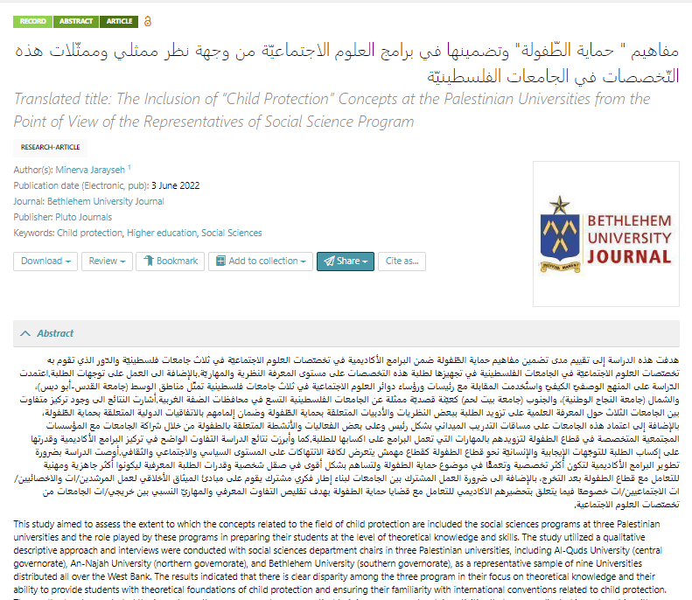
Figure 3.

Metrics of Success
ScienceOpen platform has built-in a wide range of metrics for impact and attention. Usage, citations (via ScienceOpen and Scite AI) and Altmetric Score, comments, recommendations and shares are tracked on the platform and can be viewed at the preprint-level (see example and Figure 3 ) or cumulated at the collection level for the entire subdomain.
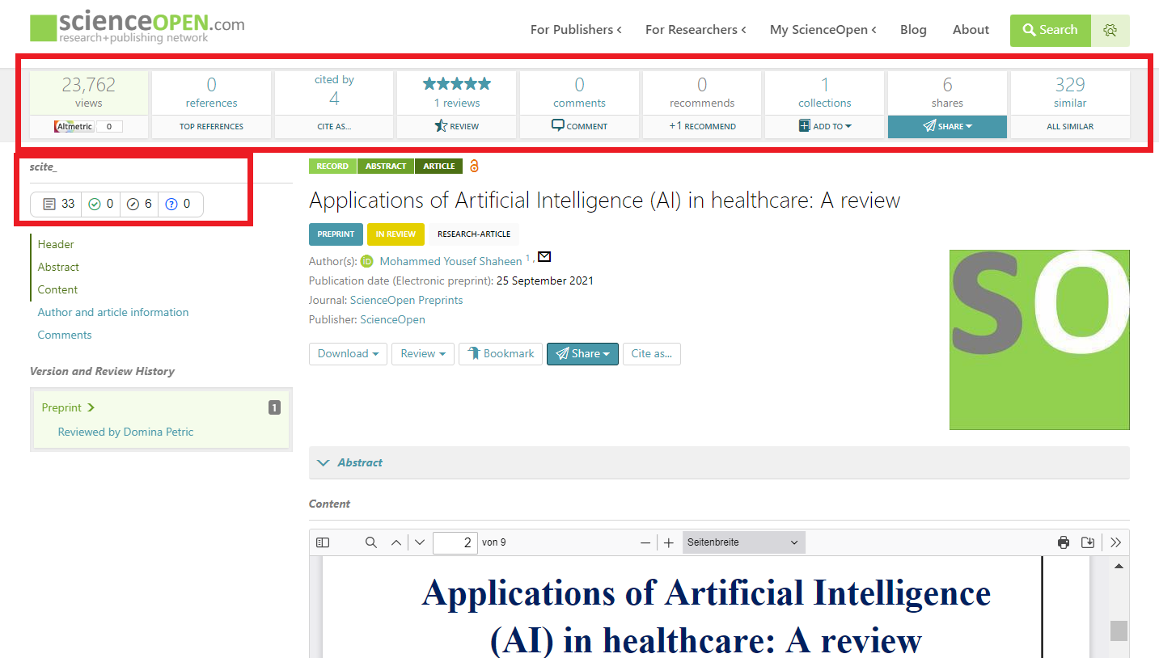

Most of these metrics are searchable/filterable categories so that top preprints can be easily identified. Each author registered on ScienceOpen can track the development of their usage and metrics over time.
The system automatically provides monthly reports of the geolocation of usage and a full excel report of usage activity at the preprint level that are delivered by e-mail and can be downloaded any time from the platform by editors with admin status.

Support
The software and database architecture of the ScienceOpen platform with its existing technological infrastructure for scientific publishing has been deployed since 2013 and will be customized to meet the requirements for the Repository. ScienceOpen will operate, maintain and update the platform and its software on a frequent basis so as to reflect the state of the art technological developments, updates with latest versions of the deployed technical solution and evolving user requirements and feedback.
ScienceOpen provides extensive support with outreach and marketing. ScienceOpen has an active blog channel that reaches ca. 40k users is active in all social media channels but particularly Twitter, Facebook, LinkedIn, Google+ and Reddit. With 187k followers on Twitter and ca. 57k on Facebook, ScienceOpen is happy to support customers by sharing and re-sharing new content on the site. We would support the launch of a new site with a press release to the main publishing industry channels and beyond, a blog post announcement and activity on all social media channels. ScienceOpen regularly promotes partner activities in international conferences, webinars, videos and more.
Basic customer service and editorial support is provided, and more extensive editorial services can be arranged.
ScienceOpen offers a dynamic team with state-of-the-art software, a proven track record and an innovative approach to launching a successful preprint server for Saudia Arabia. This platform could be extended in a number of ways including starting new open access journals, promoting topical collections, creating collections around particular institutions and more.

About ScienceOpen
Introduction
ScienceOpen, based in Berlin and Boston, was established in 2013 by Alexander Grossmann (previously publishing director and managing board member at Wiley-VCH, Wiley-Blackwell, Springer and De Gruyter for total 12 years in the publishing industry) and Tibor Tscheke (a database and XML pioneer who co-worked to develop the current electronic publishing standards). ScienceOpen.com is a freely accessible network for aggregating, sharing, and evaluating research information with currently 95 million Open Access articles and records. We provide contextual insights for content from all academic disciplines and license types, as well as tools for publishers to raise the visibility of their content.
Mission Statement
We are committed to Open Science. We believe that free access to knowledge drives creativity, innovation and development. Our mission is to facilitate open and public communication between academics and to allow ideas to be judged on their merit, regardless of where they come from. But that can mean more than just Open Access publishing. Our goal is to promote open communication across all scholarly disciplines in a fair and legal manner together with our publisher partners. We believe that the only way forward is through constructive engagement between all stakeholders in scholarly communication, and that operating within a legal framework will prove to be the most beneficial for all parties.
Key Features
ScienceOpen is a freely accessible discovery platform with 95 million article records, smart search and filtering tools and interactive features for the research community, as well as context marketing opportunities for publishers. ScienceOpen creates context for your content by tracking citations between all of the articles and records within the database. Search results can therefore be filtered by citation number. ScienceOpen also provides Altmetric™ scores on all articles, making search results filterable by social media mentions. This unique combination of filtering options gives users a broader picture of the online attention surrounding a given research field. For publishers, ScienceOpen offers opportunities to promote journals on all relevant articles within the 95 million articles in database.
ScienceOpen Aggregation
ScienceOpen aggregates Open Access articles from a variety of sources, among them the PubMed Central Open Access Data Subset, SciELO, ORCID and arXiv. We work with traditional subscription journals directly from publishers as well, creating links pointing back to publishers’ websites.
Every article on ScienceOpen is analysed by our aggregation engine. By extracting references from articles and generating new article records from them, we create the context environment around your content. Within this environment the reader is directed back to your original content, increasing the visibility of your research. The context of an individual research article is revealed in discovery tools such as the “Similar article” recommendation engine, top cited authors, top references sorted by citations, links to publisher, journal, authors and more to find similar content on ScienceOpen.
From its core data therefore, the ScienceOpen database builds up an aggregation of the best content available – because all of the records generated from the input articles have been cited at least once. This process increases the likelihood that users will find relevant content and explore further.
An Interactive Platform
ScienceOpen is a freely accessible online platform and no registration is required. Everybody can read metadata and open access papers and share them with others via e-mail or social media. Users are invited to add to the context of an article by commenting, reviewing, recommending or adding to a curated Collection.
Other functions, such as publishing, networking, following or establishing collections, reviewing, rating and commenting, require registration at ScienceOpen. Please note that registration and the use of private collaboration and networking tools are completely free of charge.
As a rule, users who want to submit a review or comment must review under their full name and everyone can read their comments. Users must verify their identity via ORCID and their comments and reviews are visible to the public. Only authenticated scientists registered at ScienceOpen via ORCID with at least 5 articles assigned to their ORCID account (please see our User categories ) may officially review a paper. Members with at least one publication assigned to their ORCID account are able to comment on a paper. Our editors may step in at any point in the process should there be concern about any misuse of the ScienceOpen reviewing and commenting tools.
User Authentication via ORCID
We intend to create a space for reliable and transparent scholarly discourse. This discourse takes place in the open and requires all participants to express their opinion under their true identity. In order to prevent misuse of our reviewing and commenting functions, registration at ScienceOpen requires a previous registration at ORCID, a non-profit organization that provides unique researcher identifiers. Profile information is synchronized with ORCID which allows easy management of profile data across a number of scientific platforms.
Some of our collaboration partners and customers:
ScienceOpen is a member of /has integrations with Altmetric, ORCID, CrossRef, OASPA and ALPSP.
ScienceOpen has worked with major publishers including Emerald Publishing, Karger Publishers, Hogrefe Publishing, EDP Sciences, Pluto Journals, Michigan Publishing, Portland Press, Bioscientifica, UCL Press, De Gruyter Publishers, BCS, Dove Medical Press, BMJ, Cold Spring Harbor Laboratory Press, Thieme, PeerJ and more. Explore over 400 featured collections.

For further information about this offer please contact:

Stephanie Dawson, PhD
ScienceOpen GmbH
Pappelallee 78/79, 10437 Berlin, Germany
Tel: +49-30-6098490-277
Skype: dawson_scienceopen
Mobile: +49-176-72614581
Stephanie.Dawson@ScienceOpen.com

