**ThingSpeak**

ThingSpeak™ is an IoT analytics platform service that allows you to aggregate, visualize and analyze live data streams in the cloud. ThingSpeak provides instant visualizations of data posted by your devices to ThingSpeak. With the ability to execute MATLAB® code in ThingSpeak you can perform online analysis and processing of the data as it comes in. ThingSpeak is often used for prototyping and proof of concept IoT systems that require analytics.

Internet of Things (IoT) describes an emerging trend where a large number of embedded devices (things) are connected to the Internet. These connected devices communicate with people and other things and often provide sensor data to cloud storage and cloud computing resources where the data is processed and analyzed to gain important insights. Cheap cloud computing power and increased device connectivity is enabling this trend.

IoT solutions are built for many vertical applications such as environmental monitoring and control, health monitoring, vehicle fleet monitoring, industrial monitoring and control, and home automation.

At a high level, many IoT systems can be described using the diagram below:

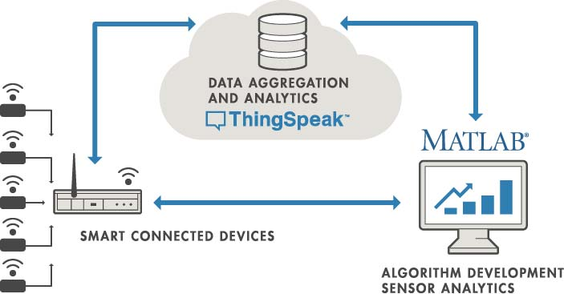

On the left, we have the smart devices (the “things” in IoT) that live at the edge of the network. These devices collect data and include things like wearable devices, wireless temperatures sensors, heart rate monitors, and hydraulic pressure sensors, and machines on the factory floor.

In the middle, we have the cloud where data from many sources is aggregated and analyzed in real time, often by an IoT analytics platform designed for this purpose.

The right side of the diagram depicts the algorithm development associated with the IoT application. Here an engineer or data scientist tries to gain insight into the collected data by performing historical analysis on the data. In this case, the data is pulled from the IoT platform into a desktop software environment to enable the engineer or scientist to prototype algorithms that may eventually execute in the cloud or on the smart device itself.

An IoT system includes all these elements. ThingSpeak fits in the cloud part of the diagram and provides a platform to quickly collect and analyze data from internet connected sensors.

**Features**

ThingSpeak allows you to aggregate, visualize and analyze live data streams in the cloud. Some of the key capabilities of ThingSpeak include the ability to:

* Easily configure devices to send data to ThingSpeak using popular IoT protocols.
* Visualize your sensor data in real-time.
* Aggregate data on-demand from third-party sources.
* Use the power of MATLAB to make sense of your IoT data.
* Run your IoT analytics automatically based on schedules or events.
* Prototype and build IoT systems without setting up servers or developing web software.
* Automatically act on your data and communicate using third-party services like Twilio® or Twitter®.