BUZZER

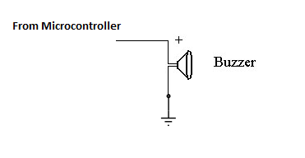

A buzzer or beeper is a signaling device, usually electronic, typically used in automobiles, household appliances such as a microwave oven, or game shows. It most commonly consists of a number of switches or sensors connected to a control unit that determines if and which button was pushed or a preset time has lapsed, and usually illuminates a light on the appropriate button or control panel, and sounds a warning in the form of a continuous or intermittent buzzing or beeping sound. Initially this device was based on an electromechanical system which was identical to an electric bell without the metal gong (which makes the ringing noise).

Often these units were anchored to a wall or ceiling and used the ceiling or wall as a sounding board. Another implementation with some AC-connected devices was to implement a circuit to make the AC current into a noise loud enough to drive a loudspeaker and hook this circuit up to a cheap 8-ohm speaker. Nowadays, it is more popular to use a ceramic-based piezoelectric sounder like a alert which makes a high-pitched tone. Usually these were hooked up to "driver" circuits which varied the pitch of the sound or pulsed the sound on and off.

Circuit description:
The circuit is designed to control the buzzer. The buzzer ON and OFF is controlled by Microcontroller. High Pulse is used for Buzzer ON by microcontroller and Low Pulse is for Buzzer OFF.

