**MAKERERE UNIVERSITY**

COCIS

**BSE 3208: Distributed Systems Development**

**Exercise 2 (PEER TO PEER)**

CRANE CLOUD

GROUP E-K

**GROUP MEMBERS**

|  |  |  |
| --- | --- | --- |
| **NO.** | **NAME** | **REG NO.** |
| 1 | MUGIRE BRUNO | 18/U/23422/EVE |
| 2 | BENGANA ANTHONY | 17/U/3569/EVE |
| 3 | SSEBALAMU RONALD GGAANYA | 18/U/23401/EVE |

GITHUB LINK: <https://github.com/theebruno/cranecloud>

INTRODUCTION:

Peer-to-Peer(P2P) Technologies are being widely used for sharing the data between the servers and the clients. One of the major technology for file sharing that is implemented nowadays is the Napster-Style Peer-to-Peer File Sharing System.

The older versions of the systems used to have a single server which stores the files in its directory that are received from the clients. The major drawback of these systems was that if a new file has been created in one of the peers, it must be transferred to the server before another peer can access it, which delays the process of transfer from one peer to another. This can be conquered using the Napster system which allows the peer to peer file transfer.

SYSTEM REQUIREMENTS:

* Python 3.7.0(3.5+)
* Command line terminal

DESIGN:

The entire project is designed using Python where we have used the concepts of Socket Programming and Multi-threading. For establishing the connections between the Server and the Clients, I have used TCP/IP protocol using the sockets.

Major Components of the Project:

* Server
* Client

Server (Central Index Server):

This server indexes the content of all the peers (i.e., Clients) that register with it. It also provides add, list, search, download facilities to peers.

Client:

As a client, the user specifies a file name with the indexing server using "lookup". The indexing server returns a list of all other peers that hold the file. The user can pick one such peer and the client then connects to this peer and downloads the file using the necessary command.

Major function of the peer:

* Download

As a server, the peer waits for requests from other peers and sends the requested file when receiving a request. The Peers (i.e., Clients) here, act as both the client and the server. This central index server indexes the files. The peer acts a client to download the files from other peers into its directory.

The peers provide the following interface to the users:

1. Add – registers the file into the server.

2. Lookup– searches the server for a file and returns the list of Clients.

3. Download – downloads the file from another Client.

4. List All – lists all the files from another Clients.

5. Shutdown – disconnects the Client from the network.

POSSIBLE IMPROVEMENTS:

Could develop a User Interface

**EXECUTION OF THE PROJECT:**

**Connecting**

Server:

We Start our execution by executing the Server –



Now Server will open its Socket and waits for the Clients to get connected

Client:

We will register 3 clusters(Peers) on to the Server as per the project requirement

Each cluster has his/her own storage space. Since we are testing multiple clusters on a single machine, the `client.py` file should be copied to several different directories to simulate real situation i.e. mkango, mpologoma and chui

For mpologoma cluster –

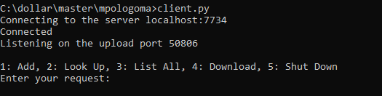

For mkango cluster -

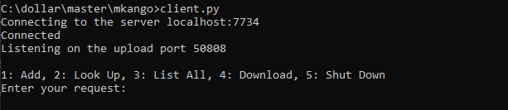

For chui cluster–

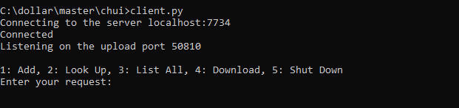

For server

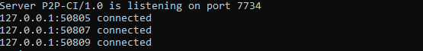

**Adding files to be shared in this test-**

Mpologoma cluster

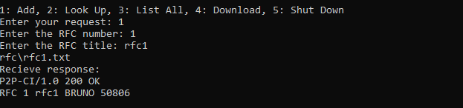

**Listing available files –**

Chui cluster

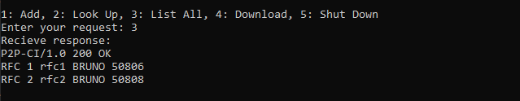

**Searching available files which shows who has the file.**

Mkango cluster

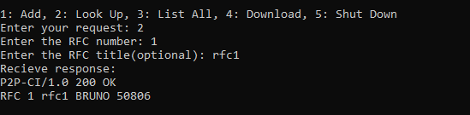

**Downloading a file.**

In this case from mpologoma cluster to mkango cluster

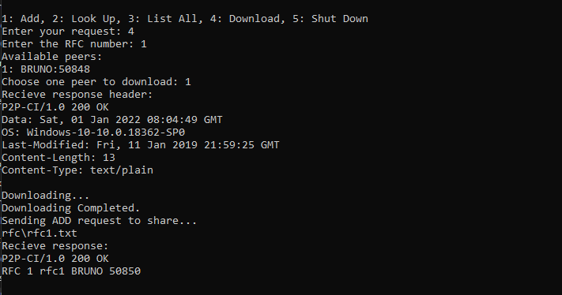

Here the rf1.txt from mpologoma is downloaded to the mkango server

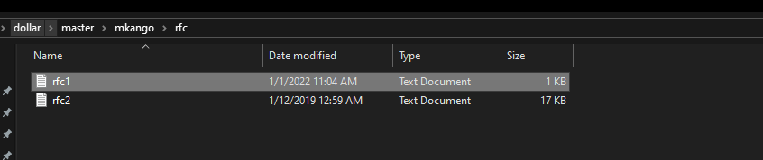

**Leaving network**

Mkango cluster is being disconnected

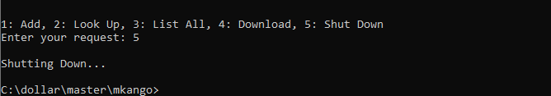

Server

C:\Users\BRUNO\AppData\Local\Microsoft\Windows\INetCache\Content.Word\pp89.png

Source Code

Client.py

|  |
| --- |
| import socket  import threading  import platform  import mimetypes  import os  import sys  import time  from pathlib import Path  class MyException(Exception):  pass  class Client(object):  def __init__(self, serverhost='localhost', V='P2P-CI/1.0', DIR='rfc'):  self.SERVER_HOST = serverhost  self.SERVER_PORT = 7734  self.V = V  self.DIR = 'rfc' # file directory  Path(self.DIR).mkdir(exist_ok=True)  self.UPLOAD_PORT = None  self.shareable = True  def start(self):  # connect to server  print('Connecting to the server %s:%s' %  (self.SERVER_HOST, self.SERVER_PORT))  self.server = socket.socket(socket.AF_INET, socket.SOCK_STREAM)  try:  self.server.connect((self.SERVER_HOST, self.SERVER_PORT))  except Exception:  print('Server Not Available.')  return  print('Connected')  # upload  uploader_process = threading.Thread(target=self.init_upload)  uploader_process.start()  while self.UPLOAD_PORT is None:  # wait until upload port is initialized  pass  print('Listening on the upload port %s' % self.UPLOAD_PORT)  # interactive shell  self.cli()  def cli(self):  command_dict = {'1': self.add,  '2': self.lookup,  '3': self.listall,  '4': self.pre_download,  '5': self.shutdown}  while True:  try:  req = input(  '\n1: Add, 2: Look Up, 3: List All, 4: Download, 5: Shut Down\nEnter your request: ')  command_dict.setdefault(req, self.invalid_input)()  except MyException as e:  print(e)  except Exception:  print('System Error.')  except BaseException:  self.shutdown()  def init_upload(self):  # listen upload port  self.uploader = socket.socket(socket.AF_INET, socket.SOCK_STREAM)  self.uploader.bind(('', 0))  self.UPLOAD_PORT = self.uploader.getsockname()[1]  self.uploader.listen(5)  while self.shareable:  requester, addr = self.uploader.accept()  handler = threading.Thread(  target=self.handle_upload, args=(requester, addr))  handler.start()  self.uploader.close()  def handle_upload(self, soc, addr):  header = soc.recv(1024).decode().splitlines()  try:  version = header[0].split()[-1]  num = header[0].split()[-2]  method = header[0].split()[0]  path = '%s/rfc%s.txt' % (self.DIR, num)  if version != self.V:  soc.sendall(str.encode(  self.V + ' 505 P2P-CI Version Not Supported\n'))  elif not Path(path).is_file():  soc.sendall(str.encode(self.V + ' 404 Not Found\n'))  elif method == 'GET':  header = self.V + ' 200 OK\n'  header += 'Data: %s\n' % (time.strftime(  "%a, %d %b %Y %H:%M:%S GMT", time.gmtime()))  header += 'OS: %s\n' % (platform.platform())  header += 'Last-Modified: %s\n' % (time.strftime(  "%a, %d %b %Y %H:%M:%S GMT", time.gmtime(os.path.getmtime(path))))  header += 'Content-Length: %s\n' % (os.path.getsize(path))  header += 'Content-Type: %s\n' % (  mimetypes.MimeTypes().guess_type(path)[0])  soc.sendall(header.encode())  # Uploading  try:  print('\nUploading...')  send_length = 0  with open(path, 'r') as file:  to_send = file.read(1024)  while to_send:  send_length += len(to_send.encode())  soc.sendall(to_send.encode())  to_send = file.read(1024)  except Exception:  raise MyException('Uploading Failed')  # total_length = int(os.path.getsize(path))  # print('send: %s | total: %s' % (send_length, total_length))  # if send_length < total_length:  # raise MyException('Uploading Failed')  print('Uploading Completed.')  # Restore CLI  print(  '\n1: Add, 2: Look Up, 3: List All, 4: Download\nEnter your request: ')  else:  raise MyException('Bad Request.')  except Exception:  soc.sendall(str.encode(self.V + ' 400 Bad Request\n'))  finally:  soc.close()  def add(self, num=None, title=None):  if not num:  num = input('Enter the RFC number: ')  if not num.isdigit():  raise MyException('Invalid Input.')  title = input('Enter the RFC title: ')  file = Path('%s/rfc%s.txt' % (self.DIR, num))  print(file)  if not file.is_file():  raise MyException('File Not Exit!')  msg = 'ADD RFC %s %s\n' % (num, self.V)  msg += 'Host: %s\n' % socket.gethostname()  msg += 'PORT: %s\n' % self.UPLOAD_PORT  msg += 'Title: %s\n' % title  self.server.sendall(msg.encode())  res = self.server.recv(1024).decode()  print('Recieve response: \n%s' % res)  def lookup(self):  num = input('Enter the RFC number: ')  title = input('Enter the RFC title(optional): ')  msg = 'LOOKUP RFC %s %s\n' % (num, self.V)  msg += 'Host: %s\n' % socket.gethostname()  msg += 'PORT: %s\n' % self.UPLOAD_PORT  msg += 'Title: %s\n' % title  self.server.sendall(msg.encode())  res = self.server.recv(1024).decode()  print('Recieve response: \n%s' % res)  def listall(self):  l1 = 'LIST ALL %s\n' % self.V  l2 = 'Host: %s\n' % socket.gethostname()  l3 = 'PORT: %s\n' % self.UPLOAD_PORT  msg = l1 + l2 + l3  self.server.sendall(msg.encode())  res = self.server.recv(1024).decode()  print('Recieve response: \n%s' % res)  def pre_download(self):  num = input('Enter the RFC number: ')  msg = 'LOOKUP RFC %s %s\n' % (num, self.V)  msg += 'Host: %s\n' % socket.gethostname()  msg += 'PORT: %s\n' % self.UPLOAD_PORT  msg += 'Title: Unkown\n'  self.server.sendall(msg.encode())  lines = self.server.recv(1024).decode().splitlines()  if lines[0].split()[1] == '200':  # Choose a peer  print('Available peers: ')  for i, line in enumerate(lines[1:]):  line = line.split()  print('%s: %s:%s' % (i + 1, line[-2], line[-1]))  try:  idx = int(input('Choose one peer to download: '))  title = lines[idx].rsplit(None, 2)[0].split(None, 2)[-1]  peer_host = lines[idx].split()[-2]  peer_port = int(lines[idx].split()[-1])  except Exception:  raise MyException('Invalid Input.')  # exclude self  if((peer_host, peer_port) == (socket.gethostname(), self.UPLOAD_PORT)):  raise MyException('Do not choose yourself.')  # send get request  self.download(num, title, peer_host, peer_port)  elif lines[0].split()[1] == '400':  raise MyException('Invalid Input.')  elif lines[0].split()[1] == '404':  raise MyException('File Not Available.')  elif lines[0].split()[1] == '500':  raise MyException('Version Not Supported.')  def download(self, num, title, peer_host, peer_port):  try:  # make connnection  soc = socket.socket(socket.AF_INET, socket.SOCK_STREAM)  # connect_ex return errors  if soc.connect_ex((peer_host, peer_port)):  # print('Try Local Network...')  # if soc.connect_ex(('localhost', peer_port)):  raise MyException('Peer Not Available')  # make request  msg = 'GET RFC %s %s\n' % (num, self.V)  msg += 'Host: %s\n' % socket.gethostname()  msg += 'OS: %s\n' % platform.platform()  soc.sendall(msg.encode())  # Downloading  header = soc.recv(1024).decode()  print('Recieve response header: \n%s' % header)  header = header.splitlines()  if header[0].split()[-2] == '200':  path = '%s/rfc%s.txt' % (self.DIR, num)  print('Downloading...')  try:  with open(path, 'w') as file:  content = soc.recv(1024)  while content:  file.write(content.decode())  content = soc.recv(1024)  except Exception:  raise MyException('Downloading Failed')  total_length = int(header[4].split()[1])  # print('write: %s | total: %s' % (os.path.getsize(path), total_length))  if os.path.getsize(path) < total_length:  raise MyException('Downloading Failed')  print('Downloading Completed.')  # Share file, send ADD request  print('Sending ADD request to share...')  if self.shareable:  self.add(num, title)  elif header[0].split()[1] == '400':  raise MyException('Invalid Input.')  elif header[0].split()[1] == '404':  raise MyException('File Not Available.')  elif header[0].split()[1] == '500':  raise MyException('Version Not Supported.')  finally:  soc.close()  # Restore CLI  # print('\n1: Add, 2: Look Up, 3: List All, 4: Download\nEnter your request: ')  def invalid_input(self):  raise MyException('Invalid Input.')  def shutdown(self):  print('\nShutting Down...')  try:  sys.exit(0)  except SystemExit:  os._exit(0)  if __name__ == '__main__':  if len(sys.argv) == 2:  client = Client(sys.argv[1])  else:  client = Client()  client.start() |

Server.py

|  |
| --- |
| import socket  import threading  import os  import sys  from collections import defaultdict  class Server(object):  def __init__(self, HOST='', PORT=7734, V='P2P-CI/1.0'):  self.HOST = HOST  self.PORT = PORT  self.V = V  # element: {(host,port), set[rfc #]}  self.peers = defaultdict(set)  # element: {RFC #, (title, set[(host, port)])}  self.rfcs = {}  self.lock = threading.Lock()  # start listenning  def start(self):  try:  self.s = socket.socket(socket.AF_INET, socket.SOCK_STREAM)  self.s.bind((self.HOST, self.PORT))  self.s.listen(5)  print('Server %s is listening on port %s' %  (self.V, self.PORT))  while True:  soc, addr = self.s.accept()  print('%s:%s connected' % (addr[0], addr[1]))  thread = threading.Thread(  target=self.handler, args=(soc, addr))  thread.start()  except KeyboardInterrupt:  print('\nShutting down the server..\nGood Bye!')  try:  sys.exit(0)  except SystemExit:  os._exit(0)  # connect with a client  def handler(self, soc, addr):  # keep recieve request from client  host = None  port = None  while True:  try:  req = soc.recv(1024).decode()  print('Recieve request:\n%s' % req)  lines = req.splitlines()  version = lines[0].split()[-1]  if version != self.V:  soc.sendall(str.encode(  self.V + ' 505 P2P-CI Version Not Supported\n'))  else:  method = lines[0].split()[0]  if method == 'ADD':  host = lines[1].split(None, 1)[1]  port = int(lines[2].split(None, 1)[1])  num = int(lines[0].split()[-2])  title = lines[3].split(None, 1)[1]  self.addRecord(soc, (host, port), num, title)  elif method == 'LOOKUP':  num = int(lines[0].split()[-2])  self.getPeersOfRfc(soc, num)  elif method == 'LIST':  self.getAllRecords(soc)  else:  raise AttributeError('Method Not Match')  except ConnectionError:  print('%s:%s left' % (addr[0], addr[1]))  # Clean data if necessary  if host and port:  self.clear(host,port)  soc.close()  break  except BaseException:  try:  soc.sendall(str.encode(self.V + ' 400 Bad Request\n'))  except ConnectionError:  print('%s:%s left' % (addr[0], addr[1]))  # Clean data if necessary  if host and port:  self.clear(host,port)  soc.close()  break  def clear(self, host, port):  self.lock.acquire()  nums = self.peers[(host, port)]  for num in nums:  self.rfcs[num][1].discard((host, port))  if not self.rfcs[num][1]:  self.rfcs.pop(num, None)  self.peers.pop((host, port), None)  self.lock.release()  def addRecord(self, soc, peer, num, title):  self.lock.acquire()  try:  self.peers[peer].add(num)  self.rfcs.setdefault(num, (title, set()))[1].add(peer)  finally:  self.lock.release()  # print(self.rfcs)  # print(self.peers)  header = self.V + ' 200 OK\n'  header += 'RFC %s %s %s %s\n' % (num,  self.rfcs[num][0], peer[0], peer[1])  soc.sendall(str.encode(header))  def getPeersOfRfc(self, soc, num):  self.lock.acquire()  try:  if num not in self.rfcs:  header = self.V + ' 404 Not Found\n'  else:  header = self.V + ' 200 OK\n'  title = self.rfcs[num][0]  for peer in self.rfcs[num][1]:  header += 'RFC %s %s %s %s\n' % (num,  title, peer[0], peer[1])  finally:  self.lock.release()  soc.sendall(str.encode(header))  def getAllRecords(self, soc):  self.lock.acquire()  try:  if not self.rfcs:  header = self.V + ' 404 Not Found\n'  else:  header = self.V + ' 200 OK\n'  for num in self.rfcs:  title = self.rfcs[num][0]  for peer in self.rfcs[num][1]:  header += 'RFC %s %s %s %s\n' % (num,  title, peer[0], peer[1])  finally:  self.lock.release()  soc.sendall(str.encode(header))  if __name__ == '__main__':  s = Server()  s.start() |