CIS 301: Logical Foundations of Programming

Practice Exam 1

**This test is closed-notes and closed-computers.**

(This exam is similar to a previous exam, but has been edited to match the new Logika format.)

Name: _______________________________________________________________________

1. (15 pts) Consider the following questions about logical analysis of conditional statements.

a) (7 pts) Consider the following code fragment:

num = 4;

if (x < 10 || (y > 100 && y < 200)) {

if (x >= 10) {

num = 18;

}

}

// 🡨 suppose we are right here

Suppose *num* has the value 18 immediately after the above code fragment finishes (i.e., at the point marked with the 🡨 just after the brackets). What can we conclude about *x* and *y*? Explain as concisely as you can.

Answer:

Since num was initially 4 and is now 18, we can conclude that we went inside both if-  
statements. This tells us that x < 10 || (y > 100 && y < 200) and also that x >= 10. Putting those  
together, we can conclude that the second side of the || in the first condition must have been  
true, since x can’t be both < 10 and also >= 10. This tells us that **x >= 10 and that 100 < y < 200**.

b) (8 pts) Consider the following code fragment:

num = 4;

if (val1 > 0 || val2 < 10) {

num = 7;

}

else if (val1 < 0) {

num = 10;

}

else {

num = 20;

}

// 🡨 suppose we are right here

Suppose *num* has the value 20 immediately after the above code fragment finishes (i.e., at the point marked with the 🡨 just after the brackets). What can we conclude about *val1* and *val2*? Explain as concisely as you can.

Answer:  
Since num was initially 4 and is now 20, we can conclude that we went inside the else  
statement. This tells us that both the if condition and the else if conditions were false. From the  
if, we know that val1 <= 0 && val2 >= 10. From the else if, we know that val1 >= 0. Putting them  
together, we can conclude that **val1 == 0 and that val2 >= 10**.

1. (8 pts) Draw a circuit for the following logical formula: **(p OR NOT q) AND (NOT p OR q).** Use only a combination of AND, OR, and NOT gates.

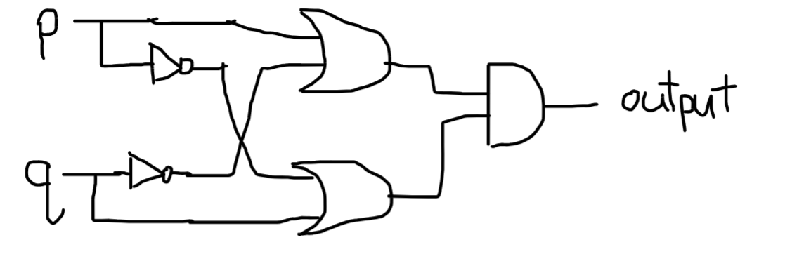

1. (8 pts) Draw a parse tree for the following logical formula:

p → q V ¬r ∧ p

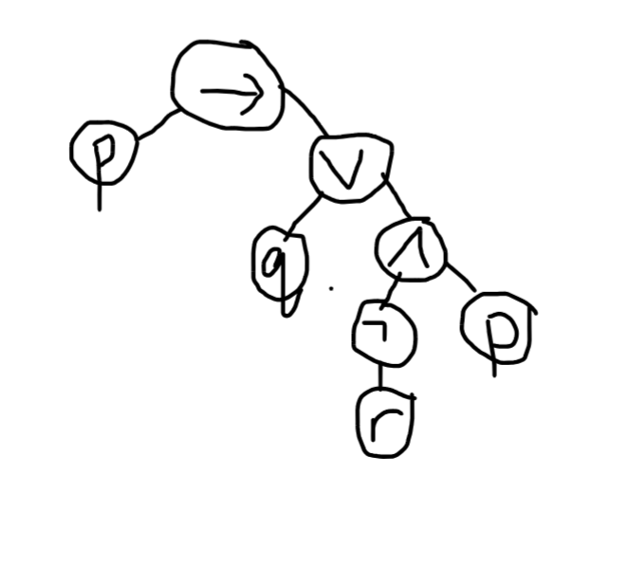

1. (13 pts) Use two truth tables to demonstrate that the following two statements are logically equivalent:

(p → q) ∧ (q → p)

(p V ¬q) ∧ (q V ¬p)

Afterwards, give a brief explanation about why your truth tables demonstrate that the statements are equivalent.

*  
--------------------------  
p q # (p →: q) ∧ (q →: p)  
--------------------------  
T T # T T T  
T F # F F T  
F T # T F F  
F F # T T T  
------------------------  
Contingent  
T: [T T] [F F]  
F: [T F] [F T]

*  
------------------------------  
p q # (p V ¬q) ∧ (q V ¬p)  
------------------------------  
T T # T F T T F  
T F # T T F F F  
F T # F F F T T  
F F # T T T T T  
------------------------------  
Contingent  
T: [T T] [F F]  
F: [T F] [F T]

We know the two statements are equivalent because both statements have the same output for every possible input.

1. (8 pts) Apply DeMorgan's laws to write an if-statement whose condition is the negation of the condition in the if-statement below. Write your if-statement in such a way that it does not use any ! (not) symbols.

if ((total >= 100 && Character.isDigit(ch) == false) || num < 10) {

//statements

}

Write your negated if-statement below:

if ((total < 100 || Character.isDigit(ch) == true) && num >= 10) {

//statements

}

1. (8 pts) Is the statement (p V ¬q) ∧ (¬p V ¬q) ∧ (p → q) satisfiable? How do we know?

Yes. If we let p = F and q = F, then the output of the statement is true. Thus, the statement is  
satisfiable (there is a truth assignment that makes the output true).

1. (11 pts) Consider the following (invalid) argument:

**Premises:**

If I order fries, then I get ketchup.

If I get ketchup, then I get a cheeseburger.

I don’t get ketchup.

**Conclusion**:

I don’t get a cheeseburger.

a) (4 pts) Translate each premise and conclusion to propositional logic. Start by identifying each propositional atom.

p: I order fries  
q: I get ketchup  
r: I get a cheeseburger

Premises: p → q, q → r, ¬q  
Conclusion: ¬r

b) (7 pts) Provide a truth assignment for your translations in (a) that demonstrates that the argument is NOT valid. How do you know that truth assignment makes the argument invalid? Explain.

Counterexample: p = F, q = F, r = T  
This assignment makes each premise true and the conclusion false, so the argument is not  
valid.

1. (14 pts) Complete the following natural deduction proof:

( a ∧ b ∧ d, e ) ⊢ ( (b ∧ e ) ∨ (d ∧ a ) )

Proof(

//YOUR PROOF GOES HERE

1 ( a ∧ b ∧ d ) by Premise,

2 ( e ) by Premise,

3 ( a ∧ b ) by AndE1(1),

4 ( d ) by AndE2(1),

5 ( a ) by AndE1(3),

6 ( b ) by AndE2(3),

7 ( b ∧ e ) by AndI(6, 2),

8 ( (b ∧ e ) ∨ (d ∧ a ) ) by OrI1(7)

//there are a lot of different ways to

//finish this proof that would all work

)

1. (15 pts) Complete the following natural deduction proof:

( a ∨ b, a  → c ∧ d, b → g, d → g ) ⊢ ( g )

Proof(

//YOUR PROOF GOES HERE

1 ( a ∨ b ) by Premise,

2 ( a  → c ∧ d ) by Premise,

3 ( b → g ) by Premise,

4 ( d → g ) by Premise,

5 SubProof(

6 Assume(a),

7 ( c ∧ d ) by ImplyE(2, 6),

8 ( d ) by AndE2(7),

9 ( g ) by ImplyE(4, 8),

//goal: g

),

10 SubProof(

11 Assume (b),

12 ( g ) by ImplyE(3, 11)

//goal: g

),

13 ( g ) by OrE(1, 5, 10)

)