Grade 9 Science

TOPIC 1: Mixtures Elements And Compounds

1. Structure of the Atom

# Structure of the atom and the Periodic Table

**Structure of the Atom**

The atom is defined as the smallest particle of an element that can take part in a chemical reaction.

Atom is made up of even smaller particles.

These smaller particles are collectively called **sub-atomic particles**.

The sub-atomic particles are;

**neutrons,**

**protons**

**electrons.**

The atom is made up of two regions, a small central part called the nucleus and a larger region surrounding the nucleus.

The nucleus consists of **protons** and **neutrons**.

The protons and neutrons are referred to as **nucleons** because they are found in the nucleus. The larger region surrounding the nucleus consists of electrons. The general structure of an atom is as shown.

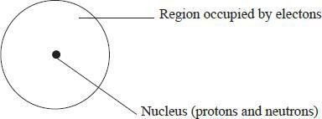

*General structure of an atom*

The hydrogen atom, which is the simplest in composition has one proton, one electron and has no neutron.

The atom of the next element, helium has two protons, two electrons and two neutrons.

The structure of the atoms of the first two elements is as shown in,

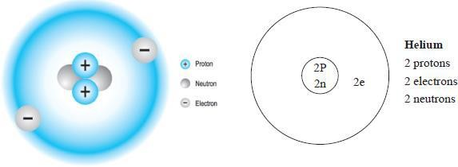

*Fig 1.2 Structure of a helium atom*

The proton is positively charged, the electron is negatively charged while the neutron has no charge.

The number of protons is equal to the number of electrons for any given atom.

This makes the atom to be electrically neutral. For example, a hydrogen atom has one proton and one electron while a helium atom has two protons and two electrons. The neutrons in the nucleus contribute to the stability of the nucleus.

##### **Atomic Number and Mass Number**

The mass of any given atom is equal to the sum of the relative masses of the protons and neutrons in its nucleus.

Since the hydrogen atom is made up of one proton and one electron, the mass of the hydrogen atom is largely due to the mass of the one proton. The hydrogen atom is arbitrally assigned atomic mass of one unit.

Summary of the characteristics of sub-atomic particles.

***Characteristics of the sub atomic particles***

|  |  |  |
| --- | --- | --- |
| **Sub atomic particle** | **Relative mass** | **Electrical charge** |
| Proton | 1 | + 1 (positive) |
| Neutron | 1 | 0 (neutral) |
| Electron |  | – 1 (negative) |

**Atomic number** *is the number of protons in the nucleus of an atom*. For example, a hydrogen atom has 1 proton in the nucleus; therefore its atomic number is 1.

Likewise, an atom of helium has 2 protons and therefore its atomic number is 2. Sodium has 11 protons in the nucleus therefore it’s atomic number is 11.

**Mass number** *is the sum of the protons and neutrons in an atom of an element*. For example, an atom of hydrogen has 1 proton and no neutrons in it’s nucleus; therefore the mass number is 1.

**Note**

Mass No: = protons + neutrons, e.g., Sodium has 11 protons and 12 neutrons. Hence, its mass number is 11 + 12 = 23

* 1. proton + 0 neutrons = 1

A helium atom has 2 protons and 2 neutrons. Consequently, the mass number is 4.

* 1. protons + 2 neutrons = 4

Both mass and atomic number can be written along with the symbol of an element. The conventional way of representing the mass number is to write the mass number as a **superscript** infront of the chemical symbol e.g. 23Na. the atomic number is written as a subscript (infront of the symbol) e.g. 11Na. therefore, the element is represented as Na.

Copy and complete table 1.2 for the first twenty elements.

***Table 1.2: A list of the first Twenty Elements***

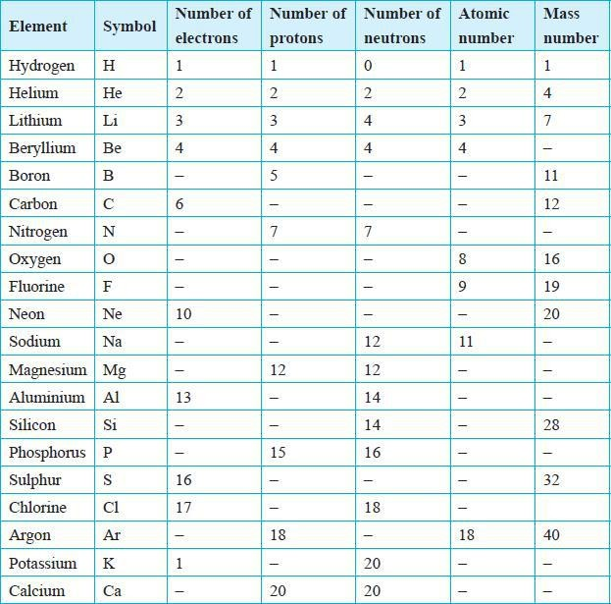

### Isotopes

Atoms of the same element have the same number of protons but they may have different number of neutrons. Therefore this means that atoms of the same element may have different mass numbers. For example, some atoms of chlorine have 18 neutrons while others have 20 neutrons but they have the same number of protons.

Thus, atoms of the same element may have the same atomic number but different mass numbers. Such atoms are called **isotopes**. Table 1.3 gives examples of isotopes of some elements.

***Table 1.3 Examples of Isotopes***

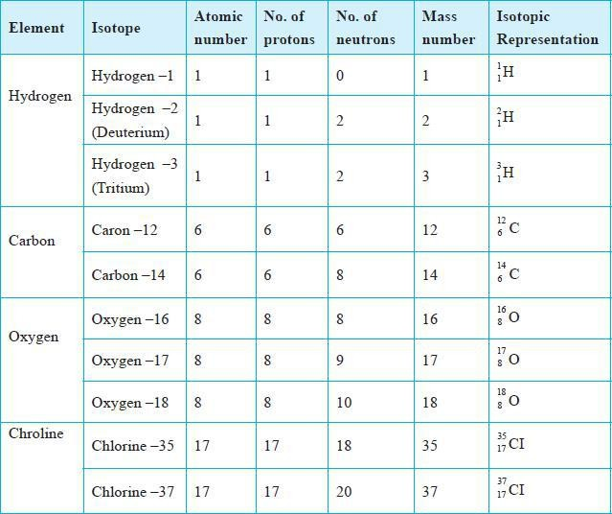

##### Energy Levels and Electron Arrangement

Electrons occupy regions around the nucleus known as **energy levels**. Electrons occupying the same energy level have approximately the same amount of energy. These energy levels are numbered 1, 2, 3, … starting with the one closest to the nucleus. Each energy level can only accommodate a given maximum number of electrons. The first energy level can only hold a maximum of two electrons and the second energy level a maximum of eight electrons. For the first twenty elements, the third energy level accommodates a maximum of eight electrons.

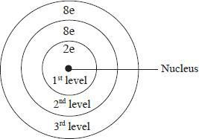

*Fig 1.4 Electron configuration*

Hydrogen has one electron in the first energy level. Helium with two electrons, has the two electrons in its first energy level. Helium therefore has one energy level which is filled up.

When an energy level is full, additional electrons occupy the next energy level until it is completely filled up. Thus, lithium with three electrons, has two electrons in its first energy level and one electron in its second energy level.

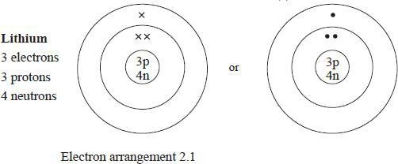The distribution of electrons in the energy levels of an atom is referred to as **electron arrangement** (**electron configuration**). This can be represented as: 1 for hydrogen, 2 for helium, 2.1 for lithium and 2.8 for neon. Electron arrangement may also be represented by a diagram in which electrons are represented by crosses (×) or dots (·) as shown in figure 1.5 to 1.7. Note in this book crosses (×) are used.

*Fig 1.5 Lithium atom*

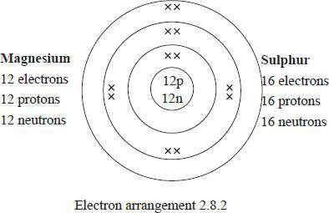

*Fig 1.6 Magnesium atom*

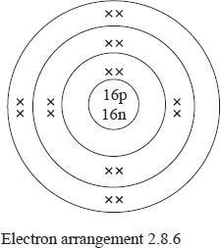

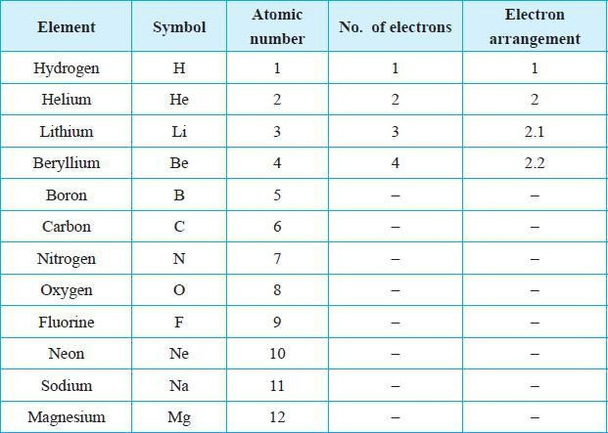***Table 1.4: Electron Arrangement of the First twenty (20) Elements***

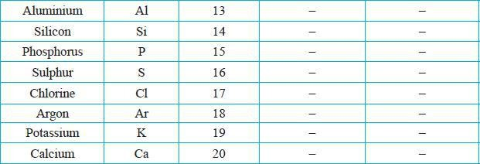

### Discussion

The elements with the same number of occupied energy levels belong to the same **period**. For example, hydrogen and helium have one occupied energy level hence they belong to Period 1. Lithium, beryllium, boron, carbon, nitrogen, oxygen, fluorine and neon have two occupied energy levels. These elements belong to Period 2. Similarly, sodium, magnesium, aluminium, silicon, phosphorus, sulphur, chlorine and argon have three occupied energy levels and hence belong to Period 3. Those elements with the same number of occupied energy levels can be arranged in the same row, starting with the elements with the lowest atomic number.

***Elements with same number of occupied energy levels***

|  |  |
| --- | --- |
| **First row**  Period 1 | Hydrogen and helium. |
| **Second row**  Period 2 | Lithium, beryllium, boron, carbon, nitrogen, oxygen, flourine and neon. |
| **Third row**  Period 3 | Sodium, magnesium, aluminium, silicon, phosphorus, sulphur and argon. |
| **Fourth row**  Period 4 | Potassium and calcium. |

Elements with the same number of electrons in the outermost energy level form a **group**. For example, hydrogen, lithium, sodium, potassium have one electron in the outermost energy level hence they belong to group I. Similarly, beryllium, magnesium, calcium have two electrons in the outermost energy level, therefore they belong to group II.

Elements with the same number of electrons in the outermost energy level can be arranged in the same vertical column. The columns represent members of a group. There are eight groups numbered in Roman numerals. The first twenty elements are arranged into their respective groups in table 1.6. Group 8 is also referred to as **group zero**. This is because these elements have little tendency to lose or gain electrons during reactions. This will become more clear in latter sections of this book.

***Elements with same number of electrons in the outermost energy level***

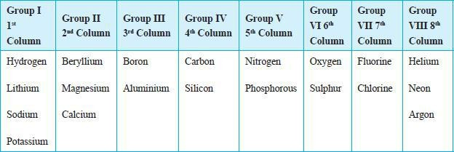

This information can be merged into a grid. The resulting figure is the **periodic table of elements**.

The periodic table shown in table 1.7 is a simplified form. It shows the electron arrangement and atomic numbers of the first twenty elements. The arrangement of elements in the periodic table is based on increasing atomic number.

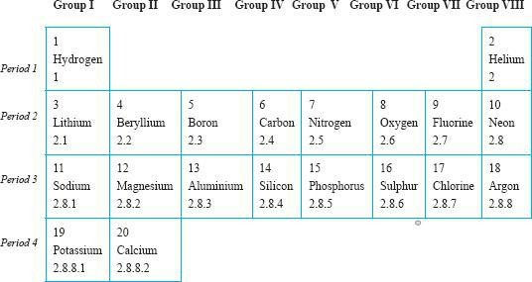***Table 1.7: Development of the Periodic Table***

In the periodic table of elements, the atomic numbers and mass numbers are usually shown in the style described earlier. See next page for a complete version of the modern periodic tabl

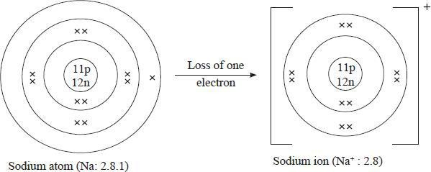

*Fig. 1.8(a): The formation of a Sodium ion Na+*

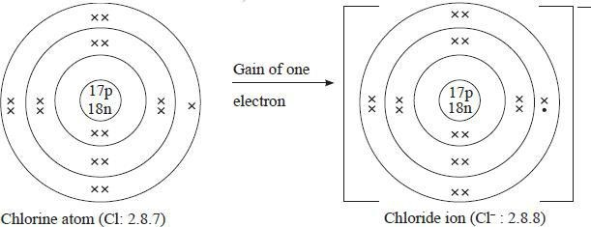A chlorine ion can also be formed, Cl–.

*Fig. 1.8(b): The formation of a chloride ion Cl–*

Thus, a chlorine atom with atomic number 17 and an electron configuration of 2.8.7 can acquire a configuration of 2.8 by losing seven electrons or a configuration of 2.8.8 by gaining one electron. It is easier for the chlorine atom to gain one electron than to lose seven. Therefore, a chorine atom with 17 electrons and 7 protons will gain an electron and have 18 electrons. Since it still has 17 protons, a chlorine particle with a net negative charge of 1 is formed i.e a chlorine ion. The ion formed is written as Cl–. See figure 1.8 (b). It is also refered to as a chloride ion.

The ideas used to explain the formation of sodium ions and chloride ions can be used to predict the formation of ions of other elements.

More examples; Magnesium has an atomic number of 12. The electron arrangement is

2.8.2. The magnesium atom can acquire the stable electron configuration of 2.8 by losing the

two electrons in the outermost energy level. This means that the resulting particle will have a net positive charge of two. The ion formed is called a magnesium ion, and is written as Mg2+. See figure 1.9.

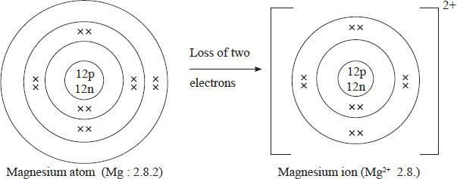

*Fig. 1.9: The formation of a Magnesium ion, Mg2+*

In a similar manner, oxygen atomic number 8 and electron arrangement of 2.6 can acquire a stable electron configuration of 2.8 by gaining two electrons. The resulting particle will have a net negative charge of two. The ion formed is an oxide ion and is written as O2–.

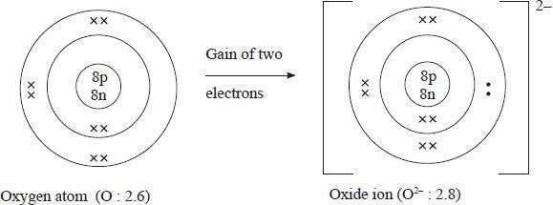

QUESTIONS