SHAP Feature Importance Summary Plots for XGBoost with SMOTE and ADASYN
Overview
This SHAP feature importance summary plot with interaction terms demonstrates how pairs of features influence the model's predictions for the dependent variable. Each column represents a specific feature being analyzed for its interactions with other features, and the rows represent how those interactions impact the model's predictions.
- X-axis: The SHAP interaction values, which quantify the joint effect of a pair of features on the model's output.
- Y-axis: The specific features interacting with the feature in the corresponding column.
In this way, the plot visualizes the magnitude and direction of feature interactions. For example, if one feature strongly interacts with another, the SHAP interaction values (dots) will be farther from zero on the X-axis, indicating a stronger combined influence on the prediction. Each dot's color represents the feature value (low to high), adding further interpretability to how interactions occur at different value levels of the feature.

The SHAP Feature Importance Summary plots provide insights into how specific features impact the predictions of the XGBoost models trained using SMOTE and ADASYN. These plots allow us to understand the direction (positive or negative) and magnitude of feature contributions, as well as how the value of each feature correlates with its SHAP value. Here, we analyze and compare the plots for the XGBoost models trained using the two sampling techniques.

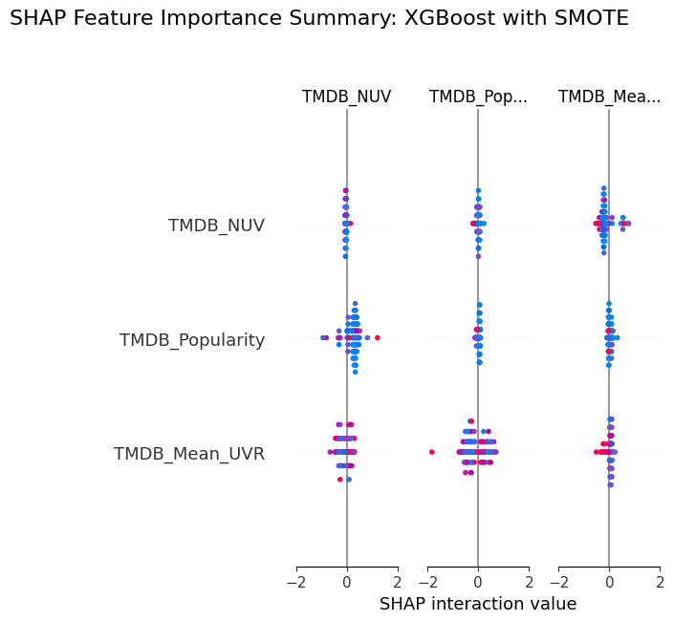
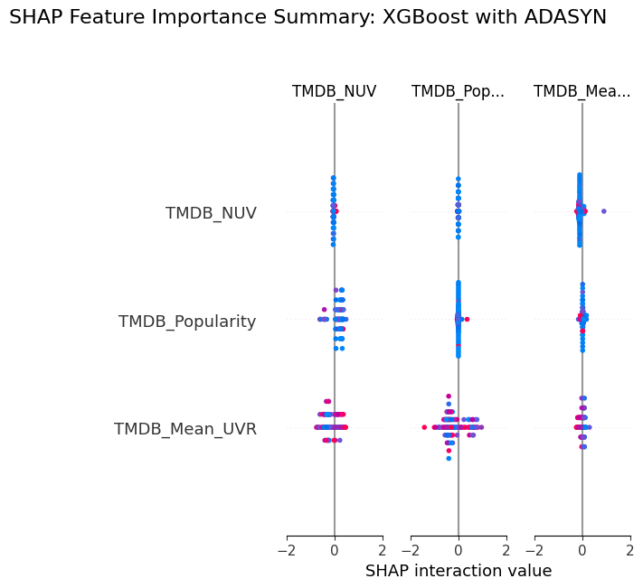
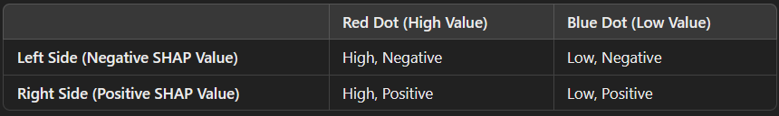

SHAP Feature Importance Summary: XGBoost with SMOTE
- Key Observations:
  - TMDB_NUV (Feature 1): The feature has a wide range of SHAP values, spanning from approximately -2 to 2. Higher values (indicated by blue dots on the right side) contribute positively to the predictions, whereas lower values (red dots on the left side) contribute negatively. The dense clustering of red dots near -2 indicates that low values of TMDB_NUV strongly drive negative predictions.
  - TMDB_Popularity (Feature 2): This feature shows a more symmetric distribution of SHAP values around zero, with a narrower range compared to TMDB_NUV. High feature values (blue dots on the right) slightly increase the SHAP values positively, while low feature values (red dots on the left) contribute negatively but to a lesser extent. The impact of TMDB_Popularity appears relatively moderate.
  - TMDB_Mean_UVR (Feature 3): The SHAP values range between -2 and 2, with isolated red and blue dots at the extremes. An isolated red dot on the left side suggests that a low value of TMDB_Mean_UVR might strongly contribute to a specific prediction. The general trend indicates that high feature values (blue dots) have positive SHAP values, while low feature values (red dots) have negative SHAP values.
- General Trends:
  - TMDB_NUV and TMDB_Mean_UVR appear to have the most significant influence, as indicated by their broader SHAP value ranges.
  - TMDB_Popularity, while still relevant, has a smaller and more symmetric distribution of SHAP values, suggesting a lesser impact compared to the other two features.
  - The overall behavior shows that the model effectively utilizes these features to separate classes and make predictions.

SHAP Feature Importance Summary: XGBoost with ADASYN
- Key Observations:
  - TMDB_NUV (Feature 1): Similar to the SMOTE model, TMDB_NUV displays a wide range of SHAP values from -2 to 2. High feature values (blue dots) drive positive predictions, and low feature values (red dots) drive negative predictions. The clustering of blue dots near 2 indicates a stronger positive influence for high TMDB_NUV values compared to the SMOTE model.
  - TMDB_Popularity (Feature 2): The SHAP values for TMDB_Popularity range from -2 to 2, showing a broader impact compared to the SMOTE model. High feature values (blue dots) contribute positively, while low feature values (red dots) contribute negatively. The feature's influence is slightly more pronounced in this model.
  - TMDB_Mean_UVR (Feature 3): The SHAP values exhibit a similar range as in the SMOTE model, between -2 and 2. However, there is a denser clustering of points near the center (SHAP values close to 0), suggesting that the model places less emphasis on this feature compared to the SMOTE model. Isolated points at the extremes indicate occasional strong influences.
- General Trends:
  - TMDB_NUV remains the most influential feature, with a similar pattern to the SMOTE model but with a stronger positive influence for high feature values.
  - TMDB_Popularity's role appears to increase slightly, with a broader range and more significant contributions compared to the SMOTE model.
  - TMDB_Mean_UVR shows reduced importance, with fewer extreme SHAP values and more clustering near zero.

Comparison of SMOTE and ADASYN Models
- Feature Importance:
  - In both models, TMDB_NUV emerges as the most influential feature, with a wide range of SHAP values and clear separation between high and low feature values.
  - TMDB_Popularity plays a more significant role in the ADASYN model, as indicated by the broader SHAP value distribution and increased contributions from both high and low feature values.
  - TMDB_Mean_UVR is more impactful in the SMOTE model, where it exhibits a wider range of SHAP values and isolated extreme points, suggesting stronger contributions to specific predictions.
- Model Behavior:
  - The SMOTE model appears to rely more heavily on TMDB_Mean_UVR, potentially due to the balanced class distribution created by the SMOTE sampling technique, which might amplify the importance of subtle features.
  - The ADASYN model places more emphasis on TMDB_Popularity, likely because the adaptive sampling strategy of ADASYN focuses on difficult-to-classify instances, highlighting the relevance of this feature in those cases.
- Distribution of SHAP Values:
  - The SMOTE model shows more isolated extreme SHAP values, particularly for TMDB_Mean_UVR, indicating that the model makes occasional strong predictions based on extreme feature values.
  - The ADASYN model exhibits more clustering of SHAP values near zero for TMDB_Mean_UVR, suggesting that the model generally considers this feature less critical.
- Impact of Sampling Techniques:
  - SMOTE’s balanced sampling might enhance the influence of features like TMDB_Mean_UVR, which may not be as prominent in the ADASYN model.
  - ADASYN’s focus on challenging instances might increase the significance of TMDB_Popularity, as this feature might help resolve ambiguous cases.

Conclusion
The SHAP Feature Importance Summary plots highlight key differences in how the XGBoost models trained with SMOTE and ADASYN utilize the input features. TMDB_NUV consistently emerges as the most important feature across both models, with a similar impact on predictions. However, TMDB_Popularity plays a slightly larger role in the ADASYN model, while TMDB_Mean_UVR is more impactful in the SMOTE model. These differences reflect the unique characteristics of the two sampling techniques, with SMOTE emphasizing balanced class distributions and ADASYN focusing on hard-to-classify instances.
By analyzing these plots, we gain a deeper understanding of the models’ behavior and the interplay between features and sampling strategies, showcasing the advanced interpretability provided by SHAP values in the context of imbalanced datasets.

SHAP Interaction Plots for XGBoost with SMOTE and ADASYN
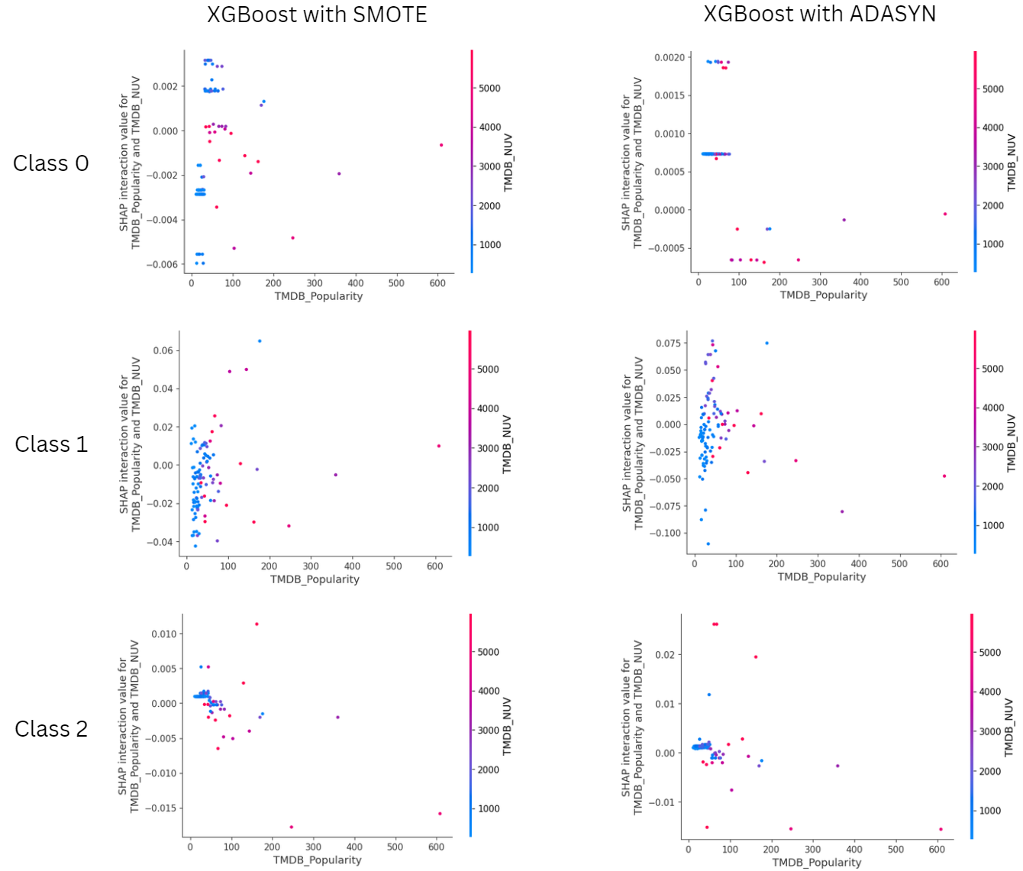
The combined plot showcases the SHAP interaction values for the "TMDB_Popularity" and "TMDB_NUV" features across three classes (Class 0, Class 1, and Class 2) using two different data sampling techniques: SMOTE and ADASYN. Each column represents a sampling method (XGBoost with SMOTE on the left and XGBoost with ADASYN on the right), while each row corresponds to a specific class. The plot provides a visual comparison of how the two features interact in influencing predictions for each class under different sampling approaches.
XGBoost with SMOTE
In the SMOTE column, the interaction effects between "TMDB_Popularity" and "TMDB_NUV" display relatively structured patterns. For Class 0, the points are clustered more densely near lower values of "TMDB_Popularity," indicating stronger interaction effects in this range. The SHAP interaction values are relatively stable, with limited variability as "TMDB_NUV" changes, as shown by the consistent color distribution.
For Class 1, the plot highlights a more spread-out pattern compared to Class 0, suggesting that "TMDB_Popularity" has a broader interaction effect on predictions. The impact of "TMDB_NUV" is moderate, with color gradients showing a mild variation.
Class 2 presents a distinct pattern with tighter clusters, where interaction values are lower compared to the other classes. The interaction between "TMDB_Popularity" and "TMDB_NUV" seems less influential for Class 2 predictions, as indicated by the near-horizontal alignment of points and reduced variability in SHAP interaction values.
XGBoost with ADASYN
The ADASYN column demonstrates greater dispersion in SHAP interaction values compared to SMOTE. For Class 0, the points are more widely spread along both the X-axis ("TMDB_Popularity") and Y-axis (interaction values), indicating that ADASYN introduces more variability in the interaction effects. The color gradient shows a more dynamic range of "TMDB_NUV" values, suggesting a broader influence of this feature on predictions.
In Class 1, the points are even more scattered, with SHAP interaction values displaying notable outliers at higher "TMDB_Popularity" values. The interaction effects seem less stable, and the influence of "TMDB_NUV" is more variable, as evidenced by the diverse color distribution.
Class 2 under ADASYN shows a similar spread-out pattern, with interaction values displaying a higher degree of variability. Unlike the SMOTE plots, the ADASYN plots suggest that "TMDB_NUV" contributes more significantly to interaction effects for Class 2 predictions, with wider ranges of SHAP interaction values.
Comparison Between SMOTE and ADASYN
The primary difference between SMOTE and ADASYN lies in the dispersion and variability of SHAP interaction values. SMOTE generates more structured and stable patterns, with tighter clusters and consistent interaction effects across classes. This reflects the nature of SMOTE, which focuses on creating synthetic samples evenly distributed in feature space, leading to more homogeneous interaction effects.
In contrast, ADASYN generates synthetic samples in a more targeted manner, emphasizing areas with higher class imbalance. This approach introduces greater variability and dispersion in SHAP interaction values, as seen in the broader spread of points and more dynamic color gradients in the plots. While this may capture nuanced interactions, it can also lead to less stable patterns.
Insights
- SMOTE appears to provide more predictable and stable interaction effects, making it suitable for analyses requiring consistency.
- ADASYN highlights subtle variations in interaction effects, which may uncover hidden relationships but could also introduce noise.
- For Class 0 and Class 2, SMOTE offers more concentrated patterns, while ADASYN introduces higher variability, especially in Class 1.
In summary, the SHAP interaction plots reveal that SMOTE and ADASYN impact the interaction effects of "TMDB_Popularity" and "TMDB_NUV" differently. SMOTE results in more structured and uniform patterns, while ADASYN generates more dispersed effects, emphasizing the variability in synthetic sample generation. The choice of sampling technique should depend on whether stability or variability in feature interactions is more desirable for the analysis.

