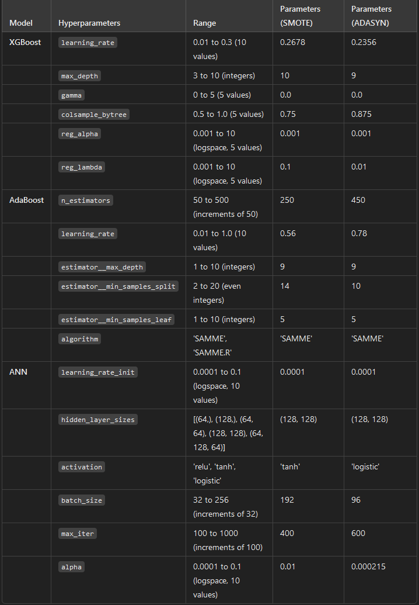
XGBoost
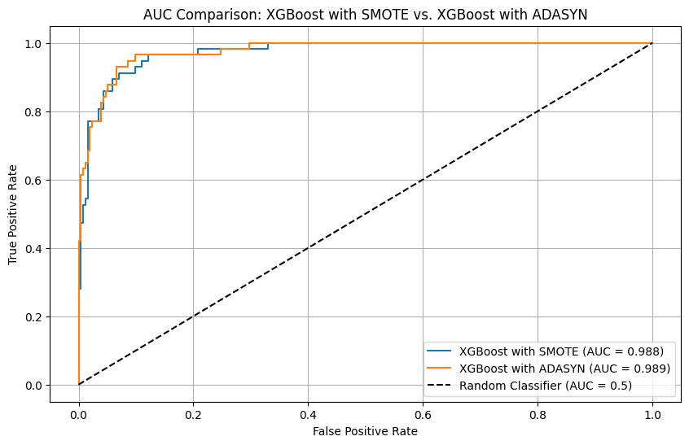
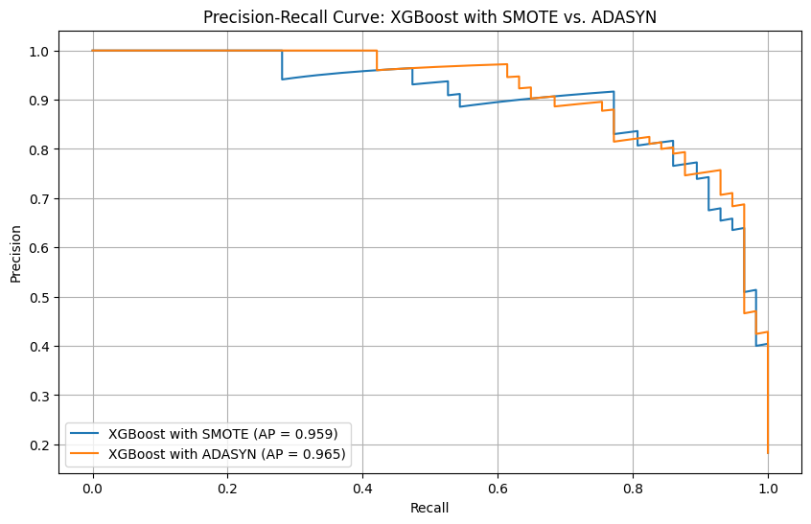
AUC Curve Interpretation
The AUC (Area Under the Curve) comparison graph for XGBoost models using SMOTE and ADASYN depicts the performance of both models in terms of their True Positive Rate (sensitivity) versus the False Positive Rate. Both models have very high AUC scores: 0.988 for SMOTE and 0.989 for ADASYN.
- Observation: The AUC scores are nearly identical, indicating that both SMOTE and ADASYN have similar performance when it comes to classifying positive cases accurately while keeping the rate of false positives low.
- Implications: This similarity suggests that the choice between SMOTE and ADASYN does not have a significant impact on the model’s ability to discriminate between classes. However, even slight differences can be critical depending on the application.
- Model Comparison: Although ADASYN shows a marginally higher AUC, the difference is minimal. Both models perform well, which is a good indicator that both data sampling techniques are effective at improving model performance.
Precision-Recall (PR) Curve Interpretation
The PR curve compares the precision (the ratio of true positive predictions to the total positive predictions) to recall (the model's ability to identify all positive instances). The average precision (AP) scores are 0.959 for SMOTE and 0.965 for ADASYN.
- Observation: ADASYN has a slightly higher average precision than SMOTE, indicating that the ADASYN model is a bit more effective at balancing precision and recall.
- Performance Analysis: Both curves demonstrate strong performance, with high precision and recall values throughout most of the range. However, towards the higher recall region, the precision for both models decreases, which is expected as models struggle to maintain precision while capturing more positive cases.
- Comparison: The ADASYN model outperforms SMOTE slightly in terms of average precision, making it preferable in scenarios where balancing precision and recall is crucial. The difference, although minor, might be significant in applications where false positives or false negatives carry high costs.
Overall, both sampling techniques show robust performance, with ADASYN having a slight edge in precision-recall balance. However, the AUC analysis suggests that the difference between the two is negligible in terms of overall discrimination ability. Depending on specific requirements for precision or recall in our project, one method might be chosen over the other.

AdaBoost
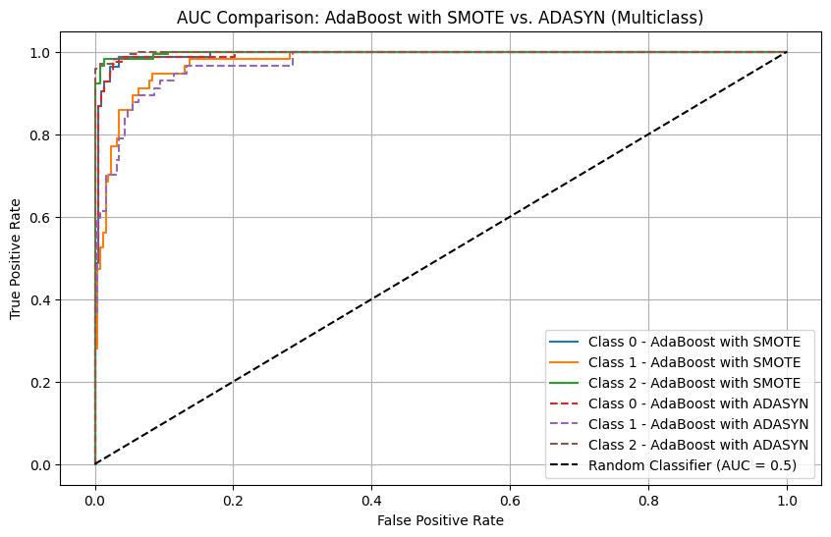
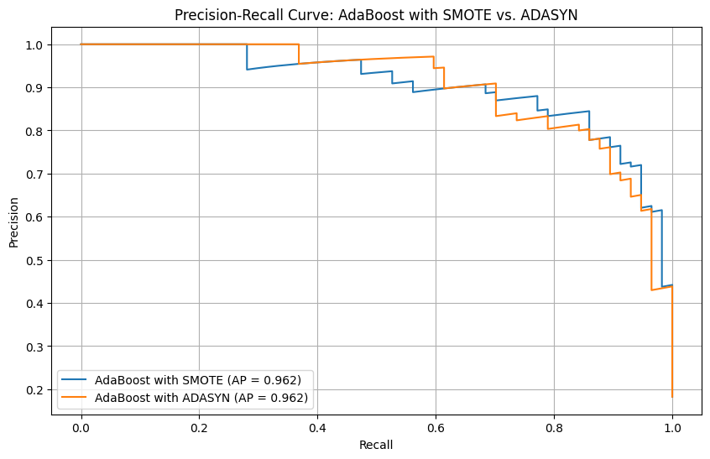
Why AUC need to have multi-class?
Why AUC Works Differently:
- XGBoost:
  - XGBoost is optimized for handling multiclass problems natively, and its predict_proba() method typically returns well-formatted probabilities for each class. When computing AUC using roc_auc_score, the library can handle the output appropriately, especially if you specify a multiclass strategy like 'ovr' (one-vs-rest).
  - This allows the AUC calculation to be handled seamlessly in most cases.
- AdaBoost:
  - AdaBoost, especially when using sklearn’s AdaBoostClassifier, is structured differently. When working with multiple classes, its probabilities may need to be treated differently for metrics like the ROC curve.
  - The roc_curve() function in sklearn is designed for binary classification and requires extra handling for multiclass problems. This means we need to implement a one-vs-rest approach manually to evaluate the AUC for each class or find another way to aggregate the results.
In Summary:
- XGBoost: The built-in functions handle multiclass scenarios better, making AUC calculations more straightforward.
- AdaBoost: Requires manual handling because the roc_curve() function does not directly support multiclass without adjustments.

AUC Comparison for AdaBoost with SMOTE and ADASYN (Multiclass)
This AUC plot illustrates how well AdaBoost performs in distinguishing between the different classes in our dataset after applying SMOTE and ADASYN. In this multiclass problem, we have separate AUC curves for each class label. The graph includes:
- Class 0, 1, and 2 - AdaBoost with SMOTE: Represented by solid lines, these show how AdaBoost with SMOTE performs across each class.
- Class 0, 1, and 2 - AdaBoost with ADASYN: Depicted by dashed lines, these indicate the performance of AdaBoost with ADASYN.
- Random Classifier (AUC = 0.5): A dashed diagonal line that serves as a baseline comparison.
Interpretation:
- Both methods show strong performance, with AUC values close to 1 for all classes, indicating that AdaBoost is effective at separating classes. The solid and dashed lines are closely aligned, suggesting that there is not a significant difference in performance between SMOTE and ADASYN for AdaBoost in terms of AUC.
- Minimal gaps between the lines indicate consistent classifier performance across all class labels, reinforcing the effectiveness of AdaBoost with either sampling method.
Precision-Recall Curve for AdaBoost with SMOTE and ADASYN
The PR curve illustrates the trade-off between precision and recall for AdaBoost with SMOTE and ADASYN. In this curve:
- Precision: How many of the samples predicted as positive are actually positive.
- Recall: How many of the actual positive samples are captured by the model.
- Average Precision (AP): The area under the Precision-Recall curve.
Interpretation:
- Both methods achieve high precision and recall, as indicated by the high values of Average Precision (AP = 0.962 for both SMOTE and ADASYN). This signifies that AdaBoost models are robust in capturing positive samples while maintaining a low false positive rate.
- The curves are very close, implying that both SMOTE and ADASYN perform similarly for AdaBoost when evaluated with precision and recall metrics. Small differences in the curves suggest only a marginal impact of the resampling method on AdaBoost’s performance.
Overall Comparison
- Effectiveness: Both SMOTE and ADASYN improve the model's ability to handle class imbalance effectively, as shown by the high AUC and AP scores.
- Consistency: The performance metrics and curves indicate that AdaBoost's behavior is stable across different classes and metrics, with both resampling methods achieving nearly equivalent results.
In summary, while there are slight variations between SMOTE and ADASYN, AdaBoost appears to handle both techniques well, making them interchangeable in terms of performance. This suggests flexibility in choosing a resampling technique for AdaBoost, depending on the specific needs or constraints of our analysis.

ANN
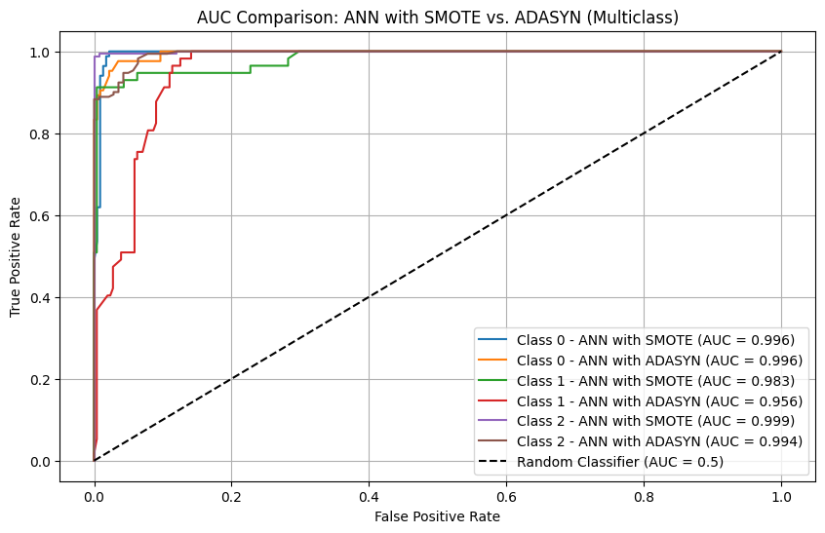
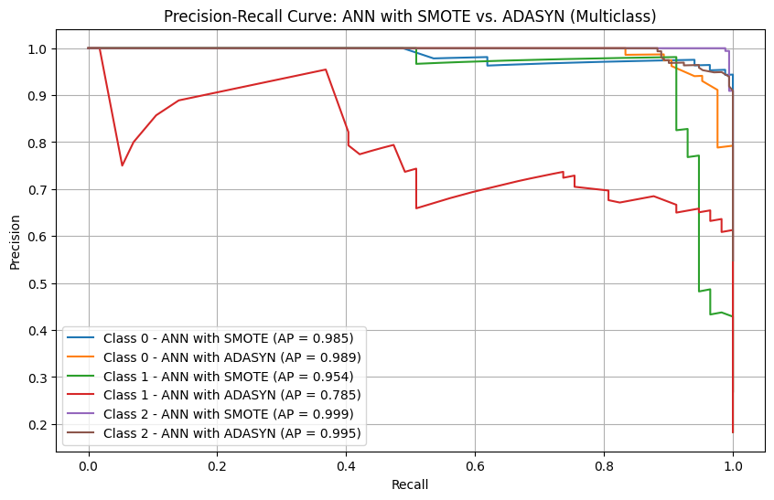
AUC Comparison: ANN with SMOTE vs. ADASYN
- Overall Trends:
  - The AUC curves for both SMOTE and ADASYN indicate excellent model performance across all classes. The curves for each class are very close to the upper-left corner of the graph, signifying a high True Positive Rate (Recall) and a low False Positive Rate.
  - For Class 0, both sampling techniques yield an identical AUC of 0.996, showing that the model is highly effective in distinguishing Class 0 from the others.
  - Class 1 shows some variation: the AUC for ANN with SMOTE is 0.983, while the AUC for ADASYN is lower at 0.956. This suggests that SMOTE better handles the class imbalance for Class 1.
  - For Class 2, SMOTE achieves a perfect AUC of 0.999, and ADASYN slightly trails at 0.994, both indicating strong model performance but with a minor advantage for SMOTE.
- Comparison Across Classes:
  - Class 0: Both SMOTE and ADASYN perform exceptionally well, showing no significant difference.
  - Class 1: SMOTE clearly outperforms ADASYN, which shows some degradation in distinguishing Class 1 from other classes. This could be due to the nature of how ADASYN generates synthetic samples.
  - Class 2: Both methods perform well, but SMOTE still holds a slight edge.
Precision-Recall Curve: ANN with SMOTE vs. ADASYN
- Class 0:
  - The Average Precision (AP) is slightly better for ADASYN (0.989) compared to SMOTE (0.985), but both are very high. This means both sampling techniques maintain high precision and recall for Class 0.
- Class 1:
  - The difference is more pronounced for Class 1, where SMOTE achieves an AP of 0.954, while ADASYN drops to 0.785. This reflects a notable decrease in precision and recall when using ADASYN, suggesting that SMOTE handles Class 1 significantly better.
- Class 2:
  - Both methods achieve nearly perfect precision and recall, with SMOTE at 0.999 and ADASYN at 0.995. This reinforces that both techniques are effective for Class 2, but SMOTE still has a slight advantage.
Key Insights:
- Overall Performance: ANN models perform exceptionally well across all classes, but the choice between SMOTE and ADASYN impacts performance, especially for Class 1. SMOTE generally offers more consistent and superior performance in handling class imbalances.
- SMOTE vs. ADASYN:
  - SMOTE is preferable when we are particularly concerned with ensuring balanced performance across all classes. This is evident in the higher AUC and AP scores for Class 1 when using SMOTE.
  - ADASYN, although effective for Class 0 and Class 2, struggles with precision and recall for Class 1, making it less reliable for this particular model and dataset.

Why SMOTE is better for class 1 in ANN model?
SMOTE (Synthetic Minority Over-sampling Technique) appears to be better for Class 1 in this ANN model, and there are several potential reasons for this, rooted in the way SMOTE and ADASYN handle class imbalances and how these techniques interact with neural network learning:
1. Data Distribution and Synthetic Sample Creation
- SMOTE generates synthetic samples by interpolating between existing minority class data points. It focuses on creating evenly distributed synthetic examples within the minority class, thereby expanding the decision boundaries for Class 1 more evenly in feature space.
- In contrast, ADASYN generates more synthetic samples for minority class instances that are harder to classify (those closer to the decision boundary), and fewer samples for easier cases. This focus on more difficult instances can cause ADASYN to create a skewed representation of Class 1, leading to greater overlap with other classes and potential misclassification.
- For Class 1, if the class distribution is not well-separated or has clusters that are harder to learn, SMOTE’s even sampling might better reinforce the class structure and help the ANN learn clearer boundaries.
2. Impact on ANN Learning
- ANNs are sensitive to how training data is distributed. If synthetic data generated by ADASYN is not diverse enough or if it emphasizes difficult areas too much, the network could overfit to these complex areas, resulting in poorer generalization.
- SMOTE's method of creating more evenly distributed synthetic samples helps ensure that the ANN learns the underlying patterns of Class 1 without being biased toward difficult or ambiguous areas, leading to better performance and higher Average Precision and AUC scores for Class 1.

3. Neural Network Architecture and Complexity
- The architecture of the ANN (e.g., the number of hidden layers and neurons) may also influence how well the model learns from different sampling techniques. For this specific ANN configuration, it seems that the network benefits from the more balanced approach provided by SMOTE, as it likely aligns better with the model’s capacity to generalize across the data.
- Additionally, neural networks tend to perform better when trained on data with more representative and evenly spaced samples, which SMOTE provides. ADASYN’s focus on hard-to-classify regions might not provide enough support for the overall class structure, making the network struggle with misclassifications.
4. Potential Overlap and Noise
- Class 1’s feature space could have significant overlap with other classes. SMOTE’s uniform synthetic data creation helps in delineating clear boundaries between Class 1 and other classes. On the other hand, ADASYN, by focusing on difficult areas, might introduce noise and increase overlap, complicating the ANN’s task of learning accurate decision boundaries.
5. Data Characteristics
- The characteristics of Class 1 in your dataset could be such that the uniform distribution of synthetic samples by SMOTE better represents the class's true distribution. If Class 1 has distinct clusters or if the natural distribution isn’t highly complex, SMOTE’s approach will enhance the model’s performance. ADASYN, which emphasizes hard instances, may not adequately capture this underlying structure.
Conclusion
SMOTE’s ability to create a more even and representative sample distribution for Class 1 likely helps the ANN establish clearer decision boundaries and better generalize during training. The performance difference emphasizes that when using ANNs on imbalanced datasets, understanding the interaction between data sampling methods and the model's architecture is crucial.

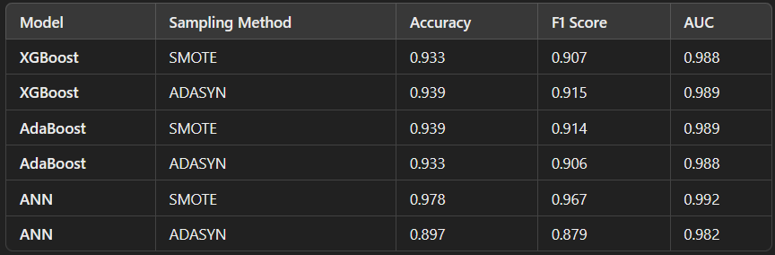
- XGBoost Results:
  - Both SMOTE and ADASYN perform well for XGBoost, with ADASYN slightly edging out SMOTE in terms of accuracy and F1 score. The AUC scores are nearly identical, indicating that both sampling methods provide excellent separation between classes. This suggests that ADASYN may offer a slight advantage when used with XGBoost in our case, but the performance difference is minimal.
- AdaBoost Results:
  - With AdaBoost, SMOTE achieves slightly better performance metrics compared to ADASYN. The accuracy and F1 score for SMOTE are marginally higher, and the AUC is very close between both sampling methods. This indicates that for AdaBoost, SMOTE might be the preferable choice, especially if consistency in performance metrics is a priority.
- ANN Results:
  - For the ANN model, SMOTE clearly outperforms ADASYN. The accuracy, F1 score, and AUC for SMOTE are significantly higher compared to ADASYN. This stark difference suggests that SMOTE is far more effective for balancing the data when training an ANN, likely due to the complex nature of neural networks and their sensitivity to the class distribution.
Summary
- Best Performance Overall: ANN with SMOTE appears to have the highest overall performance, with an accuracy of 97.8% and an AUC of 0.992. This indicates that SMOTE is highly effective when used with neural networks.
- XGBoost and AdaBoost Comparison: The performance of XGBoost and AdaBoost is similar, with ADASYN providing a slight edge for XGBoost and SMOTE performing slightly better for AdaBoost.
- Choosing the Best Sampling Method: While both SMOTE and ADASYN work well for tree-based models, SMOTE is clearly superior for ANN, making it the more versatile choice across different types of models in our study.
The approach using SHAP to analyze and compare the effects of different data sampling techniques adds an innovative angle to traditional model performance optimization studies. Here are some key points that make this project stand out:
- Novel Use of XAI: Employing SHAP values for understanding and selecting the best data sampling technique is unique. Typically, sampling techniques are chosen based on performance metrics alone, but this method adds interpretability, which could be valuable for practitioners and researchers alike.
- Comprehensive Comparison: By comparing multiple models (XGBoost, AdaBoost, and ANN) across various metrics (AUC, Precision-Recall, SHAP values), the study provides a well-rounded evaluation. This could be particularly useful for readers looking to understand how sampling affects different types of models.
- Practical Implications: The insights gained from this study could inform data scientists about the best practices for handling imbalanced data, particularly in domains where interpretability is crucial, such as healthcare or finance.

