TECHQUEST – DOCUMENTATION
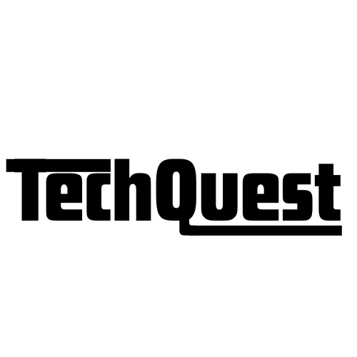

Every click brings you one step closer to success

https://techquest.pages.dev/

TechQuest is a dynamic interactive comprehensive and beginner-friendly tech learning platform created to help newcomers start their career journey with complete clarity and confidence. It provides structured, role-based roadmaps that guide users step-by-step from the basics to job-ready skills, making the entire learning experience simple, clear, and well-organized. Each roadmap is divided into multiple levels, clearly explaining what to learn at each stage, why that concept is important, and how it contributes to real-world tech roles. To support learners further, every level includes curated, high-quality resource links such as tutorials, tools, documentation, and videos, so users never have to waste time searching across the internet. TechQuest also includes a built-in progress tracking system, allowing learners to mark topics as completed, monitor their growth, and stay motivated throughout their learning path. Along with learning support, the platform features a free resume-builder tool that enables users to create clean, professional resumes and download them instantly without needing any external templates or software. This makes TechQuest not only a learning companion but also a career-building assistant for students and beginners. The entire platform is designed to be lightweight, user-friendly, and accessible on all devices, ensuring that learning can happen anytime and anywhere. By bringing together roadmaps, curated resources, progress tracking, and resume-building tools under one roof, TechQuest aims to make the start of every learner’s tech journey smooth, structured, and completely free.

Features Provided By TechQuest :

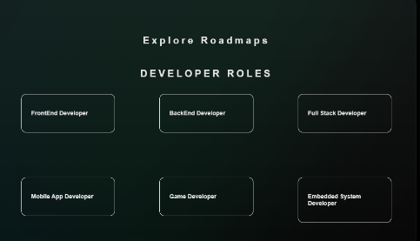
- Role-Based Tech Roadmaps
TechQuest provides structured roadmaps for various tech roles, broken into clear levels that explain what to learn, why each skill matters, and how it connects to the overall career path.

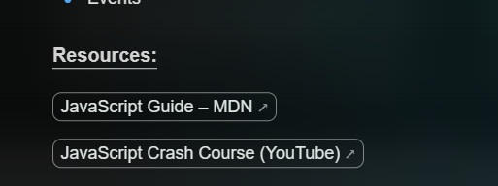
- Curated Learning Resources
Each roadmap includes carefully selected resource links such as tutorials, courses, tools, and documentation to help users learn efficiently without wasting time searching.

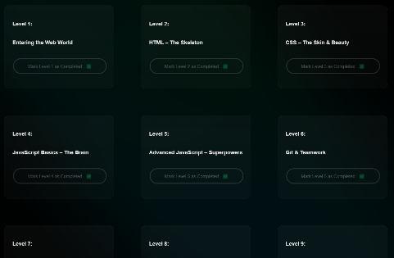
- Level-Based Learning Structure
The platform breaks the learning journey into multiple levels, making it easy for beginners to move step-by-step from basics to advanced topics.

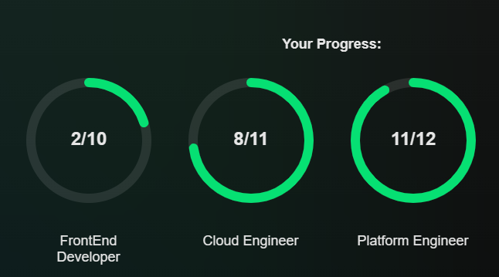
- Progress Tracking System
Users can mark topics as completed and track their overall progress, helping them stay consistent and motivated throughout their learning journey.

- Free Resume Builder Tool
TechQuest includes a simple, user-friendly resume builder that allows users to create and download a clean, professional resume instantly.

- Field Explanations – Clear guidance for each resume section so beginners know what to write.
- Sample Data (Examples) – Pre-filled examples to help users understand formatting and content style.
- Guided Input Support – Step-by-step input flow to help users complete their resume easily.
- 5 Stunning Templates – Multiple visually appealing templates to choose from.
- Resume Preview Option – Users can preview their resume live before downloading.
- PDF-Ready Download in One Click – Instantly generates a polished PDF resume.
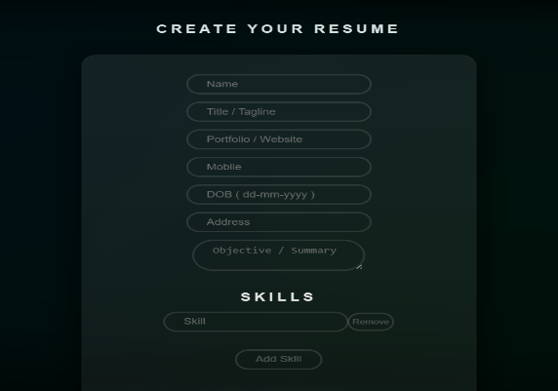

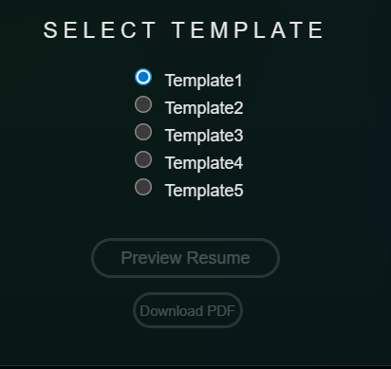
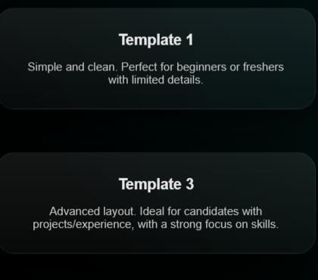
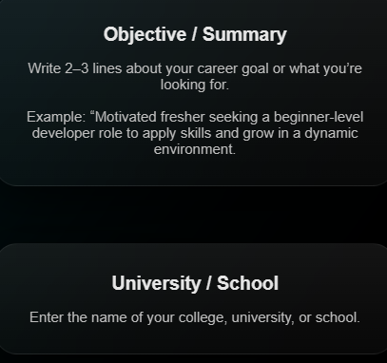
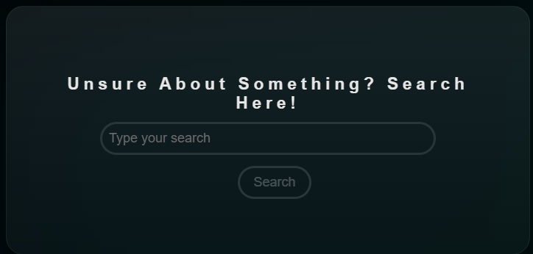
- Personal Search Engine (PSE)
A custom search tool that helps learners research any tech topic directly within the platform, giving quick and relevant results without distractions.

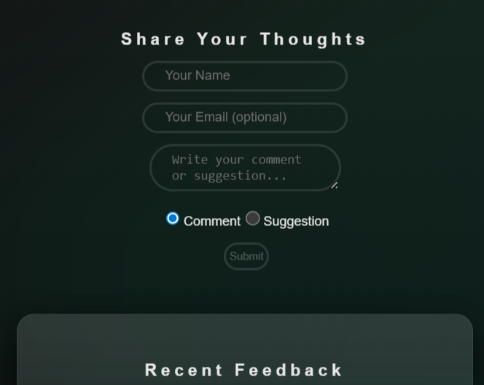
- Feedback & Suggestions System
Users can share their feedback, comments, and suggestions directly through the platform. This helps in improving the site experience and allows users to communicate what new features or enhancements they want. It creates an interactive loop between the platform and its users.

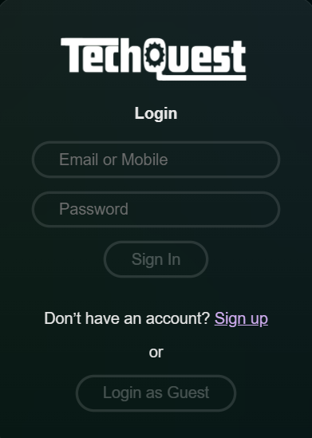
- Guest Login Option
TechQuest includes a guest login feature that allows users to explore roadmaps, resources, and tools without creating an account. This makes the platform instantly accessible and encourages beginners to try the features without any signup barriers.

- Completely Free to Use
All features — roadmaps, resources, progress tracking, and resume builder — are available at no cost, making TechQuest accessible to all students and beginners

