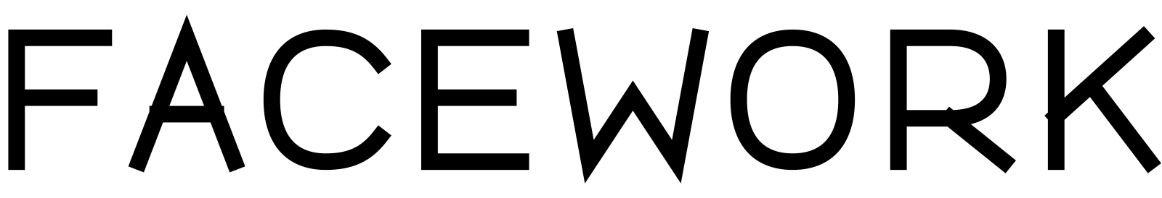
FIELD NOTE 014 / CANONICAL REFERENCE
Identity as protocol
An open ledger of the decisions that make Facework recognizable, usable, and transmissible.
STATUS CANONICAL
VERSION 0.1
DATE 2026-08-06
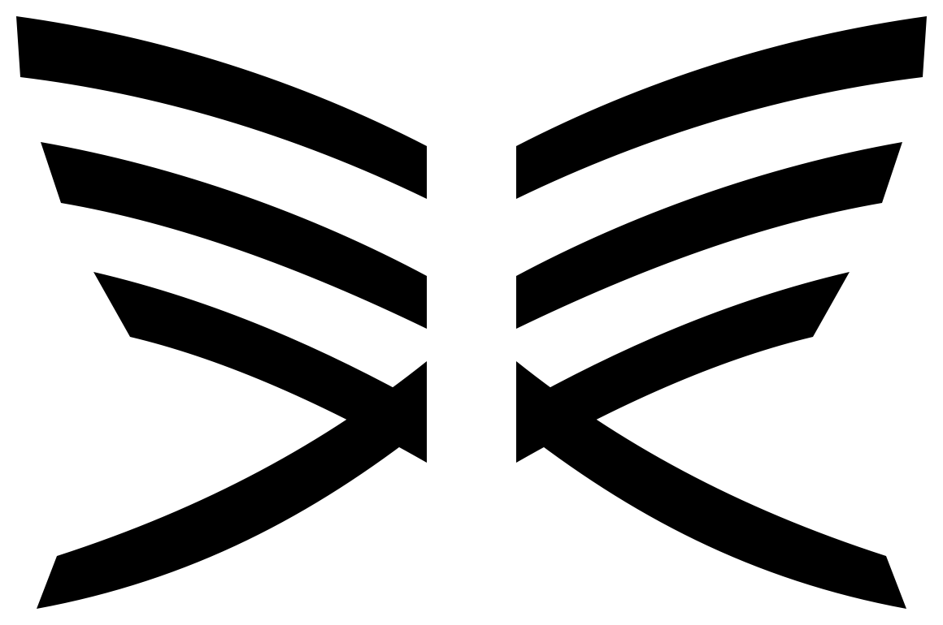

01 / FIELD NOTE 014

The identity had to be discovered.
Facework did not need a symbol applied to an idea. It needed a visible behavior that could be traced to the discipline itself.
The program began by recovering the historic butterfly mark as evidence rather than treating it as an untouchable answer. Its bilateral structure, layered forces, and open center were isolated, tested, and rebuilt as Axis Exchange.
That distinction matters. A logo can be selected because it looks appropriate. A protocol identity must show why its form belongs, how it behaves, and what future practitioners are allowed to change.
GOVERNING CLAIM
Nothing is designed until it can be derived.

What the mark preserves
Axis Exchange preserves paired forces, controlled tension, open intervals, and a visible change of direction. It removes literal insect behavior and the expectation that coherence means perfect fusion.

02 / FIELD NOTE 014

The name needed its own behavior.
A distinctive mark cannot compensate for an anonymous or rented wordmark. Register was constructed to make the name an owned artifact.
Register is a custom uppercase construction with no runtime font dependency. The central W changes direction between FACE and WORK, linking identity and practice without inserting the mark into the letters.
NAME ARCHITECTURE
Facework is the proper name. FACEWORK is the logotype. face.works is the public domain and interface.

Supporting type remains separate
Berkeley Mono carries identifiers, navigation, captions, and technical structure. A durable neutral sans carries sustained reading. Register appears only as identity. This separation prevents the entire system from becoming logo-shaped.

03 / FIELD NOTE 014

A signature is a responsive relationship.
Primary, stacked, word-only, and mark-only expressions are selected by context and legibility—not preference.
EXPRESSION | MINIMUM | USE
Primary | 24 px | First encounters and wide fields
Stacked | 48 px | Square, portrait, or ceremonial fields
Word | 18 px | Mark already present or narrow horizontal field
Mark | 32 px core | Identity established through adjacency or convention

One interval governs the field
The central interval of Axis Exchange is x. Clear space, mark-to-word separation, descriptor distance, and co-branding space all derive from x. Translation can change configuration before it loses meaning; it cannot simply shrink a preferred lockup below its minimum.

04 / FIELD NOTE 014

The grammar makes relationships legible.
Seven diagram symbols distinguish observation, artifact, boundary, connection, dependency, exchange, and transformation.
The symbols are deliberately small in number. They identify kind; adjacent labels identify meaning. Lines declare whether a relationship is asserted, conditional, contextual, directional, reciprocal, or transformative.
ACCESSIBILITY
Every diagram requires a subject title, a consequential short description, a structured text alternative, and a non-color signal for every state.

Identity stays outside the model
Axis Exchange may identify the publisher, but it never becomes a generic node or a shorthand for “coherence achieved.” The grammar shares behaviors with the mark without borrowing its silhouette.

05 / FIELD NOTE 014

Motion reveals relation through time.
Exchange Resolve shows two legible counterparts approaching a shared axis and settling without merging.
The four phases are Available, Approach, Exchange, and Resolve. The sequence lasts 520 milliseconds, uses controlled deceleration, and changes only transform and opacity. Register enters as one name, never letter by letter.
REDUCED MOTION
Render the resolved geometry immediately. Preserve state and accessible naming. Remove travel, pulse, drawing, and ambient loops.

The final test
The identity succeeds when another person can recognize it, use it, inspect its derivation, challenge its rules, and carry it into a new medium without depending on the original creator.

06 / FIELD NOTE 014

Lineage is part of the artifact.
This field note is itself a reference implementation of FVA-200. Its page behavior is derived from the same system it describes.

Derived from
- FVS-400 Composition
- FVS-500 Typography
- FVS-900 Applications
- FVI-001 Coherence Mark
- FVI-100 Facework Logotype
- FVI-200 Spatial Protocol
- FVI-300 Diagram Grammar
- FVI-400 Motion Signature
PRESERVATION NOTE
The source specifications remain authoritative. This publication demonstrates one conforming translation and does not replace them.
Nothing is designed until it can be derived.

