Parameterized Adder Comparison
Carlos Diaz | Cal Poly San Luis Obispo
CPE 5350 | Dr. Danowitz
October 27, 2026

Contents
Objective and findings
Implementation results
Experimental method
Functional verification
Architecture and topology
Scaling plots
Timing detail
Power detail
Inspect the Synthesized Hardware
Analysis questions
Optional 64 bit experiment and conclusion
Evidence and limitations
Appendix A Supplementary screenshots

Objective and findings
This experiment compares ripple-carry, Sklansky parallel-prefix, and behavioral addition at 8, 16, and 32 bits on the Basys3 FPGA. The behavioral implementation used the fewest LUTs and achieved the shortest critical path at every measured width. The Sklansky implementation improved delay relative to the explicit ripple design, but did not outperform behavioral addition. All three 32-bit implementations missed the 10 ns timing target that was based on the Basys3 base clock speed.

Implementation results
Width / design | LUTs | CARRY4 | Path delay ns | Logic power W | Power excl. I/O W
8 Ripple | 12  (0.0%) | 0 | 9.199  (0.0%) | <0.001  (0.0%) | ≈0.071  (0.0%)
8 Sklansky | 13  (-8.3%) | 0 | 8.425  (+8.4%) | <0.001  (N/A) | ≈0.071  (0.0%)
8 Behavioral | 8  (+33.3%) | 3 | 8.242  (+10.4%) | <0.001  (N/A) | ≈0.070  (+1.4%)
16 Ripple | 40  (0.0%) | 0 | 9.975  (0.0%) | <0.001  (0.0%) | ≈0.071  (0.0%)
16 Sklansky | 38  (+5.0%) | 0 | 9.877  (+1.0%) | <0.001  (N/A) | ≈0.071  (0.0%)
16 Behavioral | 16  (+60.0%) | 5 | 8.982  (+10.0%) | <0.001  (N/A) | ≈0.071  (0.0%)
32 Ripple | 83  (0.0%) | 0 | 16.009  (0.0%) | <0.001  (0.0%) | ≈0.073  (0.0%)
32 Sklansky | 184  (-121.7%) | 0 | 12.791  (+20.1%) | 0.001  (N/A) | ≈0.075  (-2.7%)
32 Behavioral | 32  (+61.4%) | 9 | 11.789  (+26.4%) | <0.001  (N/A) | ≈0.072  (+1.4%)
Parentheses show percentage reduction from ripple at the same width. Positive means less power, fewer LUTs, or shorter delay. Ripple is 0.0% by definition. N/A means the rounded power data do not support a percentage. Carry counts remain absolute because the ripple baseline is zero.
Power excluding I/O is reported as total on-chip power minus I/O power and includes device static power. The table uses the utilization summary consistently.
Experimental method
The target was the Artix-7 xc7a35tcpg236-1 on the Basys3 board. The supplied simulator log identifies Vivado 2025.2. Each architecture was selected as the top-level module and implemented separately at each width. Results below are from the supplied implemented-design reports. The comparison assumes the same synthesis and implementation strategies across runs.
A 10 ns virtual clock defines the common timing reference. Input and output delays were set to zero for both minimum and maximum constraints. The path reports include 0.025 ns clock uncertainty. The virtual clock provides an analysis reference for these combinational circuits, these results do not demonstrate a registered board-level design operating at 100 MHz.
Power settings were reported as common across configurations: 50% default input toggle rate, 0.5 static probability, and the 100 MHz virtual reference. The environmental settings were typical process, 25 °C ambient, zero output load, and the cooling assumptions shown in Appendix A2. These describe the estimation model, not measured board conditions. Every supplied power report has Low confidence.
Functional verification
All three architectures passed the supplied arithmetic checks at every tested width. The table below summarizes verification. Supporting simulator screenshots are retained in Appendix A.
The required reference is the unsigned N + 1 bit result A + B + Cin, compared with the concatenated output {Cout, S}. The reference addition must be evaluated at N + 1 bits so that carry-out is retained. The simulator logs document case counts and mismatch totals.
Width | Test method | Directed | Random | Cases per adder | Result
8 | Exhaustive | — | — | 131,072 | Pass
16 | Directed + random | 732 | 5,000 | 5,732 | Pass
32 | Directed + random | 2,460 | 5,000 | 7,460 | Pass
64 | Directed + random | 8,988 | 5,000 | 13,988 | Pass
The 8-bit test covers 256 × 256 × 2 = 131072 input combinations per architecture, including both carry-in values. All three adders reported zero mismatches, for 393216 comparisons. Wider tests used seed 12345 and also reported zero mismatches. For wider designs, the required corner cases include zero operands, alternating patterns, carry generation and propagation, and overflow. These tests provide sampled coverage rather than exhaustive or formal proof.

Architecture and topology
The intended ripple structure instantiates one full adder per bit. Its carry equation is c[i+1] = g[i] OR (p[i] AND c[i]), with g[i] = A[i] AND B[i] and p[i] = A[i] XOR B[i]. A carry can therefore depend sequentially on preceding bits. The measured ripple implementations contain LUTs and no CARRY4 primitives.
The Sklansky structure combines adjacent generate and propagate groups. For upper group H and lower group L, G = G_H OR (P_H AND G_L) and P = P_H AND P_L. At zero-based stage s, HALF = 2^s and GROUP = 2 × HALF. For bit k, BASE = floor(k/GROUP) × GROUP. Lower-half positions pass through unchanged; upper-half positions combine their current pair with PARTNER = BASE + HALF − 1 from the preceding stage. Many upper-half positions share that partner, creating the characteristic Sklansky fanout.
For example, at stage s = 2, GROUP = 8 and HALF = 4. Bits 4 through 7 combine with bit 3, while bits 0 through 3 pass through. Integer division makes floor(6/8) = 0, so bit 6 has BASE = 0 and PARTNER = 3. In this construction, the stage arrays keep one entry per bit; their bit dimension is not halved. Prefix coverage grows while the number of stages is log2(N): 3, 4, 5, and 6 for the tested widths.
After the last prefix stage, c[i+1] = G[i:0] OR (P[i:0] AND Cin), c[0] = Cin, S[i] = p[i] XOR c[i], and Cout = c[N]. Here p[i] is the original bit propagate term, while G[i:0] and P[i:0] describe the complete prefix through bit i.
The supplied RTL schematics show stage-indexed G and P logic and branching group computations. This supports the intended prefix construction, but arithmetic tests alone cannot establish Sklansky topology. Mapped critical-path schematics show that Vivado folds the Boolean network into LUTs rather than preserving one physical cell for every RTL prefix operation.
Behavioral addition mapped to 8, 16, and 32 LUT2 primitives and 3, 5, and 9 CARRY4 primitives, respectively. The schematics show connected carry blocks. The full primitive inventory is used for totals: a selected critical-path view can show fewer carry blocks than the complete design. This mapping explains why the behavioral implementation must be evaluated using carry resources as well as LUT count.

Scaling plots
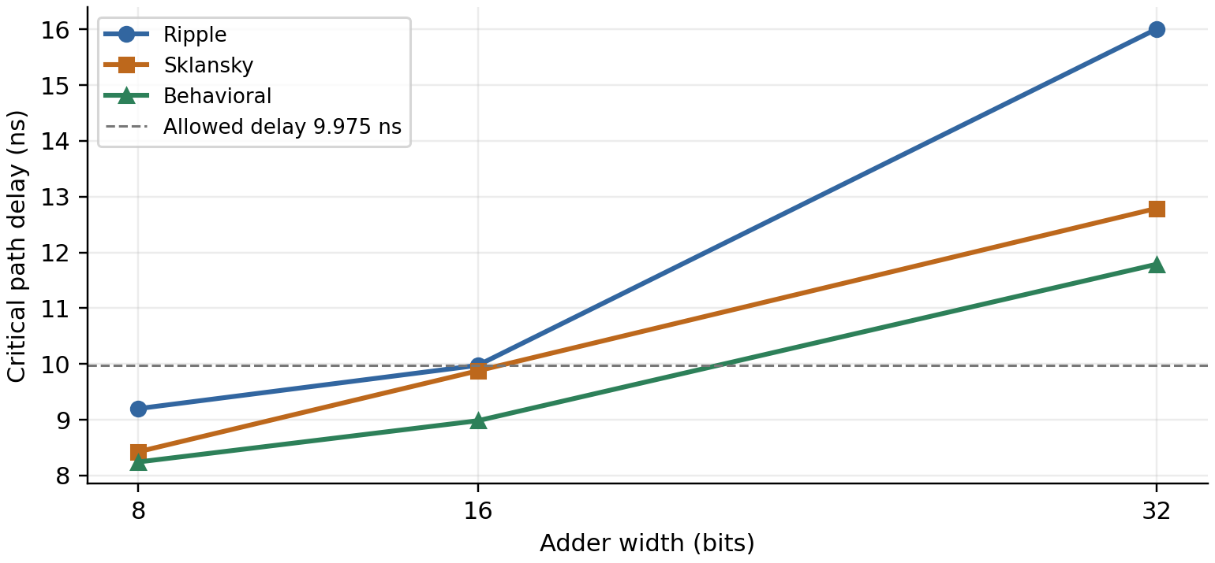
Figure 1. Critical-path delay versus width. Lines connect the measured points.
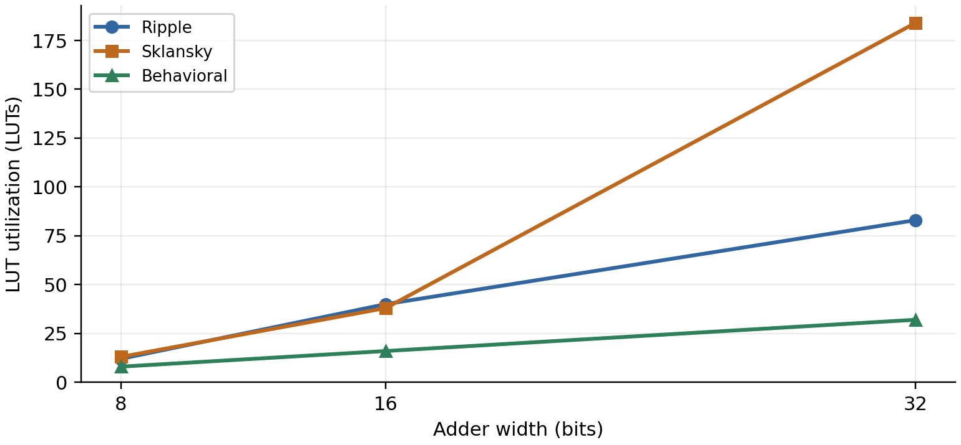
Figure 2. Implemented LUT utilization versus width.
These are measurements of one implementation per configuration. The connecting lines show trends between tested widths.

Timing detail
Width / design | Logic delay ns | Net delay ns | WNS ns | WHS ns | Setup failures
8 Ripple | 4.059  (0.0%) | 5.139  (0.0%) | +0.776 | +2.088 | 0/9
8 Sklansky | 3.953  (+2.6%) | 4.472  (+13.0%) | +1.550 | +2.059 | 0/9
8 Behavioral | 4.712  (-16.1%) | 3.530  (+31.3%) | +1.733 | +2.203 | 0/9
16 Ripple | 4.292  (0.0%) | 5.683  (0.0%) | +0.000 | +2.206 | 0/17
16 Sklansky | 4.064  (+5.3%) | 5.813  (-2.3%) | +0.098 | +2.259 | 0/17
16 Behavioral | 4.955  (-15.4%) | 4.027  (+29.1%) | +0.993 | +2.351 | 0/17
32 Ripple | 5.192  (0.0%) | 10.817  (0.0%) | -6.034 | +2.461 | 30/33
32 Sklansky | 4.148  (+20.1%) | 8.642  (+20.1%) | -2.816 | +2.323 | 25/33
32 Behavioral | 5.446  (-4.9%) | 6.344  (+41.4%) | -1.814 | +3.122 | 30/33
WNS and WHS are worst setup and hold slack. Setup failures are failing endpoints divided by total endpoints. All 8-bit and 16-bit designs meet the reported timing constraints. The 16-bit ripple result has 0.000 ns setup slack at the displayed precision. At 32 bits, setup total negative slack is −96.834 ns for ripple, −45.391 ns for Sklansky, and −25.249 ns for behavioral. No hold violations are reported.

Power detail
Width / design | Total W | I/O W | Total minus I/O W | Logic W | Signals W
8 Ripple | 0.076  (0.0%) | 0.005  (0.0%) | ≈0.071  (0.0%) | <0.001  (0.0%) | <0.001  (0.0%)
8 Sklansky | 0.076  (0.0%) | 0.005  (0.0%) | ≈0.071  (0.0%) | <0.001  (N/A) | <0.001  (N/A)
8 Behavioral | 0.076  (0.0%) | 0.006  (-20.0%) | ≈0.070  (+1.4%) | <0.001  (N/A) | <0.001  (N/A)
16 Ripple | 0.081  (0.0%) | 0.010  (0.0%) | ≈0.071  (0.0%) | <0.001  (0.0%) | <0.001  (0.0%)
16 Sklansky | 0.081  (0.0%) | 0.010  (0.0%) | ≈0.071  (0.0%) | <0.001  (N/A) | 0.001  (N/A)
16 Behavioral | 0.082  (-1.2%) | 0.011  (-10.0%) | ≈0.071  (0.0%) | <0.001  (N/A) | <0.001  (N/A)
32 Ripple | 0.093  (0.0%) | 0.020  (0.0%) | ≈0.073  (0.0%) | <0.001  (0.0%) | 0.002  (0.0%)
32 Sklansky | 0.096  (-3.2%) | 0.021  (-5.0%) | ≈0.075  (-2.7%) | 0.001  (N/A) | 0.004  (-100.0%)
32 Behavioral | 0.095  (-2.2%) | 0.023  (-15.0%) | ≈0.072  (+1.4%) | <0.001  (N/A) | 0.002  (0.0%)
Logic is Vivado’s logic dynamic power category; Signals is routing dynamic power. Both exclude device static power. All logic-power baselines are reported as <0.001 W, so logic-power percentages cannot be calculated reliably, including the 32-bit tree value rounded to 0.001 W. N/A does not mean zero.
Device static power is displayed as 0.070 W for every configuration. At 32 bits, power excluding I/O is approximately 0.073 W for ripple, 0.075 W for Sklansky, and 0.072 W for behavioral. Differences of a few milliwatts should not be treated as precise rankings.

Inspect the Synthesized Hardware
The implemented critical-path schematics and primitive inventories in Appendix A3 were compared with the tree RTL views in Appendix A4.

Ripple carry implementation
The ripple implementation maps to LUT logic without CARRY4 primitives. Its 32-bit critical path runs from B[4] to Cout through a long sequence of LUTs, including LUT2 and LUT6 cells (Figure A25). This preserves a serial carry dependency. Boolean functions and intermediate carry terms have been combined into LUT functions.

Behavioral addition
Vivado infers a dedicated carry-chain implementation for the behavioral + operator. The primitive inventories contain 8, 16, and 32 LUT2 cells and 3, 5, and 9 CARRY4 blocks at the respective widths. The mapped schematics show LUT logic feeding cascaded CARRY4 cells, followed by an output buffer (Figures A31, A37, and A43). The circuit is an FPGA carry chain, rather than a visible parallel-prefix tree.

Sklansky tree and intermediate signals
The RTL views show branching, stage-indexed generate and propagate computations, making the intended prefix tree visible. After mapping, the selected paths contain LUTs instead of separate AND and OR cells for every prefix operation. The 8-bit path contains LUT5, LUT5, and LUT6 logic; the 16-bit path contains LUT6, LUT3, LUT6, and LUT5 logic; the 32-bit path contains LUT6, LUT3, LUT3, LUT6, and LUT6 logic (Figures A49, A55, and A61). No CARRY4 primitives are reported for these tree designs.

Fanout and architectural similarities
The 32-bit tree path report lists high-fanout values as large as 20. These observations help explain why prefix sharing can introduce routing and resource costs. Ripple and Sklansky both become LUT networks. Behavioral addition also uses LUTs and buffers, yet its dedicated carry cascade is a clear structural difference. The inspection therefore shows that similar arithmetic behavior does not imply identical mapped hardware.

Analysis questions

1 Fewest LUTs and shortest path
Behavioral addition uses the fewest LUTs and has the shortest total path at all three widths. Relative to ripple, it reduces LUT use by 33.3%, 60.0%, and 61.4% at 8, 16, and 32 bits, respectively, and reduces path delay by 10.4%, 10.0%, and 26.4%. Behavioral addition also uses 3, 5, and 9 CARRY4 blocks, so the LUT reductions alone do not measure total hardware area.

2 Delay scaling and tree advantage
Sklansky reduces total path delay relative to ripple by 8.4%, 1.0%, and 20.1% at 8, 16, and 32 bits. Its logic delay is lower by 2.6%, 5.3%, and 20.1%, while net delay is lower by 13.0% at 8 bits, higher by 2.3% at 16 bits, and lower by 20.1% at 32 bits. The 16-bit routing increase offsets much of the logic improvement. From 8 to 32 bits, ripple path delay grows by 74.0%, compared with 51.8% for Sklansky. Routing accounts for about 68% of the 32-bit tree path, limiting the benefit of reduced logic depth, which is why the behavioral adder had the shortest path.

3 Behavioral hardware quality
Behavioral addition produces the best total path delay even though its logic delay is 16.1%, 15.4%, and 4.9% higher than ripple at 8, 16, and 32 bits. Its net delay is lower by 31.3%, 29.1%, and 41.4%, respectively, more than offsetting the logic-delay increases. Dedicated CARRY4 resources appear in every behavioral design and not in the ripple-carry or tree design. These results show why logic delay must be considered together with routing delay when evaluating FPGA hardware.

4 When Sklansky becomes advantageous
Sklansky already has an 8.4% path-delay advantage over ripple at 8 bits, at the cost of 8.3% more LUTs. At 16 bits it uses 5.0% fewer LUTs but improves path delay by only 1.0%, a small difference in a single run. At 32 bits it reduces delay by 20.1% while using 121.7% more LUTs. Thus, its strongest measured timing advantage comes with a substantial resource cost. At none of the tested widths does Sklansky outperform behavioral addition in LUT count or total path delay.

5 Choice for an FPGA design
For this FPGA, behavioral addition would be my starting point: at 32 bits it provides 61.4% fewer LUTs and 26.4% lower path delay than ripple. Power does not establish an equally clear winner. At 32 bits, total power is approximately 2.2% higher for behavioral and 3.2% higher for Sklansky than ripple. Power excluding I/O is 1.4% lower and 2.7% higher, respectively. These small differences come from rounded, Low-confidence estimates dominated by static and I/O power. Logic-power percentage reductions cannot be determined because every ripple baseline is reported only as <0.001 W. Therefore, the recommendation rests on LUT and timing results, not on power results. All three 32-bit designs still miss the 10 ns timing target so they would fail to operate in one clock cycle without overclocking if needed in a sequential circuit.

6 Applicability to an ASIC
For an ASIC implementation, the Sklansky tree adder appears promising because it had the lowest logic delay at every tested width, 2.6%, 5.3%, and 20.1% lower than ripple at 8, 16, and 32 bits. Its parallel carry computation suggests an advantage as width increases. Behavioral addition’s FPGA timing advantage also depends on dedicated carry resources, which would not transfer directly to a standard-cell ASIC. These results support investigating the tree adder as the strongest candidate for low logic delay, although confirming the best overall ASIC design would account for design time which may larger for the tree adder due to the due to the large amount of LUT’S used in the FPGA implementation.

Optional 64 bit experiment and conclusion
All three architectures passed 64-bit directed and random simulation. Implementation was also attempted for all three, each encountered the same I/O overutilization failure. A fully exposed N-bit adder requires 2N + 1 input pins and N + 1 output pins, totaling 3N + 2. At 64 bits this is 194 pins, exceeding the selected package’s 106 available user I/O pins. The supplied ripple error screenshot documents the failure. The behavioral and tree failures were also reported during the experiment.
The experiment shows that the RTL architecture and mapped FPGA hardware must be considered together. The tree reduces delay compared with the explicit ripple structure, while behavioral addition gives the best measured LUT and timing results through carry-chain mapping. The tree’s smaller number of mapped logic levels does not eliminate routing cost. None of the three 32-bit designs meets the chosen 10 ns constraint under the present setup.

Evidence and limitations
The simulation logs and Vivado reports are the sources for the verification and implementation results. Appendix A retains the supporting screenshots. These are tool estimates from one run per configuration, not physical board measurements.
Power excluding I/O means total on-chip power minus I/O power and includes static power; the Logic and Signals categories separately report logic and routing dynamic power. All power estimates have Low confidence. Logic-power percentages are unavailable because the ripple baselines are below the displayed 0.001 W precision. AI assistance was used for plots, partial tree adder implementation, and report preparation.

Appendix A Supplementary screenshots
This appendix is supporting reference material and is separate from the main report. These additional screenshots are not needed to follow its discussion.
The evidence is organized into simulation verification, experimental settings, implementation reports, and RTL schematic views.
Appendix group | Contents
A1 Simulation verification | 8, 16, 32, and 64 bit test results
A2 Experimental settings | Power settings and virtual clock
A3 Implementation reports | Timing, power, utilization, primitives, and mapped schematics for all nine configurations
A4 RTL schematic views | Tree structure at 8, 16, and 32 bits
A5 Optional 64 bit attempt | I/O overutilization error

A1 Verification at eight and 16 bit
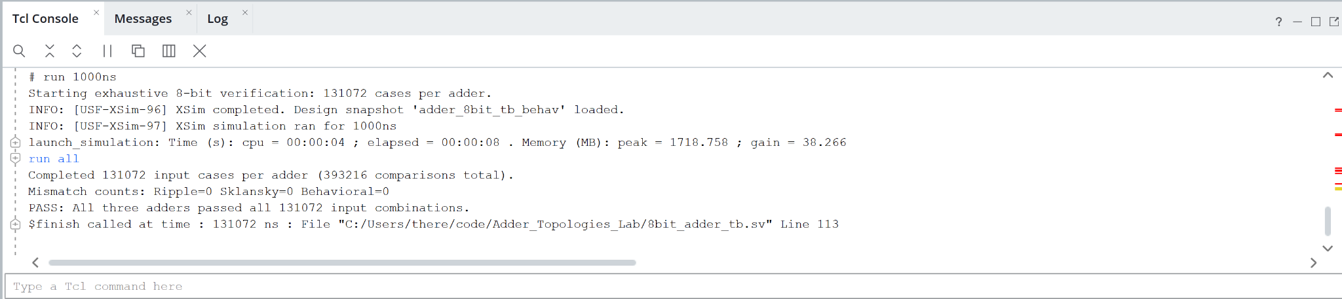
Figure A1. Exhaustive 8-bit verification
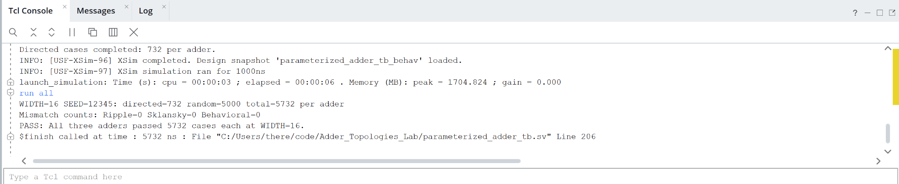
Figure A2. 16-bit directed and random verification

A1 Verification at thirty two and sixty four bits
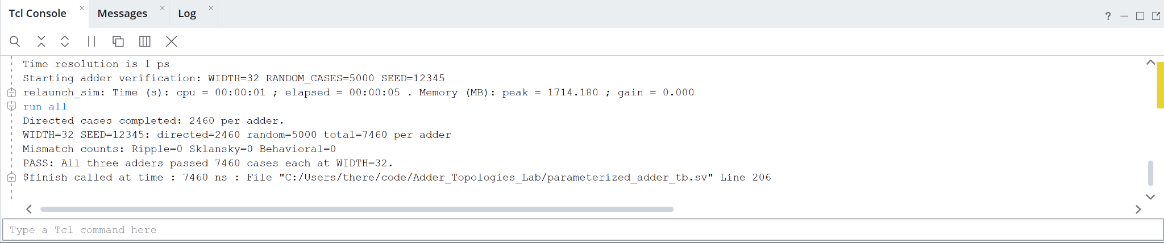
Figure A3. 32-bit directed and random verification
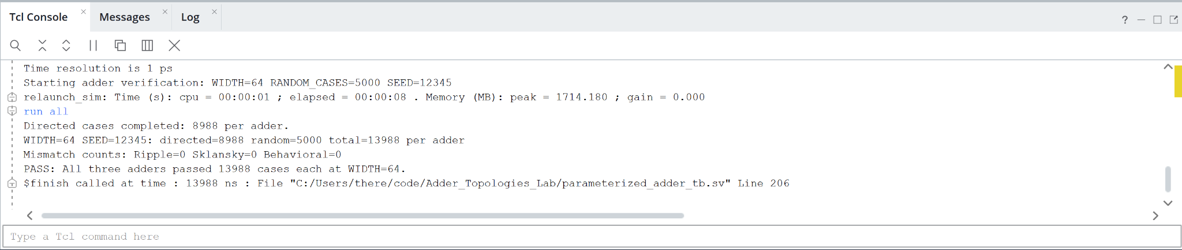
Figure A4. 64-bit directed and random verification

A2 Power and timing settings
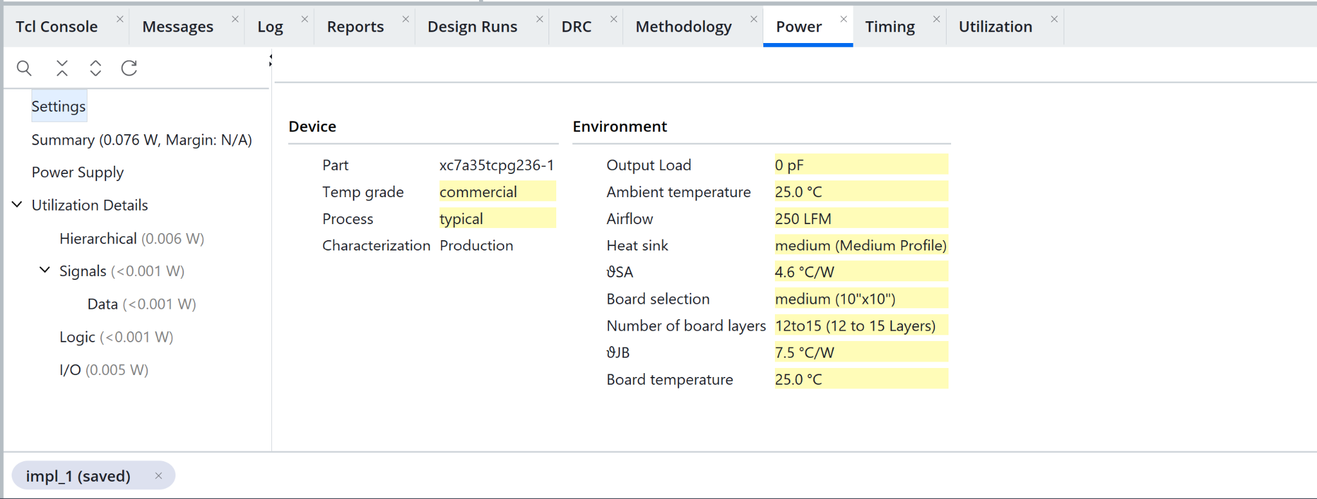
Figure A5. Power environment settings
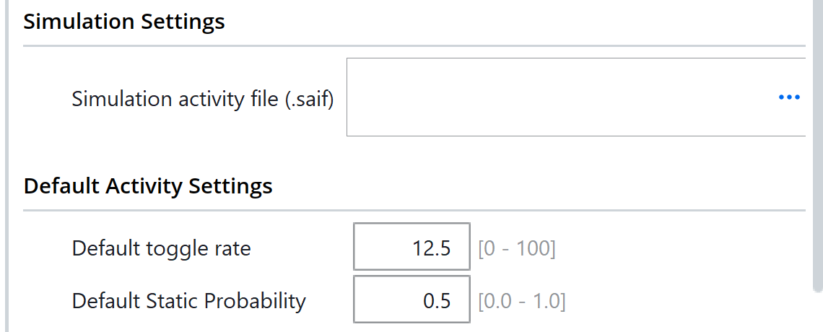
Figure A6. Initial activity settings before the reported change
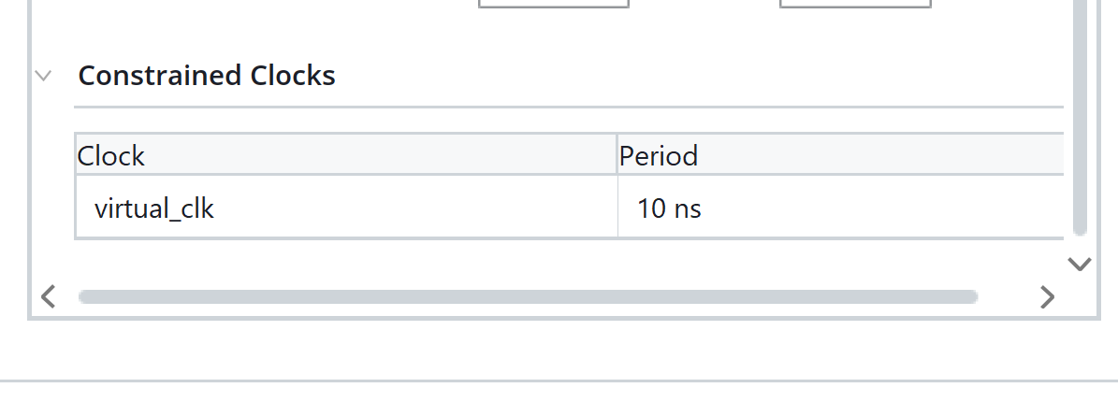
Figure A7. Virtual clock period

A3 Ripple 8 bit timing and power
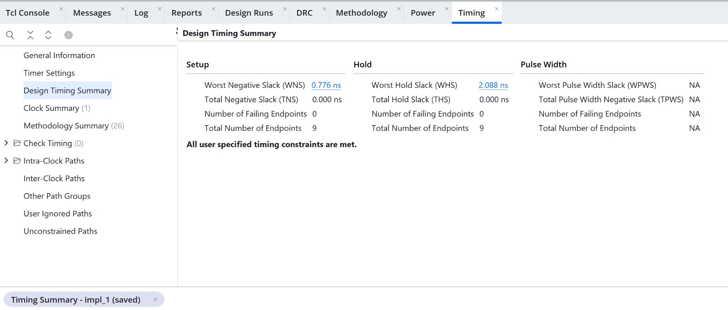
Figure A8. Timing summary
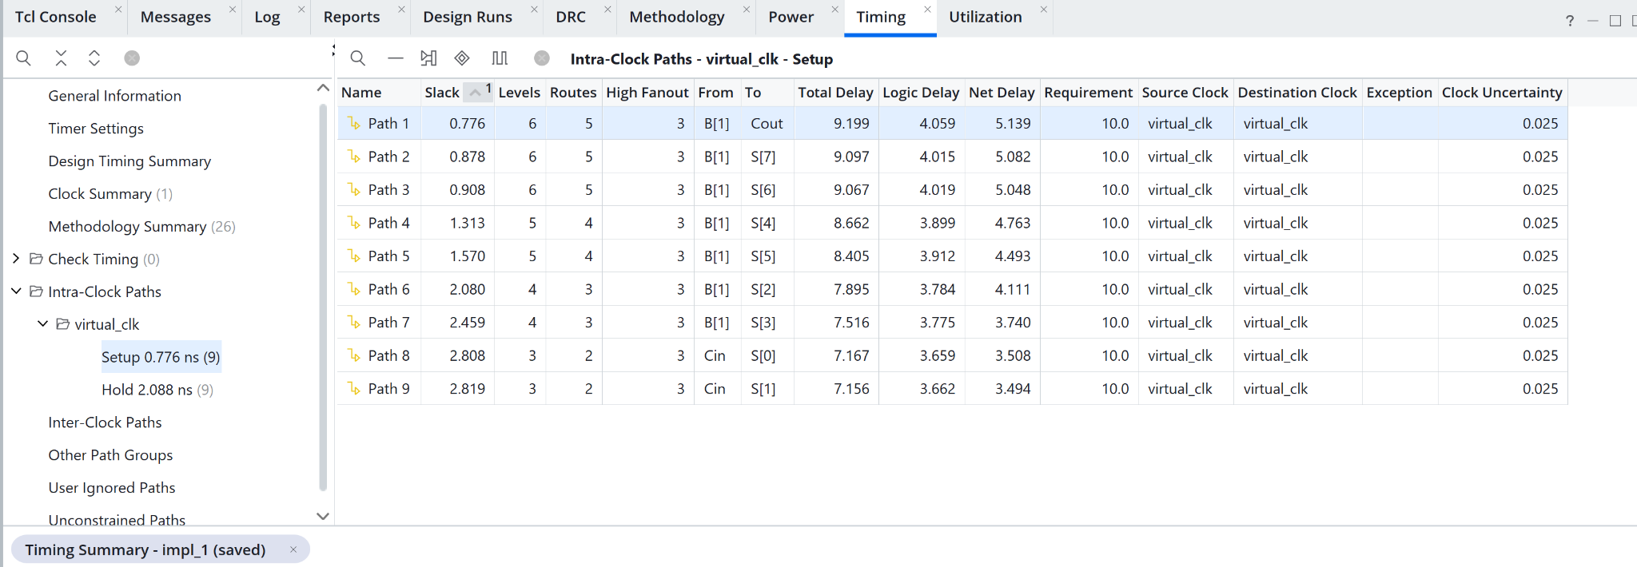
Figure A9. Setup paths
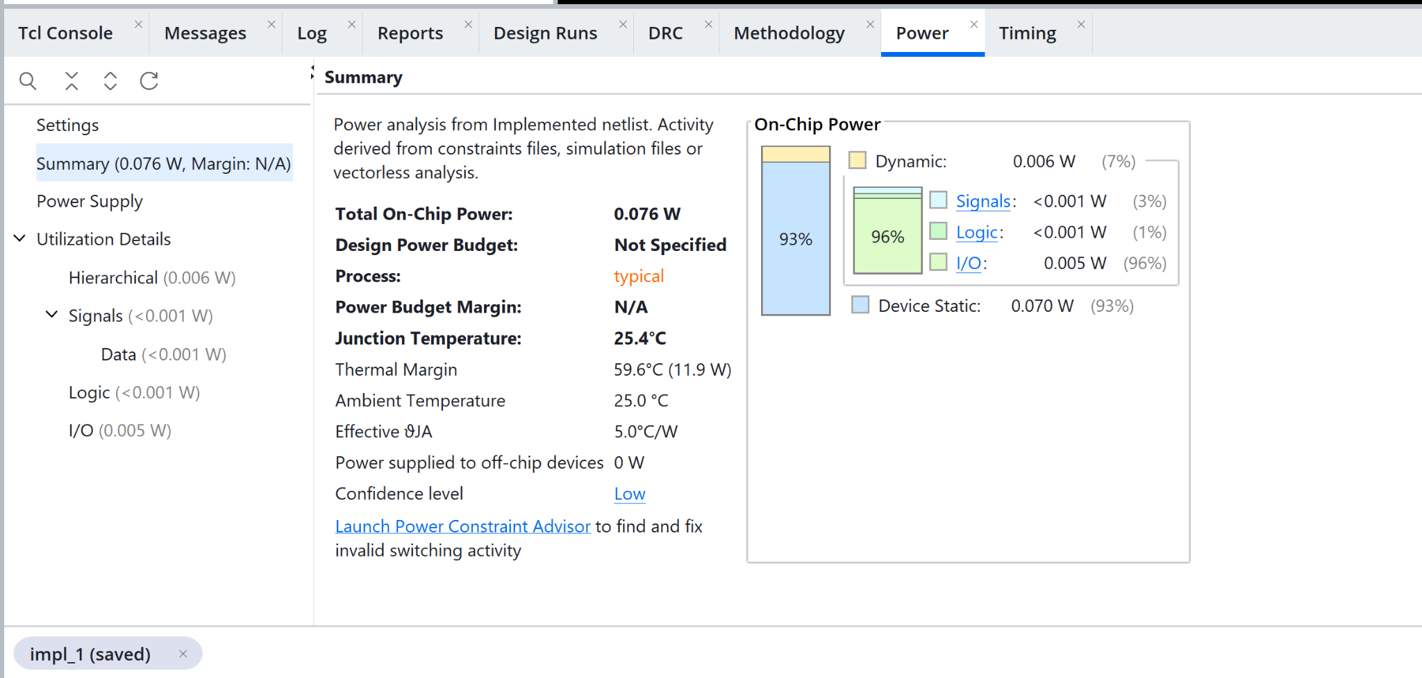
Figure A10. Power estimate

A3 Ripple 8 bit hardware
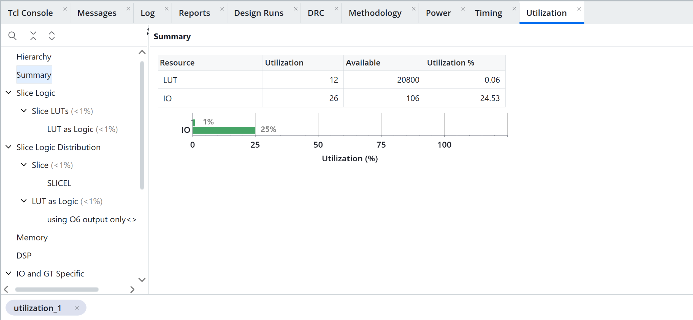
Figure A11. Utilization
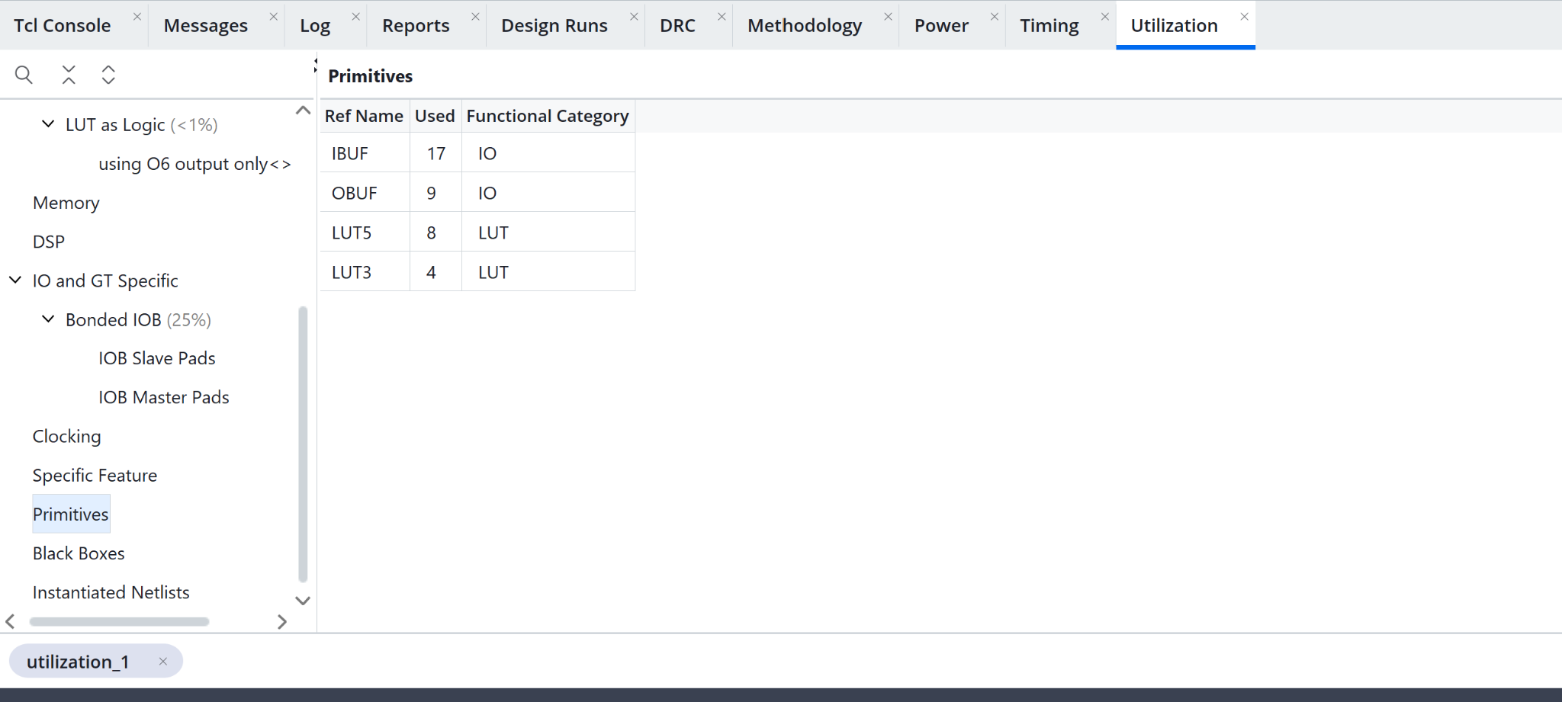
Figure A12. Primitive inventory
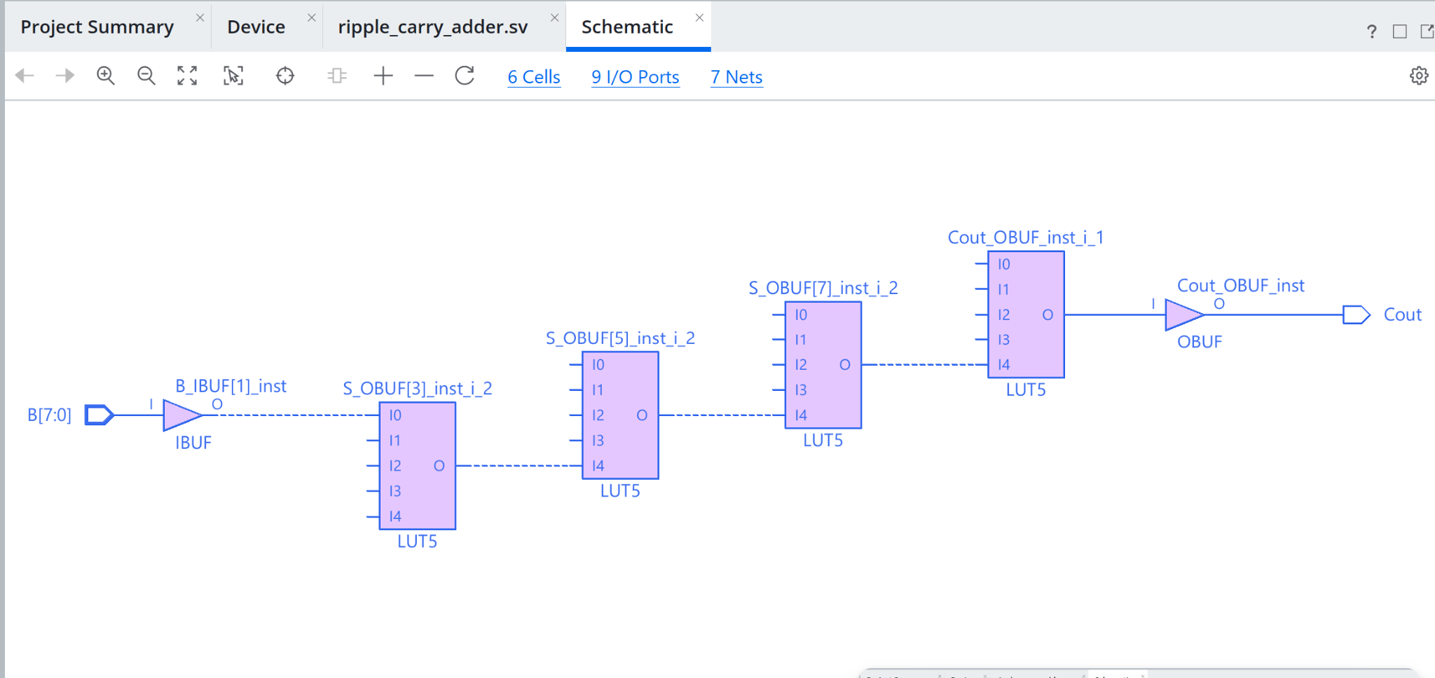
Figure A13. Schematic view

A3 Ripple 16 bit timing and power
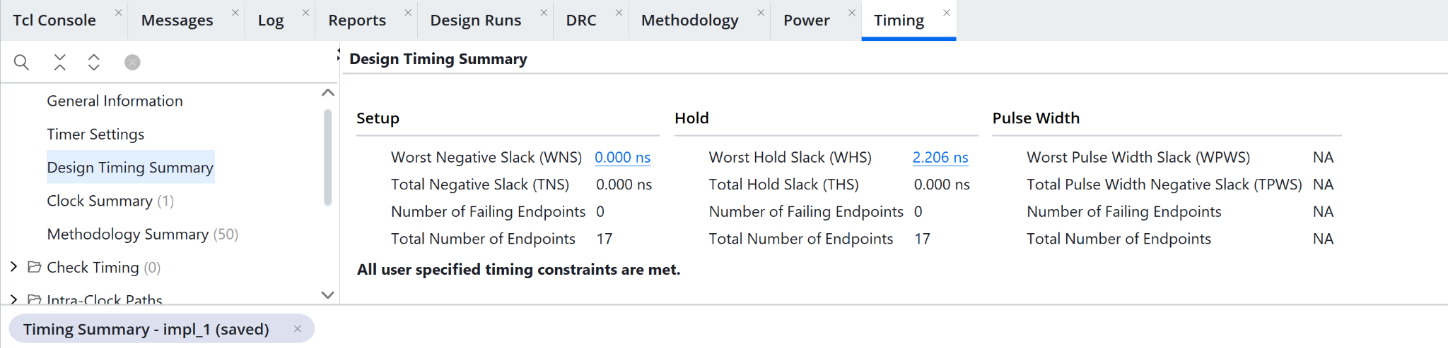
Figure A14. Timing summary
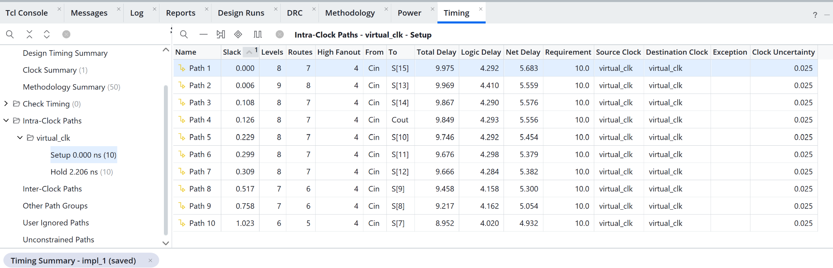
Figure A15. Setup paths
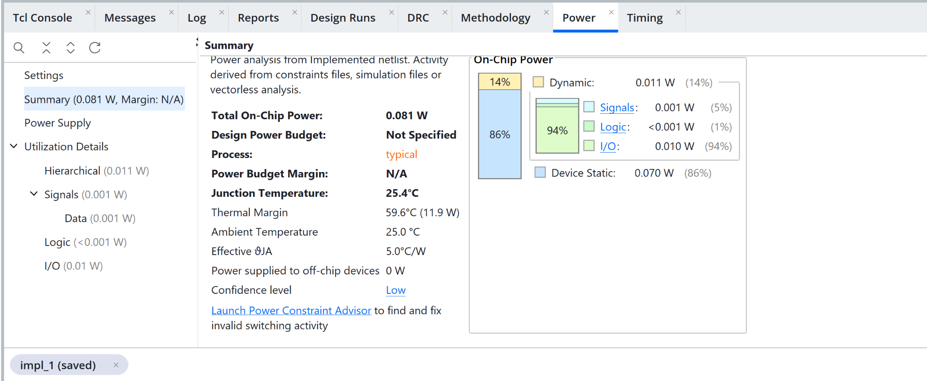
Figure A16. Power estimate

A3 Ripple 16 bit hardware
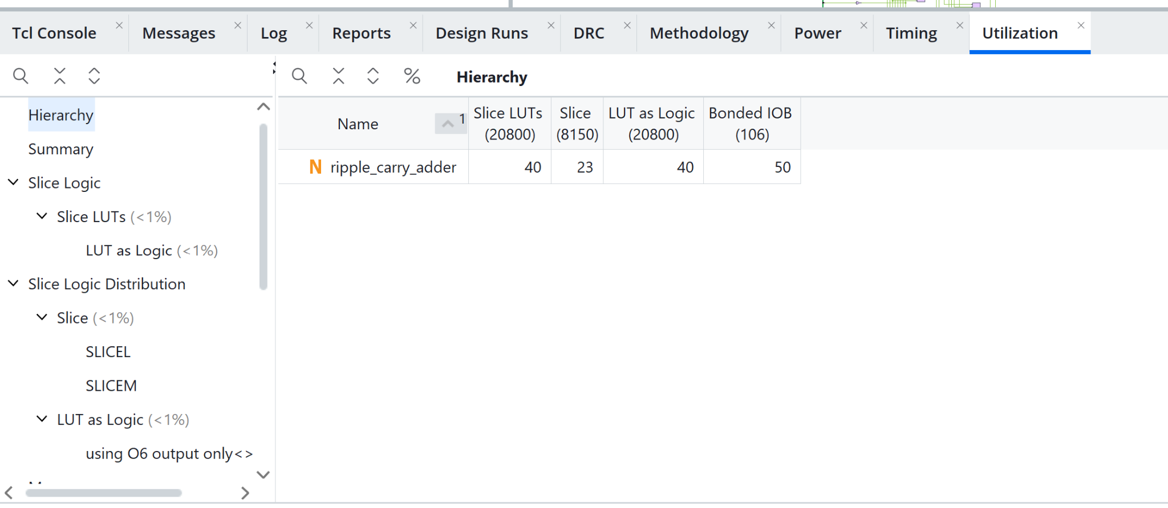
Figure A17. Utilization
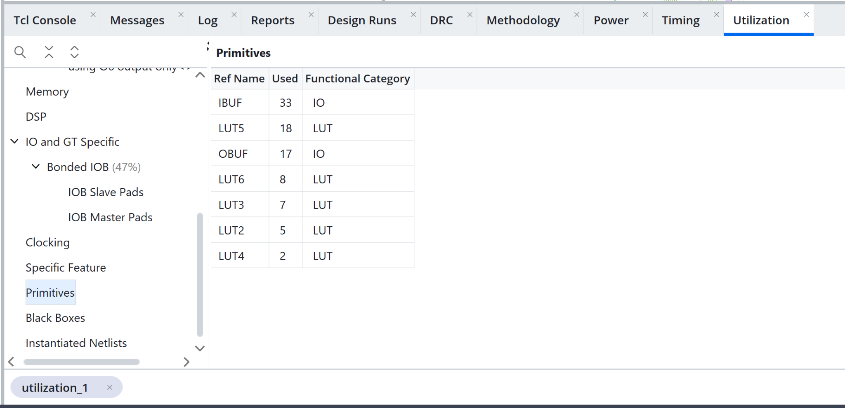
Figure A18. Primitive inventory
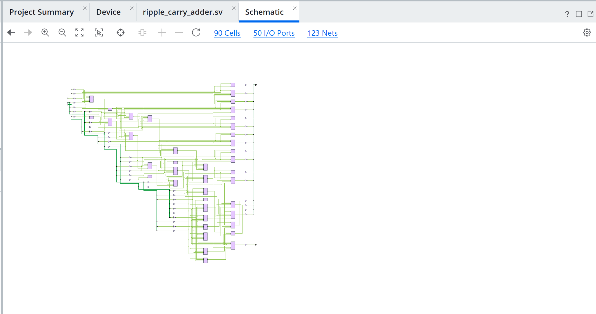
Figure A19. Schematic view

A3 Ripple 32 bit timing and power
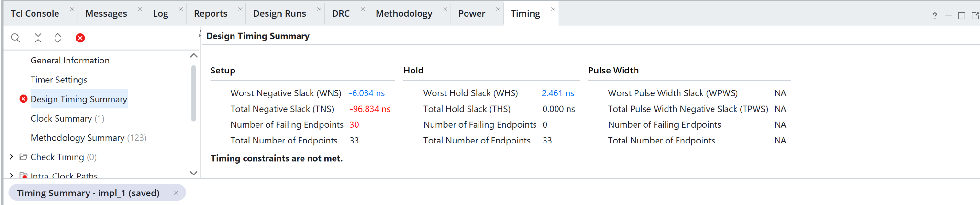
Figure A20. Timing summary
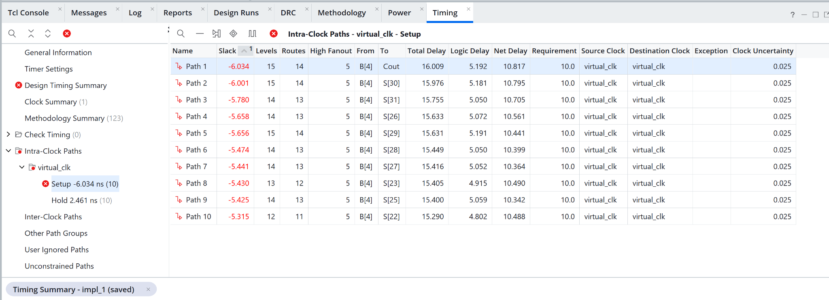
Figure A21. Setup paths
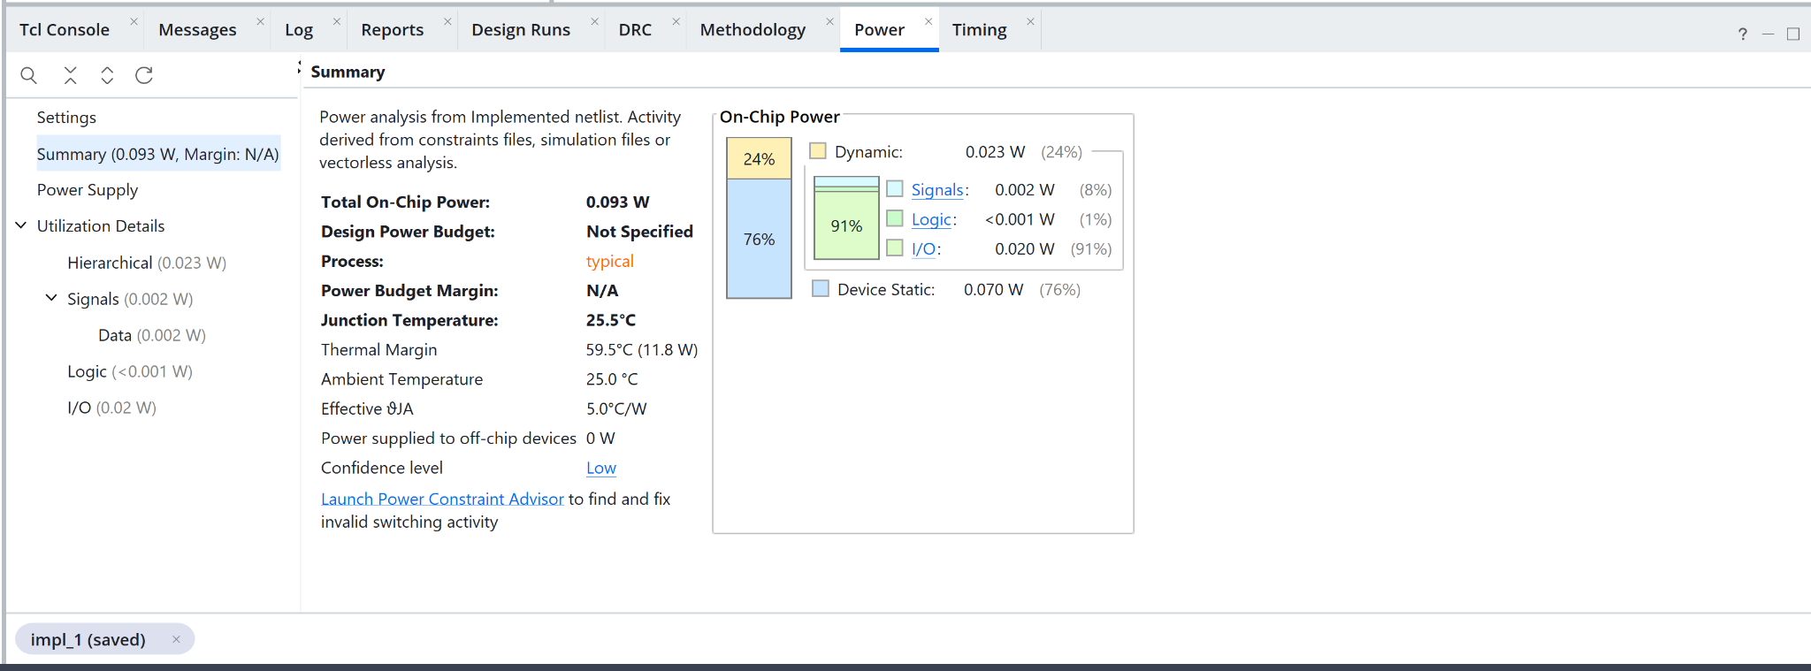
Figure A22. Power estimate

A3 Ripple 32 bit hardware
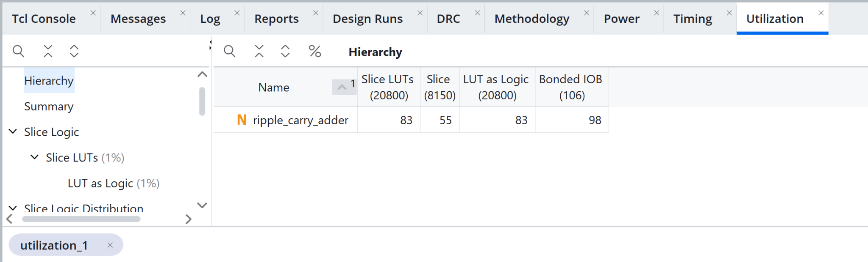
Figure A23. Utilization
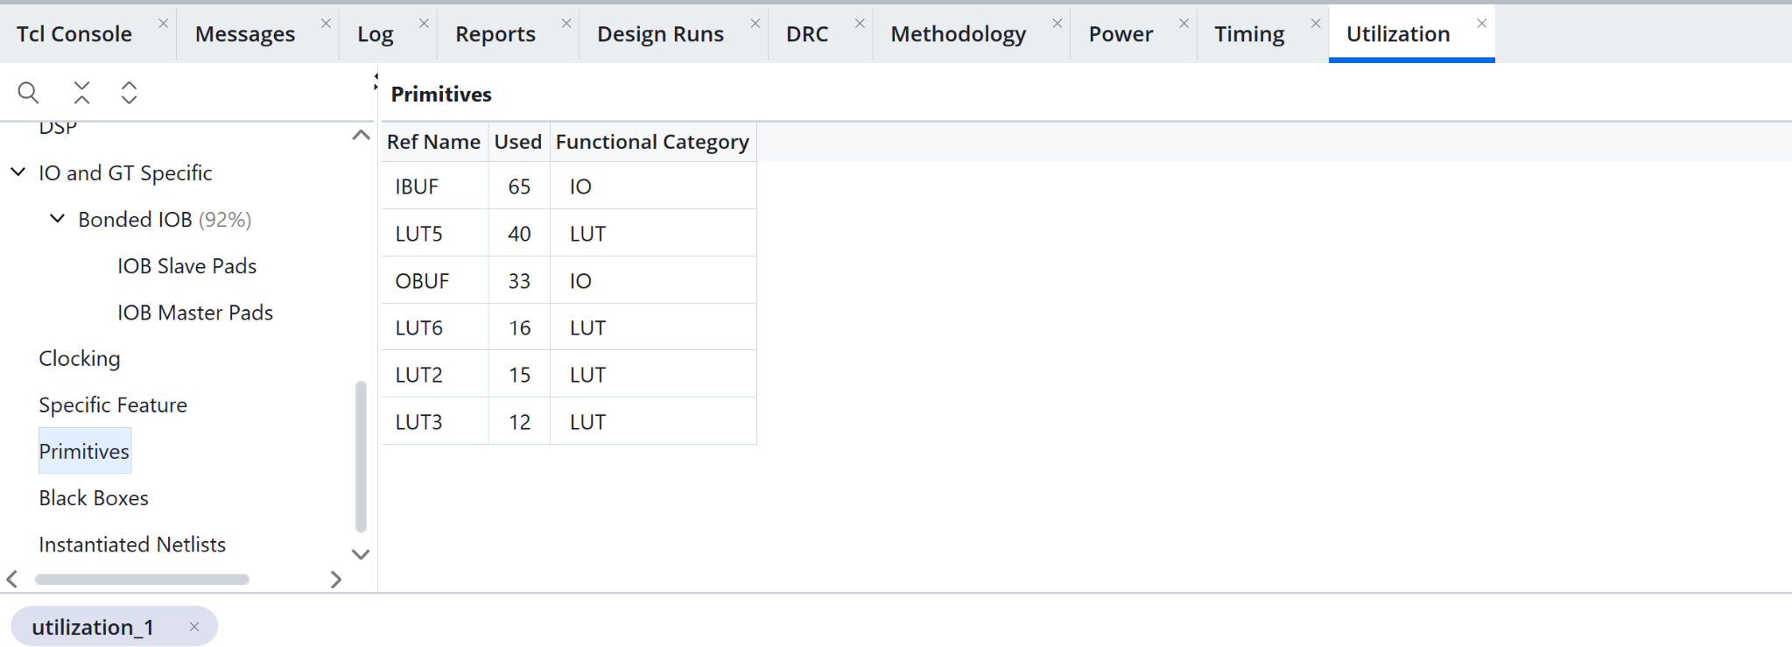
Figure A24. Primitive inventory
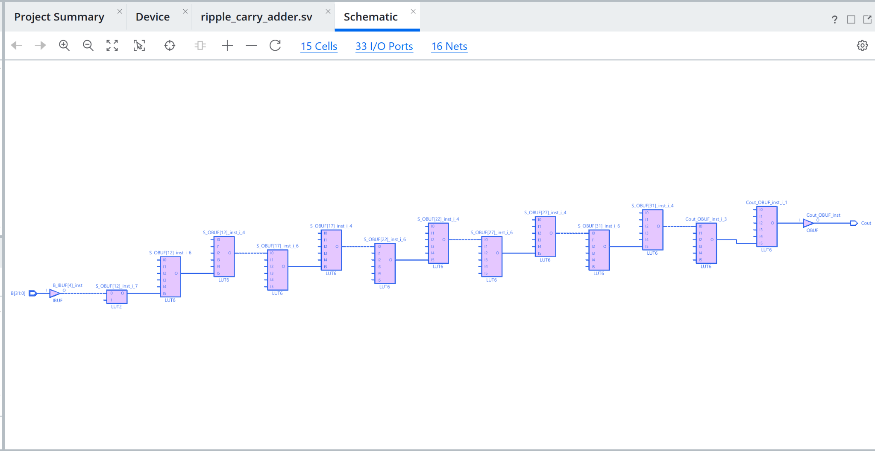
Figure A25. Schematic view

A3 Behavioral 8 bit timing and power
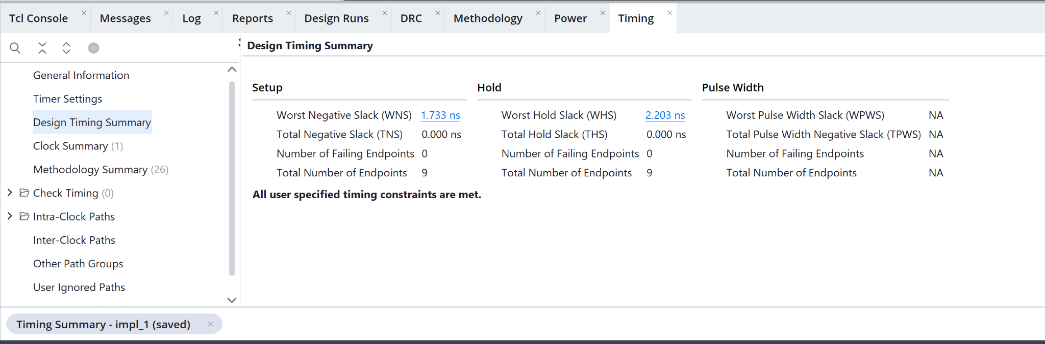
Figure A26. Timing summary
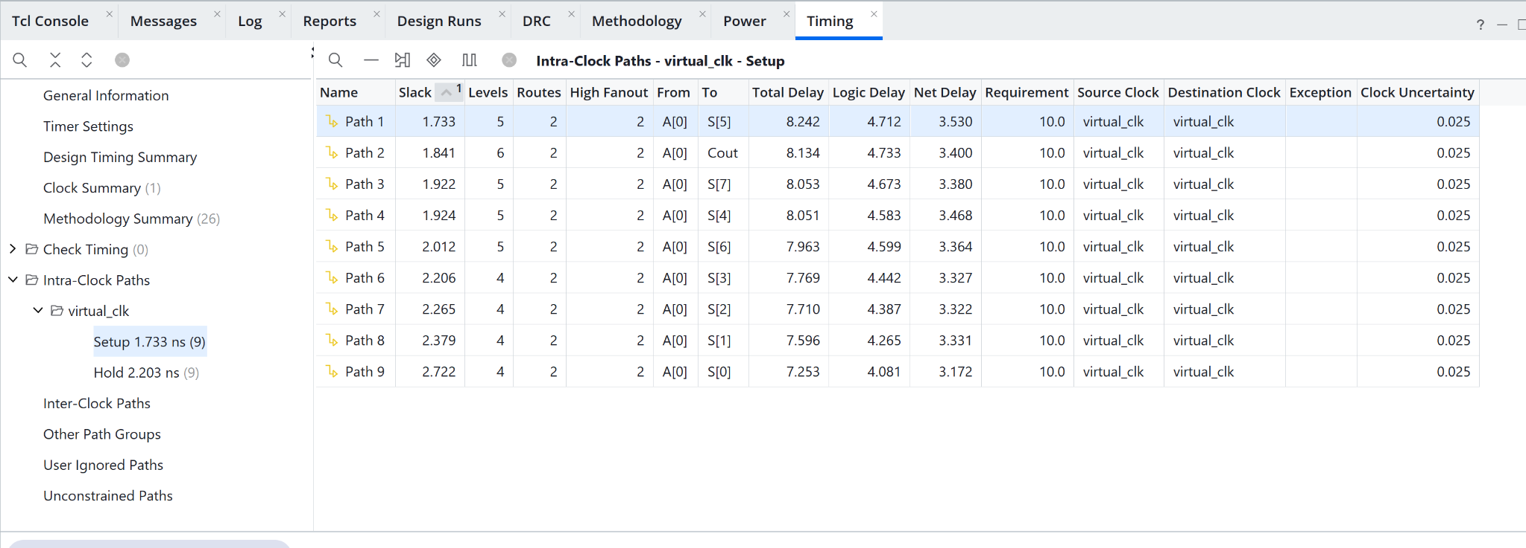
Figure A27. Setup paths
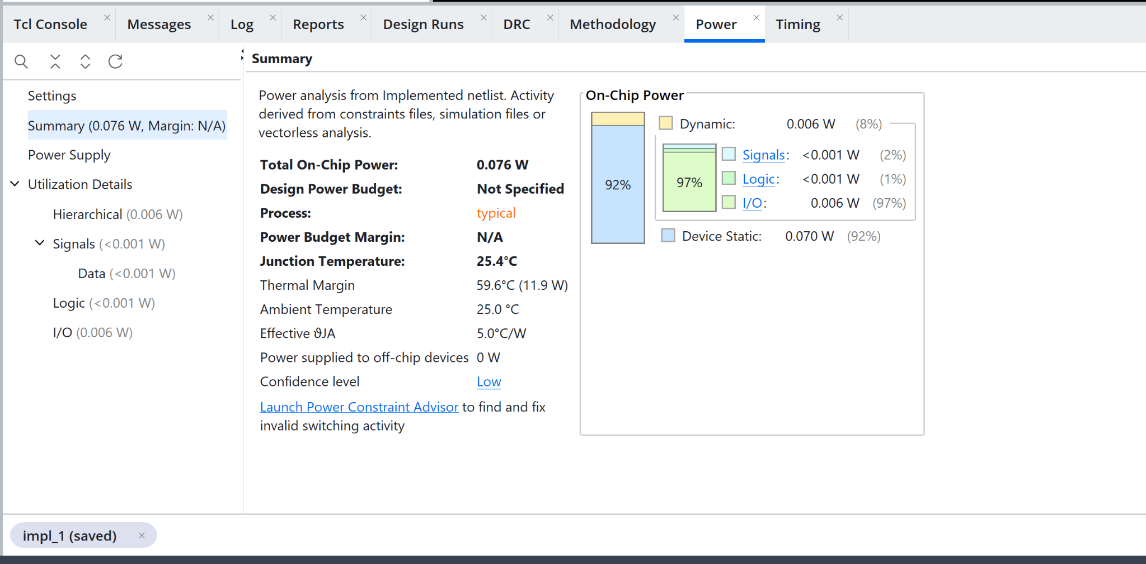
Figure A28. Power estimate

A3 Behavioral 8 bit hardware
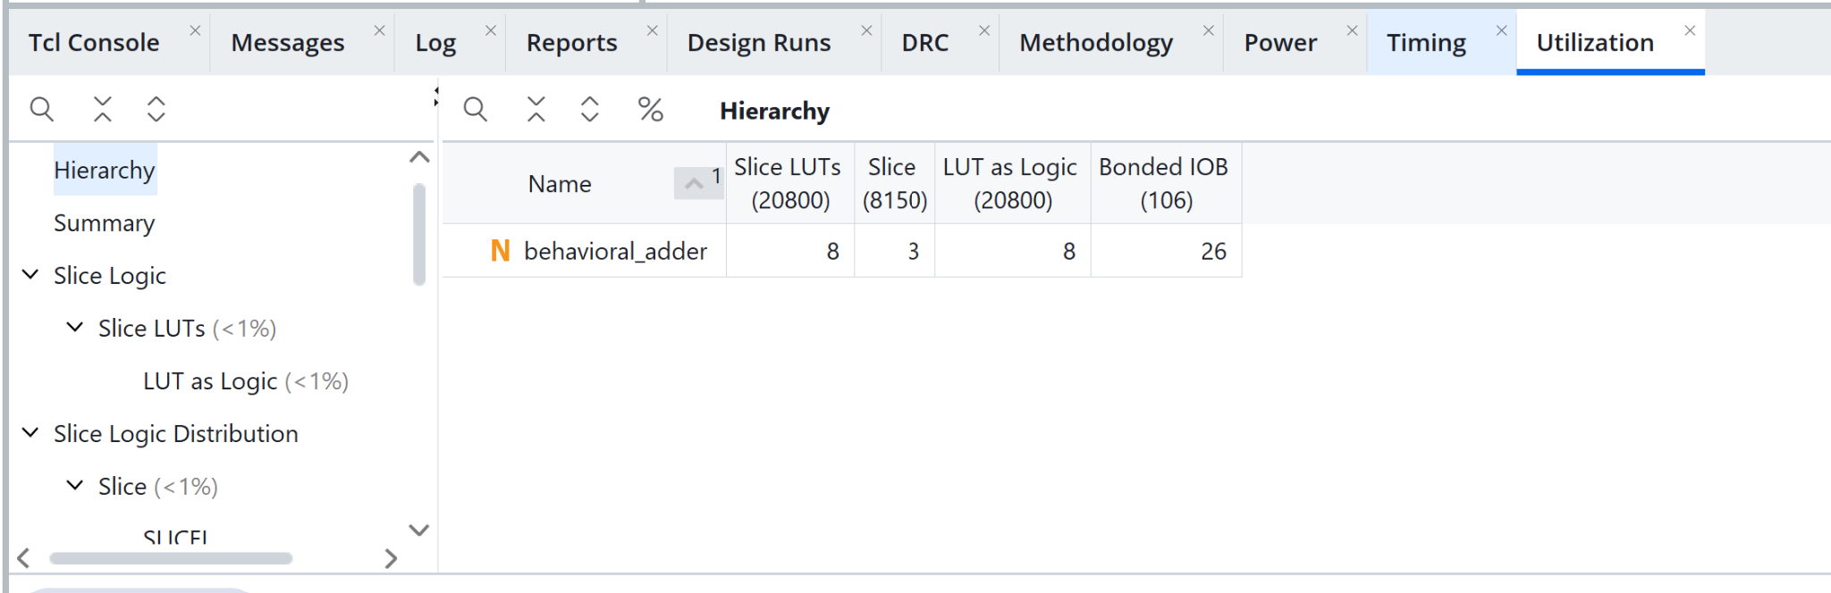
Figure A29. Utilization
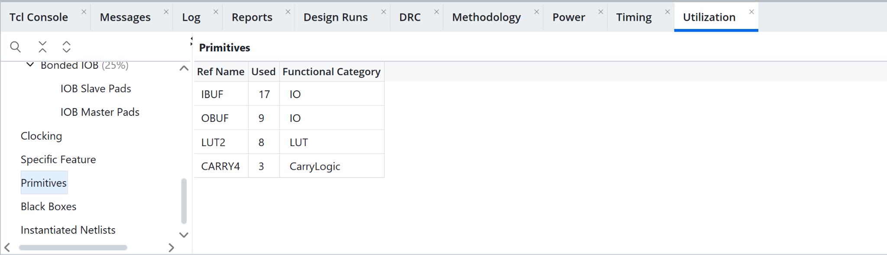
Figure A30. Primitive inventory
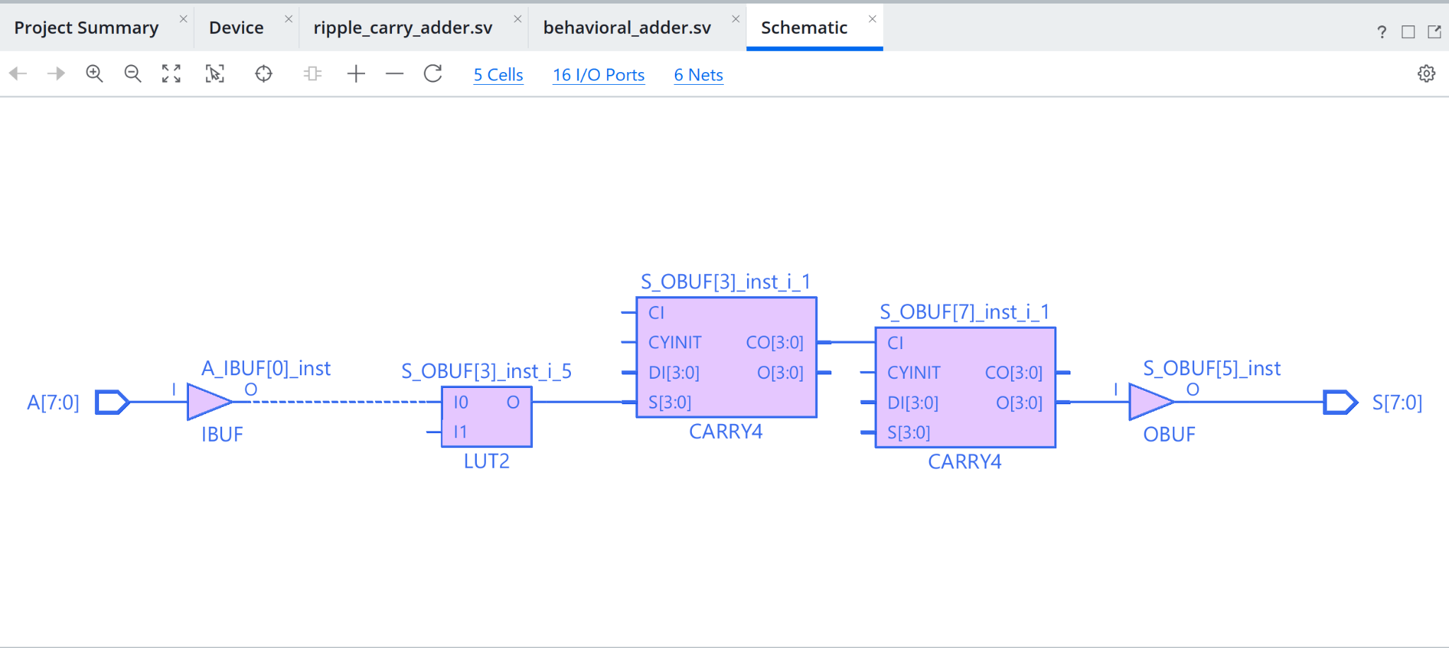
Figure A31. Schematic view

A3 Behavioral 16 bit timing and power
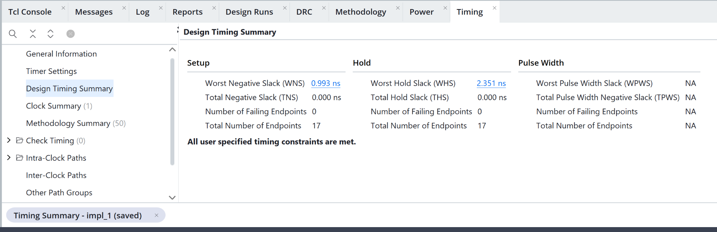
Figure A32. Timing summary
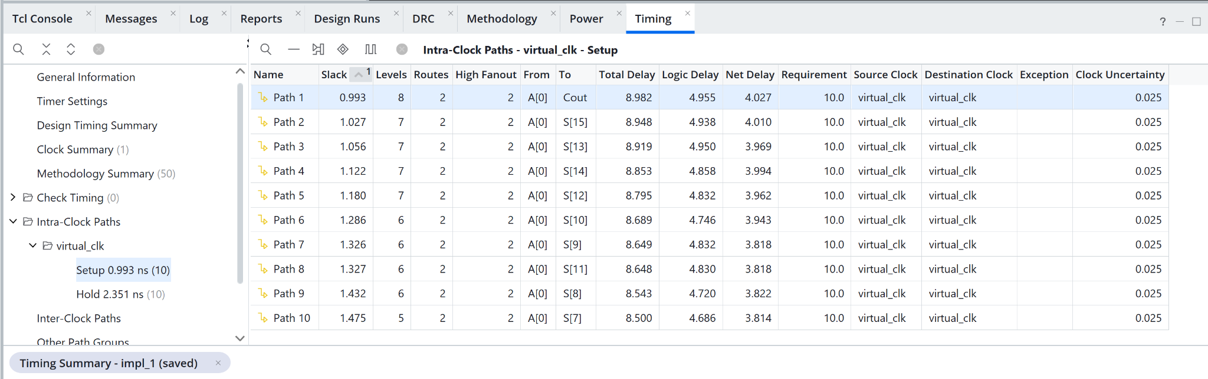
Figure A33. Setup paths
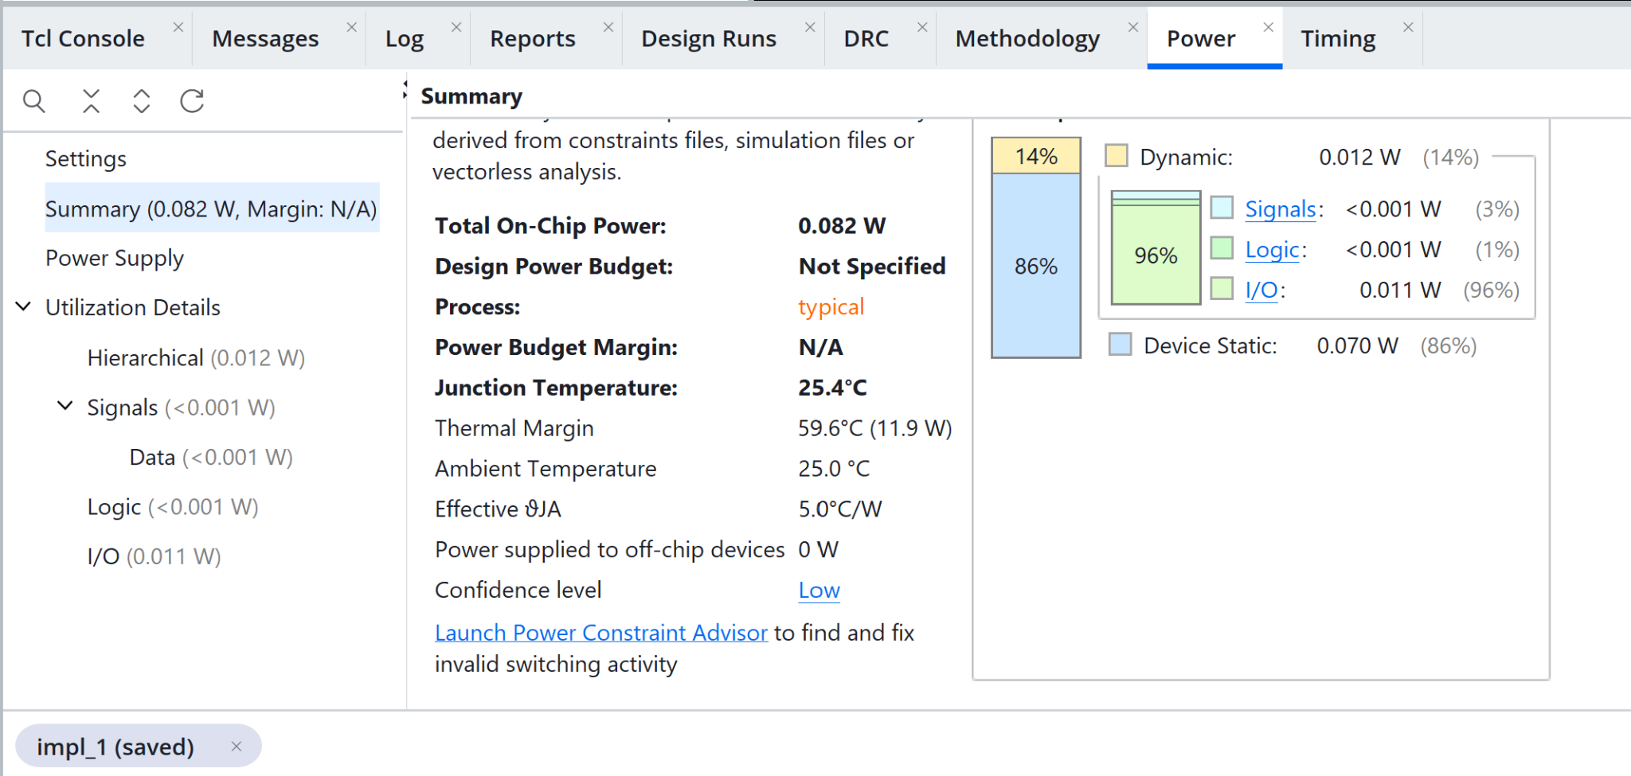
Figure A34. Power estimate

A3 Behavioral 16 bit hardware
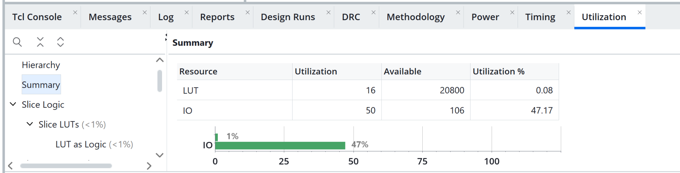
Figure A35. Utilization
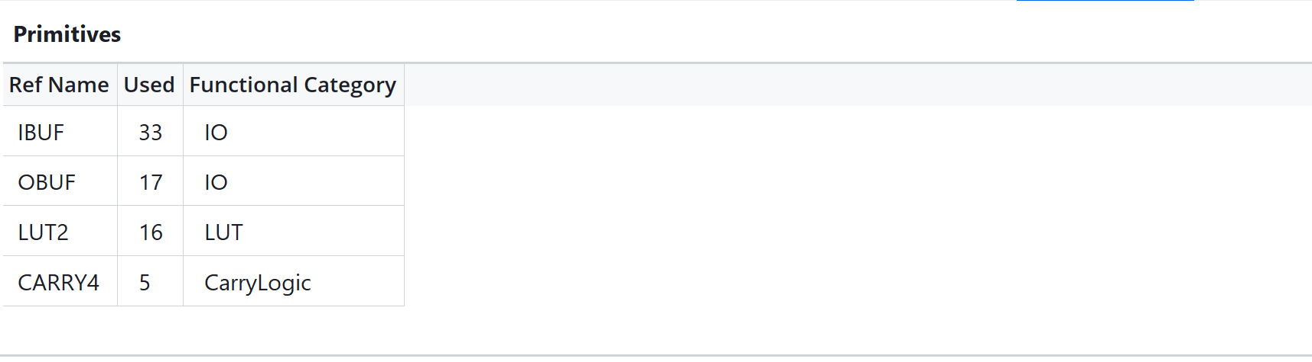
Figure A36. Primitive inventory
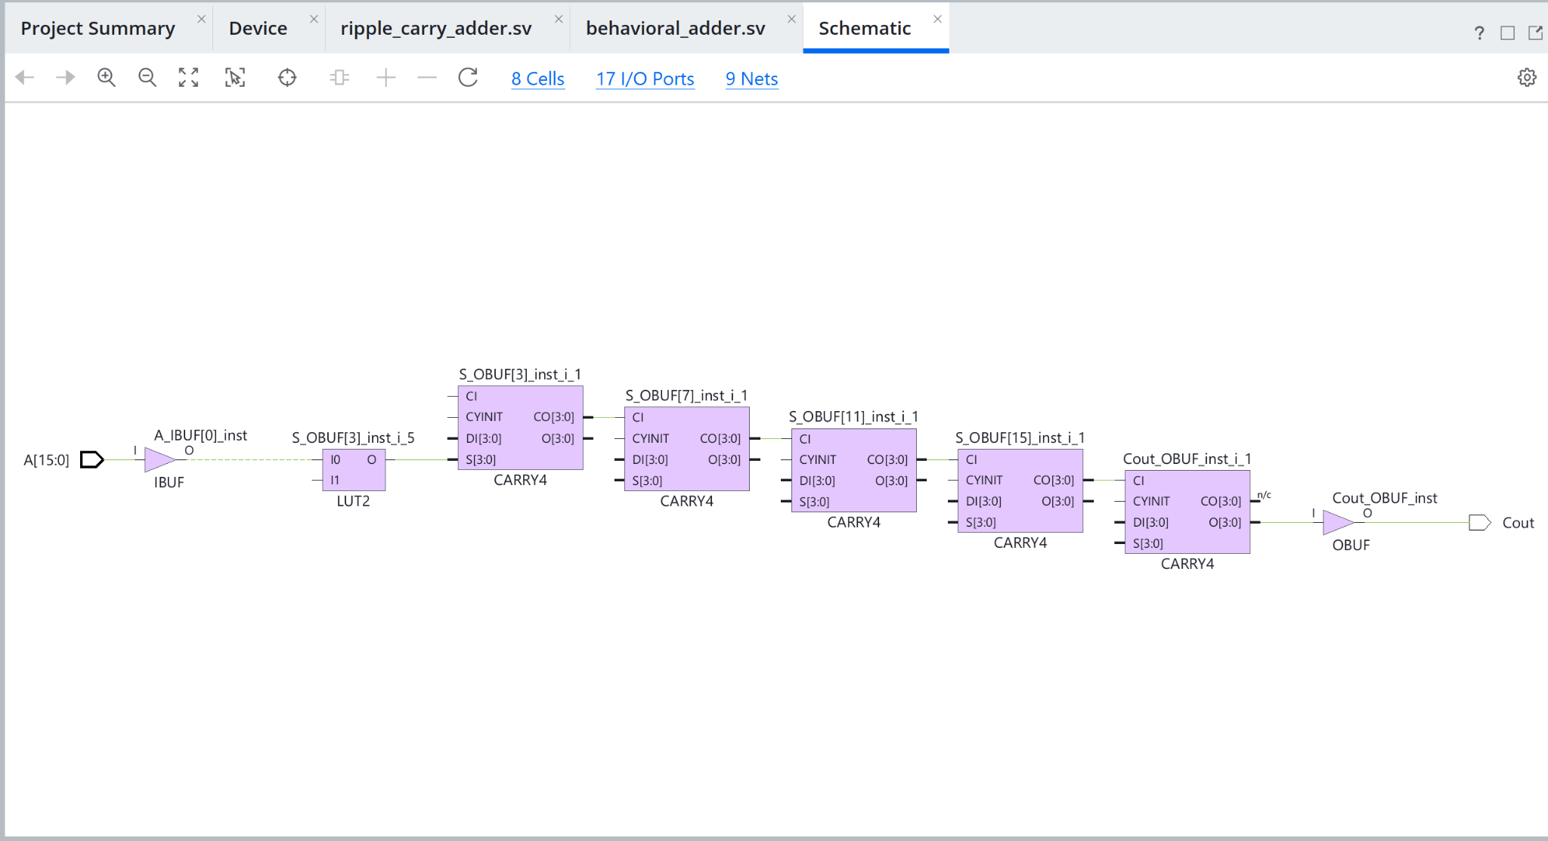
Figure A37. Schematic view

A3 Behavioral 32 bit timing and power
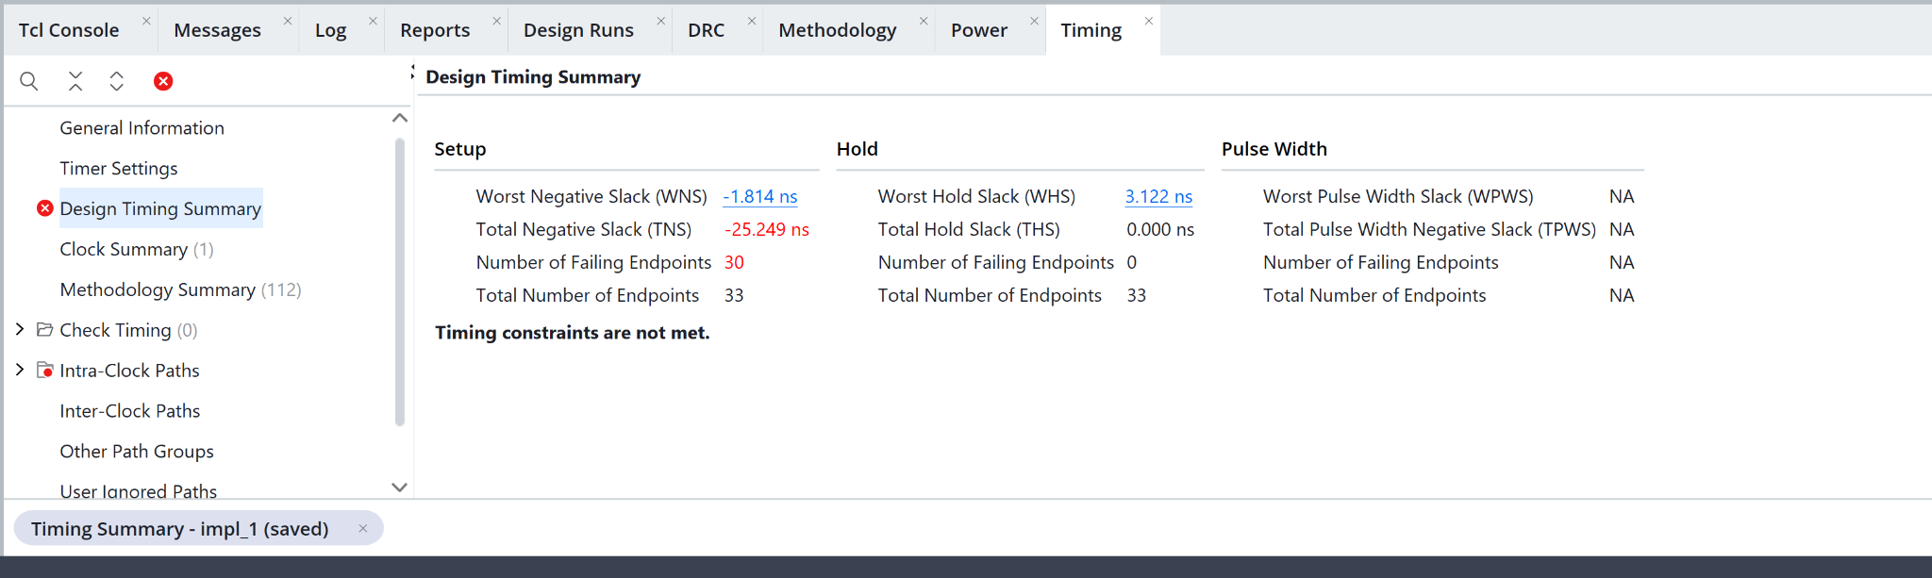
Figure A38. Timing summary
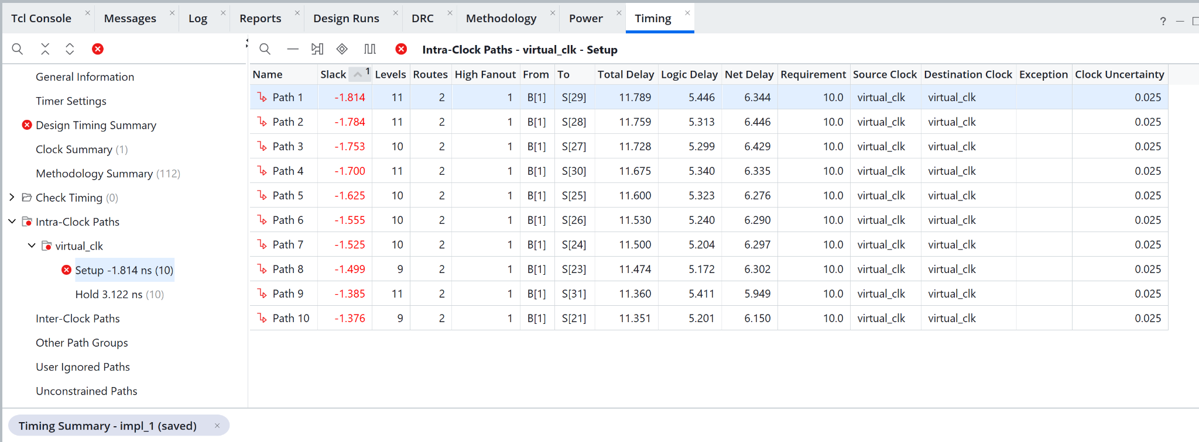
Figure A39. Setup paths
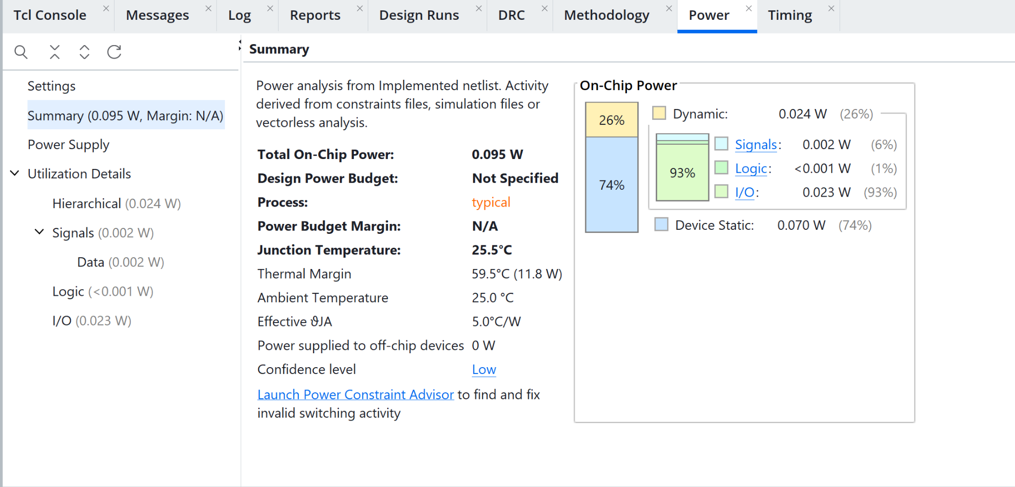
Figure A40. Power estimate

A3 Behavioral 32 bit hardware
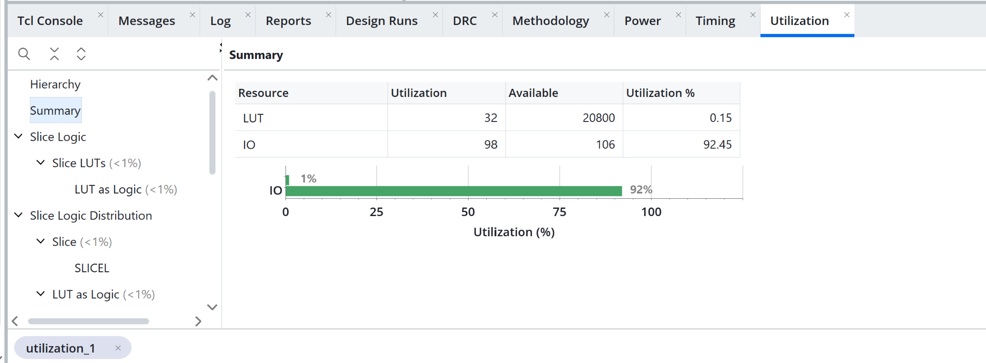
Figure A41. Utilization
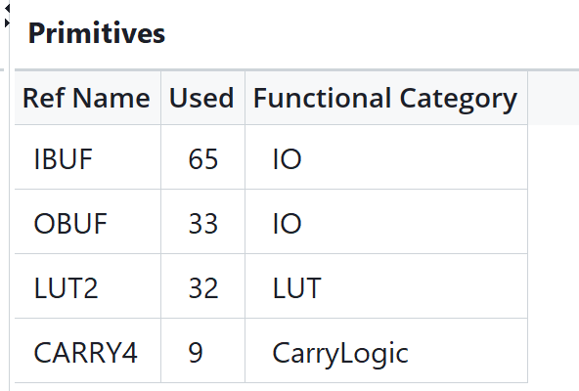
Figure A42. Primitive inventory
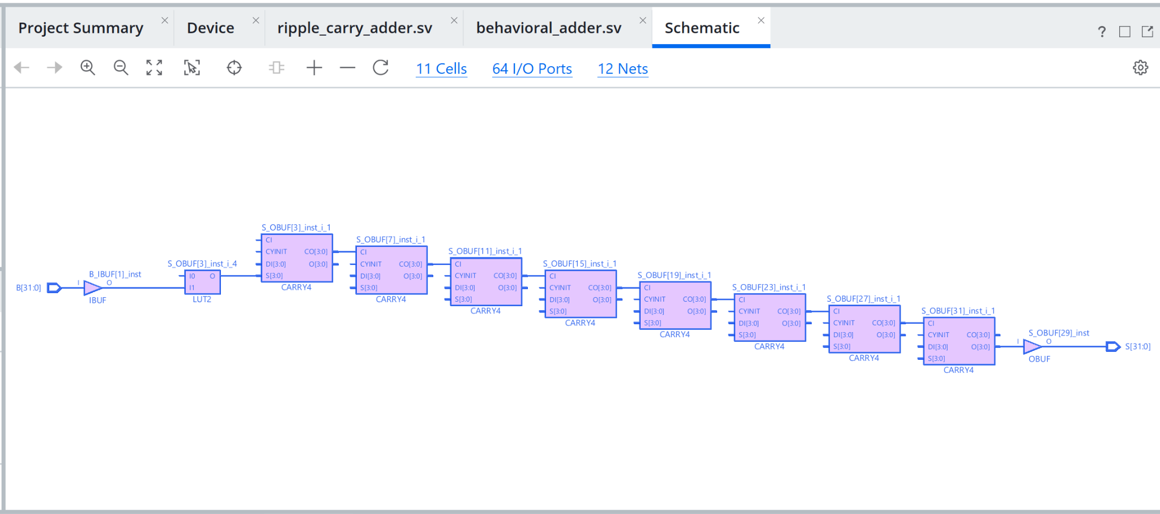
Figure A43. Schematic view

A3 Sklansky 8 bit timing and power
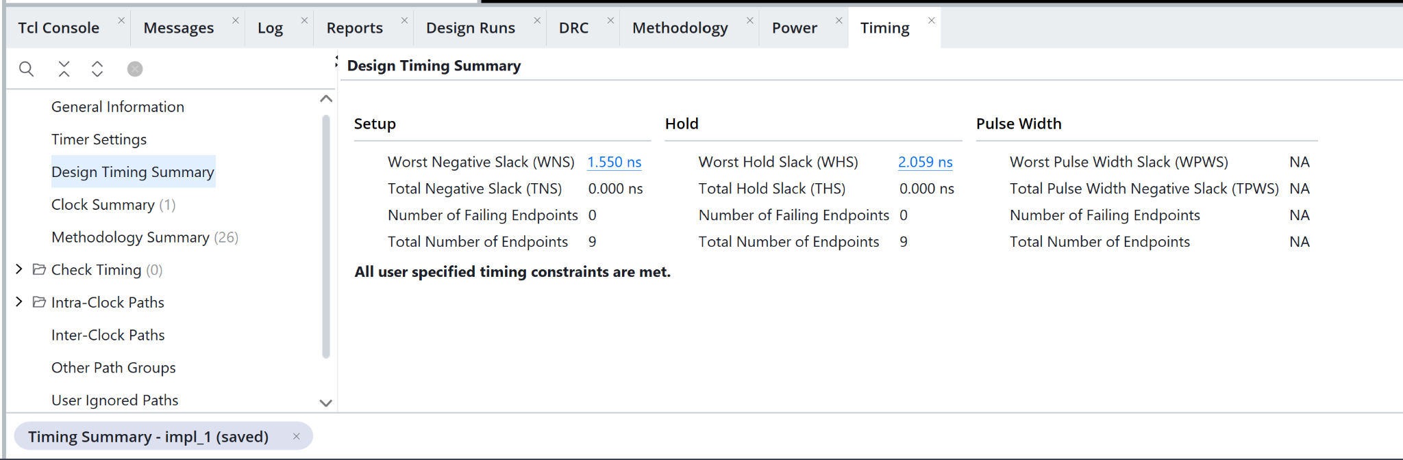
Figure A44. Timing summary
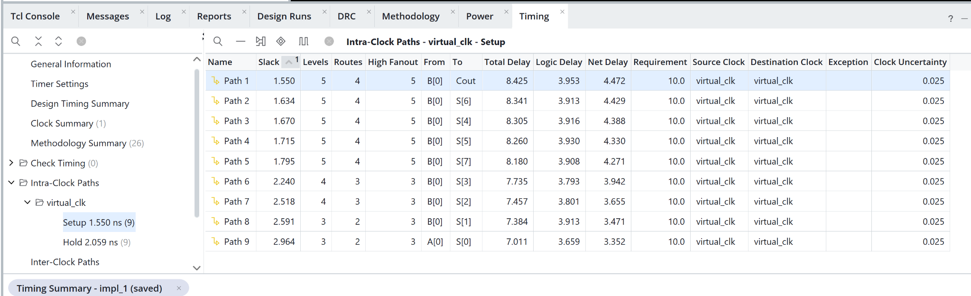
Figure A45. Setup paths
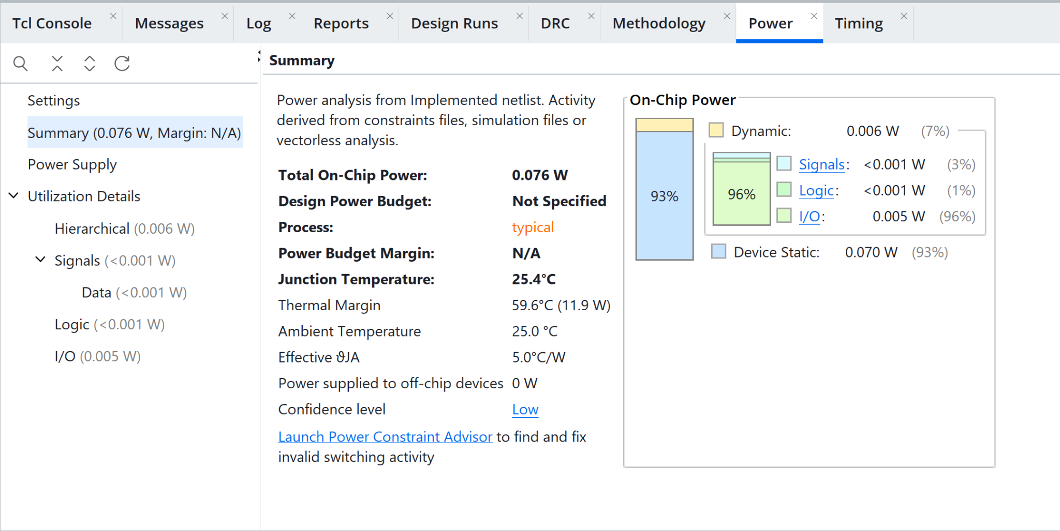
Figure A46. Power estimate

A3 Sklansky 8 bit hardware
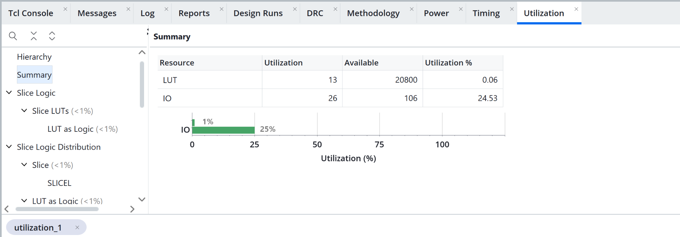
Figure A47. Utilization
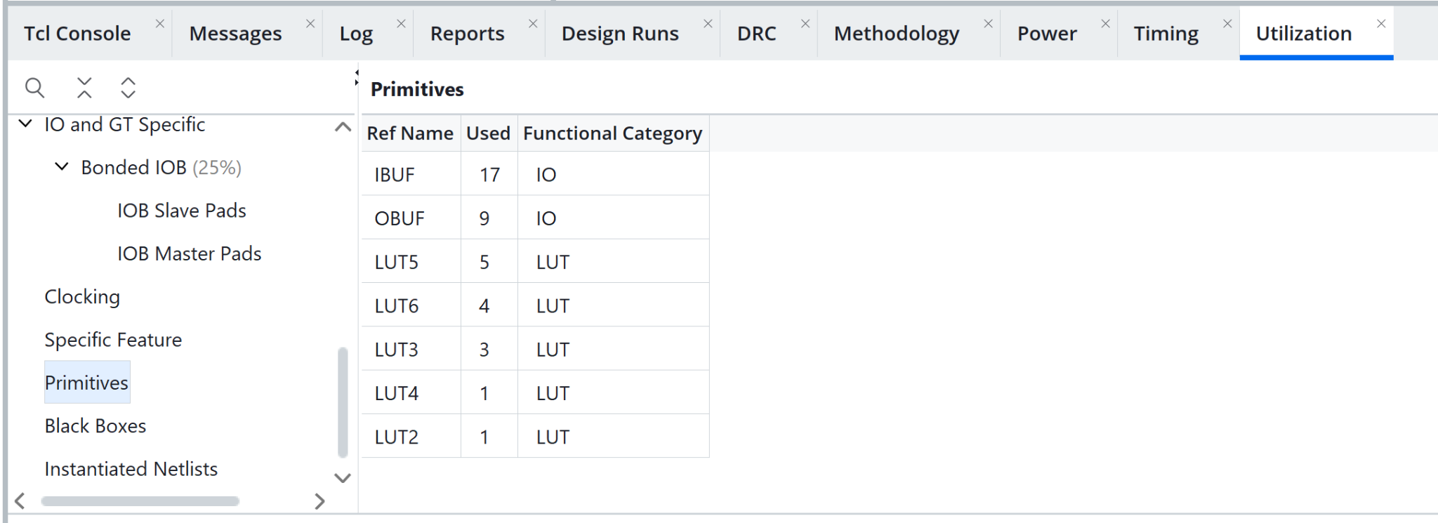
Figure A48. Primitive inventory
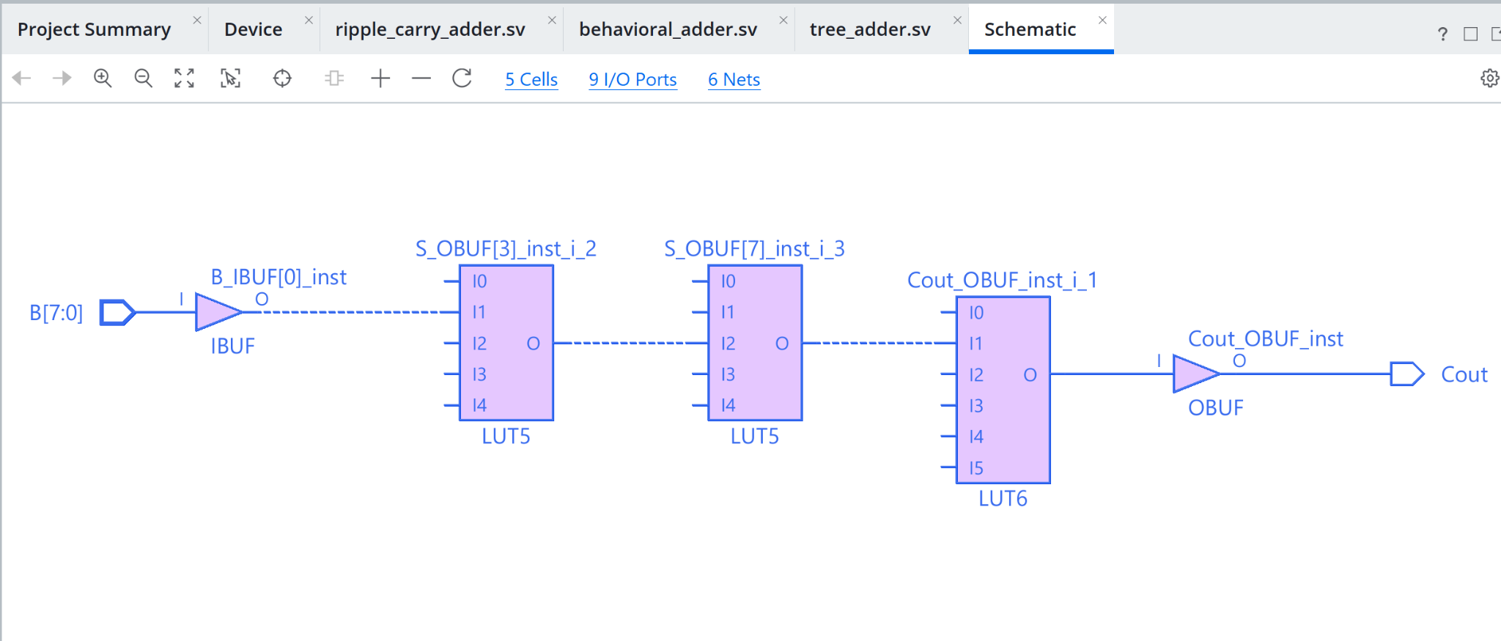
Figure A49. Schematic view

A3 Sklansky 16 bit timing and power
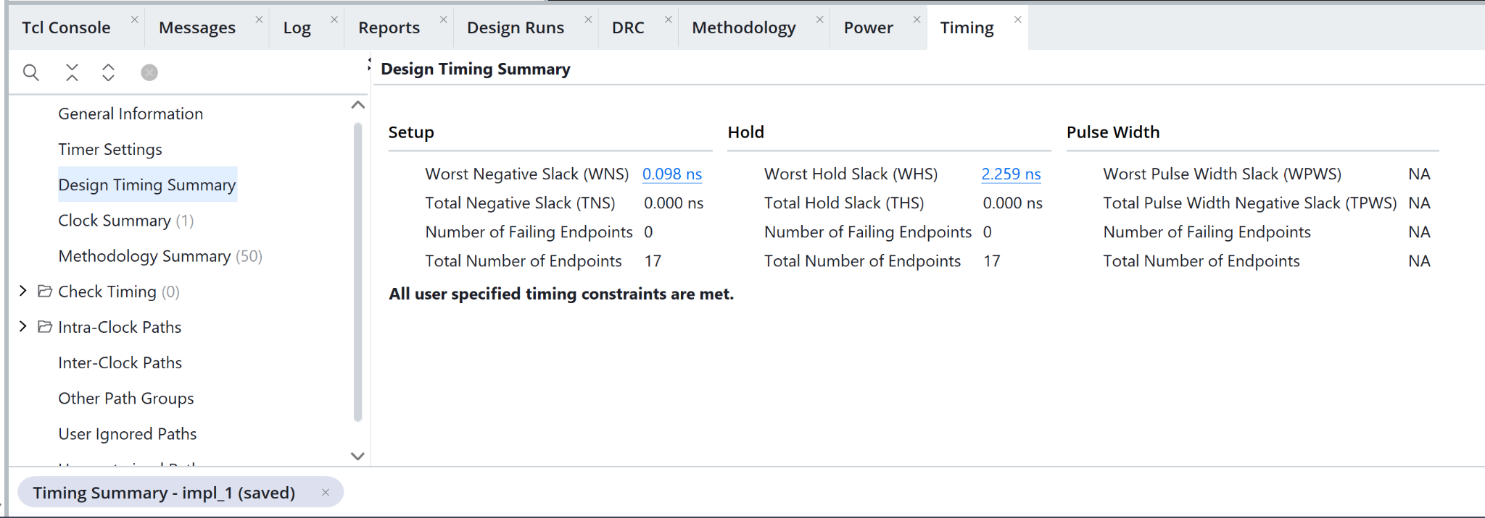
Figure A50. Timing summary
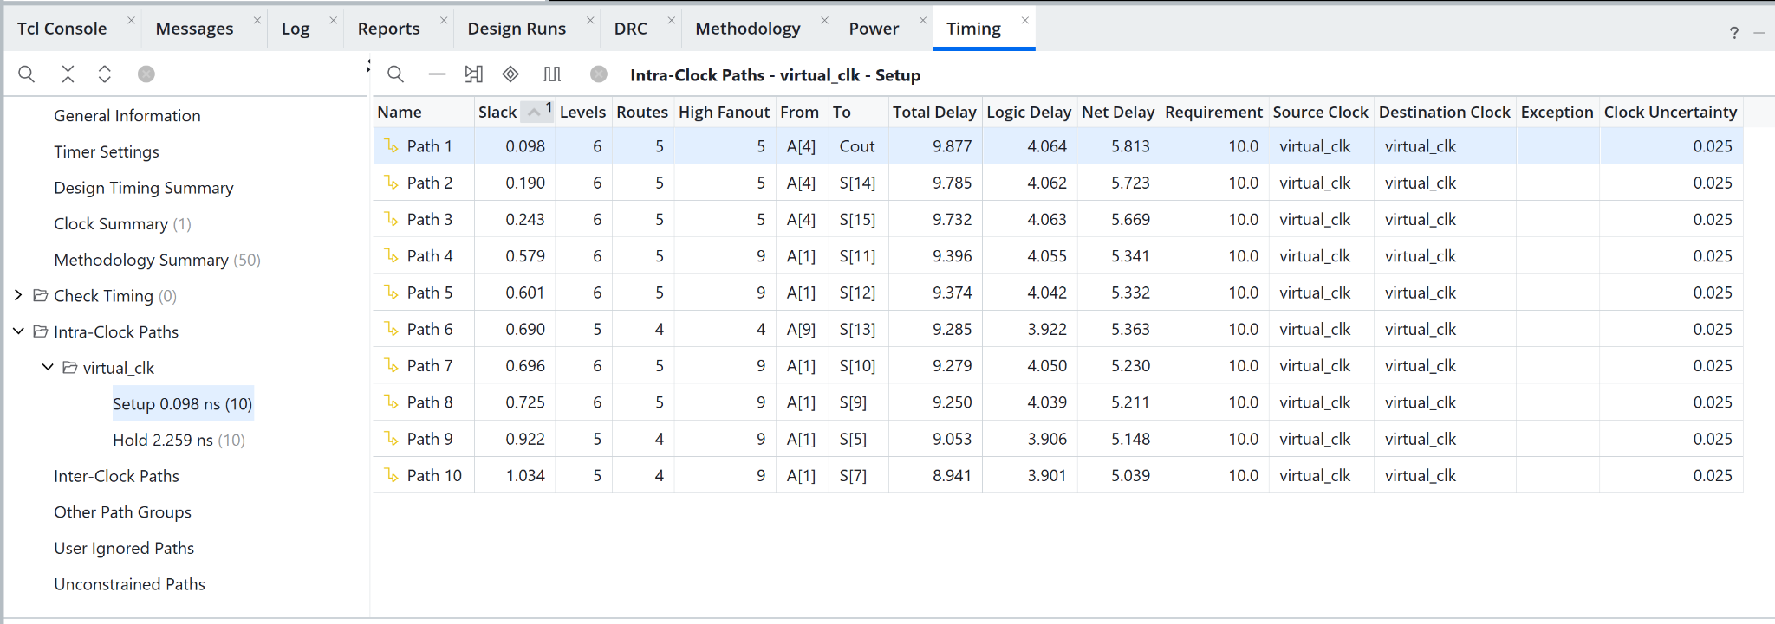
Figure A51. Setup paths
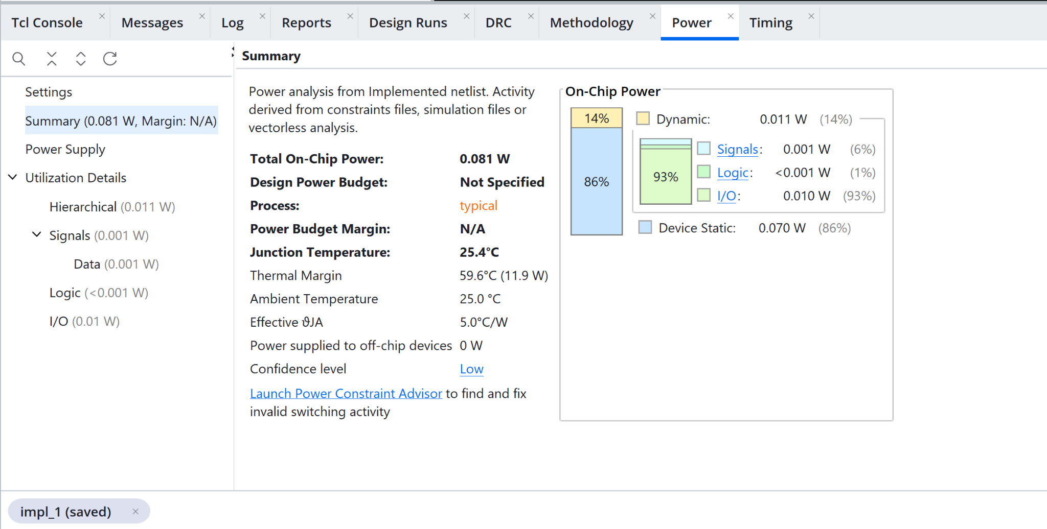
Figure A52. Power estimate

A3 Sklansky 16 bit hardware
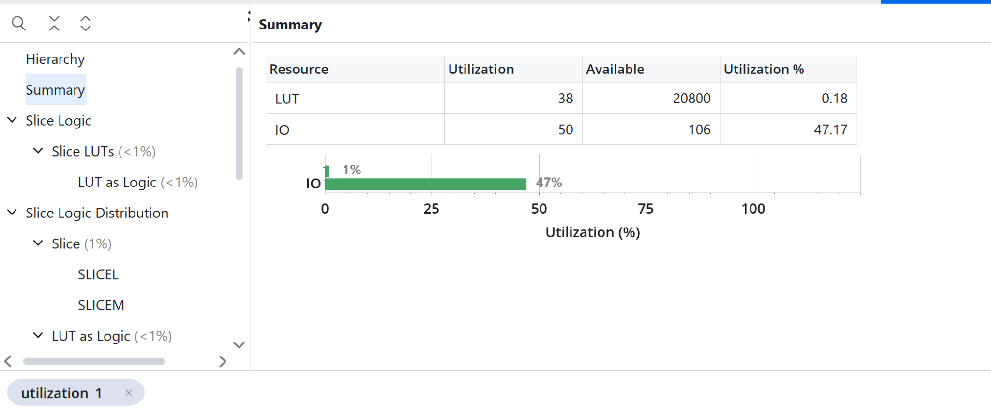
Figure A53. Utilization
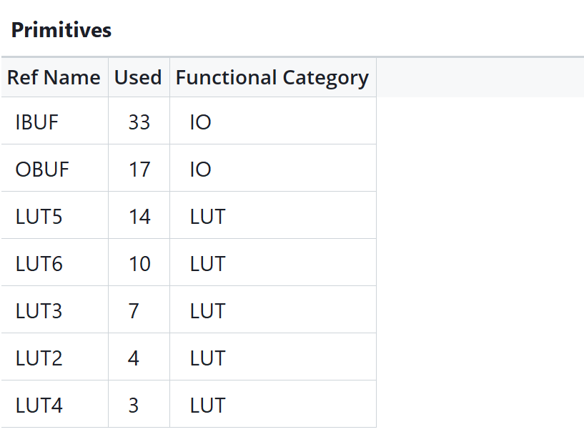
Figure A54. Primitive inventory
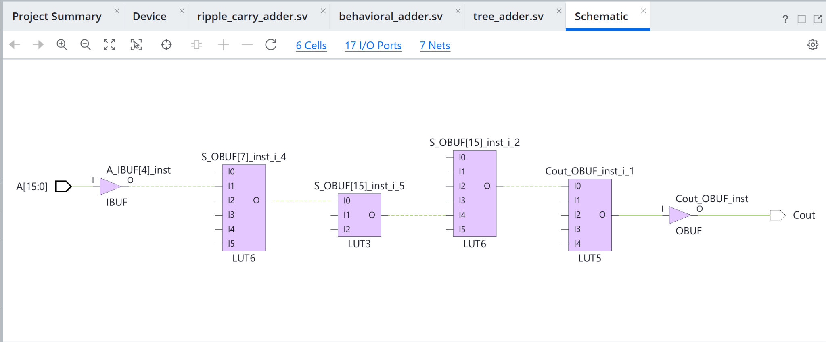
Figure A55. Schematic view

A3 Sklansky 32 bit timing and power
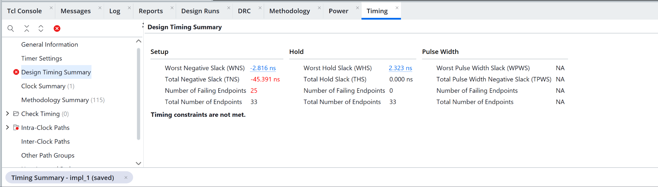
Figure A56. Timing summary
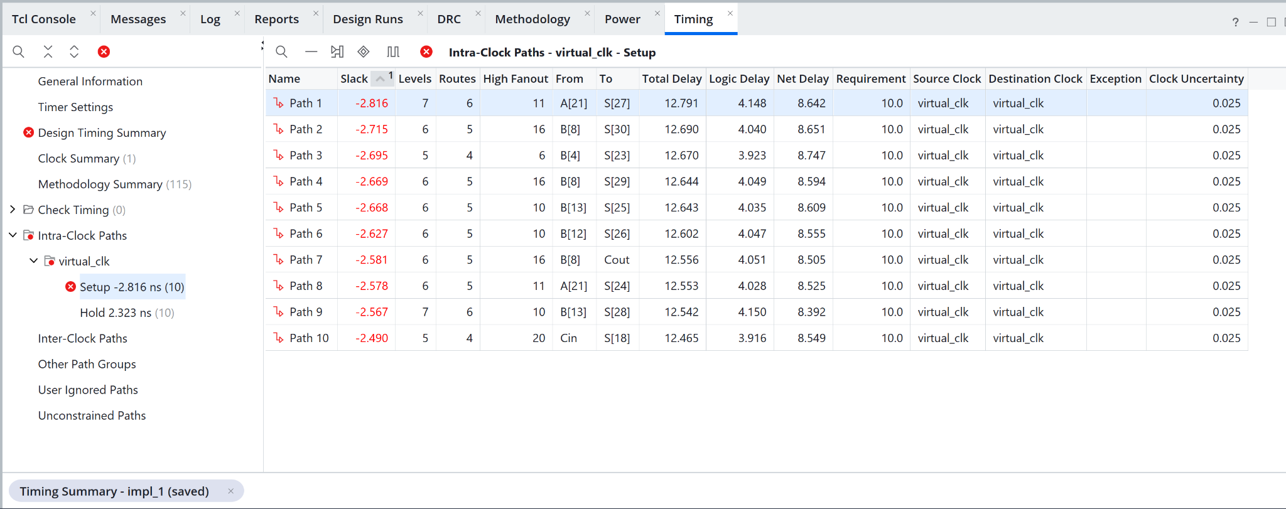
Figure A57. Setup paths
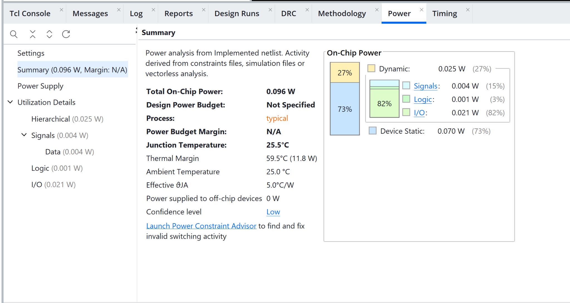
Figure A58. Power estimate

A3 Sklansky 32 bit hardware
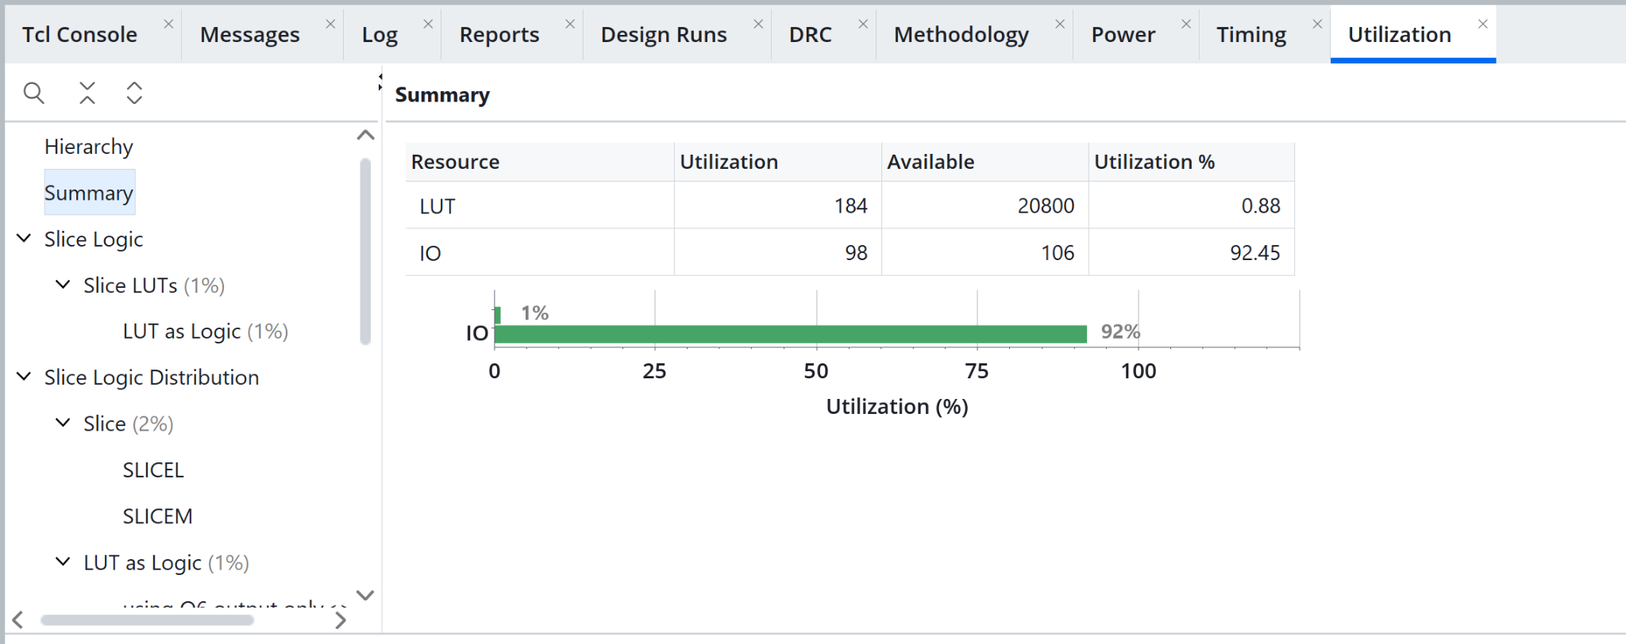
Figure A59. Utilization
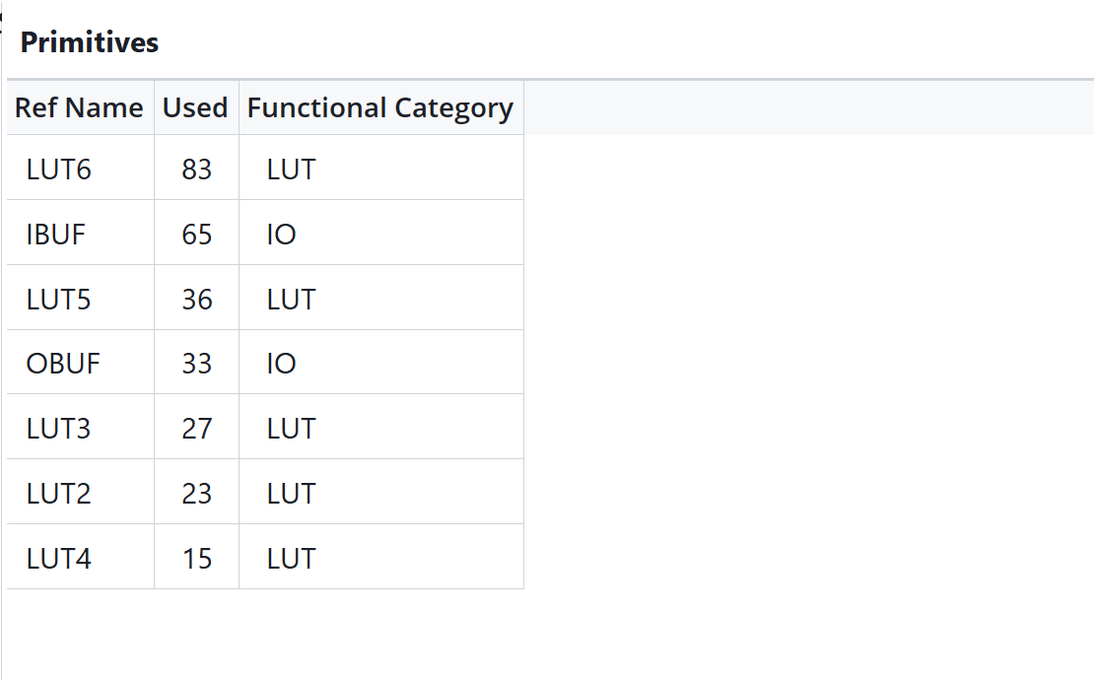
Figure A60. Primitive inventory
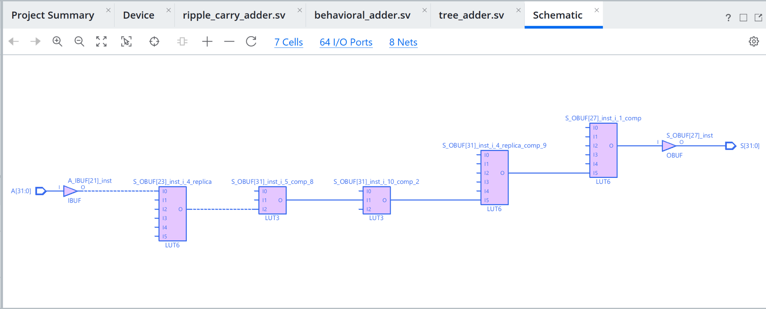
Figure A61. Schematic view

A4 8 bit tree RTL
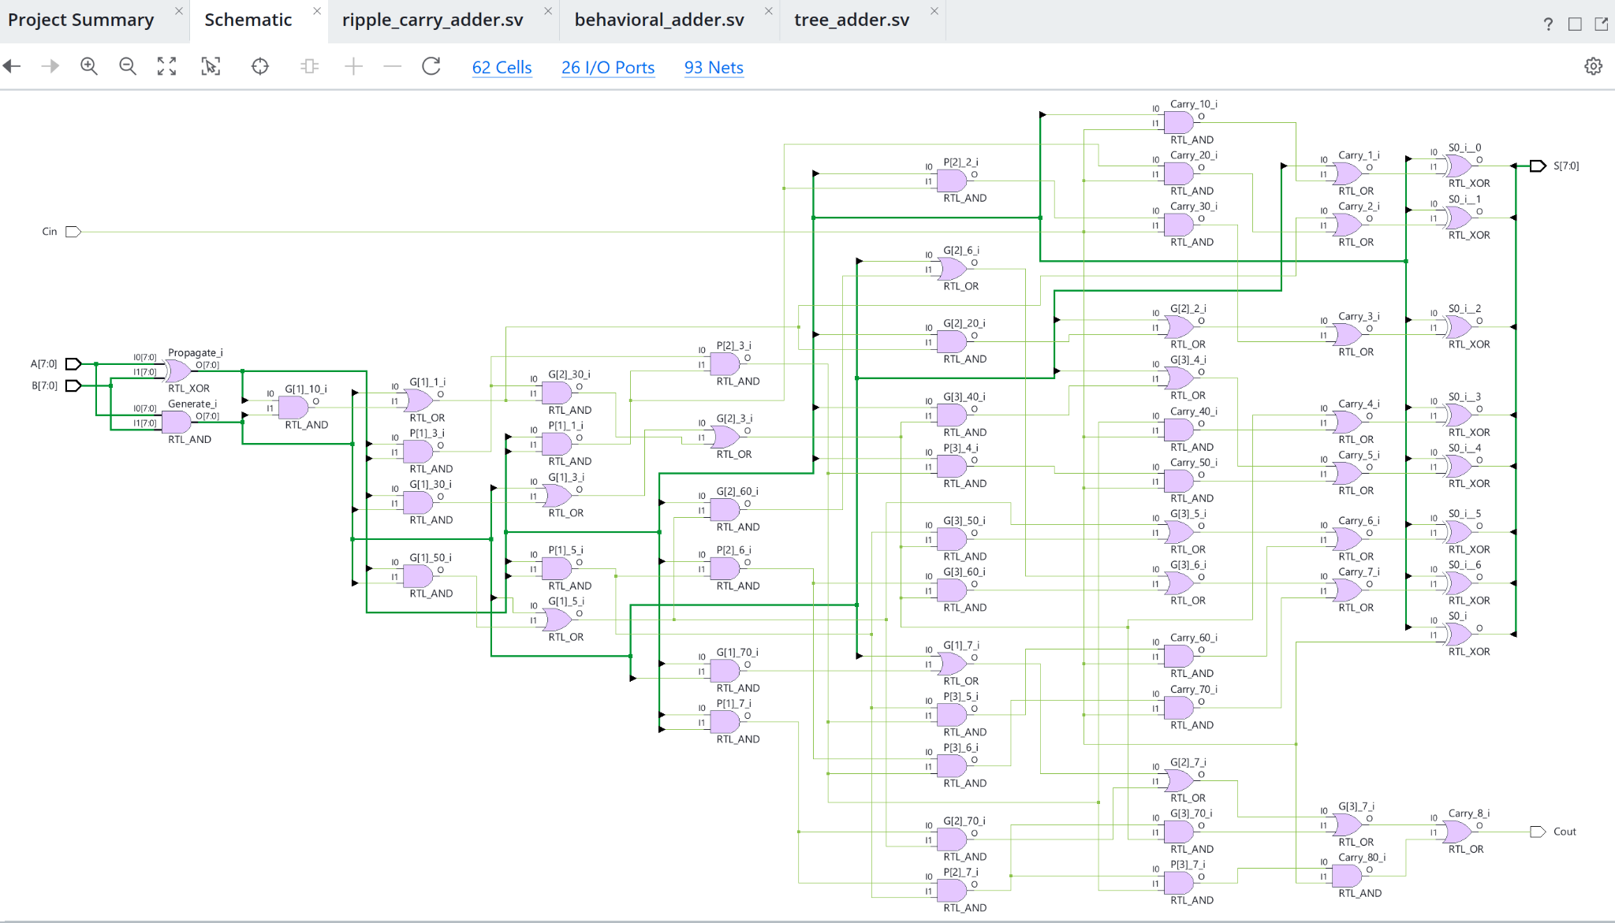
Figure A62. RTL schematic showing the generated prefix network. Wider views serve as structural overviews.

A4 16 bit tree RTL
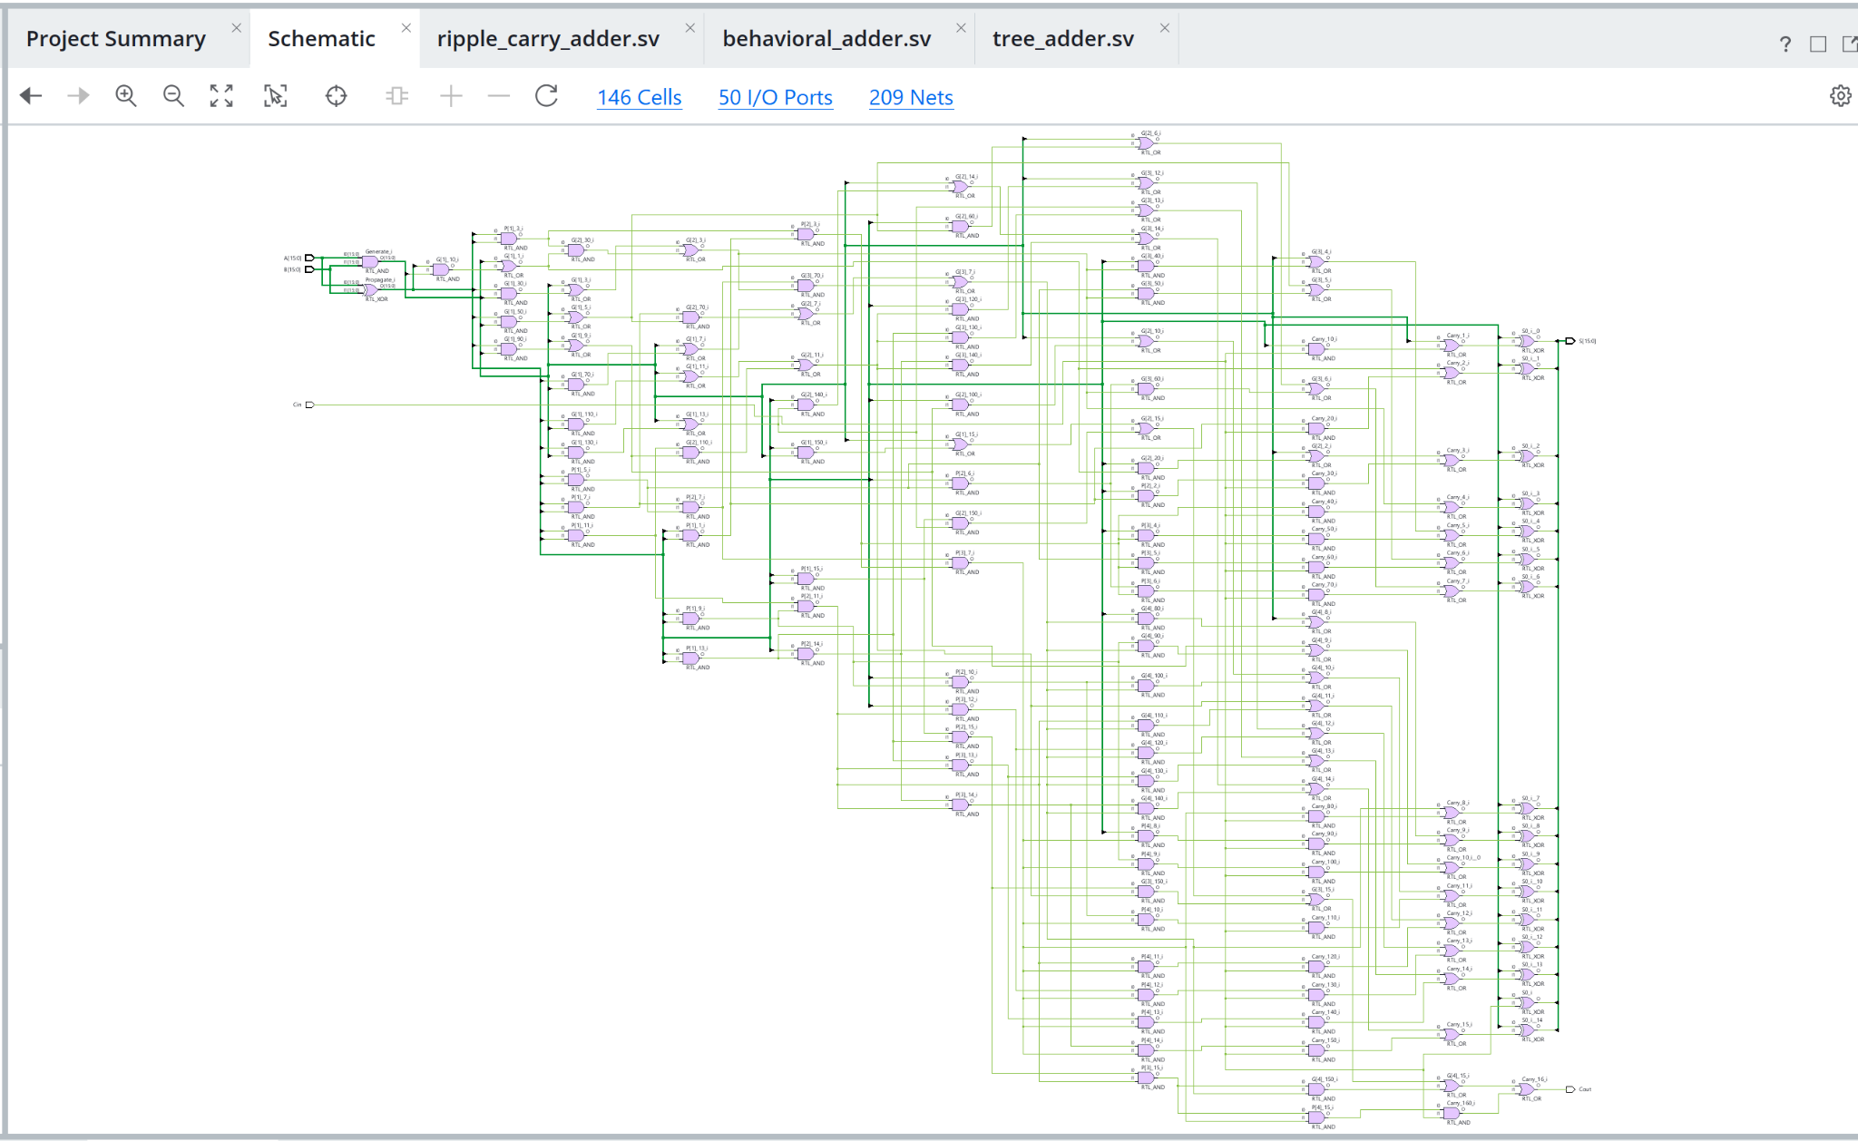
Figure A63. RTL schematic showing the generated prefix network. Wider views serve as structural overviews.

A4 32 bit tree RTL
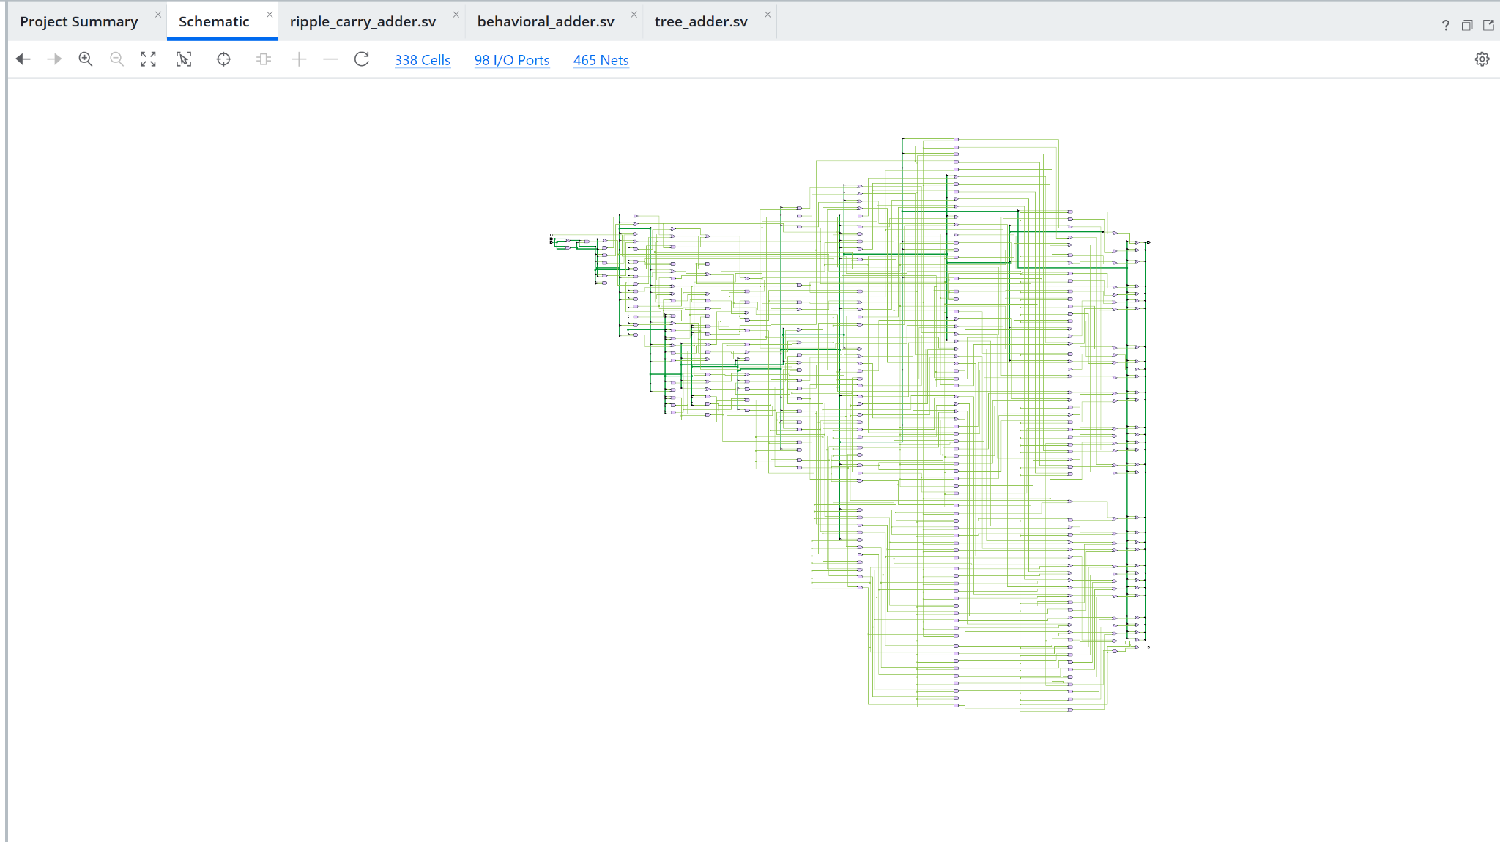
Figure A64. RTL schematic showing the generated prefix network. Wider views serve as structural overviews.

A5 Optional 64 bit implementation error
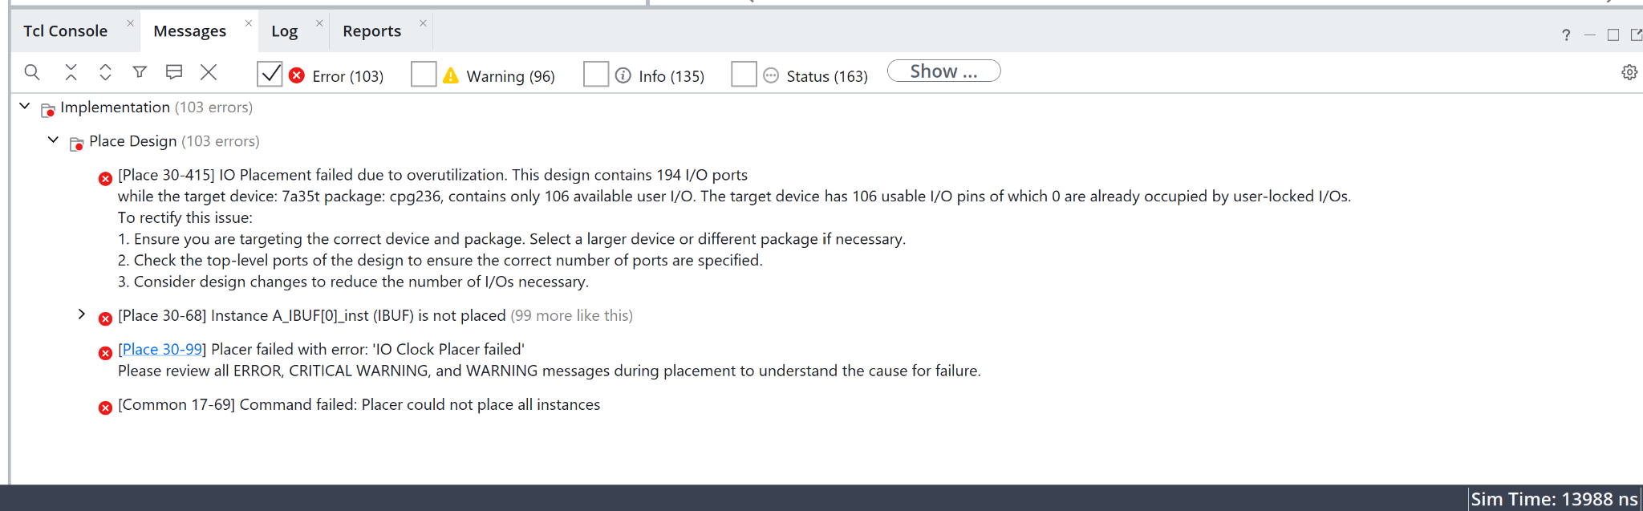
Figure A65. The 64-bit ripple placement failure reports 194 required I/O ports and 106 available pins.

