This assignment is designed to test component architecture, state orchestration, design-token translation, micro-interactions, responsive CSS performance, and LLM-driven Generative UI rendering.

Senior UI/UX & React Engineer Assessment
Project Title: Dynamic Engine — Generative AI Dashboard & Widget Builder
Time Allocation: 6 – 8 Hours (Take-Home)
Tech Stack Required: React 18+ (Next.js or Vite), TypeScript, Tailwind CSS, Node.js (Express/FastAPI), Lucide/Radix Primitives.

Executive Summary & Objective
You are tasked with building Dynamic Engine, an adaptive workspace application that renders real-time, customizable UI widgets based on structured responses from an LLM server and render the BI dynamic dashboard for the user query on portal.
The core objective is to demonstrate your ability to bridge high-fidelity UI/UX execution (pixel precision, fluid micro-interactions, accessibility) with advanced React architecture (dynamic runtime component orchestration, performance optimization, and robust error isolation) and understanding of the rendering performance issue while dealing with the huge dynamic streaming data.

Technical Requirements & Deliverables

Part 1: Backend Mock Server (Node.js / Express)
Create a minimal Node.js server that simulates a streaming LLM response returning structured JSON schemas for UI widgets.
- Endpoint: POST /api/generate-dashboard
- Behavior:
  - Accepts a prompt (e.g., "Show me real-time system analytics and active user regions").
  - Streams back or returns a payload containing a list of dynamic widget configurations with different visual archetypes:
    - Metrics Card (KPI + mini Sparkline/Chart)
    - Interactive Data Table (Sortable, filterable, virtualized)
    - Actionable Command Panel (Form inputs with dynamic validation rules)
- Dynamic State Changes: Provide a POST /api/widget-action endpoint that simulates updating widget data or layout rules dynamically based on user interaction with the generated components.
- Use the python framework like fastapi preferred to develop the rest CRUD endpoint and integrate it with the UI, data shall come from the mocked/db via api which needs to be rendered on the UI. [Sample snapshot at end of the document.]

Part 2: Frontend Core Architecture (React + TypeScript)
A. Dynamic Generative UI Registry
- Implement a Dynamic Component Resolver/Registry that parses the incoming JSON schema from your backend and dynamically maps each schema object to its corresponding React component at runtime.
- Provide a graceful fallback mechanism (Error Boundary + Component Skeleton) for unknown schema types, missing fields, or broken data payloads without crashing the rest of the workspace.
- Note: User

B. CSS & UI/UX Execution (Tailwind CSS + Flexbox/Grid)
- Design Token Synchronization: Implement a dynamic theme toggle (Dark / Light / High-Contrast) using CSS Custom Properties integrated directly into Tailwind (theme.extend).
- Auto-Layout Matrix: Build a drag-and-drop or configurable multi-column grid layout using CSS Grid and Flexbox where widgets auto-fill available container space without causing layout reflows or horizontal scroll leaks.
- Layout Shift Prevention (CLS): Ensure zero Cumulative Layout Shift during streaming or async component loading by reserving layout space via custom skeleton drivers.

C. Micro-Interactions & Perceived Performance
- Optimistic UI Updates: When a user interacts with a widget (e.g., toggling a status, submitting a command form, or rearranging widgets), update the UI state instantly, dispatch the API call in the background, and seamlessly roll back state with a non-intrusive notification if the API request fails.
- Fluid Motion: Implement smooth micro-interactions (hover states, modal transitions, widget layout updates) using Tailwind transitions or Framer Motion.

Schema Specification (LLM Payload Format)
Your frontend must accurately handle payloads structured like this mock sample [Note: Treat it as sample json, create your own to resolve the widget on the basis of the data from backend]:
JSON
{
"layout": "grid-3-col",
"theme": "dark",
"widgets": [
{
"id": "wgt_01",
"type": "METRIC_CARD",
"title": "API Request Rate",
"data": {
"value": "14,280",
"unit": "req/sec",
"trend": "+12.4%",
"status": "success",
"sparkline": [10, 25, 40, 35, 60, 85, 90]
}
},
{
"id": "wgt_02",
"type": "DYNAMIC_FORM",
"title": "Agent Parameter Adjuster",
"data": {
"fields": [
{ "name": "temperature", "label": "Model Temperature", "type": "slider", "min": 0, "max": 1, "default": 0.7 },
{ "name": "fallbackMode", "label": "Enable Fallback", "type": "toggle", "default": true }
],
"actionEndpoint": "/api/widget-action"
}
}
]
}
Evaluation Criteria for Reviewers
Candidates will be assessed across six key pillars:
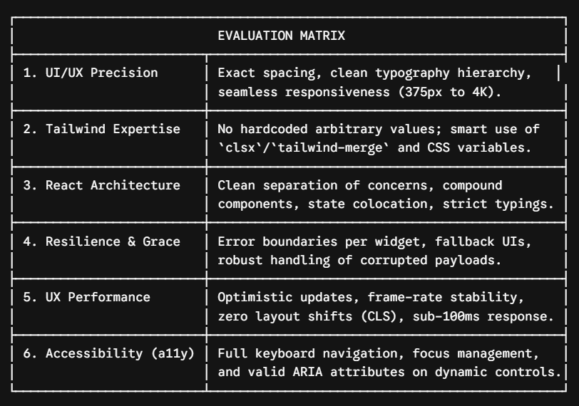

Instructions for Candidate Submission
- Repository Structure:
  - /client: React frontend with full TypeScript typings.
  - /server: Express/Node.js API returning mock LLM schemas.
- Documentation (README.md):
  - Clear instructions on how to launch both server and client locally.
  - Brief architectural breakdown of your Dynamic Component Registry and Optimistic State strategy.
  - Highlight key UI/UX trade-offs made during development.

Outcome should look like below:
Candidate can feel free to create exact ui/ux of given sample for an assignment with all outcome criteria mention above in the table.

