costmap_2d

TASKS PERFORMED IT
- It takes in sensor data from the world, builds a 2D(or 3D: depending on whether a voxel based implementation is used) occupancy grid of the data, and inflates costs in a 2D costmap based on the occupancy grid and a user specified inflation radius.
Voxel: 3-D grid (Eg. Minecraft maps).
- also provides support for map_server based initialization of a costmap, rolling window based costmaps, and parameter based subscription to and configuration of sensor topics.

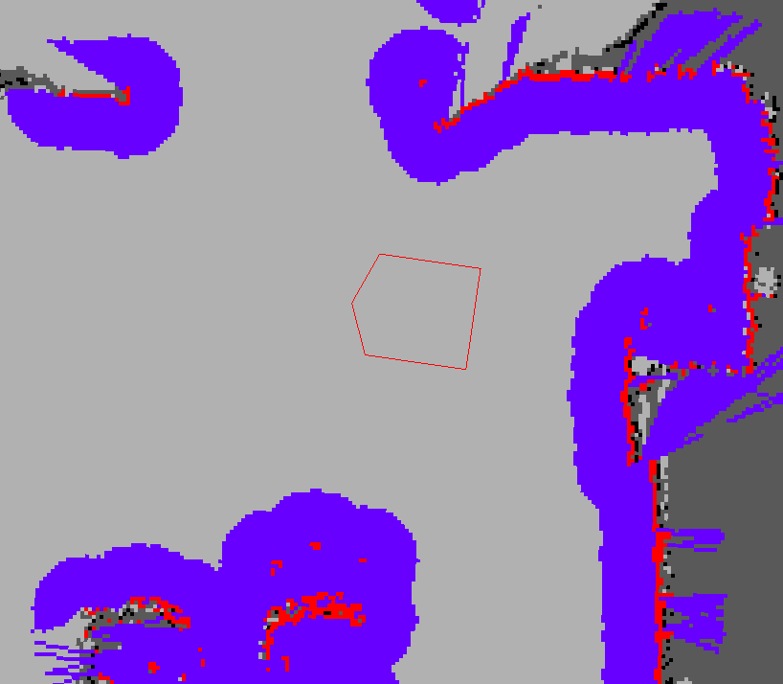 the red cells represent obstacles in the costmap
the blue cells represent obstacles inflated by the inscribed radius of the robot
the red polygon represents the footprint of the robot

To avoid collision
the footprint of the robot should never intersect a red cell
the center point of the robot should never cross a blue cell

The costmap uses sensor data and information from the static map to store and update information about obstacles in the world through the costmap_2d::Costmap2DROS object.
Costmap2DROS: provides a purely two dimensional interface to its users, meaning that queries about obstacles can only be made in columns(no. Of columns occupied = cost of the grid).

As of Hydro release, Each bit of functionality exists in a Layer.
Layer: It’s a custom costmap that enables us to work on a specific costmap.
Eg.: static map, obstacle,inflation.

Each layer is instantiated in the Costmap2DROS using pluginlib and is added to the LayeredCostmap. The layers themselves may be compiled individually.

MARKING & CLEARING
Costmap automatically subscribes to sensors topics over ROS and updates itself accordingly.
Each sensor can do 2 things:
1. Mark Obstacles: Basically an index into an array to change the cost of the cell.
2. Clear Obstacles: Raytracing(i.e. moving in a st. line) from origin of sensor outwards for each observation reported.

SETTING OCCUPIED, FREE & UNKNOWN SPACE
Each cell in the costmap can have one of 255(8-bit) different cost values. But the underlying structure can only represent 3.
Hence we require 3 threshold values.
- Columns that have a certain number of unknown cells(see unknown_threshold parameter) are assigned a costmap_2d::NO_INFORMATION cost.
- Columns that have a certain number of occupied cells (see mark_threshold parameter) are assigned a costmap_2d::LETHAL_OBSTACLE cost
- Others are assigned a costmap_2d::FREE_SPACE cost.

MAP UPDATES
Controlled by update_frequency parameter.
In each cycle:
- Sensor data comes in.
- Marking & clearing operations are performed in occupancy structure of the costmap.
- Appropriate cost values are assigned.
- Obstacle inflation is performed on each cell with a costmap_2d::LETHAL_OBSTACLE cost.

TF
In order to insert data from sensor sources into the costmap, the costmap_2d::Costmap2DROS object makes extensive use of tf. The transform_tolerance sets the maximum amount of latency allowed between these transforms. If thetf tree doesn’t update within the given frequency, navigation stack stops the robot.

INFLATION
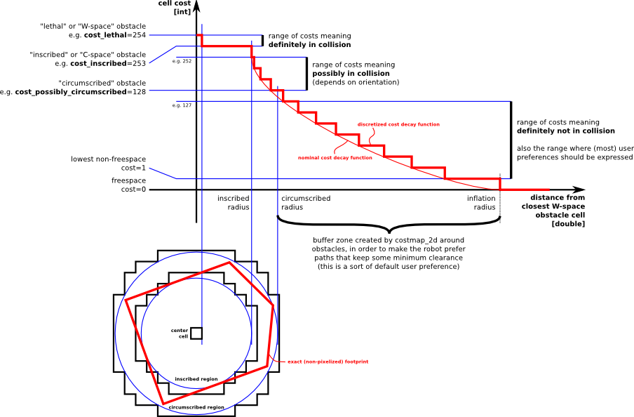
Inflation is propagating cost values out from occupied cells that decrease with distance. For this purpose, we define 5 specific symbols for costmap.
- Lethal: Collision imminent
- Inscribed: Collision Imminent.
- Circumscribed: Possible collision.
- Freespace: Nothing keeping the bot from going there.
- Unknown: Cost value can be set as pleased.

MAP TYPES
Maps can be initialized in 2 ways:
- Through a user defined static-map in conjunction with a localization system(E-Kalman Filter).
- Info. Provided: Height, Width & obstacles.
- Rolling window: Here the bot is always kept at the centre of the costmap as it moves throughout the world, dropping obstacle info. From map as the bot moves too far from a given area.
- Info. Provided: Height, Width & rolling_window parameter set to true.

SUBSCIRBED TOPICS
~<name>/footprint (geometry_msgs/Polygon)

PUBLISHED TOPICS
- ~<name>/costmap (nav_msgs/OccupancyGrid)
# This represents a 2-D grid map, in which each cell `
represents the probability of
# occupancy.

Header header

#MetaData for the map
MapMetaData info

# The map data, in row-major order, starting with (0,0). Occupancy
# probabilities are in the range [0,100]. Unknown is -1.
int8[] data

- ~<name>/costmap_updates (map_msgs/OccupancyGridUpdate)
  - Basically, it tells us about the cells whose cost values have been updated.
- ~<name>/voxel_grid (costmap_2d/VoxelGrid) {WILL NOT BE USED IN IGVC}

PARAMETERS {PRE-HYDRO}
NOTE:- Hydro and later releases use plugins for all costmap_2d layers. If you don't provide a plugins parameter then the initialization code will assume that your configuration is pre-Hydro and will load a default set of plugins with default namespaces. Your parameters will be moved to the new namespaces automagically.~<name>/robot_base_frame (string, default: "base_link")
DEFAULT NAMESPACES:
- static_layer
- obstacle_layer
- inflation_layer

- ~<name>/plugins (sequence, default: pre-Hydro behavior)
- ~<name>/global_frame (string, default: "/map")

- ~<name>/robot_base_frame (string, default: "base_link")

- ~<name>/transform_tolerance (double, default: 0.2)

- ~<name>/update_frequency (double, default: 5.0)
- ~<name>/publish_frequency (double, default: 0.0)
- ~<name>/rolling_window (bool, default: false)
Most probably will be set true.
- ~<name>/always_send_full_costmap (bool, default: false)
Most probably will be set true.

